Bayou Bend Asymptomatic Bacteriuria (ASB) Report
Date of Report: April 2024*
*This data report is based on cases submitted from September 2023 – March 2024 and does not include previous data.
Inappropriate Diagnosis of UTI measure
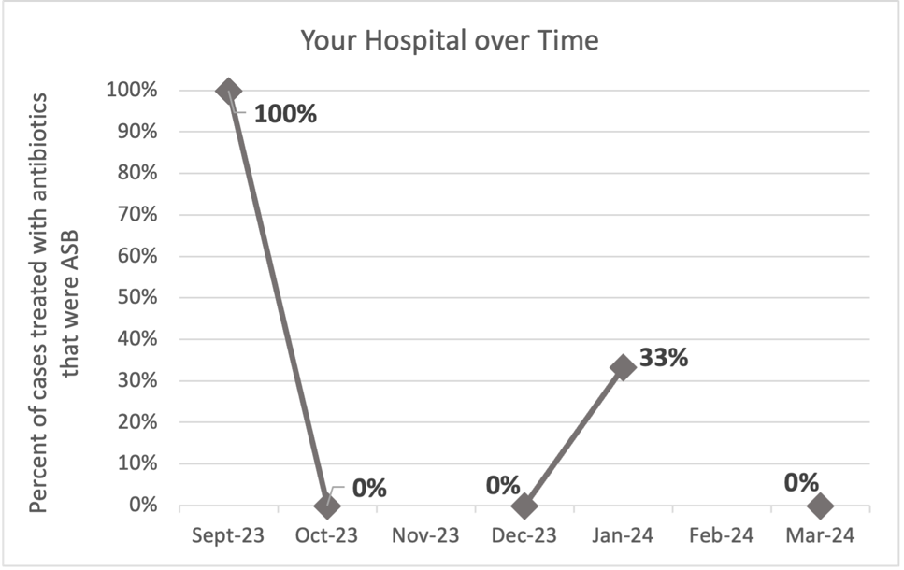
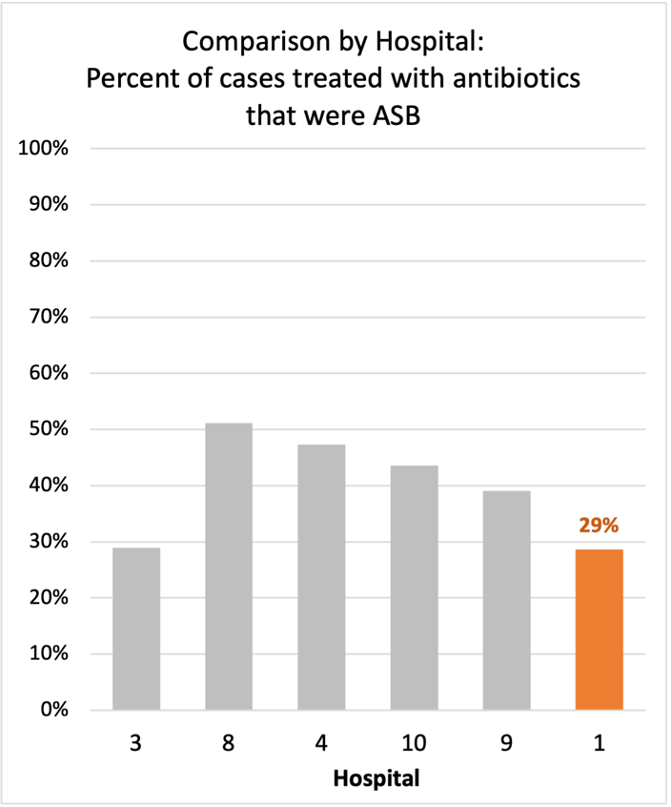
Average across hospitals in cohort: 38.3% ; HMS Hospital Average*: 23.2%
Inappropriate Diagnosis of UTI measure: $\frac{Number of patients treated for ASB}{Number of positive urine cultures treated (UTI+ASB)}$
- Goal: lower % = better
- You can lower this number by either reducing unnecessary urine cultures (diagnostic stewardship) or reducing antibiotic treatment when unnecessary cultures are obtained (antibiotic stewardship)
*The HMS hospital average was amongst 46 hospitals in the Michigan Hospital Medicine Safety Consortium that participated in a similar quality improvement study.

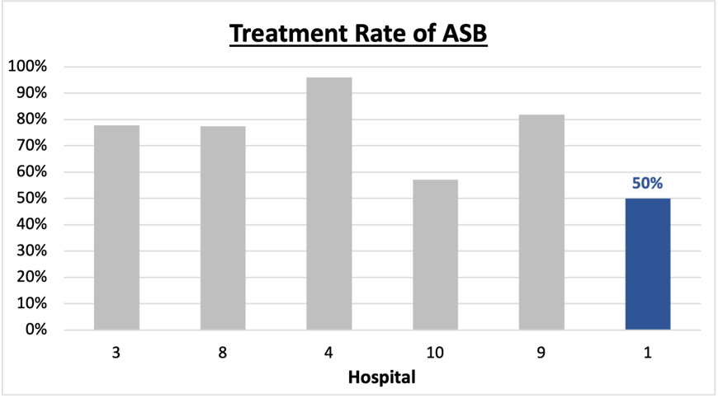
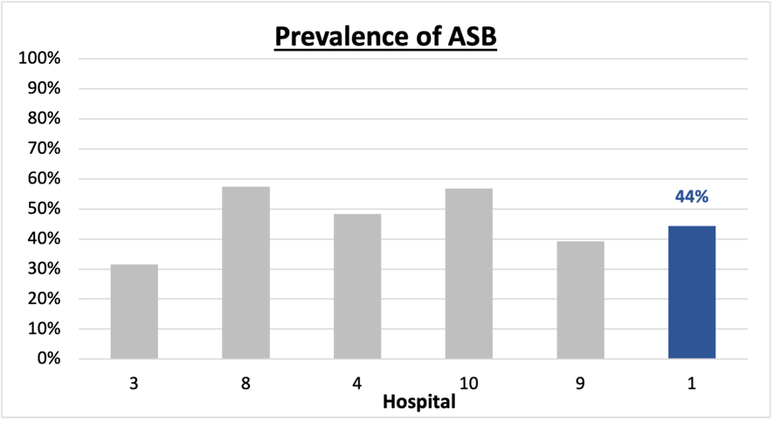
Prevalence and Treatment Rate of ASB
Prevalence of ASB:
$$\frac{Number of ASB cases}{Number of positive urine cultures}$$
$$\frac{Number of treated ASB cases}{Number of ASB cases}$$
Treatment Rate
of ASB:

Data submissions
Total cases (positive urine cultures) included for your site: 9
Cases included per month for your site (median & IQR): 1 (1-2)

Prevalence of ASB
Prevalence of ASB across hospitals: 204 of 483 (42.2%)
Prevalence of ASB at your site: 4 of 9 (44.4%)

Treatment Rate of ASB
Treatment rate of ASB in overall cohort: 164 of 204 (80.4%)
Treatment rate of ASB at your site: 2 of 4 (50%)
Previous treatment rate at your site (from ASB 101 cohort): 6 of 8 (75%)

Antibiotic Tables
Table 1: Three Most Common Antibiotics comparing UTI & ASB
IV |  | Oral
UTI, n= 5 | ASB, n = 2 | UTI, n=1 | ASB, n = 0
Ceftriaxone (n=2) | Ceftriaxone (n=1) | Levofloxacin (n=1) | NA
Levofloxacin (n=2) | Pip-tazo (n=1) | NA | NA
Meropenem (n=1) | NA | NA | NA
Table 2: Antibiotic Duration (days) | UTI |  | ASB
Table 2: Antibiotic Duration (days) | Prior, n=4 | This Month, n=1 | Prior, n=3 | This Month, n=1
Total Antibiotic Duration; median (IQR) | 5.5 (2-10) | 4 (4-4) | 2 (1-6.5) | 0
Number of Cases Receiving >7 days; n (%) | 2 (50%) | 0 | 1(33.3%) | 0

*Should this table include treated and untreated cases?
Prior is Sept 2023 - Feb 2024 & this month is March 2024
Table 3: Characteristics comparing this month to prior n (%) | UTI |  | ASB
Table 3: Characteristics comparing this month to prior n (%) | Prior, n=4 | This Month, n=1 | Prior, n=3 | This Month, n=1
Setting where culture obtained
ED, then admitted | 3 (75%) | 0 | 3 (100%) | 1 (100%)
ED, then discharged | 0 | 0 | 0 | 0
Ambulatory care clinic | 0 | 0 | 0 | 0
Inpatient | 1 (25%) | 1 (100%) | 0 | 0
Other | 0 | 0 | 0 | 0
From reflex test | 3 (75%) | 1 (100%) | 2 (66.7%) | 1 (100%)
Men | 1 (25%) | 0 | 0 | 0
Age >75 | 2 (50%) | 0 | 2 (66.7%) | 0
Acute altered mental status changes alone | 0 | 0 | 0 | 1 (100%)
Characteristic Tables
Prior is Sept 2023 - Feb 2024 & this month is March 2024
Table 4: Prescribing Characteristics | UTI |  | ASB
Table 4: Prescribing Characteristics | Prior, n= 4 | This Month, n=1 | Prior, n= 3 | This Month, n=1
Top 3 Prescriber IDs (if available)
 | 1 (n=1) | 6 (n=1) | A (n=1) | H (n=1)
 | C (n=1) | NA | M (n=1) | NA
 | H (n=1) | NA | O (n=1) | NA
Prescriber type, n (%)
Physician | 4 (100%) | 1 (100%) | 3 (100%) | 1 (100%)
Physician Assistant | 0 | 0 | 0 | 0
Nurse Practitioner | 0 | 0 | 0 | 0
Contract of prescribing provider, n (%) (if available)
Employed by hospital | 1 (25%) | 1 (100%) | 0 | 0
Contracted from outside group/locum | 3 (75%) | 0 | 3 (100%) | 1 (100%)
Not sure | 0 | 0 | 0 | 0
Prior is Sept 2023 - Feb 2024 & this month is March 2024
Case IDs for the treated ASB cases
"67406" "77720"

Key Terms and Definitions
- Positive urine culture: Any growth on culture
  - Prevalence of ASB: A positive urine culture without any documented signs or symptoms attributable to urinary tract infection per National Hospital Safety Network (NHSN) and Infectious Diseases Society of America (IDSA) Guidelines.
- Signs or symptoms of UTI includes:
- Fever (>38°C)
- Suprapubic tenderness
- Costovertebral angle pain or tenderness
- Urinary urgency
- Urinary frequency
- Dysuria
- Altered Mental Status + 2 or more SIRS criteria
- Treatment rate of ASB: antibiotic treatment for ASB

Action items/Insight:
Based on the Inappropriate Diagnosis of UTI Measure, your hospital is a performing below average in terms of percentage of UTI cases that were actually ASB. Please continue to try and work on improving this. Additional comments:
Positives to Highlight:
- Low/trending down ASB treatment rate: Throughout the year, your percent of cases treated that were actually ASB trended down. This is a very positive trend! Celebrate this success and maintain this momentum!
- Treatment duration in ASB is lower than UTI: If convincing clinicians to stop prescribing antibiotics for ASB is a challenge at your hospital, it might be easier to convince them to prescribe short durations (eg. 3 days). This trend suggests clinicians at your site are starting to distinguish ASB versus UTI. As a result, they are recognizing when antibiotics are unnecessary and shortening treatment durations.

Areas of Improvement:
- Prevalence rate of ASB is 44%: Although your treatment rate has improved, this suggests that almost half of the urine studies being obtained at your site may be unnecessary (collected in asymptomatic patients).
- Below case submission requirement: given the low number of includes cases, it may be harder to identify outliers or trends in your data.
- Long treatment durations and broad spectrum use in UTI: In the future, you may focus on encouraging clinicians to use less harmful/more narrow therapy (eg. Nitrofurantoin) for patients with UTI as well as try to limit treatment durations <7 days.

