Bayou Bend Asymptomatic Bacteriuria (ASB) Report
Date of Report: July 2024*
*This data report is based on cases submitted from September 2023 – June 2024 and does not include previous data.
Inappropriate Diagnosis of UTI measure
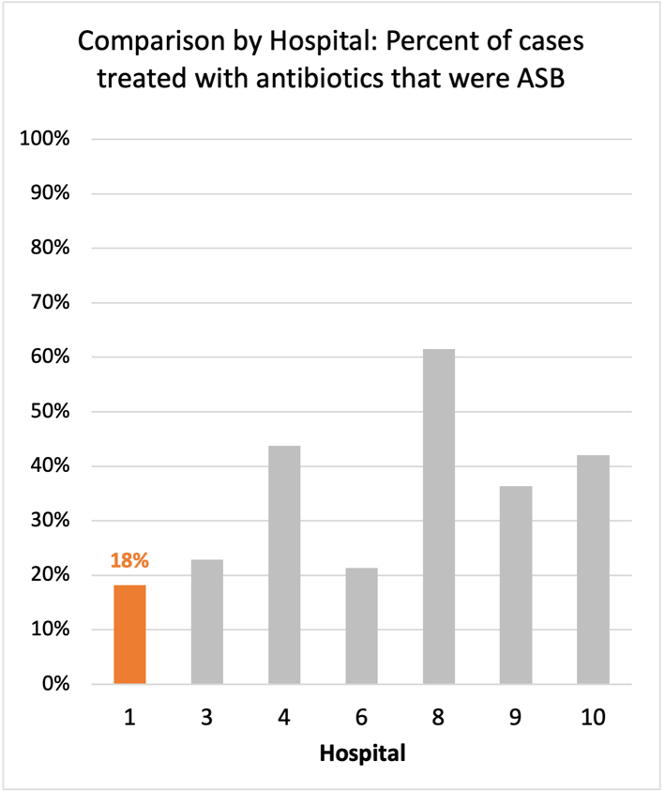
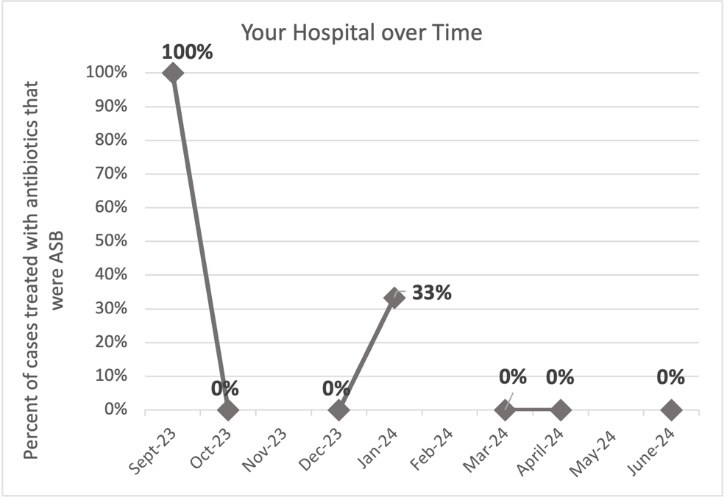
Average across hospitals in cohort: 35.6% ; HMS Hospital Average*: 23.2%
Inappropriate Diagnosis of UTI measure: $\frac{Number of patients treated for ASB}{Number of positive urine cultures treated (UTI+ASB)}$
- Goal: lower % = better
- You can lower this number by either reducing unnecessary urine cultures (diagnostic stewardship) or reducing antibiotic treatment when unnecessary cultures are obtained (antibiotic stewardship)
*The HMS hospital average was amongst 46 hospitals in the Michigan Hospital Medicine Safety Consortium that participated in a similar quality improvement study.

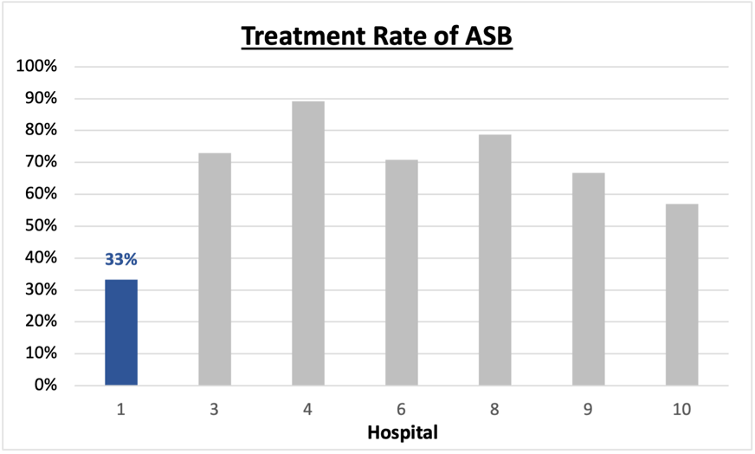
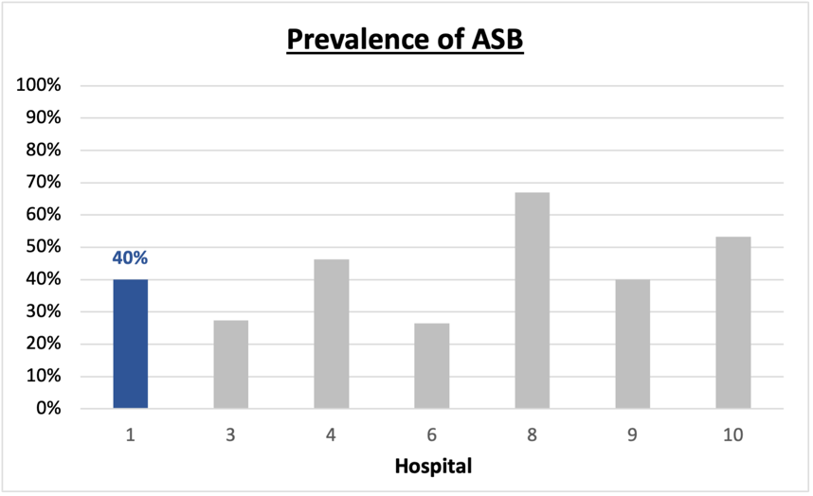
Prevalence and Treatment Rate of ASB

$$\frac{Number of ASB cases}{Number of positive urine cultures}$$
Prevalence of ASB:
$$\frac{Number of treated ASB cases}{Number of ASB cases}$$
Treatment Rate
of ASB:

Data submissions
Total cases (positive urine cultures) included for your site: 15
Cases included per month for your site (median & IQR): 1 (1-2.5)

Prevalence of ASB
Prevalence of ASB across hospitals: 356 of 868 (41.0%)
Prevalence of ASB at your site: 6 of 15 (40%)

Treatment Rate of ASB
Treatment rate of ASB in overall cohort: 266 of 356 (74.7%)
Treatment rate of ASB at your site: 2 of 6 (33.3%)
Previous treatment rate at your site (from ASB 101 cohort): 6 of 8 (75%)

Antibiotic Tables
Table 1: Three Most Common Antibiotics comparing UTI & ASB
IV |  | Oral
UTI, n = 10 | ASB, n = 2 | UTI, n = 1 | ASB, n = 0
Ceftriaxone (n=5) | Ceftriaxone (n=1) | Levofloxacin (n=1)
Levofloxacin (n=2) | Pip-tazo (n=1)
Ertapenem (n=1)
Table 2: Antibiotic Duration (days) | UTI |  | ASB
Table 2: Antibiotic Duration (days) | Prior, n=8 | This Month, n=1 | Prior, n=6 | This Month, n=0
Total Antibiotic Duration; median (IQR) | 5 (3.5-10) | 3 (3-3) | 0 (0-1.5)
Number of Cases Receiving >7 days; n (%) | 3 (37.5%) | 0 | 1(16.7%)

Prior is Sept 2023 - May 2024 & this month is June 2024
Table 3: Characteristics comparing this month to prior n (%) | UTI |  | ASB
Table 3: Characteristics comparing this month to prior n (%) | Prior, n=8 | This Month, n=1 | Prior, n=6 | This Month, n=0
Setting where culture obtained
ED, then admitted | 5 (62.5%) | 1 (100%) | 6 (100%)
ED, then discharged | 0 | 0 | 0
Ambulatory care clinic | 0 | 0 | 0
Inpatient | 3 (37.5%) | 0 | 0
Other | 0 | 0 | 0
From reflex test | 7 (87.5%) | 1 (100%) | 5 (83.3%)
Men | 1 (12.5%) | 1 (100%) | 0
Age >75 | 3 (37.5%) | 1 (100%) | 3 (50%)
Acute altered mental status changes alone | 0 | 0 | 2 (33.3%)
Characteristic Tables
Prior is Sept 2023 - May 2024 & this month is June 2024
Table 4: Prescribing Characteristics | UTI |  | ASB
Table 4: Prescribing Characteristics | Prior, n=8 | This Month, n=1 | Prior, n=6 | This Month, n=0
Top 3 Prescriber IDs (if available)
 | 6 (n=2) | N (n=1) | H (n=2)
 | O (n=2) |  | A (n=1)
 | 1 (n=1) |  | M (n=1)
Prescriber type, n (%)
Physician | 8 (100%) | 1 (100%) | 6 (100%)
Physician Assistant | 0 | 0 | 0
Nurse Practitioner | 0 | 0 | 0
Contract of prescribing provider, n (%) (if available)
Employed by hospital | 3 (37.5%) | 0 | 0
Contracted from outside group/locum | 5 (62.5%) | 2 (100%) | 6 (100%)
Not sure | 0 | 0 | 0

Prior is Sept 2023 - May 2024 & this month is June 2024
Case IDs for the treated ASB cases
"67406" "77720"

Key Terms and Definitions
- Positive urine culture: Any growth on culture
  - Prevalence of ASB: A positive urine culture without any documented signs or symptoms attributable to urinary tract infection per National Hospital Safety Network (NHSN) and Infectious Diseases Society of America (IDSA) Guidelines.
- Signs or symptoms of UTI includes:
- Fever (>38°C)
- Suprapubic tenderness
- Costovertebral angle pain or tenderness
- Urinary urgency
- Urinary frequency
- Dysuria
- Altered Mental Status + 2 or more SIRS criteria
- Treatment rate of ASB: antibiotic treatment for ASB

Action items/Insight:
Based on the Inappropriate Diagnosis of UTI Measure, your hospital is a performing above average in terms of percentage of UTI cases that were actually ASB. GREAT work!
Additional comments:
Positives to Highlight:
- Low/trending down ASB treatment rate: Throughout the year, your percent of cases treated that were actually ASB trended down (previous report was 29% and now at 18%). This is a very positive trend! Celebrate this success and maintain this momentum! This is also below the cohort average. The treatment rate of ASB at your site has also decreased from 50% at the previous report to 33%.
- Decreased treatment duration in ASB and UTI.
Areas of Improvement:
- Prevalence rate of ASB is 40%: Although your treatment rate has improved, this suggests that a little less than half of the urine studies being obtained at your site may be unnecessary (collected in asymptomatic patients).
- Below case submission requirement: given the low number of includes cases (~1 case submission per month), it may be harder to identify outliers or trends in your data.

