Coulee Asymptomatic Bacteriuria (ASB) Report
Date of Report: April 2024*
*This data report is based on cases submitted from September 2023 – March 2024 and does not include previous data.
Inappropriate Diagnosis of UTI measure
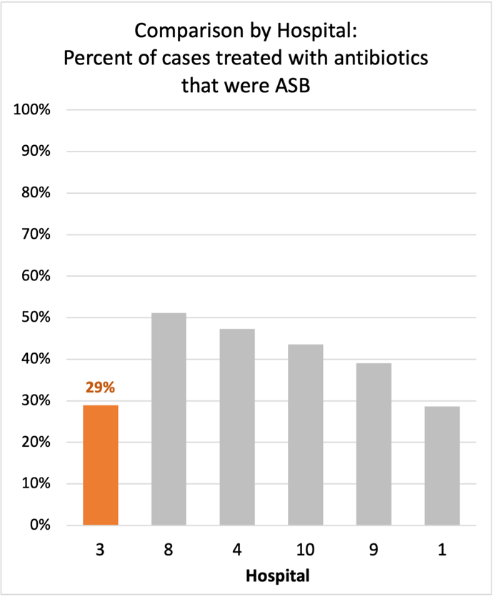
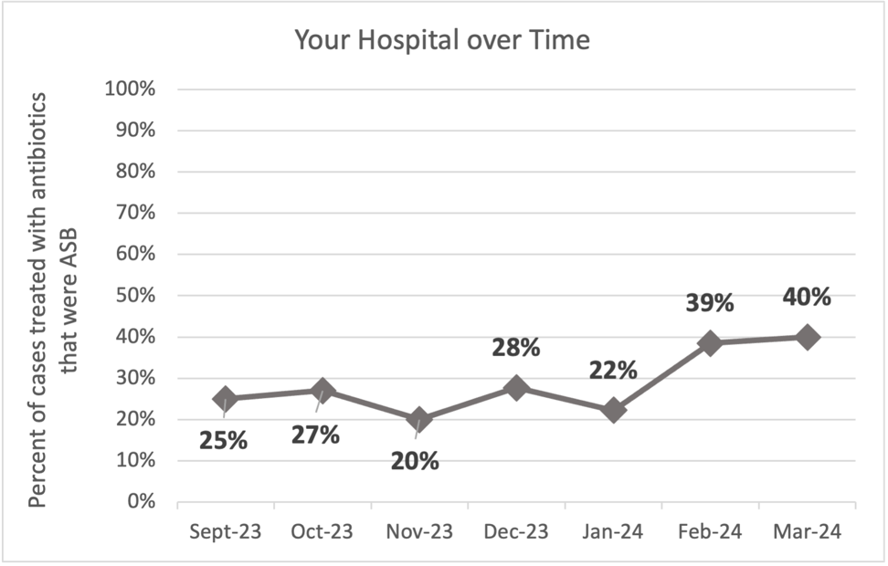
Average across hospitals in cohort: 38.3% ; HMS Hospital Average*: 23.2%
Inappropriate Diagnosis of UTI measure: $\frac{Number of patients treated for ASB}{Number of positive urine cultures treated (UTI+ASB)}$
- Goal: lower % = better
- You can lower this number by either reducing unnecessary urine cultures (diagnostic stewardship) or reducing antibiotic treatment when unnecessary cultures are obtained (antibiotic stewardship)
*The HMS hospital average was amongst 46 hospitals in the Michigan Hospital Medicine Safety Consortium that participated in a similar quality improvement study.

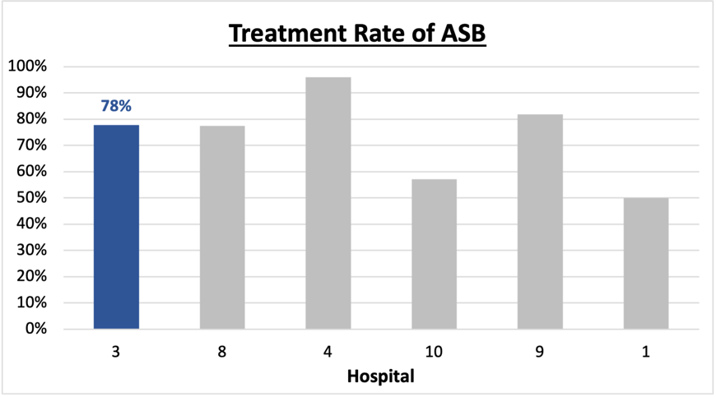
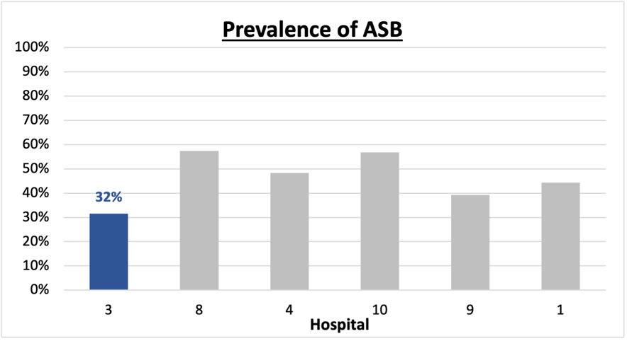
Prevalence and Treatment Rate of ASB

$$\frac{Number of ASB cases}{Number of positive urine cultures}$$
Prevalence of ASB:
$$\frac{Number of treated ASB cases}{Number of ASB cases}$$
Treatment Rate
of ASB:

Data submissions
Total cases (positive urine cultures) included for your site: 114
Cases included per month for your site (median & IQR): 16 (14.5 – 18)

Prevalence of ASB
Prevalence of ASB across hospitals: 204 of 483 (42.2%)
Prevalence of ASB at your site: 36 of 114 (31.6%)

Treatment Rate of ASB
Treatment rate of ASB in overall cohort: 164 of 204 (80.4%)
Treatment rate of ASB at your site: 28 of 36 (77.8%)
Previous treatment rate at your site (from ASB 101 cohort): 27 of 32 (84%)

Antibiotic Tables
Table 1: Three Most Common Antibiotics comparing UTI & ASB
IV |  | Oral
UTI, n= 5 | ASB, n = 6 | UTI, n= 72 | ASB, n = 28
Ceftriaxone (n=5) | Ceftriaxone (n=6) | Nitrofurantoin (n=46) | Nitrofurantoin (n=14)
NA | NA | Tri-sulfa (n=9) | Tri-sulfa (n=4)
NA | NA | Cephalexin (n=5) | Ciprofloxacin (n=3)
Table 2: Antibiotic Duration (days) | UTI |  | ASB
Table 2: Antibiotic Duration (days) | Prior, n=68 | This Month, n=10 | Prior, n=27 | This Month, n=9
Total Antibiotic Duration; median (IQR) | 5 (5-7) | 5 (5-5) | 6 (3-7) | 5 (0-7)
Number of Cases Receiving >7 days; n (%) | 13 (19.1%) | 1 (10%) | 6 (22.2%) | 2 (22.2%)

Prior is Sept 2023 - Feb 2024 & this month is March 2024
Table 3: Characteristics comparing this month to prior n (%) | UTI |  | ASB
Table 3: Characteristics comparing this month to prior n (%) | Prior, n=68 | This Month, n=10 | Prior, n=27 | This Month, n=9
Setting where culture obtained
ED, then admitted | 1 (1.5%) | 0 | 2 (7.4%) | 1 (11.1%)
ED, then discharged | 16 (23.5%) | 1 (10%) | 16 (59.3%) | 5 (55.6%)
Ambulatory care clinic | 51 (75%) | 9 (90%) | 8 (29.6%) | 3 (33.3%)
Inpatient | 0 | 0 | 1 (3.7%) | 0
Other | 0 | 0 | 0 | 0
From reflex test | 27 (39.7%) | 1 (10%) | 21 (77.8%) | 7 (77.8%)
Men | 8 (11.8%) | 1 (10%) | 11 (40.7%) | 1 (11.1%)
Age >75 | 20 (29.4%) | 3 (30%) | 7 (25.9%) | 3 (33.3%)
Acute altered mental status changes alone | 0 | 0 | 5 (18.5%) | 0
Characteristic Tables
Prior is Sept 2023 - Feb 2024 & this month is March 2024
Table 4: Prescribing Characteristics | UTI |  | ASB
Table 4: Prescribing Characteristics | Prior, n=68 | This Month, n=10 | Prior, n=27 | This Month, n=9
Top 3 Prescriber IDs (if available)
 | H (n=42) | H (n=9) | H (n=7) | K (n=3)
 | E (n=6) | K (n=1) | B (n=4) | B (n=20
 | K (n=4) |  | E (n=3) | H (n=2)
Prescriber type, n (%)
Physician | 5 (7.4%) | 0 | 7 (25.9%) | 1 (11.1%)
Physician Assistant | 6 (8.8%) | 1 (10%) | 3 (11.1%) | 3 (33.3%)
Nurse Practitioner | 57 (83.8%) | 9 (90%) | 17 (63.0%) | 5 (55.6%)
Contract of prescribing provider, n (%) (if available)
Employed by hospital | 22 (32.4%) | 1 (10%) | 17 (63.0%) | 6 (66.7%)
Contracted from outside group/locum | 46 (67.6%) | 9 (90%) | 10 (37.0%) | 3 (33.3%)
Not sure | 0 | 0 | 0 | 0

Prior is Sept 2023 - Feb 2024 & this month is March 2024

Case IDs for the treated ASB cases
"#908" "#920" "#924" "#926" "#1000" "#1008" "#1013" "#1110" "#1121"
"#1126" "1210" "1217" "1218" "1227" "1231" "#0113" "#0114" "204"
"213" "216" "218" "221" "306" "317" "318" "320" "321" "322"

Key Terms and Definitions
- Positive urine culture: Any growth on culture
  - Prevalence of ASB: A positive urine culture without any documented signs or symptoms attributable to urinary tract infection per National Hospital Safety Network (NHSN) and Infectious Diseases Society of America (IDSA) Guidelines.
- Signs or symptoms of UTI includes:
- Fever (>38°C)
- Suprapubic tenderness
- Costovertebral angle pain or tenderness
- Urinary urgency
- Urinary frequency
- Dysuria
- Altered Mental Status + 2 or more SIRS criteria
- Treatment rate of ASB: antibiotic treatment for ASB

Action items/Insight:
Based on the Inappropriate Diagnosis of UTI Measure, your hospital is a performing below average in terms of percentage of UTI cases that were actually ASB. Please continue to try and work on improving this. Additional comments:
Positives to Highlight:
- Below average in inappropriate diagnosis of UTI measure: This is a very positive trend! Celebrate this success and maintain this momentum!
- Met case submission requirement: Great job submitting cases! Celebrate this success! (Sandy you rock).
- Low/trending down ASB treatment rate: Throughout the year, your percent of ASB cases treated with antibiotics has trended down (84% in IQIC 101 and now 78%). This is a very positive trend! Work to maintain this momentum!
- High nitrofurantoin use: Less harmful/more narrow therapy use is high at your site! Great job!

Areas of Improvement:
- Up-trending ASB treatment rate: Throughout quality improvement work, it is important to recognize that valleys and peaks occur within this process. When reflecting on prior rates at your facility, please celebrate that this is a huge improvement in overall process. However, this could be an opportunity to investigate what was done differently in Feb/March 2024 to contribute to this.
- Fluoroquinolone use in ASB patients: Fluoroquinolones were the third most commonly prescribed oral agents in ASB treated patients.
- High Treatment of patients with AMS: Treatment in patients presenting with acute altered mental status changes alone appears to be a common finding at your site. Would recommend educating providers on this if possible.

