Skyline Asymptomatic Bacteriuria (ASB) Report
Date of Report: August 2024*
*This data report is based on cases submitted from September 2023 – July 2024 and does not include previous data.
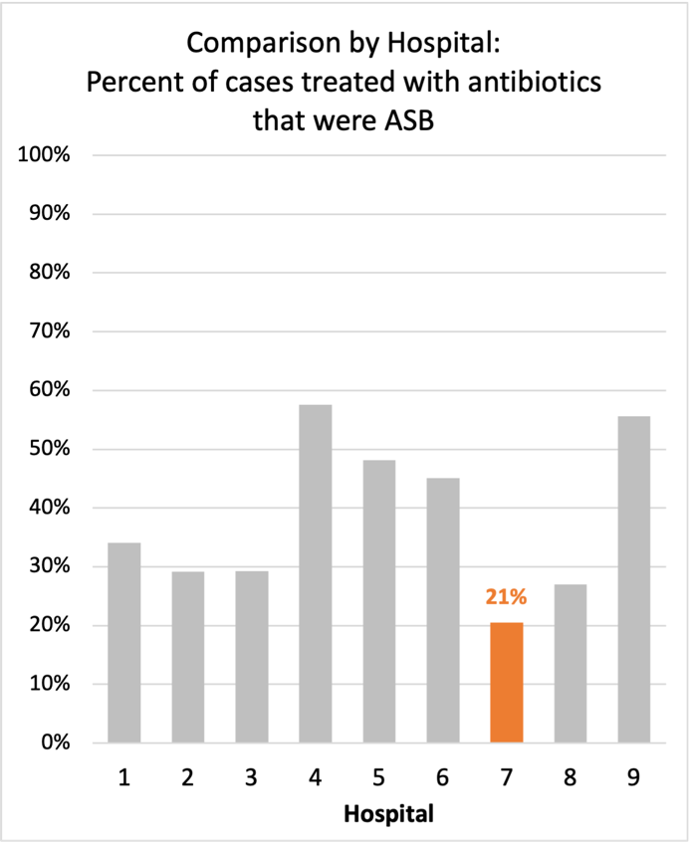
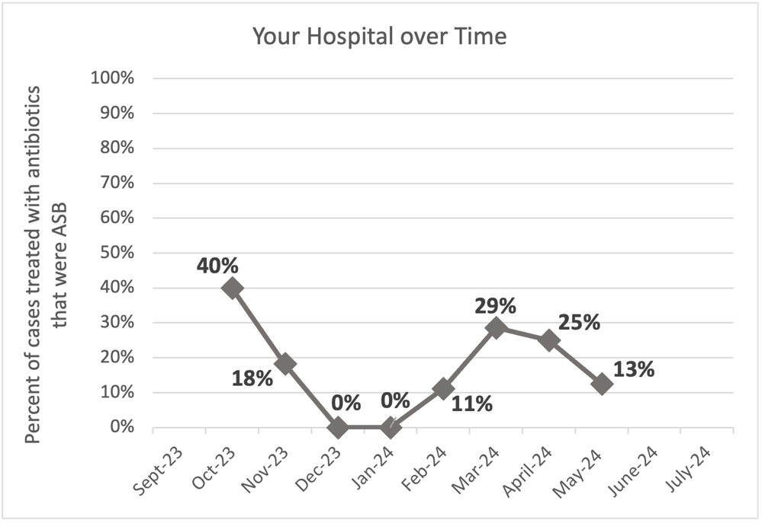
Inappropriate Diagnosis of UTI measure

Average across hospitals in cohort: 35.1% ; HMS Hospital Average*: 23.2%
Inappropriate Diagnosis of UTI measure: $\frac{Number of patients treated for ASB}{Number of positive urine cultures treated (UTI+ASB)}$
- Goal: lower % = better
- You can lower this number by either reducing unnecessary urine cultures (diagnostic stewardship) or reducing antibiotic treatment when unnecessary cultures are obtained (antibiotic stewardship)
*The HMS hospital average was amongst 46 hospitals in the Michigan Hospital Medicine Safety Consortium that participated in a similar quality improvement study.

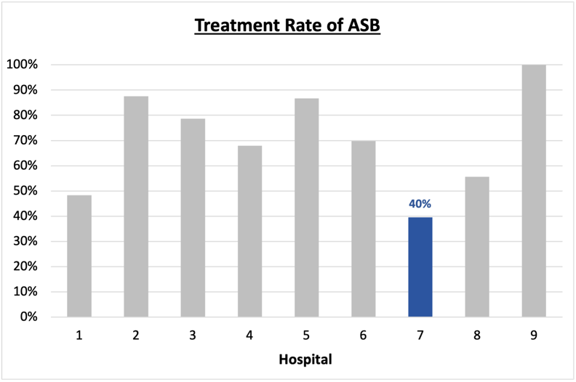
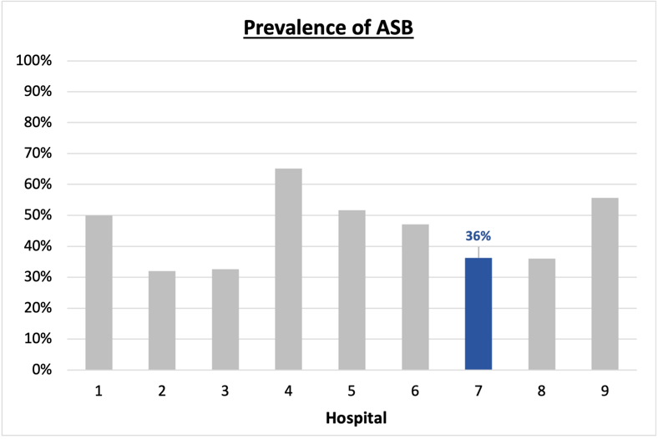
Prevalence and Treatment Rate of ASB
Prevalence of ASB:
$$\frac{Number of treated ASB cases}{Number of ASB cases}$$
Treatment Rate
of ASB:

$$\frac{Number of ASB cases}{Number of positive urine cultures}$$

Data submissions
Total cases (positive urine cultures) included for your site: 105
Cases included per month for your site (median & IQR): 11.5 (9-15.25)

Prevalence of ASB
Prevalence of ASB across hospitals: 207 of 484 (42.8%)
Prevalence of ASB at your site: 38 of 105 (36.2%)

Treatment Rate of ASB
Treatment rate of ASB in overall cohort: 133 of 207 (64.3%)
Treatment rate of ASB at your site: 15 of 38 (39.5%)

Antibiotic Tables
Table 1: Three Most Common Antibiotics comparing UTI & ASB
IV |  | Oral
UTI, n=17 | ASB, n =7 | UTI, n=57 | ASB, n = 13
Ceftriaxone (n=16) | Ceftriaxone (n=6) | Cephalexin (n=23) | Cephalexin (n=6)
Meropenem (n=1) | Ciprofloxacin (n=1) | Trim-sulfa (n=10) | Ciprofloxacin (n=3)
 |  | Nitrofurantoin (n=9) | Cefdinir (n=1)
Table 2: Antibiotic Duration (days) | UTI |  | ASB
Table 2: Antibiotic Duration (days) | Prior, n=60 | This Month, n=7 | Prior, n=36 | This Month, n=2
Total Antibiotic Duration; median (IQR) | 7 (5-7) | 6 (5-7.5) | 0 (0-5) | 2.5 (1.25-3.75)
Number of Cases Receiving >7 days; n (%) | 12 (20%) | 2 (28.6%) | 2 (5.6%) | 0

Prior is Sept 2023 - April 2024 & this month is May 2024
Table 3: Characteristics comparing this month to prior n (%) | UTI |  | ASB
Table 3: Characteristics comparing this month to prior n (%) | Prior, n=60 | This Month, n=7 | Prior, n=36 | This Month, n=2
Setting where culture obtained
ED, then admitted | 7 (11.7%) | 1 (14.3%) | 8 (22.2%) | 1 (50%)
ED, then discharged | 36 (60%) | 5 (71.4%) | 22 (61.1%) | 1 (50%)
Ambulatory care clinic | 17 (28.3%) | 1 (14.3%) | 5 (13.9%) | 0
Inpatient | 0 | 0 | 1 (2.8%) | 0
Other | 0 | 0 | 0 | 0
From reflex test | 56 (93.3%) | 6 (85.7%) | 33 (91.2%) | 2 (100%)
Men | 6 (10%) | 1 (14.3%) | 10 (27.8%) | 0
Age >75 | 18 (30%) | 4 (57.1%) | 15 (41.7%) | 1 (50%)
Acute altered mental status changes alone | 0 | 0 | 9 (25%) | 0
Characteristic Tables
Prior is Sept 2023 - April 2024 & this month is May 2024

Table 4: Prescribing Characteristics | UTI |  | ASB
Table 4: Prescribing Characteristics | Prior, n=60 | This Month, n=7 | Prior, n=36 | This Month, n=2
Top 3 Prescriber IDs (if available)
 | 60 (n=8) | 65 (n=2) | 45 (n=6) | 125 (n=1)
 | 90 (n=7) | 105 (n=1) | 85 (n=5) | 90 (n=1)
 | 45 (n=7) | 30 (n=1) | 125 (n=4)
Prescriber type, n (%)
Physician | 40 (66.7%) | 6 (85.7%) | 27 (75%) | 2 (100%)
Physician Assistant | 20 (33.3%) | 1 (14.3%) | 9 (25%) | 0
Nurse Practitioner | 0 | 0 | 0 | 0
Contract of prescribing provider, n (%) (if available)
Employed by hospital | 24 (40%) | 2 (28.6%) | 14 (38.9%) | 1 (50%)
Contracted from outside group/locum | 36 (60%) | 5 (71.4%) | 22 (61.1%) | 1 (50%)
Not sure | 0 | 0 | 0 | 0
Prior is Sept 2023 - April 2024 & this month is May 2024
Case IDs for the treated ASB cases
"107" "110" "111" "116" "118" "119" "127" "138" "166" "169" "233" "272" "283" "313" "321"

Key Terms and Definitions
- Positive urine culture: Any growth on culture
  - Prevalence of ASB: A positive urine culture without any documented signs or symptoms attributable to urinary tract infection per National Hospital Safety Network (NHSN) and Infectious Diseases Society of America (IDSA) Guidelines.
- Signs or symptoms of UTI includes:
- Fever (>38°C)
- Suprapubic tenderness
- Costovertebral angle pain or tenderness
- Urinary urgency
- Urinary frequency
- Dysuria
- Altered Mental Status + 2 or more SIRS criteria
- Treatment rate of ASB: antibiotic treatment for ASB

Action items/Insight:
Based on the Inappropriate Diagnosis of UTI Measure, your hospital is a performing above average in terms of percentage of UTI cases that were actually ASB. Continue the good work on all you are doing to improve this number! Additional comments:
- Met case submission requirement: Great job submitting cases! Celebrate this success!
- Low/trending down ASB treatment rate: Throughout the year, the percent of cases treated that were actually ASB trended down. This is a very positive trend; celebrate this success and maintain this momentum!
- Reduced ciprofloxacin use: Ciprofloxacin previously was the second most common antibiotic used to treat UTI, and now it is no longer in the top 3 most commonly used antibiotics for UTI. This is a huge success! Continue to emphasize the importance of choosing first-line medications over fluoroquinolones whenever possible.
- High treatment duration: Your median treatment duration for UTI during the last quarter was 6 days; while this is an improvement from prior, nearly one third of patients with UTI are still receiving >7 days of therapy. This may be an area on which you could focus to help reduce overall antibiotic use.
- Low treatment of patients with AMS: Identification and treatment of ASB in patients with acute altered mental status changes alone has dropped to zero. This represents phenomenal improvement compared to prior – congratulations on this success!

