Syringa Asymptomatic Bacteriuria (ASB) Report
Date of Report: August 2024*
*This data report is based on cases submitted from September 2023 – July 2024 and does not include previous data.
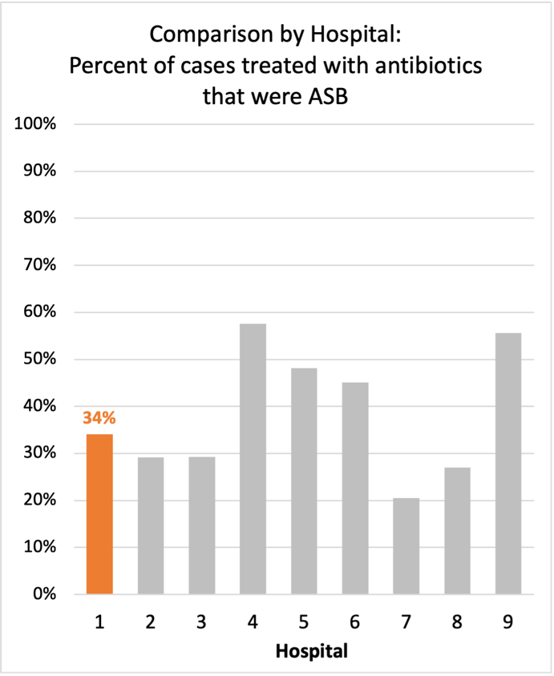
Inappropriate Diagnosis of UTI measure
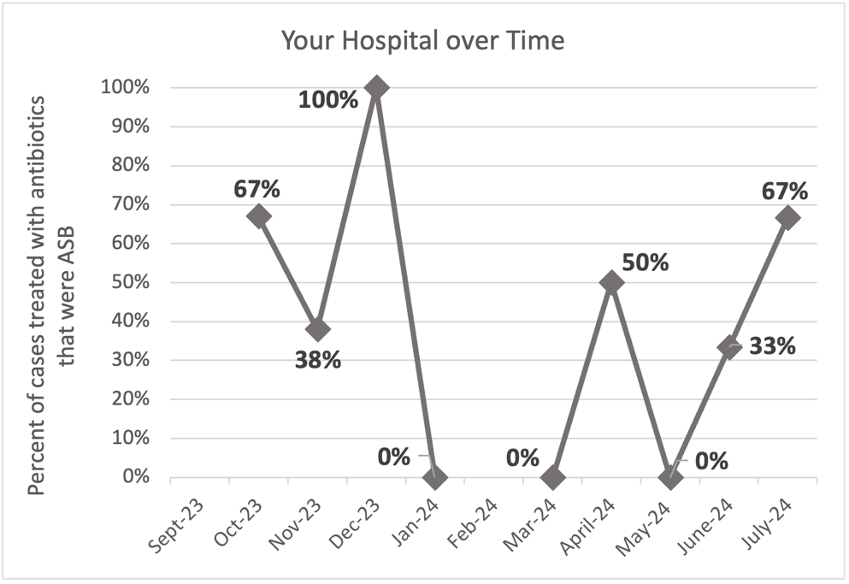
Average across hospitals in cohort: 35.1% ; HMS Hospital Average*: 23.2%
Inappropriate Diagnosis of UTI measure: $\frac{Number of patients treated for ASB}{Number of positive urine cultures treated (UTI+ASB)}$
- Goal: lower % = better
- You can lower this number by either reducing unnecessary urine cultures (diagnostic stewardship) or reducing antibiotic treatment when unnecessary cultures are obtained (antibiotic stewardship)
*The HMS hospital average was amongst 46 hospitals in the Michigan Hospital Medicine Safety Consortium that participated in a similar quality improvement study.

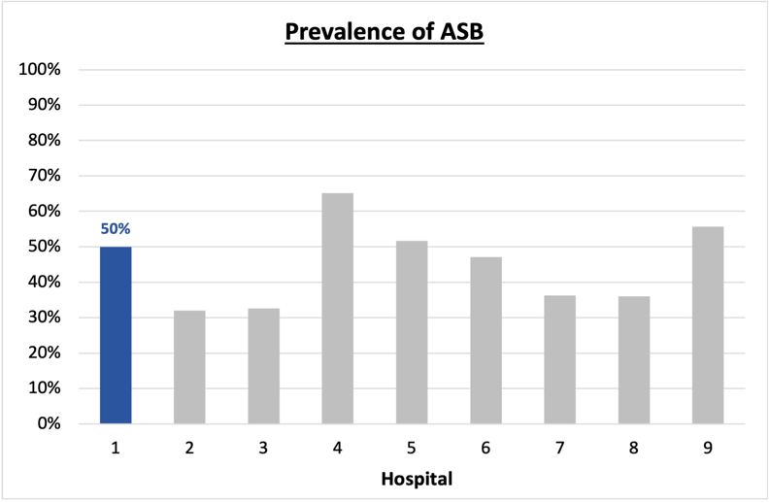
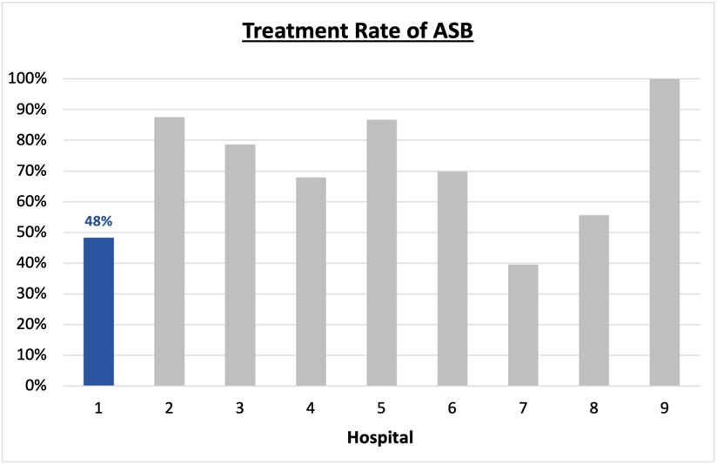
Prevalence and Treatment Rate of ASB
Prevalence of ASB:
$$\frac{Number of treated ASB cases}{Number of ASB cases}$$
Treatment Rate
of ASB:

$$\frac{Number of ASB cases}{Number of positive urine cultures}$$

Data submissions
Total cases (positive urine cultures) included for your site: 58
Cases included per month for your site (median & IQR): 6 (5-8)

Prevalence of ASB
Prevalence of ASB across hospitals: 207 of 484 (42.8%)
Prevalence of ASB at your site: 29 of 58 (50%)

Treatment Rate of ASB
Treatment rate of ASB in overall cohort: 133 of 207 (64.3%)
Treatment rate of ASB at your site: 14 of 29 (48.3%)

Antibiotic Tables
Table 1: Three Most Common Antibiotics comparing UTI & ASB
IV |  | Oral
UTI, n=8 | ASB, n =6 | UTI, n=27 | ASB, n = 11
Ceftriaxone (n=7) | Ceftriaxone (n=6) | Trim-sulfa (n=10) | Trim-sulfa (n=3)
Ciprofloxacin (n=1) |  | Ciprofloxacin (n=8) | Cephalexin (n=2)
 |  | Nitrofurantoin (n=4) | Nitrofurantoin (n=2)
Table 2: Antibiotic Duration (days) | UTI |  | ASB
Table 2: Antibiotic Duration (days) | Prior, n=27 | This Month, n=2 | Prior, n=24 | This Month, n=5
Total Antibiotic Duration; median (IQR) | 7 (5-7) | 8.5 (7.5-9.25) | 0 (0-5) | 8 (2-10)
Number of Cases Receiving >7 days; n (%) | 5 (18.5%) | 1 (50%) | 3 (12.5%) | 3 (60%)

Prior is Sept 2023 - June 2024 & this month is July 2024
Table 3: Characteristics comparing this month to prior n (%) | UTI |  | ASB
Table 3: Characteristics comparing this month to prior n (%) | Prior, n=27 | This Month, n=2 | Prior, n=24 | This Month, n=5
Setting where culture obtained
ED, then admitted | 0 | 0 | 3 (12.5%) | 3 (60%)
ED, then discharged | 9 (33.3%) | 1 (50%) | 11 (45.8%) | 2 (40%)
Ambulatory care clinic | 17 (63.0%) | 1 (50%) | 10 (41.7%) | 0
Inpatient | 0 | 0 | 0 | 0
Other | 1 (3.7%) | 0 | 0 | 0
From reflex test | 20 (74.1%) | 1 (50%) | 20 (83.3%) | 5 (100%)
Men | 6 (22.2%) | 0 | 9 (37.5%) | 1 (20%)
Age >75 | 4 (14.8%) | 0 | 10 (41.7%) | 2 (40%)
Acute altered mental status changes alone | 0 | 0 | 2 (8.3%) | 1 (20%)
Characteristic Tables
Prior is Sept 2023 - June 2024 & this month is July 2024

Table 4: Prescribing Characteristics | UTI |  | ASB
Table 4: Prescribing Characteristics | Prior, n=27 | This Month, n=2 | Prior, n=24 | This Month, n=5
Top 3 Prescriber IDs (if available)
Prescriber type, n (%)
Physician | 20 (74.1%) | 2 (100%) | 20 (83.3%) | 4 (80%)
Physician Assistant | 3 (11.1%) | 0 | 1 (4.2%) | 1 (20%)
Nurse Practitioner | 4 (14.8%) | 0 | 3 (12.5%) | 0
Contract of prescribing provider, n (%) (if available)
Employed by hospital | 26 (96.3%) | 1 (50%) | 20 (83.3%) | 5 (100%)
Contracted from outside group/locum | 1 (3.7%) | 1 (50%) | 3 (12.5%) | 0
Not sure | 0 | 0 | 1 (4.2%) | 0
Prior is Sept 2023 - June 2024 & this month is July 2024
Case IDs for the treated ASB cases
"75411" "18828" "565861" "565512" "566577" "571204" "586864" "587630" "596307" "597233" "600950" "600115" "600955"
"600414"

Key Terms and Definitions
- Positive urine culture: Any growth on culture
  - Prevalence of ASB: A positive urine culture without any documented signs or symptoms attributable to urinary tract infection per National Hospital Safety Network (NHSN) and Infectious Diseases Society of America (IDSA) Guidelines.
- Signs or symptoms of UTI includes:
- Fever (>38°C)
- Suprapubic tenderness
- Costovertebral angle pain or tenderness
- Urinary urgency
- Urinary frequency
- Dysuria
- Altered Mental Status + 2 or more SIRS criteria
- Treatment rate of ASB: antibiotic treatment for ASB

Action items/Insight:
Based on the Inappropriate Diagnosis of UTI Measure, your hospital is a performing average in terms of percentage of UTI cases that were actually ASB. Additional comments:
- Met case submission requirement: Great job submitting cases! Celebrate this success!
- Prevalence of ASB was higher than average: This suggests that there may be room for improved diagnostic stewardship of urine culture studies to help reduce this prevalence.
- High ciprofloxacin use: Ciprofloxacin continues to be the one of the most frequently prescribed oral agents for both UTI (though use of cipro for ASB seems to have improved!). We would recommend assessing if this is appropriate based on allergy history or susceptibility profile of organisms. If not, we would recommend clinician education on the harms associated with fluoroquinolone use.
- High treatment duration: Your median treatment duration for UTI during the last month was 8.5 days, and more than half of patients treated for both UTI and ASB receive >7 days of therapy. This remains an area on which you could focus to help reduce overall antibiotic use.

