GS Health Asymptomatic Bacteriuria (ASB) Report
Date of Report: April 2024*
*This data report is based on cases submitted from September 2023 – March 2024 and does not include previous data.
Inappropriate Diagnosis of UTI measure
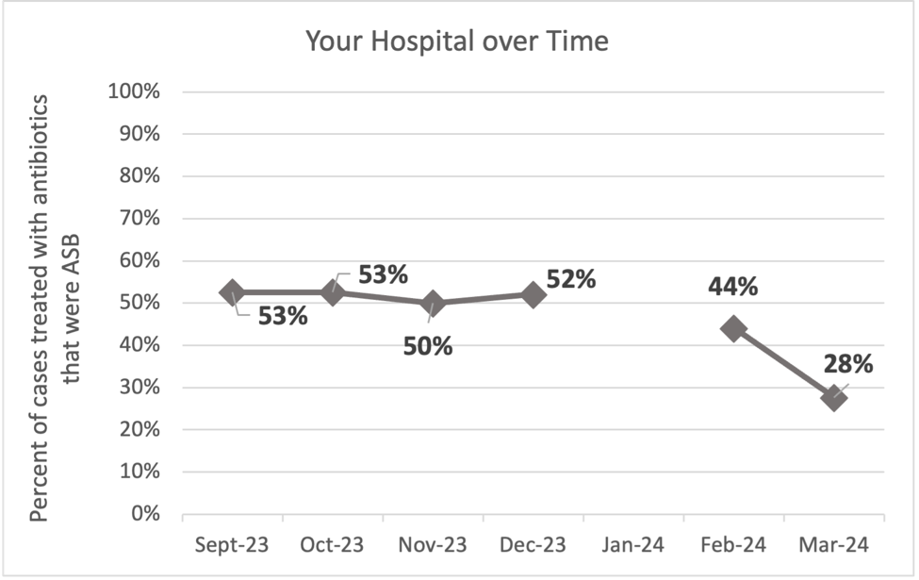
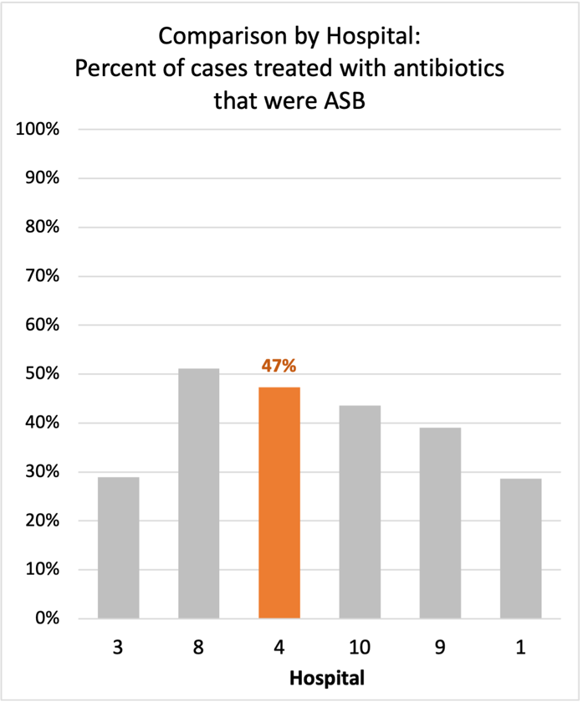
Average across hospitals in cohort: 38.3% ; HMS Hospital Average*: 23.2%
Inappropriate Diagnosis of UTI measure: $\frac{Number of patients treated for ASB}{Number of positive urine cultures treated (UTI+ASB)}$
- Goal: lower % = better
- You can lower this number by either reducing unnecessary urine cultures (diagnostic stewardship) or reducing antibiotic treatment when unnecessary cultures are obtained (antibiotic stewardship)
*The HMS hospital average was amongst 46 hospitals in the Michigan Hospital Medicine Safety Consortium that participated in a similar quality improvement study.

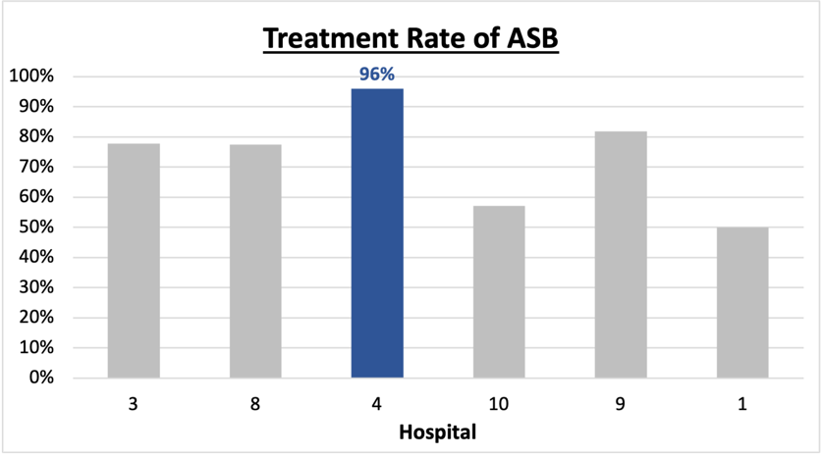
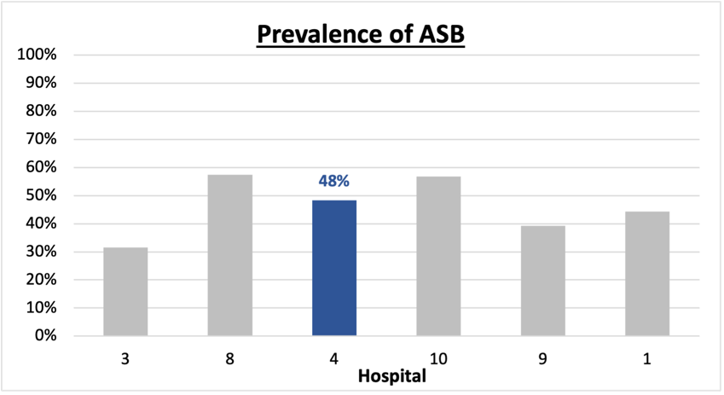
Prevalence and Treatment Rate of ASB

$$\frac{Number of ASB cases}{Number of positive urine cultures}$$
Prevalence of ASB:
$$\frac{Number of treated ASB cases}{Number of ASB cases}$$
Treatment Rate
of ASB:

Data submissions
Total cases (positive urine cultures) included for your site: 153
Cases included per month for your site (median & IQR): 22 (18.5 - 31.5)

Prevalence of ASB
Prevalence of ASB across hospitals: 204 of 483 (42.2%)
Prevalence of ASB at your site: 74 of 153 (48.4%)

Treatment Rate of ASB
Treatment rate of ASB in overall cohort: 164 of 204 (80.4%)
Treatment rate of ASB at your site: 71of 74 (95.9%)
Previous treatment rate at your site (from ASB 101 cohort): 23 of 27 (85%)

Antibiotic Tables
Table 1: Three Most Common Antibiotics comparing UTI & ASB
IV |  | Oral
UTI, n= 29 | ASB, n = 41 | UTI, n= 79 | ASB, n = 68
Ceftriaxone (n=25) | Ceftriaxone (n=36) | Cephalexin (n=26) | Cephalexin (n = 19)
Ciprofloxacin (n=1) | Pip-tazo (n=2) | Nitrofurantoin (n=16) | Ciprofloxacin (n=12)
Ertapenem (n=1) | Ciprofloxacin (n=1) | Cefdinir (n=12) | Tri-sulfa (n=12)
Table 2: Antibiotic Duration (days) | UTI |  | ASB
Table 2: Antibiotic Duration (days) | Prior, n= 66 | This Month, n= 13 | Prior, n= 69 | This Month, n= 5
Total Antibiotic Duration; median (IQR) | 8 (7-9) | 8 (6-8) | 8 (5-8) | 8 (8-9)
Number of Cases Receiving >7 days; n (%) | 37 (56.1%) | 7 (53.8%) | 36 (52.2%) | 5 (100%)

Prior is Sept 2023 - Feb 2024 & this month is March 2024
Table 3: Characteristics comparing this month to prior n (%) | UTI |  | ASB
Table 3: Characteristics comparing this month to prior n (%) | Prior, n= 66 | This Month, n= 13 | Prior, n= 69 | This Month, n= 5
Setting where culture obtained
ED, then admitted | 3 (4.5%) | 0 | 15 (21.7%) | 0
ED, then discharged | 63 (95.5%) | 13 (100%) | 51 (73.9%) | 5 (100%)
Ambulatory care clinic | 0 | 0 | 0 | 0
Inpatient | 0 | 0 | 2 (2.9%) | 0
Other | 0 | 0 | 1 (1.4%) | 0
From reflex test | 61 (95.5%) | 12 (92.3%) | 66 (95.7%) | 5 (100%)
Men | 13 (19.7%) | 1 (7.7%) | 14 (20.3%) | 1 (20%)
Age >75 | 16 (24.2%) | 3 (23.1%) | 32 (46.4%) | 2 (40%)
Acute altered mental status changes alone | 3 (4.5%) | 0 | 17 (24.6%) | 0
Characteristic Tables
Prior is Sept 2023 - Feb 2024 & this month is March 2024
Table 4: Prescribing Characteristics | UTI |  | ASB
Table 4: Prescribing Characteristics | Prior, n= 66 | This Month, n= 13 | Prior, n= 66 | This Month, n= 13
Top 3 Prescriber IDs (if available)
 | HGSP 002 (n=8) | HGSP 002 (n=3) | HGSP 008 (n=14) | HGSP 018 (n=3)
 | HGSP 005 (n=8) | HGSP 004 (n=1) | HGSP 018 (n=9) | HGSP 002 (n=1)
 | HGSP 017 (n=7) | HGSP 005 (n=1) | HGSP 021 (n=6) | HGSP 010 (n=1)
Prescriber type, n (%)
Physician | 31 (47.0%) | 6 (46.2%) | 58 (84.1%) | 4 (80%)
Physician Assistant | 9 (13.6%) | 3 (23.1%) | 4 (5.8%) | 1 (20%)
Nurse Practitioner | 26 (39.4%) | 4 (30.8%) | 7 (10.1%) | 0
Contract of prescribing provider, n (%) (if available)
Employed by hospital | 34 (51.5%) | 13 (100%) | 38 (55.1%) | 5 (100%)
Contracted from outside group/locum | 20 (30.3%) | 0 | 18 (26.1%) | 0
Not sure | 12 (18.2%) | 0 | 13 (18.8%) | 0

Prior is Sept 2023 - Feb 2024 & this month is March 2024
Case IDs for the treated ASB cases
“HGS 1002" "HGS 1003" "HGS 1004" "HGS 1005" "HGS 1013" "HGS 1015" "HGS1025" "HGS 1026" "HGS1027"
"HGS 1034" "HGS 1037" "HGS 1038" "HGS 1043" "HGS 1044" "HGS 1045" "HGS 1046" "HGS 1048" "HGS 1049"
"HGS 1050" "HGS 1056" "HGS 1059" "HGS 1062" "HGS 1064" "HGS 1074" "HGS 1075" "HGS 1078" "HGS 1083"
"HGS 1084" "HGS 1085" "HGS 1090" "HGS 1091" "HGS 1094" "HGS 1097" "HGS 1098" "HGS 1101" "HGS 1102"
"HGS 1104" "HGS 1105" "HGS 1106" "HGS 1108" "HGS 1109" "HGS 1111" "HGS 1114" "HGS 1115" "HGS 1117"
"HGS 1118" "HGS 1129" "HGS 1133" "HGS 1134" "HGS 1136" "HGS 1140" "HGS 1148" "HGS 1149" "HGS 1153"
"HGS 1155" "HGS 1156" "HGS 1159" "HGS 1160" "HGS 1164" "HGS 1168" "HGS 1169" "HGS 1174" "HGS 1177"
"HGS 1183" "HGS 1184" "HGS 1185" "HGS 1193" "HGS 1195" "HGS 1196" "HGS 1202" "HGS 1203"

Key Terms and Definitions
- Positive urine culture: Any growth on culture
  - Prevalence of ASB: A positive urine culture without any documented signs or symptoms attributable to urinary tract infection per National Hospital Safety Network (NHSN) and Infectious Diseases Society of America (IDSA) Guidelines.
- Signs or symptoms of UTI includes:
- Fever (>38°C)
- Suprapubic tenderness
- Costovertebral angle pain or tenderness
- Urinary urgency
- Urinary frequency
- Dysuria
- Altered Mental Status + 2 or more SIRS criteria
- Treatment rate of ASB: antibiotic treatment for ASB

Action items/Insight:
Based on the Inappropriate Diagnosis of UTI Measure, your hospital is a performing above average in terms of percentage of UTI cases that were actually ASB. However, your site has shown significant improvement! Additional comments:
Positives to Highlight:
- Low/trending down ASB treatment rate: Throughout the year, your percent of cases treated that were actually ASB trended down. This is a very positive trend! Celebrate this success and maintain this momentum! (Inappropriate diagnosis of UTI measure decreasing from 52% at the last report to 47% now is incredible).
- Met case submission requirement: Great job submitting cases! Celebrate this success.
- High cephalosporin use: Less harmful/more narrow therapy use is high at your site! Great job!

Areas of Improvement:
- High Treatment of ASB: However, amongst the patients that have ASB, your clinicians are still wanting to treat (96%). Would recommend focusing on this. If convincing clinicians to stop prescribing antibiotics for ASB is a challenge at your hospital, it might be easier to convince them to prescribe short durations (eg. 3 days) or less harmful/more narrow therapy (eg. Nitrofurantoin) for patients without symptoms. This might be a compromise or intermediate step to get clinicians comfortable with less antibiotics for these patients.
- High overall Fluoroquinolone use: Fluoroquinolone use appears to be one of the commonly used antibiotics in ASB, would recommend assessing if this is appropriate based on allergy history or susceptibility profile of organisms. If not, would try to educate on harms associated with fluoroquinolone use.
- High treatment duration: Your median treatment duration for ASB during the last month was 7 days with many cases receiving >7-day treatment durations. This may be an area on which you could focus to help reduce overall antibiotic use.
- High Treatment of patients with AMS: Treatment in patients presenting with acute altered mental status changes alone appears to be a common finding at your site. Would recommend educating providers on this if possible.

