GS Health Asymptomatic Bacteriuria (ASB) Report
Date of Report: July 2024*
*This data report is based on cases submitted from September 2023 – June 2024 and does not include previous data.
Inappropriate Diagnosis of UTI measure
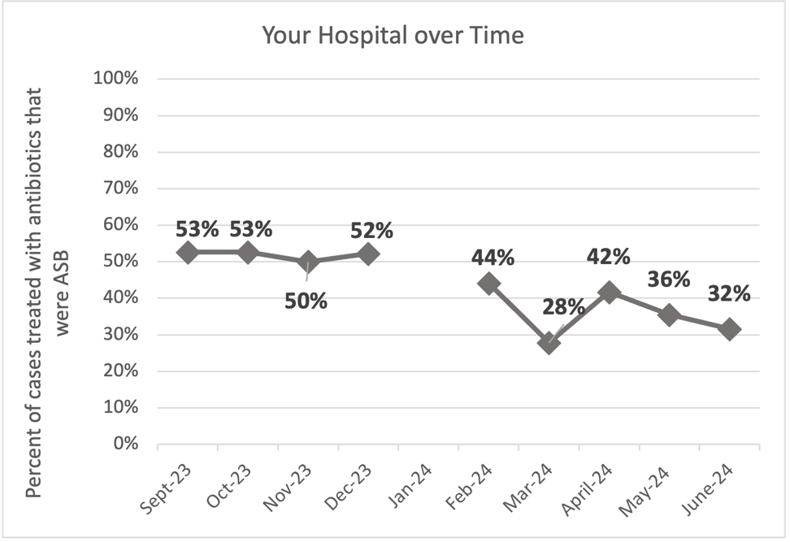
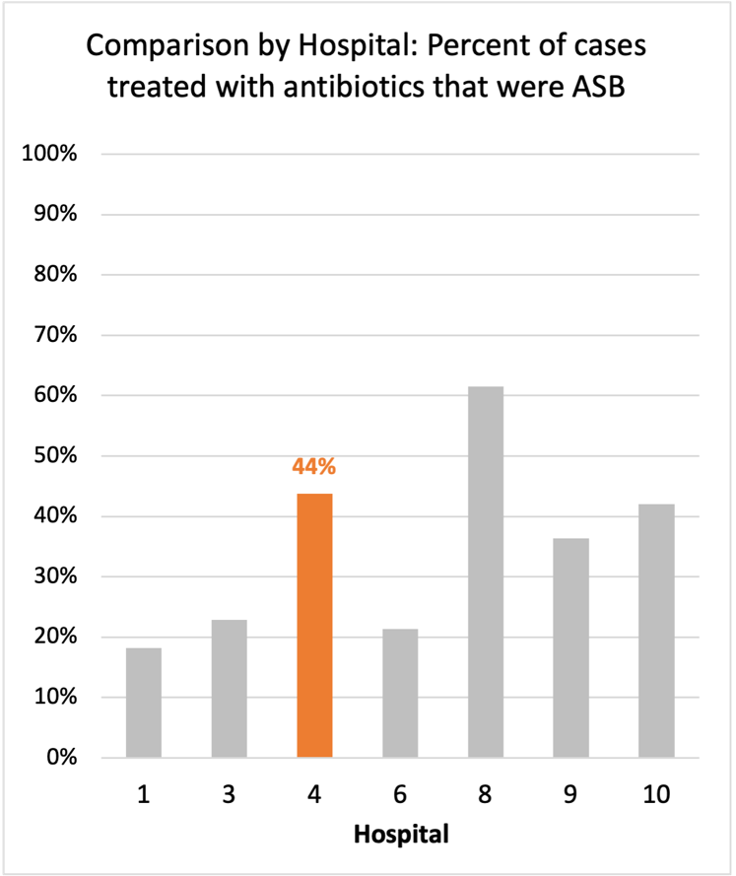
Average across hospitals in cohort: 35.6% ; HMS Hospital Average*: 23.2%
Inappropriate Diagnosis of UTI measure: $\frac{Number of patients treated for ASB}{Number of positive urine cultures treated (UTI+ASB)}$
- Goal: lower % = better
- You can lower this number by either reducing unnecessary urine cultures (diagnostic stewardship) or reducing antibiotic treatment when unnecessary cultures are obtained (antibiotic stewardship)
*The HMS hospital average was amongst 46 hospitals in the Michigan Hospital Medicine Safety Consortium that participated in a similar quality improvement study.

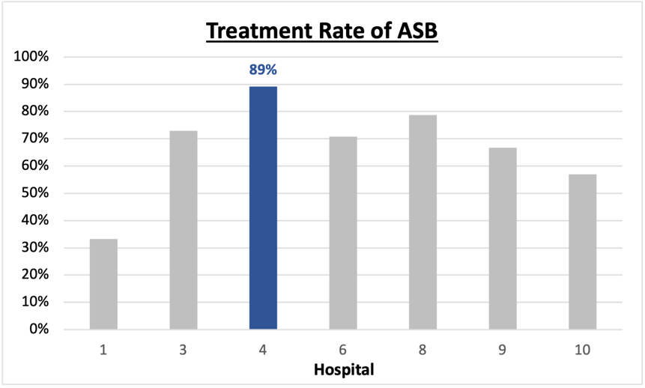
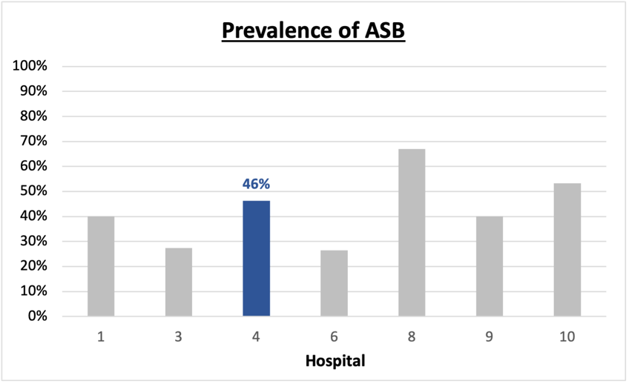
Prevalence and Treatment Rate of ASB

$$\frac{Number of ASB cases}{Number of positive urine cultures}$$
Prevalence of ASB:
$$\frac{Number of treated ASB cases}{Number of ASB cases}$$
Treatment Rate
of ASB:

Data submissions
Total cases (positive urine cultures) included for your site: 238
Cases included per month for your site (median & IQR): 24 (20-34)

Prevalence of ASB
Prevalence of ASB across hospitals: 356 of 868 (41.0%)
Prevalence of ASB at your site: 110 of 238 (46.2%)

Treatment Rate of ASB
Treatment rate of ASB in overall cohort: 266 of 356 (74.7%)
Treatment rate of ASB at your site: 98 of 110 (89.1%)
Previous treatment rate at your site (from ASB 101 cohort): 23 of 27 (85%)

Antibiotic Tables
Table 1: Three Most Common Antibiotics comparing UTI & ASB
IV |  | Oral
UTI, n = 39 | ASB, n = 54 | UTI, n = 125 | ASB, n = 89
Ceftriaxone (n=34) | Ceftriaxone (n=48) | Cephalexin (n=33) | Cephalexin (n=27)
Ciprofloxacin (n=1) | Pip-tazo (n=2) | Nitrofurantoin (n=29) | Trim-sulfa (n=16)
Ertapenem (n=1) | Ciprofloxacin (n=1) | Trim-sulfa (n=18) | Cefdinir (n=14)
Table 2: Antibiotic Duration (days) | UTI |  | ASB
Table 2: Antibiotic Duration (days) | Prior, n=115 | This Month, n=13 | Prior, n=102 | This Month, n=8
Total Antibiotic Duration; median (IQR) | 8 (7-8) | 8 (7-8) | 8 (5-8) | 5 (3.75-8)
Number of Cases Receiving >7 days; n (%) | 63 (54.8%) | 7 (53.8%) | 54 (52.9%) | 3 (37.5%)

Prior is Sept 2023 - May 2024 & this month is June 2024
Table 3: Characteristics comparing this month to prior n (%) | UTI |  | ASB
Table 3: Characteristics comparing this month to prior n (%) | Prior, n=115 | This Month, n=13 | Prior, n=102 | This Month, n=8
Setting where culture obtained
ED, then admitted | 6 (5.2%) | 0 | 20 (19.6%) | 0
ED, then discharged | 108 (93.9%) | 13 (100%) | 76 (74.5%) | 8 (100%)
Ambulatory care clinic | 0 | 0 | 0 | 0
Inpatient | 0 | 0 | 4 (3.9%) | 0
Other | 1 (0.9%) | 0 | 2 (2.0%) | 0
From reflex test | 107 (93.0%) | 13 (100%) | 95 (93.1%) | 8 (100%)
Men | 21 (18.3%) | 1 (7.7%) | 21 (20.6%) | 2 (25%)
Age >75 | 25 (21.7%) | 5 (38.5%) | 47 (46.1%) | 1 (12.5%)
Acute altered mental status changes alone | 4 (3.5%) | 0 | 19 (18.6%) | 0
Characteristic Tables
Prior is Sept 2023 - May 2024 & this month is June 2024
Table 4: Prescribing Characteristics | UTI |  | ASB
Table 4: Prescribing Characteristics | Prior, n=115 | This Month, n=13 | Prior, n=102 | This Month, n=8
Top 3 Prescriber IDs (if available)
 | HGSP 002 (n=15) | HGSP 007 (n=4) | HGSP 018 (n=18) | HGSP 016 (n=3)
 | HGSP 005 (n=14) | HGSP 022 (n=3) | HGSP 008 (n=15) | HGSP 002 (n=1)
 | HGSP 020 (n=12) | HGSP 002 (n=1) | HGSP 010 (n=7) | HGSP 008 (n=1)
Prescriber type, n (%)
Physician | 51 (44.3%) | 7 (53.8%) | 79 (77.5%) | 7 (87.5%)
Physician Assistant | 16 (13.9%) | 1 (7.7%) | 10 (9.8%) | 1 (12.5%)
Nurse Practitioner | 48 (41.7%) | 5 (38.5%) | 13 (12.7%) | 0
Contract of prescribing provider, n (%) (if available)
Employed by hospital | 82 (71.3%) | 13 (100%) | 70 (68.6%) | 8 (100%)
Contracted from outside group/locum | 20 (17.4%) | 0 | 18 (17.6%) | 0
Not sure | 13 (11.3%) | 0 | 14 (13.7%) | 0

Prior is Sept 2023 - May 2024 & this month is June 2024
Case IDs for the treated ASB cases
"HGS 1002" "HGS 1003" "HGS 1004" "HGS 1005" "HGS 1013" "HGS 1015" "HGS1025" "HGS 1026" "HGS1027"
"HGS 1034" "HGS 1037" "HGS 1038" "HGS 1043" "HGS 1044" "HGS 1045" "HGS 1046" "HGS 1048" "HGS 1049"
"HGS 1050" "HGS 1056" "HGS 1059" "HGS 1062" "HGS 1064" "HGS 1074" "HGS 1075" "HGS 1078" "HGS 1083"
"HGS 1084" "HGS 1085" "HGS 1090" "HGS 1091" "HGS 1094" "HGS 1097" "HGS 1098" "HGS 1101" "HGS 1102"
"HGS 1104" "HGS 1105" "HGS 1106" "HGS 1108" "HGS 1109" "HGS 1111" "HGS 1114" "HGS 1115" "HGS 1117"
"HGS 1118" "HGS 1129" "HGS 1133" "HGS 1134" "HGS 1136" "HGS 1140" "HGS 1148" "HGS 1149" "HGS 1153"
"HGS 1155" "HGS 1156" "HGS 1159" "HGS 1160" "HGS 1164" "HGS 1168" "HGS 1169" "HGS 1174"
"HGS 1177" "HGS 1183" "HGS 1184" "HGS 1185" "HGS 1193" "HGS 1195" "HGS 1196" "HGS 1202" "HGS 1203"
"HGS 1214" "HGS 1221" "HGS 1223" "HGS 1224" "HGS 1228" "HGS 1230" "HGS 1231" "HGSP 1233" "HGS 1235"
"HGS 1240" "HGS 1259" "HGS 1265" "HGS 1270" "HGS 1272" "HGS 1273" "HGS 1275" "HGS 1281" "HGS 1285"
"HGS 1286" "HGS 1288" "HGS 1300" "HGS 1304" "HGS 1306" "HGS 1314" "HGS 1318" "HGS 1320" "HGS 1321"

Key Terms and Definitions
- Positive urine culture: Any growth on culture
  - Prevalence of ASB: A positive urine culture without any documented signs or symptoms attributable to urinary tract infection per National Hospital Safety Network (NHSN) and Infectious Diseases Society of America (IDSA) Guidelines.
- Signs or symptoms of UTI includes:
- Fever (>38°C)
- Suprapubic tenderness
- Costovertebral angle pain or tenderness
- Urinary urgency
- Urinary frequency
- Dysuria
- Altered Mental Status + 2 or more SIRS criteria
- Treatment rate of ASB: antibiotic treatment for ASB

Action items/Insight:
Based on the Inappropriate Diagnosis of UTI Measure, your hospital is a performing worse than average in terms of percentage of UTI cases that were actually ASB. However, your site has shown improvement. Additional comments:
Positives to Highlight:
- Down trend in inappropriate diagnosis of UTI measure: Your site has decreased from 47% last report to 44% this report - this is a positive trend. Would continue to work on decreasing this metric.
- Met case submission requirement: Great job submitting cases! Celebrate this success.
- High nitrofurantoin and narrow spectrum cephalosporin use: Less harmful/more narrow therapy use is high at your site! Great job!
Areas of Improvement:
- Performing worse than average in the inappropriate diagnosis of UTI measure: Your site has decreased from 47% last report to 44% this report - this is a positive trend. However, this percentage is still higher than the rest of the cohort.
- High treatment rate of ASB: Amongst the patients that have ASB, your clinicians are still wanting to treat the majority of cases (89%). Would recommend focusing on this. If convincing clinicians to stop prescribing antibiotics for ASB is a challenge at your hospital, it might be easier to convince them to prescribe short durations (eg. 3 days). This might be a compromise or intermediate step to get clinicians comfortable with less antibiotics for these patients.
- High prevalence rate of ASB: a little under half of the patients with positive urine cultures obtained at your site are asymptomatic. Would continue to focus on diagnostic stewardship.
- High treatment duration: Your median treatment duration for UTIs was 8 days with many cases receiving >7-day treatment durations. This may be an area on which you could focus to help reduce overall antibiotic use.

