Garfield Asymptomatic Bacteriuria (ASB) Report
Date of Report: April 2024*
*This data report is based on cases submitted from September 2023 – March 2024 and does not include previous data.
Inappropriate Diagnosis of UTI measure
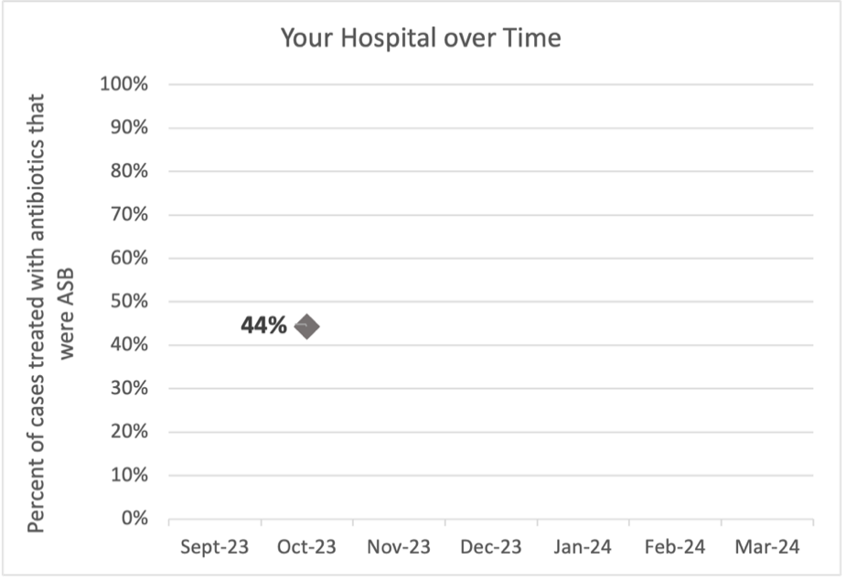
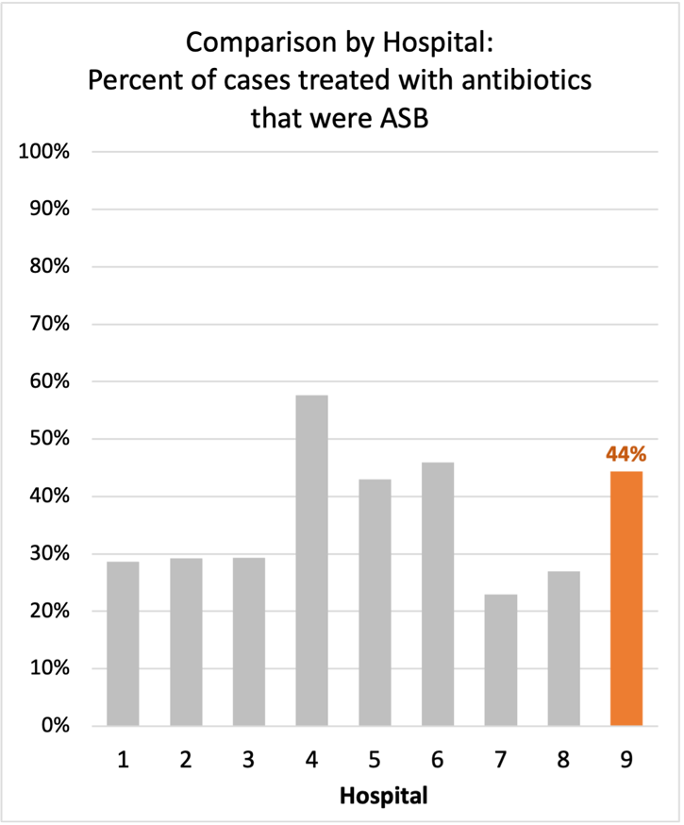
Average across hospitals in cohort: 34.5% ; HMS Hospital Average*: 23.2%
Inappropriate Diagnosis of UTI measure: $\frac{Number of patients treated for ASB}{Number of positive urine cultures treated (UTI+ASB)}$
- Goal: lower % = better
- You can lower this number by either reducing unnecessary urine cultures (diagnostic stewardship) or reducing antibiotic treatment when unnecessary cultures are obtained (antibiotic stewardship)
*The HMS hospital average was amongst 46 hospitals in the Michigan Hospital Medicine Safety Consortium that participated in a similar quality improvement study.

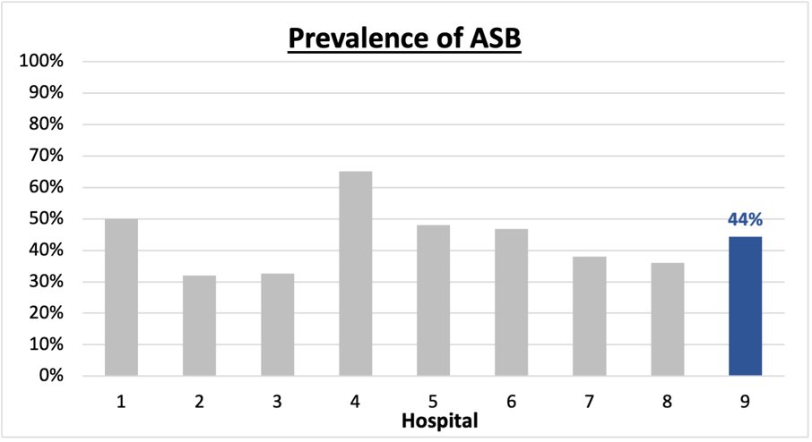
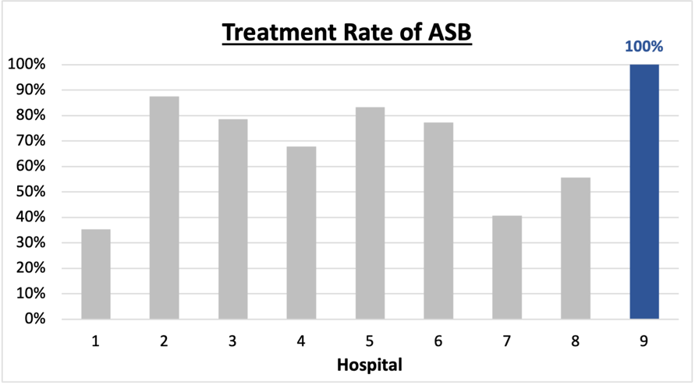
Prevalence and Treatment Rate of ASB
Prevalence of ASB:
Treatment Rate
of ASB:

$$\frac{Number of treated ASB cases}{Number of ASB cases}$$
$$\frac{Number of ASB cases}{Number of positive urine cultures}$$

Data submissions
Total cases (positive urine cultures) included for your site: 9
Cases included per month for your site (median & IQR): 9 (9-9)

Prevalence of ASB
Prevalence of ASB across hospitals: 164 of 390 (42.1%)
Prevalence of ASB at your site: 4 of 9 (44.4%)

Treatment Rate of ASB
Treatment rate of ASB in overall cohort: 106 of 164 (64.6%)
Treatment rate of ASB at your site: 4 of 4 (100%)

Antibiotic Tables
Table 1: Three Most Common Antibiotics comparing UTI & ASB
IV |  | Oral
UTI, n=2 | ASB, n=3 | UTI, n=4 | ASB, n=3
Ceftriaxone (n=2) | Ceftriaxone (n=2) | Nitrofurantoin (n=3) | Amoxicillin (n=1)
NA | Tobramycin (n=1) | Amoxicillin-clav (n=1) | Ciprofloxacin (n=1)
NA | NA | NA | Nitrofurantoin (n=1)
Table 2: Antibiotic Duration (days) | UTI |  | ASB
Table 2: Antibiotic Duration (days) | Prior, n=5 | This Month, n=0 | Prior, n=4 | This Month, n=0
Total Antibiotic Duration; median (IQR) | 5 (5-7) |  | 3 (2.25-3.5)
Number of Cases Receiving >7 days; n (%) | 0 |  | 0

Prior is Oct 2023; no submissions in other months
Table 3: Characteristics comparing this month to prior n (%) | UTI |  | ASB
Table 3: Characteristics comparing this month to prior n (%) | Prior, n=5 | This Month, n=0 | Prior, n=4 | This Month, n=0
Setting where culture obtained
ED, then admitted | 0 |  | 0
ED, then discharged | 3 (60%) |  | 0
Ambulatory care clinic | 0 |  | 0
Inpatient | 0 |  | 0
Other | 2 (40%) |  | 4 (100%)
From reflex test | 3 (60%) |  | 2 (50%)
Men | 0 |  | 1 (25%)
Age >75 | 3 (60%) |  | 1 (25%)
Acute altered mental status changes alone | 0 |  | 0
Characteristic Tables
Prior is Oct 2023; no submissions in other months

Table 4: Prescribing Characteristics | UTI |  | ASB
Table 4: Prescribing Characteristics | Prior, n=5 | This Month, n=0 | Prior, n=4 | This Month, n=0
Top 3 Prescriber IDs (if available)
 | CT (n=2) |  | CT (n=2)
 | JM (n=2) |  | JM (n=1)
 | YP (n=1) |  | OS (n=1)
Prescriber type, n (%)
Physician | 1 (20%) |  | 1 (25%)
Physician Assistant | 2 (40%) |  | 1 (25%)
Nurse Practitioner | 2 (40%) |  | 2 (50%)
Contract of prescribing provider, n (%) (if available)
Employed by hospital | 5 (100%) |  | 3 (75%)
Contracted from outside group/locum | 0 |  | 1 (25%)
Not sure | 0 |  | 0
Prior is Oct 2023; no submissions in other months
Case IDs for the treated ASB cases
"GCHD0002" "GCHD003" "GCHD0007" "GCHD0008"

Key Terms and Definitions
- Positive urine culture: Any growth on culture
  - Prevalence of ASB: A positive urine culture without any documented signs or symptoms attributable to urinary tract infection per National Hospital Safety Network (NHSN) and Infectious Diseases Society of America (IDSA) Guidelines.
- Signs or symptoms of UTI includes:
- Fever (>38°C)
- Suprapubic tenderness
- Costovertebral angle pain or tenderness
- Urinary urgency
- Urinary frequency
- Dysuria
- Altered Mental Status + 2 or more SIRS criteria
- Treatment rate of ASB: antibiotic treatment for ASB

Action items/Insight:
Based on the Inappropriate Diagnosis of UTI Measure, your hospital is a performing below average in terms of percentage of UTI cases that were actually ASB. Please continue to try and work on improving this. Additional comments:
- High Treatment of ASB: Amongst the patients that have ASB, your clinicians are very frequently treating with antibiotics. We would recommend focusing on this. If convincing clinicians to stop prescribing antibiotics for ASB is a challenge at your hospital, it might be easier to convince them to prescribe short durations (eg. 3 days) or less harmful/more narrow therapy (eg. Nitrofurantoin) for patients without symptoms. This might be a compromise or intermediate step to get clinicians comfortable with less antibiotics for these patients.
- Low treatment rate of patients with AMS: Fortunately, treatment with antibiotics for patients presenting with acute altered mental status alone appears to be uncommon at your site. This is worth celebrating!

