Lincoln Asymptomatic Bacteriuria (ASB) Report
Date of Report: April 2024*
*This data report is based on cases submitted from September 2023 – March 2024 and does not include previous data.
Inappropriate Diagnosis of UTI measure
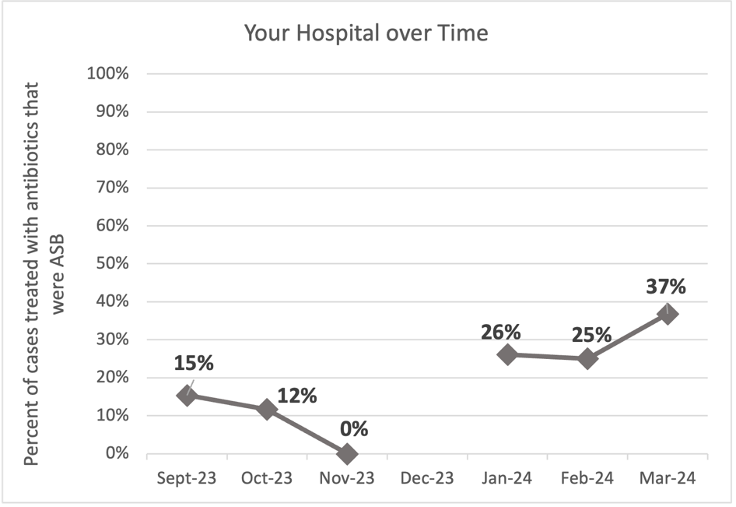
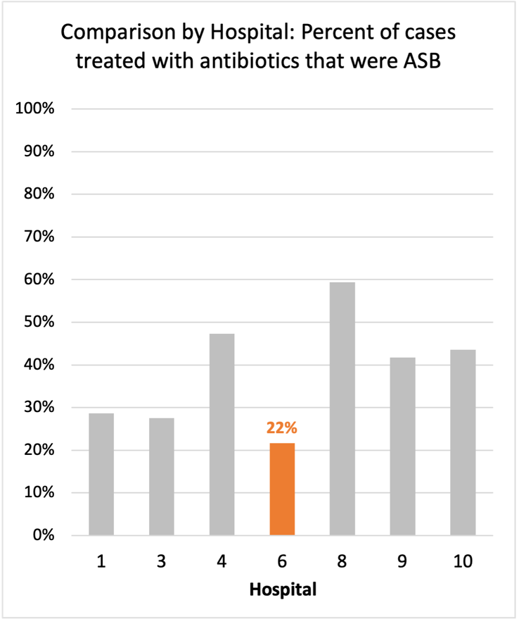
Average across hospitals in cohort: 38.6% ; HMS Hospital Average*: 23.2%
Inappropriate Diagnosis of UTI measure: $\frac{Number of patients treated for ASB}{Number of positive urine cultures treated (UTI+ASB)}$
- Goal: lower % = better
- You can lower this number by either reducing unnecessary urine cultures (diagnostic stewardship) or reducing antibiotic treatment when unnecessary cultures are obtained (antibiotic stewardship)
*The HMS hospital average was amongst 46 hospitals in the Michigan Hospital Medicine Safety Consortium that participated in a similar quality improvement study.

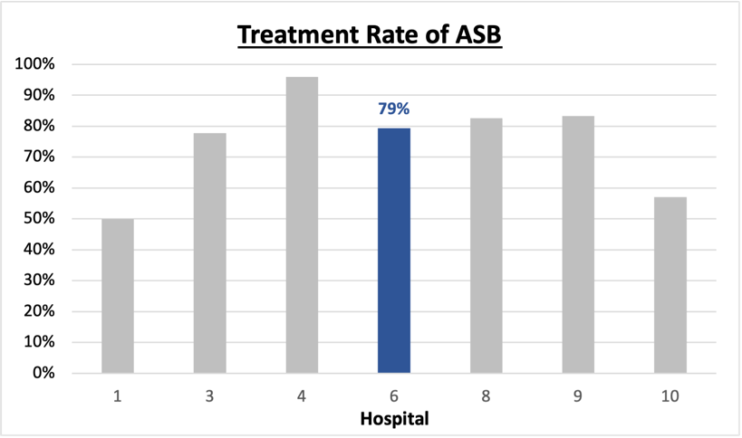
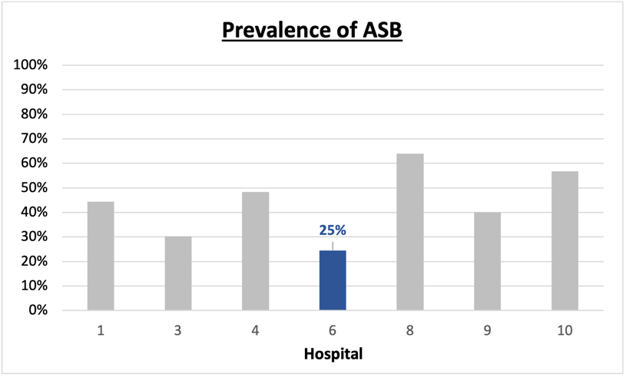
Prevalence and Treatment Rate of ASB
Prevalence of ASB:
Treatment Rate
of ASB:

$$\frac{Number of treated ASB cases}{Number of ASB cases}$$
$$\frac{Number of ASB cases}{Number of positive urine cultures}$$

Data submissions
Total cases (positive urine cultures) included for your site: 118
Cases included per month for your site (median & IQR): 21 (16.75 - 25.25)

Prevalence of ASB
Prevalence of ASB across hospitals: 243 of 508 (42.3%)
Prevalence of ASB at your site: 29 of 118 (24.5%)

Treatment Rate of ASB
Treatment rate of ASB in overall cohort: 196 of 243 (80.7%)
Treatment rate of ASB at your site: 23 of 29 (79.3%)
Previous treatment rate at your site (from ASB 101 cohort): 36 of 51 (71%)

Antibiotic Tables
Table 1: Three Most Common Antibiotics comparing UTI & ASB
IV |  | Oral
UTI, n=6 | ASB, n =3 | UTI, n=90 | ASB, n =22
Ceftriaxone (n=4) | Ceftriaxone (n=4) | Cephalexin (n=38) | Cephalexin (n=15)
Pip-tazo (n=1) | NA | Nitrofurantoin (n=22) | Levofloxacin (n=3)
Azithromycin (n=1) | NA | Tri-sulfa (n=20) | Cefdinir (n=2)
Table 2: Antibiotic Duration (days) | UTI |  | ASB
Table 2: Antibiotic Duration (days) | Prior, n=75 | This Month, n=14 | Prior, n=20 | This Month, n=9
Total Antibiotic Duration; median (IQR) | 7 (6-10) | 7 (5.5-9) | 6 (2.5-7.25) | 9 (7-10)
Number of Cases Receiving >7 days; n (%) | 24 (32%) | 5 (35.7%) | 5 (25%) | 5 (55.6%)

Prior is Sept 2023 - Feb 2024 & this month is March 2024
Table 3: Characteristics comparing this month to prior n (%) | UTI |  | ASB
Table 3: Characteristics comparing this month to prior n (%) | Prior, n=75 | This Month, n=14 | Prior, n=20 | This Month, n=9
Setting where culture obtained
ED, then admitted | 1 (1.3%) | 0 | 0 | 0
ED, then discharged | 22 (29.3%) | 2 (14.3%) | 12 (60%) | 5 (55.6%)
Ambulatory care clinic | 52 (69.3%) | 12 (85.7%) | 8 (40%) | 4 (44.4%)
Inpatient | 0 | 0 | 0 | 0
Other | 0 | 0 | 0 | 0
From reflex test | 74 (98.7%) | 14 (100%) | 18 (90%) | 9 (100%)
Men | 16 (21.3%) | 2 (14.3%) | 7 (35%) | 4 (44.4%)
Age >75 | 31 (41.3%) | 4 (28.6%) | 10 (50%) | 4 (44.4%)
Acute altered mental status changes alone | 0 | 0 | 2 (10%) | 0
Characteristic Tables
Prior is Sept 2023 - Feb 2024 & this month is March 2024

Table 4: Prescribing Characteristics | UTI |  | ASB
Table 4: Prescribing Characteristics | Prior, n=75 | This Month, n=14 | Prior, n=20 | This Month, n=9
Top 3 Prescriber IDs (if available)
 | 4 (n=25) | 1 (n=4) | 3 (n=4) | 3 (n=4)
 | 17 (n=6) | 3 (n=4) | 10 (n=3) | 1 (n=1)
 | 10 (n=5) | 4 (n=2) | 2 (n=3) | 13 (n=1)
Prescriber type, n (%)
Physician | 28 (37.3%) | 10 (71.4%) | 12 (60%) | 8 (88.9%)
Physician Assistant | 34 (45.3%) | 2 (14.3%) | 4 (20%) | 0
Nurse Practitioner | 13 (17.3%) | 2 (14.3%) | 4 (20%) | 1 (11.1%)
Contract of prescribing provider, n (%) (if available)
Employed by hospital | 59 (78.7%) | 14 (100%) | 17 (85%) | 7 (77.8%)
Contracted from outside group/locum | 16 (21.3%) | 0 | 2 (10%) | 2 (22.2%)
Not sure | 0 | 0 | 1 (5%) | 0
Prior is Sept 2023 - Feb 2024 & this month is March 2024
Case IDs for the treated ASB cases

"91823B" "9523" "91823A" "92123" "10423B" "10623A" "1424" "1924A"
"1924B" "11224" "11724C" "11824" "2224A" "2524C" "2924" "22624"
"3224" "31324A" "31324B" "32224A" "32324" "32824A" "32824B"

Key Terms and Definitions
- Positive urine culture: Any growth on culture
  - Prevalence of ASB: A positive urine culture without any documented signs or symptoms attributable to urinary tract infection per National Hospital Safety Network (NHSN) and Infectious Diseases Society of America (IDSA) Guidelines.
- Signs or symptoms of UTI includes:
- Fever (>38°C)
- Suprapubic tenderness
- Costovertebral angle pain or tenderness
- Urinary urgency
- Urinary frequency
- Dysuria
- Altered Mental Status + 2 or more SIRS criteria
- Treatment rate of ASB: antibiotic treatment for ASB

Action items/Insight:
Based on the Inappropriate Diagnosis of UTI Measure, your hospital is a performing below average in terms of percentage of UTI cases that were actually ASB! Please continue to try and work on improving this. Additional comments:
Positives to Highlight:
- Site is performing below average in terms of the percentage of UTI cases that were actually ASB! This is amazing, please continue this work! Although this measure is low compares to your peers, your rate has increased from January-March 2024. This is a great opportunity to investigate what may have influenced the increased prevalence of ASB and prescribing rates during this time period.
- Low prevalence of ASB: The prevalence rate of ASB at your site has continued to decrease (25%). Great job! Your site is starting to improve who they obtain urine studies in and decreasing collection in asymptomatic patients. Keep working on this.
- High nitrofurantoin and cephalosporin use: Less harmful/more narrow therapy use is high at your site! Great job!

Areas of Improvement:
- Treatment rate of ASB is 79%: Although this trend has improved, please continue to focus on decreasing the rate of treatment in those found to have ASB.
- Treatment duration remains high in treated ASB: If convincing clinicians to stop prescribing antibiotics for ASB is a challenge at your hospital, it might be easier to convince them to prescribe short durations (eg. 3 days).
- Higher treatment of patients with AMS: Treatment in patients presenting with acute altered mental status changes alone appears to be a common finding at your site. Would recommend educating providers on this if possible.

