Lincoln IQIC 201 Asymptomatic Bacteriuria (ASB) Report
Date of Report: January 2024*
*This data report is based on cases submitted from June 2023 to December 2023 and does not include previous data.
Inappropriate Diagnosis of UTI measure
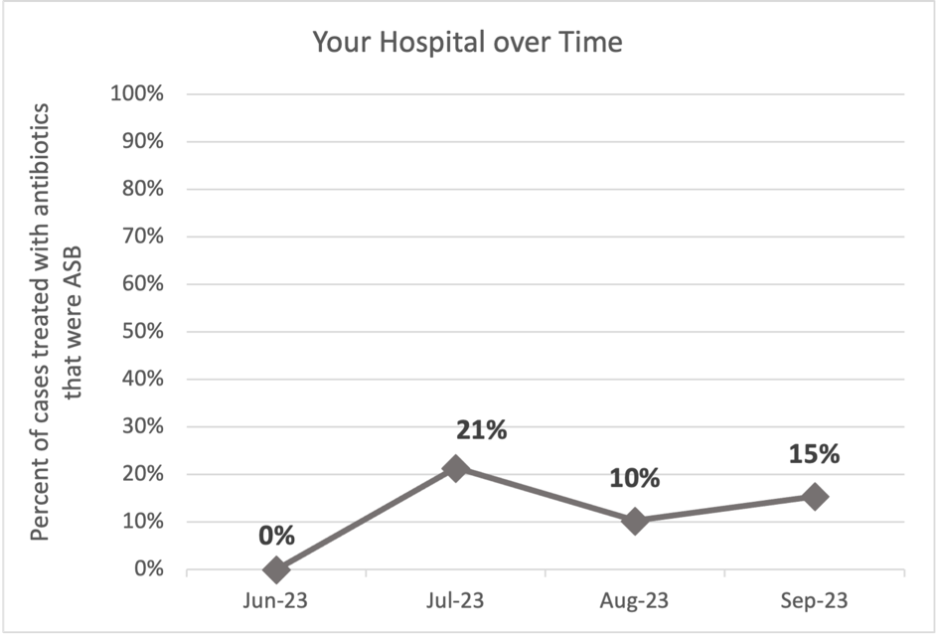
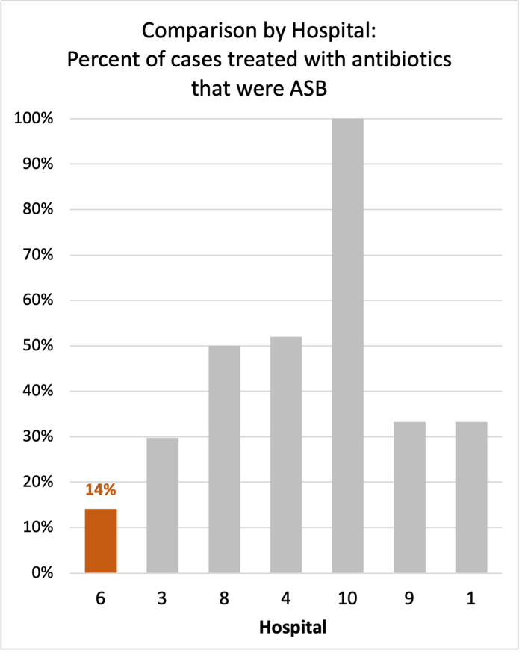
Average across hospitals in cohort: 34.8%; HMS Hospital Average*: 23.2%
Inappropriate Diagnosis of UTI measure: $\frac{Number of patients treated for ASB}{Number of positive urine cultures treated (UTI+ASB)}$
- Goal: lower % = better
- You can lower this number by either reducing unnecessary urine cultures (diagnostic stewardship) or reducing antibiotic treatment when unnecessary cultures are obtained (antibiotic stewardship)
*The HMS hospital average was amongst 46 hospitals in the Michigan Hospital Medicine Safety Consortium that participated in a similar quality improvement study.

Prevalence and Treatment Rate of ASB
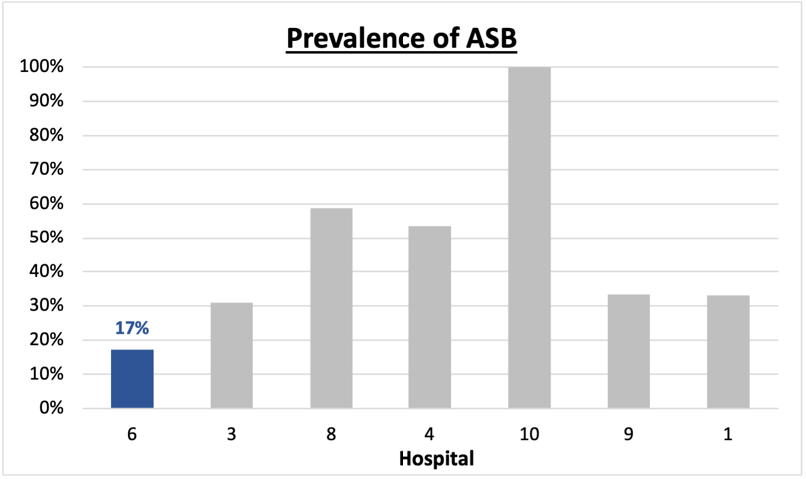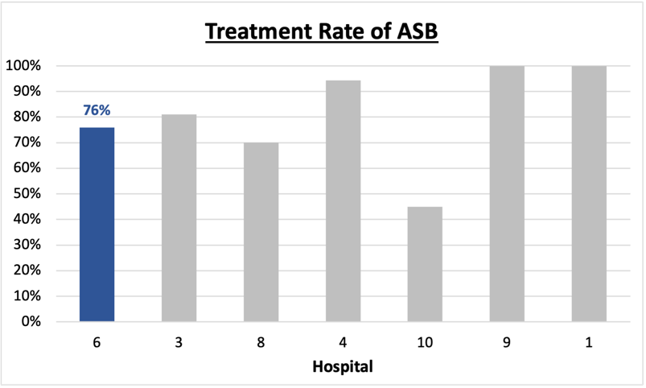
$$\frac{Number of treated ASB cases}{Number of ASB cases}$$
Prevalence of ASB:
$$\frac{Number of ASB cases}{Number of positive urine cultures}$$
Treatment Rate
of ASB:

Data submissions
Total cases (positive urine cultures) included for your site: 98
Cases included per month for your site (median & IQR): 28 (22-30.5)

Prevalence of ASB
Prevalence of ASB across hospitals: 121 (37.9%)
Prevalence of ASB at your site: 17 of 98 (17.3%)

Treatment of ASB
Treatment rate of ASB in overall cohort: 101 (83.5%)
Treatment rate of ASB at your site: 13 of 17 (76.5%)
Previous treatment rate at your site (from ASB 101 cohort): 36 of 51 (71%)

Antibiotic Tables
Table 1: Three Most Common Antibiotics comparing UTI & ASB
IV |  | Oral
UTI, n= 10 | ASB, n = 0 | UTI, n= 84 | ASB, n = 13
Ceftriaxone (n=10) | NA | Cephalexin (n=39) | Cephalexin (n=5)
NA | NA | Trimethoprim-sulfamethoxazole (n=19) | Nitrofurantoin (n=3)
NA | NA | Nitrofurantoin (n=13) | Trimethoprim-sulfamethoxazole (n=3)
Table 2: Antibiotic Duration (days) | UTI |  | ASB
Table 2: Antibiotic Duration (days) | Prior, n=59 | This Month, n=22 | Prior, n=13 | This Month, n=4
Total Antibiotic Duration; median (IQR) | 7 (6-10) | 7 (5.5-10) | 7 (5-7) | 7 (6.5-7.25)
Number of Cases Receiving >7 days; n (%) | 21 (35.6%) | 8 (36.4%) | 3 (23.1%) | 1 (25%)
Prior is June - Aug 2023 & this month is Sept 2023

Characteristic Tables
Table 3: Characteristics comparing this month to prior n (%) | UTI |  | ASB
Table 3: Characteristics comparing this month to prior n (%) | Prior, n=59 | This Month, n=22 | Prior, n=13 | This Month, n=4
Setting where culture obtained
ED, then admitted | 0 | 0 | 0 | 0
ED, then discharged | 17 (28.8%) | 8 (36.4%) | 8 (61.5%) | 3 (75%)
Ambulatory care clinic | 42 (85.7%) | 14 (63.6%) | 5 (38.5%) | 1 (25%)
Inpatient | 0 | 0 | 0 | 0
Other | 0 | 0 | 0 | 0
From reflex test | 59 (100%) | 21 (95.5%) | 12 (92.3%) | 3 (75%)
Men | 11 (18.6%) | 7 (31.8%) | 4 (30.8%) | 2 (50%)
Age >75 | 25 (42.3%) | 11 (50%) | 9 (69.2%) | 2 (50%)
Acute altered mental status changes alone | 0 | 0 | 2 (15.4%) | 0
Prior is June - Aug 2023 & this month is Sept 2023
Table 4: Prescribing Characteristics | UTI,  n=81 | ASB,  n=17
Top 3 Prescriber IDs (if available)
 | 4 (n=24) | 2 (n=3)
 | 5 (n=10) | 1 (n=2)
 | 16 (n=8) | 13 (n=2)
Prescriber type, n (%)
Physician | 25 (30.9%) | 10 (58.8%)
Physician Assistant | 49 (60.5%) | 5 (29.4%)
Nurse Practitioner | 7 (8.6%) | 2 (11.8%)
Contract of prescribing provider, n (%) (if available)
Employed by hospital | 65 (80.2%) | 11 (64.7%)
Contracted from outside group/locum | 14 (17.3%) | 5 (29.4%)
Not sure | 0 | 1 (5.9%)

Case IDs for the treated ASB cases
"71123" "71223A" "71423B" "71723A" "71923B"
"83123" "91823B" "72023A" "83123A" "83123B"
"9523" "91823A" "92123"

Key Terms and Definitions
- Positive urine culture: Any growth on culture
  - Prevalence of ASB: A positive urine culture without any documented signs or symptoms attributable to urinary tract infection per National Hospital Safety Network (NHSN) and Infectious Diseases Society of America (IDSA) Guidelines.
- Signs or symptoms of UTI includes:
- Fever (>38°C)
- Suprapubic tenderness
- Costovertebral angle pain or tenderness
- Urinary urgency
- Urinary frequency
- Dysuria
- Altered Mental Status + 2 or more SIRS criteria
- Treatment rate of ASB: antibiotic treatment for ASB

Action items/Insight:
Based on the Inappropriate Diagnosis of UTI Measure, your hospital is a high performer performing better than average in terms of percentage of UTI cases that were actually ASB. Take a moment to celebrate this success! Given your hospital’s success, we recommend continuing to try and lower this number as well as focus on sustainability and maintenance. Additional comments:
- However, amongst the patients that have ASB, your clinicians are still wanting to treat (76%). Would recommend focusing on this. If convincing clinicians to stop prescribing antibiotics for ASB is a challenge at your hospital, it might be easier to convince them to prescribe short durations (eg. 3 days) or less harmful/more narrow therapy (eg. Nitrofurantoin) for patients without symptoms. As your median duration of therapy is 7 days, this might be a compromise or intermediate step to get clinicians comfortable with less antibiotics for these patients.
- Fluoroquinolone use appears to be low at your site! Great job!

