North Valley Asymptomatic Bacteriuria (ASB) Report
Date of Report: April 2024*
*This data report is based on cases submitted from September 2023 – March 2024 and does not include previous data.
Inappropriate Diagnosis of UTI measure
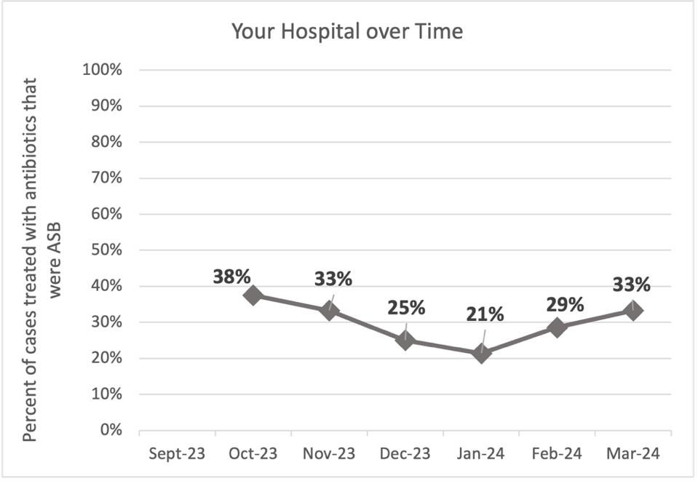
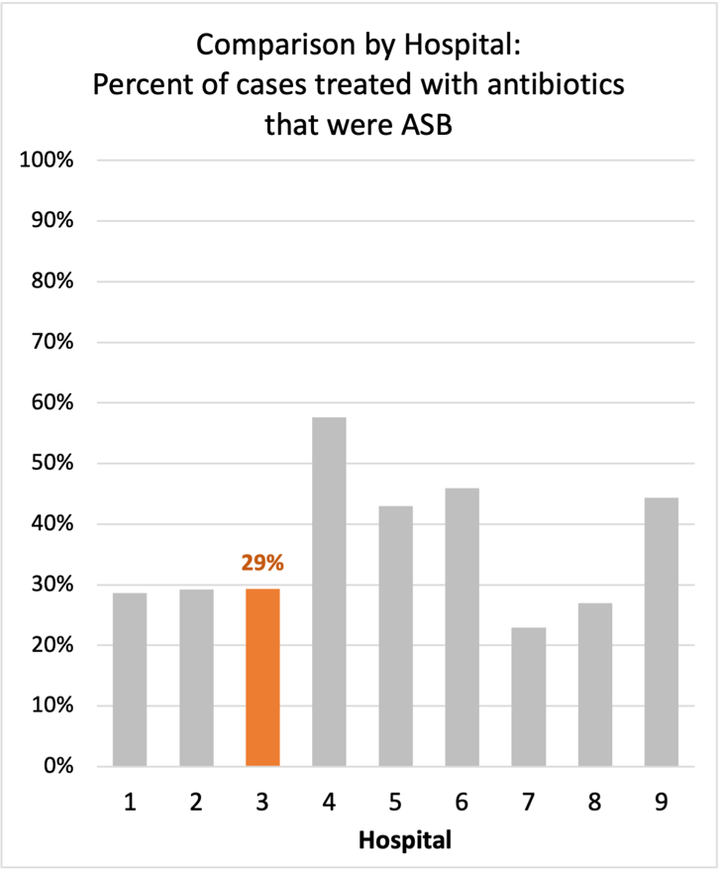
Average across hospitals in cohort: 34.5% ; HMS Hospital Average*: 23.2%
Inappropriate Diagnosis of UTI measure: $\frac{Number of patients treated for ASB}{Number of positive urine cultures treated (UTI+ASB)}$
- Goal: lower % = better
- You can lower this number by either reducing unnecessary urine cultures (diagnostic stewardship) or reducing antibiotic treatment when unnecessary cultures are obtained (antibiotic stewardship)
*The HMS hospital average was amongst 46 hospitals in the Michigan Hospital Medicine Safety Consortium that participated in a similar quality improvement study.

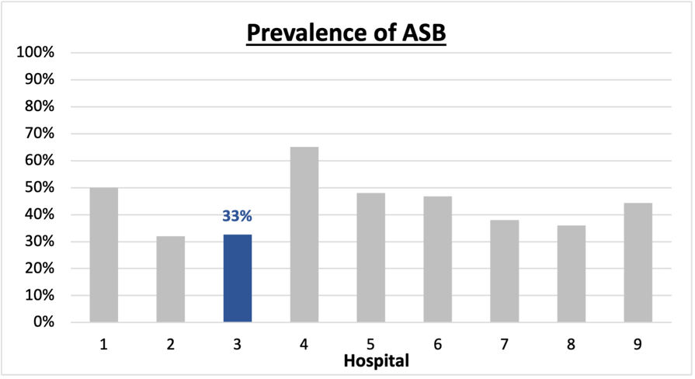
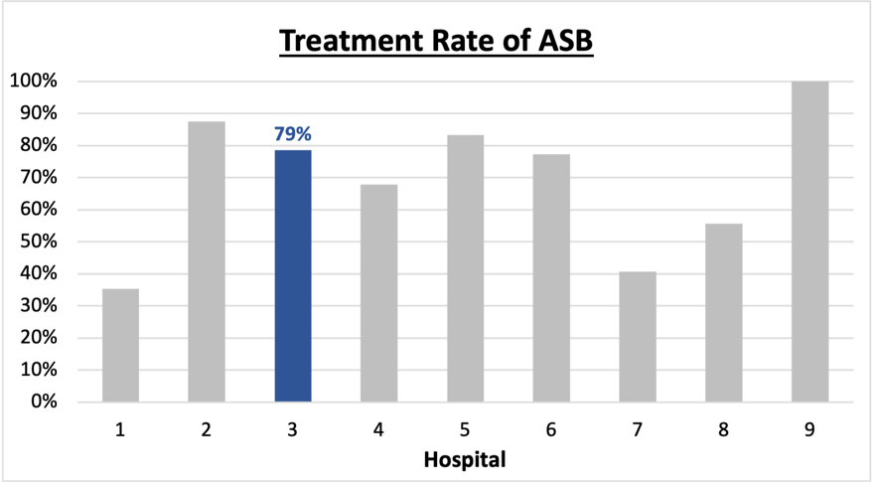
Prevalence and Treatment Rate of ASB
Prevalence of ASB:
Treatment Rate
of ASB:

$$\frac{Number of treated ASB cases}{Number of ASB cases}$$
$$\frac{Number of ASB cases}{Number of positive urine cultures}$$

Data submissions
Total cases (positive urine cultures) included for your site: 86
Cases included per month for your site (median & IQR): 13 (9.75-16.25)

Prevalence of ASB
Prevalence of ASB across hospitals: 164 of 390 (42.1%)
Prevalence of ASB at your site: 28 of 86 (32.6%)

Treatment Rate of ASB
Treatment rate of ASB in overall cohort: 106 of 164 (64.6%)
Treatment rate of ASB at your site: 22 of 28 (78.6%)

Antibiotic Tables
Table 1: Three Most Common Antibiotics comparing UTI & ASB
IV |  | Oral
UTI, n= 33 | ASB, n = 9 | UTI, n=43 | ASB, n = 19
Ceftriaxone (n=26) | Ceftriaxone (n=8) | Cephalexin (n=20) | Cefdinir (n=12)
Pip-tazo (n=3) | Ampicillin/sulbactam (n=1) | Tri-sulfa (n=9) | Nitrofurantoin (n=3)
Levofloxacin (n=2) | NA | Nitrofurantoin (n=4) | Amoxicillin-clav (n=1)
Table 2: Antibiotic Duration (days) | UTI |  | ASB
Table 2: Antibiotic Duration (days) | Prior, n=53 | This Month, n=6 | Prior, n=25 | This Month, n=3
Total Antibiotic Duration; median (IQR) | 7 (3-8) | 5 (2-5.75) | 3 (1-7) | 5 (4.5-6.5)
Number of Cases Receiving >7 days; n (%) | 17 (32.1%) | 0 | 6 (24%) | 1 (33.3%)

Prior is Sept 2023 - Feb 2024 & this month is March 2024
Table 3: Characteristics comparing this month to prior n (%) | UTI |  | ASB
Table 3: Characteristics comparing this month to prior n (%) | Prior, n=53 | This Month, n=6 | Prior, n=25 | This Month, n=3
Setting where culture obtained
ED, then admitted | 7 (13.2%) | 0 | 3 (12%) | 0
ED, then discharged | 46 (86.8%) | 6 (100%) | 22 (88%) | 3 (100%)
Ambulatory care clinic | 0 | 0 | 0 | 0
Inpatient | 0 | 0 | 0 | 0
Other | 0 | 0 | 0 | 0
From reflex test | 52 (98.1%) | 6 (100%) | 23 (92%) | 3 (100%)
Men | 19 (35.8%) | 3 (50%) | 15 (60%) | 15 (60%)
Age >75 | 20 (37.7%) | 1 (16.7%) | 11 (44%) | 11 (44%)
Acute altered mental status changes alone | 4 (7.5%) | 1 (16.7%) | 4 (16%) | 4 (16%)
Characteristic Tables
Prior is Sept 2023 - Feb 2024 & this month is March 2024

Table 4: Prescribing Characteristics | UTI |  | ASB
Table 4: Prescribing Characteristics | Prior, n=53 | This Month, n=6 | Prior, n=25 | This Month, n=3
Top 3 Prescriber IDs (if available)
 | 4 (n=22) | 6 (n=3) | 3 (n=8) | 6 (n=2)
 | 3 (n=15) | 3 (n=2) | 4 (n=7) | 4 (n=1)
 | 6 (n=6) | 1 (n=1) | 2 (n=3) | NA
Prescriber type, n (%)
Physician | 53 (100%) | 6 (100%) | 25 (100%) | 3 (100%)
Physician Assistant | 0 | 0 | 0 | 0
Nurse Practitioner | 0 | 0 | 0 | 0
Contract of prescribing provider, n (%) (if available)
Employed by hospital | 0 | 0 | 0 | 0
Contracted from outside group/locum | 53 (100%) | 6 (100%) | 25 (100%) | 3 (100%)
Not sure | 0 | 0 | 0 | 0
Prior is Sept 2023 - Feb 2024 & this month is March 2024
Case IDs for the treated ASB cases
"585707" "585366" "585356" "584924" "585119" "584920" "586278" "586549"
"587106" "587761" "587199" "588172" "587288" "586998" "589126" "588840"
"588884" "589666" "590334" "591455" "591750" "591708"

Key Terms and Definitions
- Positive urine culture: Any growth on culture
  - Prevalence of ASB: A positive urine culture without any documented signs or symptoms attributable to urinary tract infection per National Hospital Safety Network (NHSN) and Infectious Diseases Society of America (IDSA) Guidelines.
- Signs or symptoms of UTI includes:
- Fever (>38°C)
- Suprapubic tenderness
- Costovertebral angle pain or tenderness
- Urinary urgency
- Urinary frequency
- Dysuria
- Altered Mental Status + 2 or more SIRS criteria
- Treatment rate of ASB: antibiotic treatment for ASB

Action items/Insight:
Based on the Inappropriate Diagnosis of UTI Measure, your hospital is a performing above average in terms of percentage of UTI cases that were actually ASB. Congratulations! Additional comments:
- Met case submission requirement: Great job submitting cases! Celebrate this success!
- Low Fluoroquinolone use: Fluoroquinolone use appears to be low at your site! Great job!
- Downtrending treatment duration: The treatment duration for UTI was high in prior months, with 32.1% of patients receiving >7 days of therapy; however, it appears that treatment duration for both UTI is starting to trend down. Great job! Keep working on this.
- High Treatment of ASB: However, among the patients that have ASB, your clinicians are still frequently treating (78.6%). We would recommend focusing on this. If convincing clinicians to stop prescribing antibiotics for ASB is a challenge at your hospital, it might be easier to suggest short durations (eg. 3 days) or less harmful/more narrow therapy (eg. Nitrofurantoin) for patients without symptoms. This might be a compromise or intermediate step to help clinicians feel comfortable with less antibiotics for these patients.

