Syringa Asymptomatic Bacteriuria (ASB) Report
Date of Report: April 2024*
*This data report is based on cases submitted from September 2023 – March 2024 and does not include previous data.
Inappropriate Diagnosis of UTI measure
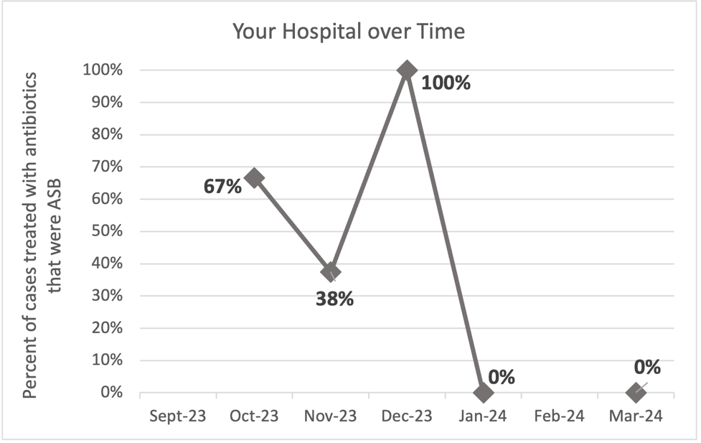
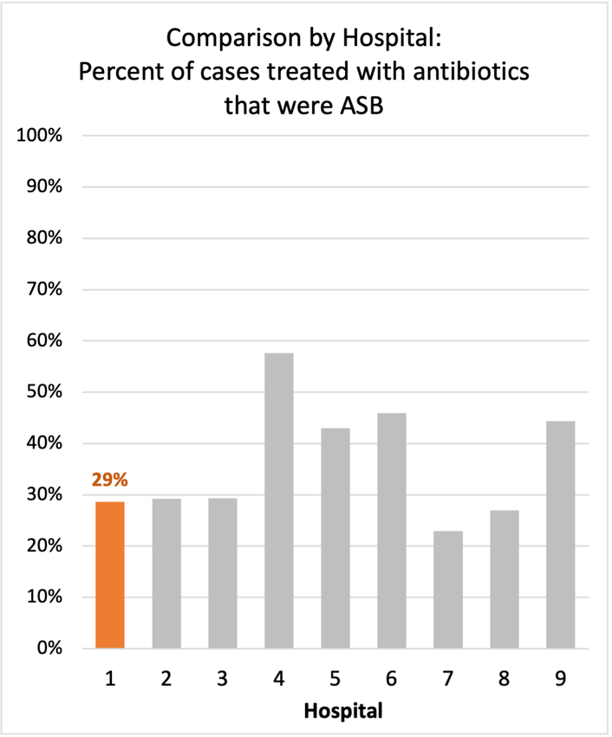
Average across hospitals in cohort: 34.5% ; HMS Hospital Average*: 23.2%
Inappropriate Diagnosis of UTI measure: $\frac{Number of patients treated for ASB}{Number of positive urine cultures treated (UTI+ASB)}$
- Goal: lower % = better
- You can lower this number by either reducing unnecessary urine cultures (diagnostic stewardship) or reducing antibiotic treatment when unnecessary cultures are obtained (antibiotic stewardship)
*The HMS hospital average was amongst 46 hospitals in the Michigan Hospital Medicine Safety Consortium that participated in a similar quality improvement study.

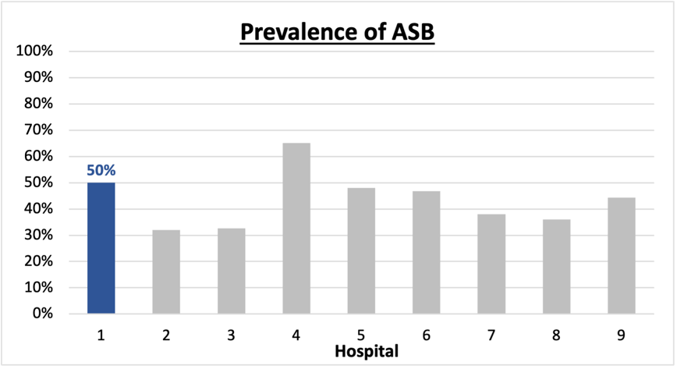
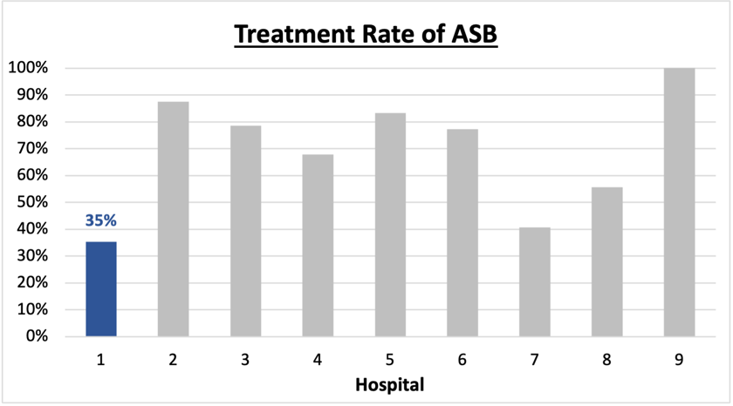
Prevalence and Treatment Rate of ASB
Prevalence of ASB:
$$\frac{Number of treated ASB cases}{Number of ASB cases}$$
Treatment Rate
of ASB:

$$\frac{Number of ASB cases}{Number of positive urine cultures}$$

Data submissions
Total cases (positive urine cultures) included for your site: 34
Cases included per month for your site (median & IQR): 8 (3-8)

Prevalence of ASB
Prevalence of ASB across hospitals: 164 of 390 (42.1%)
Prevalence of ASB at your site: 17 of 34 (50%)

Treatment Rate of ASB
Treatment rate of ASB in overall cohort: 106 of 164 (64.6%)
Treatment rate of ASB at your site: 6 of 17 (35.3%)

Antibiotic Tables
Table 1: Three Most Common Antibiotics comparing UTI & ASB
IV |  | Oral
UTI, n=6 | ASB, n =2 | UTI, n=14 | ASB, n = 5
Ceftriaxone (n=5) | Ceftriaxone (n=2) | Ciprofloxacin (n=5) | Cephalexin (n=2)
Ciprofloxacin (n=1) | NA | Tri-sulfa (n=4) | Amoxicillin (n=1)
NA | NA | Cefdinir (n=2) | Ciprofloxacin (n=1)
Table 2: Antibiotic Duration (days) | UTI |  | ASB
Table 2: Antibiotic Duration (days) | Prior, n=12 | This Month, n=5 | Prior, n=14 | This Month, n=3
Total Antibiotic Duration; median (IQR) | 5 (4-7) | 7 (7-7) | 0 (0-5) | 0 (0-0)
Number of Cases Receiving >7 days; n (%) | 1 (8.3%) | 0 | 1 (7.1%) | 0

Prior is Sept 2023 - Feb 2024 & this month is March 2024
Table 3: Characteristics comparing this month to prior n (%) | UTI |  | ASB
Table 3: Characteristics comparing this month to prior n (%) | Prior, n=12 | This Month, n=5 | Prior, n=14 | This Month, n=3
Setting where culture obtained
ED, then admitted | 0 | 0 | 2 (14.3%) | 0
ED, then discharged | 3 (25%) | 4 (80%) | 7 (50%) | 1 (33.3%)
Ambulatory care clinic | 8 (66.7%) | 1 (20%) | 5 (35.7%) | 2 (66.7%)
Inpatient | 0 | 0 | 0 | 0
Other | 1 (8.3%) | 0 | 0 | 0
From reflex test | 6 (50%) | 5 (100%) | 10 (71.4%) | 3 (100%)
Men | 2 (16.7%) | 2 (40%) | 8 (57.1%) | 0
Age >75 | 0 | 0 | 5 (35.7%) | 2 (66.7%)
Acute altered mental status changes alone | 0 | 0 | 2 (14.3%) | 0
Characteristic Tables
Prior is Sept 2023 - Feb 2024 & this month is March 2024

Table 4: Prescribing Characteristics | UTI |  | ASB
Table 4: Prescribing Characteristics | Prior, n=12 | This Month, n=5 | Prior, n=14 | This Month, n=3
Top 3 Prescriber IDs (if available)
Prescriber type, n (%)
Physician | 10 (83.3%) | 5 (100%) | 12 (85.7%) | 2 (66.7%)
Physician Assistant | 0 | 0 | 1 (7.1%) | 0
Nurse Practitioner | 2 (16.7%) | 0 | 1 (7.1%) | 1 (33.3%)
Contract of prescribing provider, n (%) (if available)
Employed by hospital | 11 (91.7%) | 5 (100%) | 13 (92.9%) | 1 (33.3%)
Contracted from outside group/locum | 1 (8.3%) | 0 | 1 (7.1%) | 1 (33.3%)
Not sure | 0 | 0 | 0 | 1 (33.3%)
Prior is Sept 2023 - Feb 2024 & this month is March 2024
Case IDs for the treated ASB cases
"75411" "18828" "565861" "565512" "566577" "571204"

Key Terms and Definitions
- Positive urine culture: Any growth on culture
  - Prevalence of ASB: A positive urine culture without any documented signs or symptoms attributable to urinary tract infection per National Hospital Safety Network (NHSN) and Infectious Diseases Society of America (IDSA) Guidelines.
- Signs or symptoms of UTI includes:
- Fever (>38°C)
- Suprapubic tenderness
- Costovertebral angle pain or tenderness
- Urinary urgency
- Urinary frequency
- Dysuria
- Altered Mental Status + 2 or more SIRS criteria
- Treatment rate of ASB: antibiotic treatment for ASB

Action items/Insight:
Based on the Inappropriate Diagnosis of UTI Measure, your hospital is a performing above average in terms of percentage of UTI cases that were actually ASB. Continue the good work on all you are doing to improve this number! Additional comments:
- Met case submission requirement: Great job submitting cases! Celebrate this success!
- Low/trending down ASB treatment rate: Throughout the year, the percent of cases treated that were actually ASB trended down. This is a very positive trend! Celebrate this success and maintain this momentum!
- Prevalence of ASB was higher than average: This suggests that there may be room for improved diagnostic stewardship of urine culture studies to help reduce this prevalence.
- High ciprofloxacin use: Ciprofloxacin appears to be the one of the most frequently prescribed oral agents for both UTI and ASB; we would recommend assessing if this is appropriate based on allergy history or susceptibility profile of organisms. If not, we would recommend clinician education on the harms associated with fluoroquinolone use.
- High treatment duration: Your median treatment duration for UTI during the last month was 7 days (though in prior months, the median was 5 days). This may be an area on which you could focus to help reduce overall antibiotic use.

