Valor Asymptomatic Bacteriuria (ASB) Report
Date of Report: April 2024*
*This data report is based on cases submitted from September 2023 – March 2024 and does not include previous data.
Inappropriate Diagnosis of UTI measure
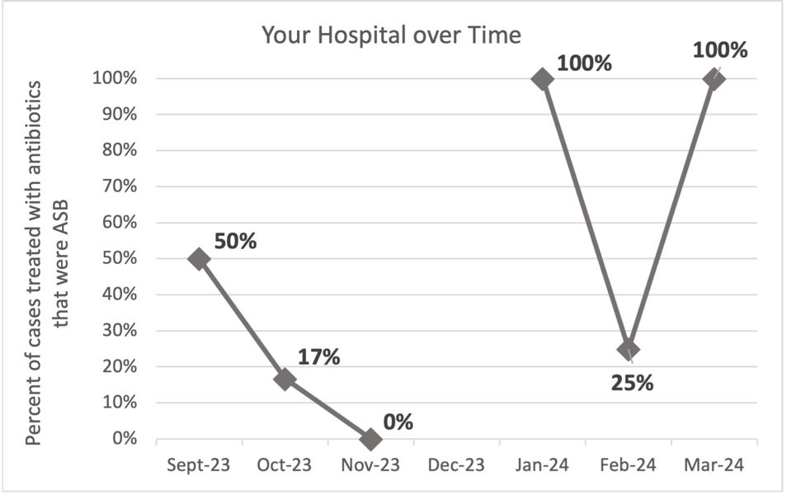
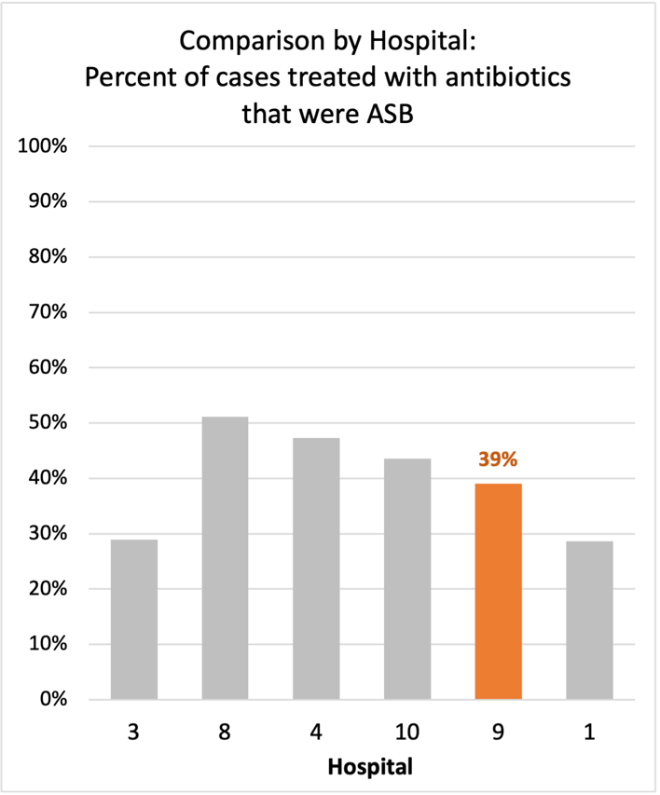
Average across hospitals in cohort: 38.3% ; HMS Hospital Average*: 23.2%
Inappropriate Diagnosis of UTI measure: $\frac{Number of patients treated for ASB}{Number of positive urine cultures treated (UTI+ASB)}$
- Goal: lower % = better
- You can lower this number by either reducing unnecessary urine cultures (diagnostic stewardship) or reducing antibiotic treatment when unnecessary cultures are obtained (antibiotic stewardship)
*The HMS hospital average was amongst 46 hospitals in the Michigan Hospital Medicine Safety Consortium that participated in a similar quality improvement study.

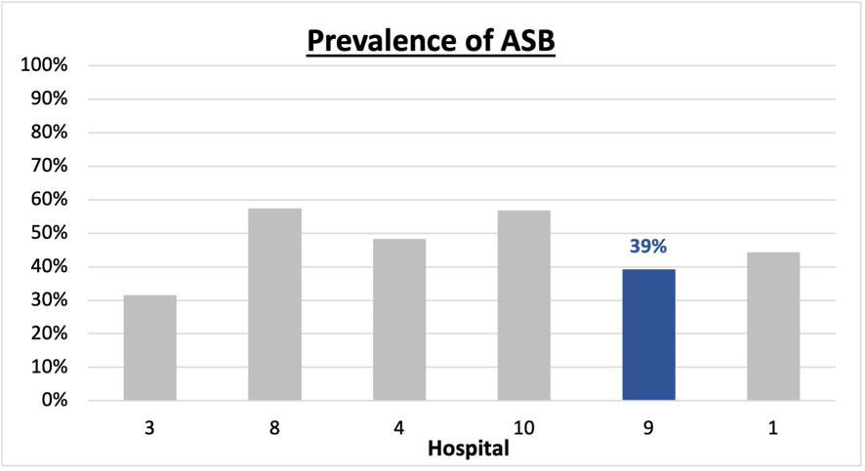
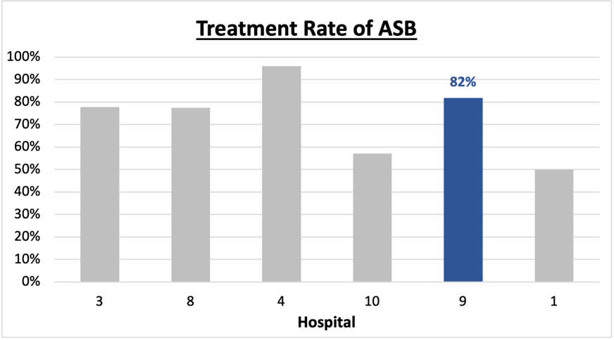
Prevalence and Treatment Rate of ASB
Treatment Rate
of ASB:

Prevalence of ASB:
$$\frac{Number of treated ASB cases}{Number of ASB cases}$$
$$\frac{Number of ASB cases}{Number of positive urine cultures}$$

Data submissions
Total cases (positive urine cultures) included for your site: 28
Cases included per month for your site (median & IQR): 5.5 (3.5 – 6)

Prevalence of ASB
Prevalence of ASB across hospitals: 204 of 483 (42.2%)
Prevalence of ASB at your site: 11 of 28 (39.3%)

Treatment Rate of ASB
Treatment rate of ASB in overall cohort: 164 of 204 (80.4%)
Treatment rate of ASB at your site: 9 of 11 (81.8%)
Previous treatment rate at your site (from ASB 101 cohort): 16 of 16 (100%)

Antibiotic Tables
Table 1: Three Most Common Antibiotics comparing UTI & ASB
IV |  | Oral
UTI, n= 3 | ASB, n = 5 | UTI, n=14 | ASB, n = 8
Ceftriaxone (n=3) | Ceftriaxone (n=5) | Nitrofurantoin (n=5) | Cephalexin (n=4)
NA | NA | Cephalexin (n=4) | Ciprofloxacin (n=2)
NA | NA | Amoxicillin-clavulanate (n=1) | Nitrofurantoin (n=1)
Table 2: Antibiotic Duration (days) | UTI |  | ASB
Table 2: Antibiotic Duration (days) | Prior, n=17 | This Month, n=0 | Prior, n= 9 | This Month, n=2
Total Antibiotic Duration; median (IQR) | 7 (3-7) | NA | 7 (3-7) | 3.5 (1.75-5.25)
Number of Cases Receiving >7 days; n (%) | 4 (23.5%) | NA | 1 (11.1%) | 0

Prior is Sept 2023 - Feb 2024 & this month is March 2024
Table 3: Characteristics comparing this month to prior n (%) | UTI |  | ASB
Table 3: Characteristics comparing this month to prior n (%) | Prior, n=17 | This Month, n=0 | Prior, n=9 | This Month, n=2
Setting where culture obtained
ED, then admitted | 1 (5.9%) | 0 | 3 (33.3%) | 0
ED, then discharged | 5 (29.4%) | 0 | 6 (66.7%) | 2 (100%)
Ambulatory care clinic | 5 (29.4%) | 0 | 0 | 0
Inpatient | 0 | 0 | 0 | 0
Other | 6 (35.3%) | 0 | 0 | 0
From reflex test | 8 (47.1%) | 0 | 7 (77.8%) | 2 (100%)
Men | 3 (17.6%) | 0 | 5 (55.6%) | 0
Age >75 | 7 (41.2%) | 0 | 5 (55.6%) | 1 (50%)
Acute altered mental status changes alone | 1 (5.9%) | 0 | 3 (33.3%) | 0
Characteristic Tables
Prior is Sept 2023 - Feb 2024 & this month is March 2024

Table 4: Prescribing Characteristics | UTI |  | ASB
Table 4: Prescribing Characteristics | Prior, n=17 | This Month, n= 0 | Prior, n=9 | This Month, n=2
Top 3 Prescriber IDs (if available)
 | 46020 (n=3) |  | 10102 (n=3) | 10145 (n=2)
 | 10102 (n=2) |  | 10147 (n=2)
 | 10169 (n=2) |  | 89377 (n=2)
Prescriber type, n (%)
Physician | 11 (64.7%) | 0 | 9 (100%) | 2 (100%)
Physician Assistant | 5 (29.4%) | 0 | 0 | 0
Nurse Practitioner | 1 (5.9%) | 0 | 0 | 0
Contract of prescribing provider, n (%) (if available)
Employed by hospital | 12 (75%) | 0 | 6 (66.7%) | 2 (100%)
Contracted from outside group/locum | 4 (25%) | 0 | 1 (11.1%) | 0
Not sure | 0 | 0 | 2 (22.2%) | 0
Prior is Sept 2023 - Feb 2024 & this month is March 2024
Case IDs for the treated ASB cases

130322290" "130322417" "130322439" "130324126" "130336310" "130336461"
"130338192" "130340072" "130344012"

Key Terms and Definitions
- Positive urine culture: Any growth on culture
  - Prevalence of ASB: A positive urine culture without any documented signs or symptoms attributable to urinary tract infection per National Hospital Safety Network (NHSN) and Infectious Diseases Society of America (IDSA) Guidelines.
- Signs or symptoms of UTI includes:
- Fever (>38°C)
- Suprapubic tenderness
- Costovertebral angle pain or tenderness
- Urinary urgency
- Urinary frequency
- Dysuria
- Altered Mental Status + 2 or more SIRS criteria
- Treatment rate of ASB: antibiotic treatment for ASB

Action items/Insight:
Based on the Inappropriate Diagnosis of UTI Measure, your hospital is a performing above average in terms of percentage of UTI cases that were actually ASB. Please continue to try and work on improving this. Additional comments:
Positives to Highlight:
- Met case submission requirement: Great job submitting cases! Celebrate this success!
- Overall, down trend in ASB treatment rate: Throughout the year, your treatment rate of ASB has trended down. In IQIC 101 and the first data report, your treatment rate was 100%. Although this number is high, you have decreased to it to 82%. Work to maintain this momentum!
- High nitrofurantoin and cephalosporin use: Less harmful/more narrow therapy use is high at your site! Great job! Minimal fluoroquinolone use on the report is awesome.

Areas of Improvement:
- Up-trending Diagnosis of UTI Measure: Throughout quality improvement work, it is important to recognize that valleys and peaks occur within this process. When reflecting on prior rates at your facility, please celebrate that this is a huge improvement in overall process. However, this could be an opportunity to investigate what was done differently in Jan/March 2024 to contribute to this.

