Valor IQIC 201 Asymptomatic Bacteriuria (ASB) Report
Date of Report: January 2024*
*This data report is based on cases submitted from August 2023 to December 2023 and does not include previous data.
Inappropriate Diagnosis of UTI measure
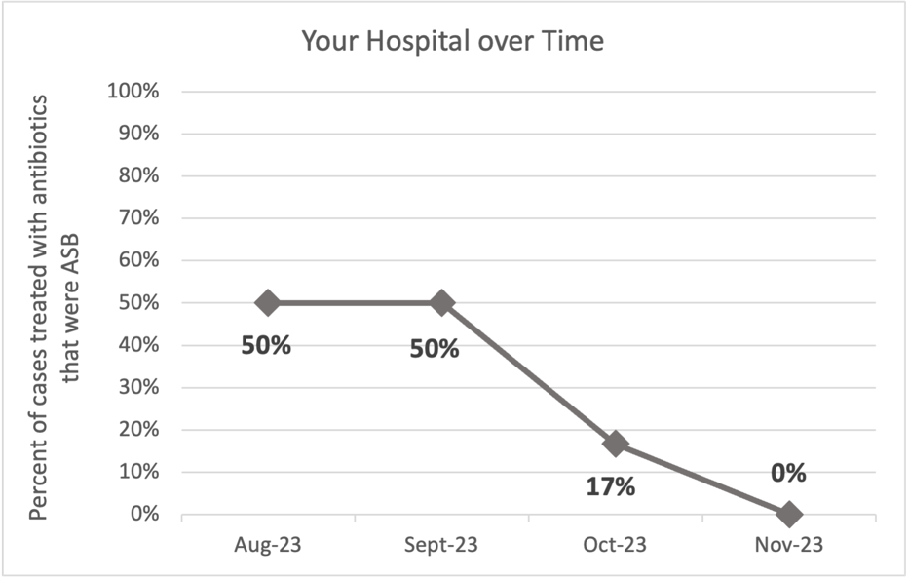
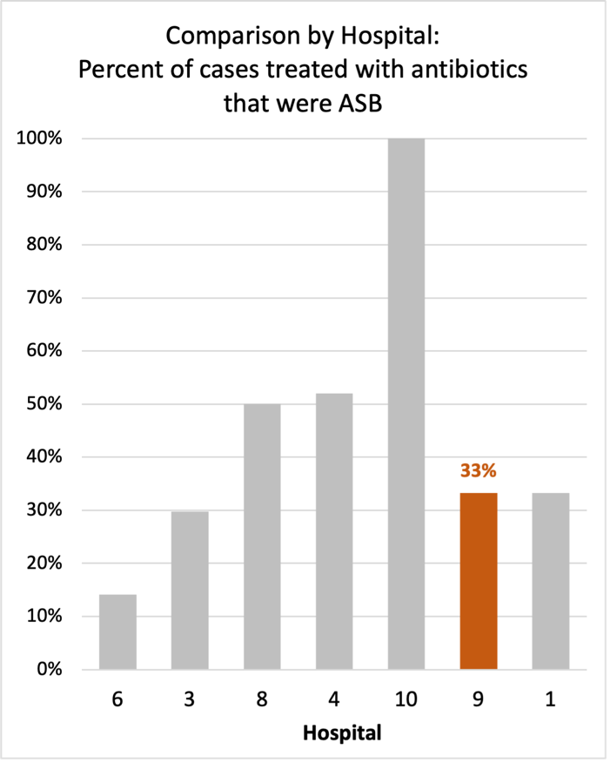
Average across hospitals in cohort: 34.8%; HMS Hospital Average*: 23.2%
Inappropriate Diagnosis of UTI measure: $\frac{Number of patients treated for ASB}{Number of positive urine cultures treated (UTI+ASB)}$
- Goal: lower % = better
- You can lower this number by either reducing unnecessary urine cultures (diagnostic stewardship) or reducing antibiotic treatment when unnecessary cultures are obtained (antibiotic stewardship)
*The HMS hospital average was amongst 46 hospitals in the Michigan Hospital Medicine Safety Consortium that participated in a similar quality improvement study.

Prevalence and Treatment Rate of ASB
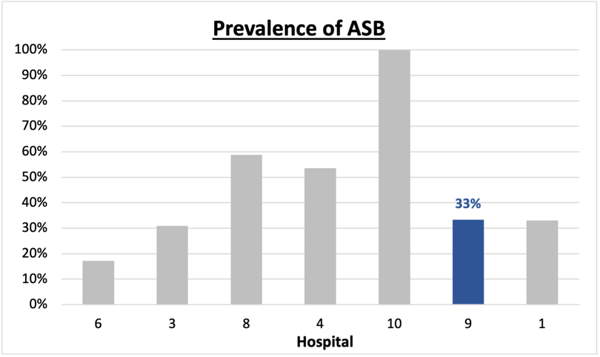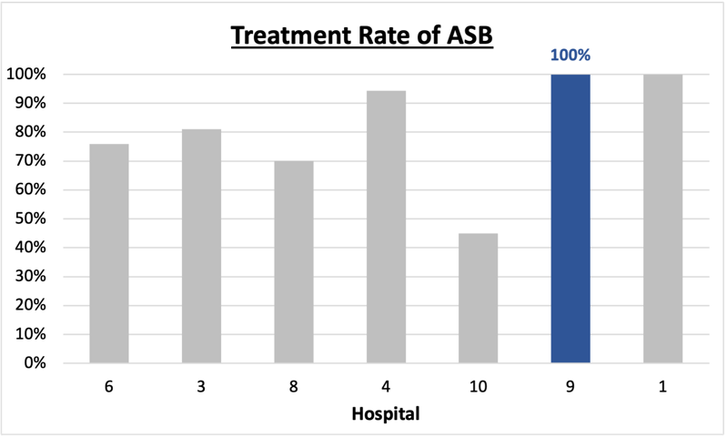
$$\frac{Number of treated ASB cases}{Number of ASB cases}$$
Prevalence of ASB:
$$\frac{Number of ASB cases}{Number of positive urine cultures}$$
Treatment Rate
of ASB:

Data submissions
Total cases (positive urine cultures) included for your site: 21
Cases included per month for your site (median & IQR): 6 (5.25-6)

Prevalence of ASB
Prevalence of ASB across hospitals: 121 (37.9%)
Prevalence of ASB at your site: 7 of 21 (33.3%)

Treatment of ASB
Treatment rate of ASB in overall cohort: 101 (83.5%)
Treatment rate of ASB at your site: 7 of 7 (100%)
Previous treatment rate at your site (from ASB 101 cohort): 16 of 16 (100%)

Antibiotic Tables
Table 1: Three Most Common Antibiotics comparing UTI & ASB
IV |  | Oral
UTI, n= 1 | ASB, n = 2 | UTI, n=14 | ASB, n = 6
Ceftriaxone (n=1) | Ceftriaxone (n=2) | Nitrofurantoin (n=6) | Nitrofurantoin (n=3)
NA | NA | Cephalexin (n=5) | Ciprofloxacin (n=2)
NA | NA | Trimethoprim-sulfamethoxazole (n=2) | Trimethoprim-sulfamethoxazole (n=1)
Table 2: Antibiotic Duration (days) | UTI |  | ASB
Table 2: Antibiotic Duration (days) | Prior, n=11 | This Month, n=3 | Prior, n=7 | This Month, n=0
Total Antibiotic Duration; median (IQR) | 7 (5-7) | 7 (7-7) | 7 (6-9) | NA
Number of Cases Receiving >7 days; n (%) | 1 (9.1%) | 0 | 3 (42.9%) | NA
Prior is Aug – Oct 2023 & this month is Nov 2023

Characteristic Tables
Table 3: Characteristics comparing this month to prior n (%) | UTI |  | ASB
Table 3: Characteristics comparing this month to prior n (%) | Prior, n=11 | This Month, n=3 | Prior, n=7 | This Month, n=0
Setting where culture obtained
ED, then admitted | 1 (9.1%) | 0 | 1 (14.3%) | NA
ED, then discharged | 1 (9.1%) | 0 | 6 (85.7%) | NA
Ambulatory care clinic | 6 (54.5%) | 0 | 0 | NA
Inpatient | 0 | 0 | 0 | NA
Other | 3 (27.3%) | 0 | 0 | NA
From reflex test | 5 (45.5%) | 0 | 6 (85.7%) | NA
Men | 1 (9.1%) | 0 | 2 (28.6%) | NA
Age >75 | 3 (27.3%) | 2 (66.7%) | 3 (42.9%) | NA
Acute altered mental status changes alone | 0 | 0 | 3 (42.9%) | NA
Prior is Aug – Oct 2023 & this month is Nov 2023
Table 4: Prescribing Characteristics | UTI,  n=14 | ASB,  n=7
Top 3 Prescriber IDs (if available)
 | 46020 (n=3) | 10102 (n=2)
 | 10169 (n=2) | 10113 (n=2)
 | 35903 (n=2) | 89377 (n=2)
Prescriber type, n (%)
Physician | 7 (50%) | 7 (100%)
Physician Assistant | 6 (42.9%) | 0
Nurse Practitioner | 1 (7.1%) | 0
Contract of prescribing provider, n (%) (if available)
Employed by hospital | 12 (85.7%) | 5 (71.4%)
Contracted from outside group/locum | 1 (7.1%) | 0
Not sure | 0 | 2 (28.6%)

Case IDs for the treated ASB cases
"130320050" "130320558" "130320568" "130322290" "130322417"
"130322439" "130324126"

Key Terms and Definitions
- Positive urine culture: Any growth on culture
  - Prevalence of ASB: A positive urine culture without any documented signs or symptoms attributable to urinary tract infection per National Hospital Safety Network (NHSN) and Infectious Diseases Society of America (IDSA) Guidelines.
- Signs or symptoms of UTI includes:
- Fever (>38°C)
- Suprapubic tenderness
- Costovertebral angle pain or tenderness
- Urinary urgency
- Urinary frequency
- Dysuria
- Altered Mental Status + 2 or more SIRS criteria
- Treatment rate of ASB: antibiotic treatment for ASB

Action items/Insight:
Based on the Inappropriate Diagnosis of UTI Measure, your hospital is starting to improve in terms of percentage of UTI cases that were actually ASB. Take a moment to celebrate this success! Given your hospital’s success, we recommend continuing to try and lower this number as well as focus on sustainability and maintenance. Additional comments:
- However, amongst the patients that have ASB, your clinicians are still wanting to treat (100%). Would recommend focusing on this. If convincing clinicians to stop prescribing antibiotics for ASB is a challenge at your hospital, it might be easier to convince them to prescribe short durations (eg. 3 days) or less harmful/more narrow therapy (eg. Nitrofurantoin) for patients without symptoms. This might be a compromise or intermediate step to get clinicians comfortable with less antibiotics for these patients.
- Ciprofloxacin appears to be the second most frequently prescribed oral agents for both UTI and ASB, would recommend assessing if this is appropriate based on allergy history or susceptibility profile of organisms. If not, would try to educate on harms associate with fluoroquinolone use.

