Whidbey Health FINAL Asymptomatic Bacteriuria Report (8/22/23)
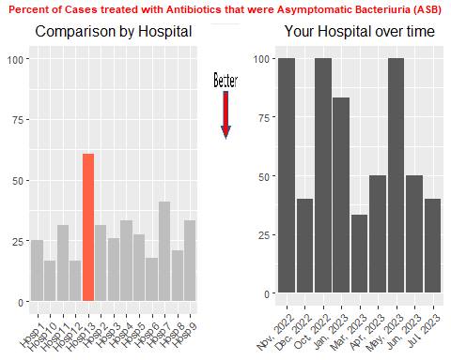
Annual Performance: 60.7% (17/28)
Average Across Hospitals: 28.1%; HMS Hospital Average: 23.2%
Number of total cases (project goal 59): 28 Number of cases this month (goal 6): 5
Case IDs for the last 2 months’ Treated ASB Cases: MS23SE146 MS23PB153 MS23HD154
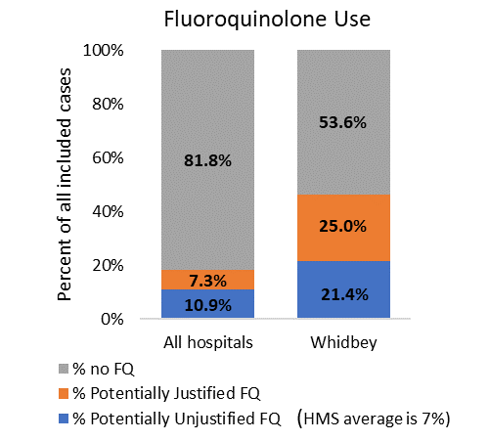
Fluoroquinolone Use:
“Potentially justified” is defined as:
Patient had a fever OR documented pyelonephritis OR 2 or more SIRS criteria. (Remaining cases treated with FQs were “potentially not justified”)
For All hospitals, 112/615 (18.5%) cases received FQs; of those, 67/23 (59.8%) were potentially not justified. In other words, 10.9% (67/615) of patients received a potentially unjustified fluoroquinolone.
For your hospital 13/28 (46.4%) cases received FQs; of those 6/13 (46.2%) were potentially not justified. In other words, 21.4% (6/28) of patients received a potentially unjustified fluoroquinolone. The HMS average is 7%.
Table 1: Three most Common Antibiotics for Empiric and Discharge comparing UTI & ASB (Entire Year)
Empiric |  |  | Discharge
UTI, n=11 |  | ASB, n=17 | UTI, n=11 | ASB, n=17
Ceftriaxone, n=8 (72.7%) |  | Ceftriaxone, n=11 (64.7%) | Ciprofloxacin, n=2 (18.2%) | Cephalexin, n=2 (11.8%)
Ciprofloxacin, n=3 (27.3%) |  | Cefepime, n=4 (23.5%) | Levofloxacin, n=2 (18.2%) | Ciprofloxacin, n=2 (11.8%)
Levofloxacin, n=2 (18.2%) |  | Ciprofloxacin, n=4 (23.5%) | Cefdinir, n=1 (9.1%) | Levofloxacin, n=2 (11.8%)

Table 2: Antibiotic Duration: July vs prior
 | UTI |  | ASB
Antibiotic Duration (days) | Prior, n=8 | July, n=3 | Prior, n=15 | July, n=2
Total Antibiotic Duration; median (IQR) | 10.0 (9.8,14.0) | 8.0 (6.5,9.5) | 7.0 (6.0,12.0) | 16.5 (13.2,19.8)
Inpatient duration; median (IQR) | 5.0 (3.0,5.0) | 7.0 (6.0,9.0) | 6.0 (5.0,7.0) | 5.5 (5.2,5.8)
Discharge duration; median (IQR) | 6.0 (4.8,8.0) | 0.0 (0.0,0.0) | 0.0 (0.0,7.0) | 11.0 (7.5,14.5)
Number of Cases Receiving >7 days; n (%) | 7 (87.5) | 1 (50.0) | 5 (33.3) | 2 (100.0)
For all hospitals, the percent of UTIs receiving >7 days was 55.6% (259/466); for ASB was 44.4% (75/169)
The HMS average is 37.7% for UTI and 22.2% for ASB.

Table 3: Patient Characteristics: July vs prior n (%)
 | UTI |  | ASB
Characteristics; n (%) | Prior, n=8 | July, n=3 | Prior, n=15 | July, n=2
Setting where culture obtained
ED, then admitted | 8 (100.0) | 3 (100.0) | 14 (93.3) | 2 (100.0)
ED, then discharged | 0 | 0 | 1 (6.7) | 0
Other | 0 | 0 | 1 (6.7) | 0
From reflex test | 8 (100.0) | 3 (100.0) | 15 (100.0) | 2 (100.0)
Men | 3 (37.5) | 0 (0.0) | 6 (40.0) | 1 (50.0)
Age >75 | 3 (37.5) | 2 (66.7) | 5 (33.3) | 2 (100.0)
Dementia | 5 (62.5) | 1 (33.3) | 1 (6.7) | 0 (0.0)
Admitted from SNF or LTAC | 6 (75.0) | 0 (0.0) | 3 (20.0) | 0 (0.0)
End stage renal disease | 0 | 0 | 0 | 0
Immune suppression | 2 (25.0) | 2 (66.7) | 4 (26.7) | 0 (0.0)
Chronic catheter use | 3 (37.5) | 0 | 0 | 0
Chronic urinary retention | 1 (12.5) | 0 (0.0) | 2 (13.3) | 1 (50.0)
Had altered mental status with or without symptoms | 4 (50.0) | 2 (66.7) | 1 (6.7) | 0
Had altered mental status without signs of infection | 1 (12.5) | 0 | 1 (6.7) | 0
Had >=2 SIRS Criteria on any day | 0 | 0 | 0 | 0
Action Items/Insight: Though there’s some month-to-month variation,* your site is generally performing worse than average in terms of ASB treatment. We also notice that your hospital is performing worse than average in terms of the % of patients who receive a potentially avoidable fluoroquinolone and the % of patients who receive antibiotic durations >7 days. If convincing clinicians to stop prescribing antibiotics for ASB is too hard at your hospital, it might be easier to convince them to prescribe shorter durations (e.g., 3 days) or less harmful/more narrow therapy (e.g., nitrofurantoin) for patients without symptoms. This might be a compromise or intermediate step to get clinicians comfortable with less antibiotics for these patients. Next year, we plan to focus on discharge antibiotic prescribing including duration and fluoroquinolone use and can help provide some strategies to work on this change.
*Please note that small numbers of cases by month mean that we don’t have enough “power” to accurately assess whether changes are happening month to month. Our prior calculations found you need at least 59 cases in the denominator (hence our annual goal) to accurately make comparisons. That means you would need to collect another 59 cases to accurately assess whether you have changed over time (we’ll be helping you with this next year!).
In HMS, we found change takes time—we measure change in years, not months. Find the small wins—from changing hearts and minds, to improving a process or building on a new guideline—to focus on. Over time, those small wins add up!

