White Mountain Asymptomatic Bacteriuria (ASB) Report
Date of Report: July 2024*
*This data report is based on cases submitted from September 2023 – June 2024 and does not include previous data.
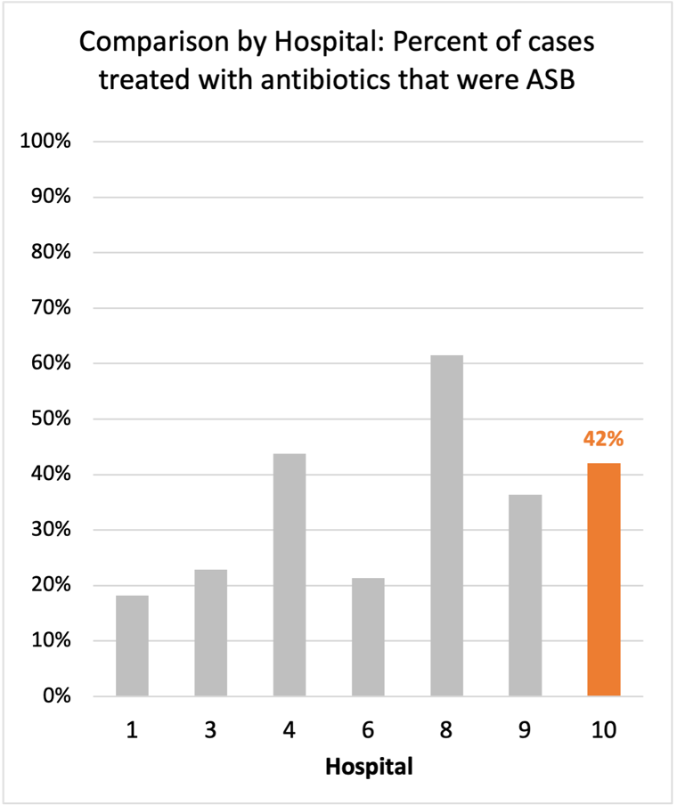
Inappropriate Diagnosis of UTI measure
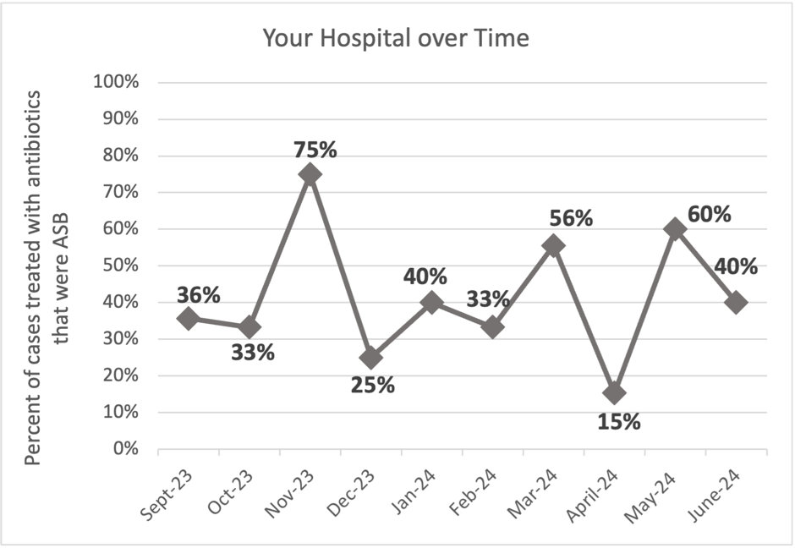
Average across hospitals in cohort: 35.6% ; HMS Hospital Average*: 23.2%
Inappropriate Diagnosis of UTI measure: $\frac{Number of patients treated for ASB}{Number of positive urine cultures treated (UTI+ASB)}$
- Goal: lower % = better
- You can lower this number by either reducing unnecessary urine cultures (diagnostic stewardship) or reducing antibiotic treatment when unnecessary cultures are obtained (antibiotic stewardship)
*The HMS hospital average was amongst 46 hospitals in the Michigan Hospital Medicine Safety Consortium that participated in a similar quality improvement study.

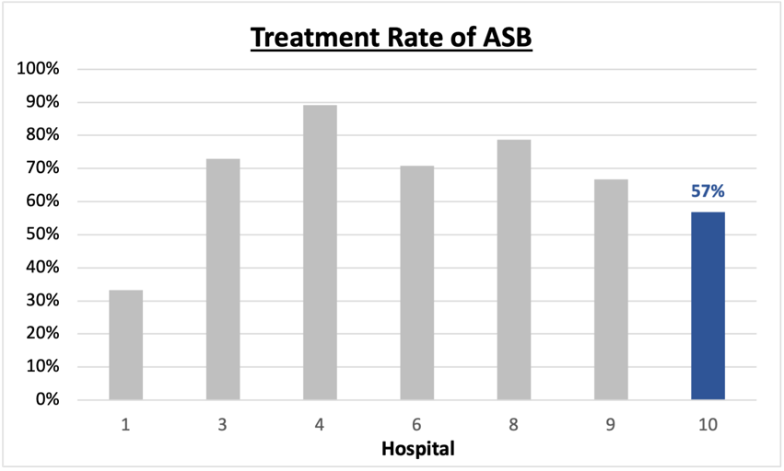
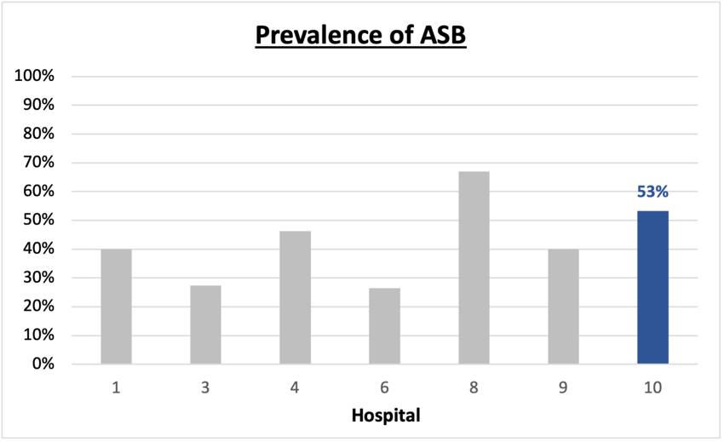
Prevalence and Treatment Rate of ASB

$$\frac{Number of ASB cases}{Number of positive urine cultures}$$
Prevalence of ASB:
$$\frac{Number of treated ASB cases}{Number of ASB cases}$$
Treatment Rate
of ASB:

Data submissions
Total cases (positive urine cultures) included for your site: 122
Cases included per month for your site (median & IQR): 12.5 (8-15.75)

Prevalence of ASB
Prevalence of ASB across hospitals: 356 of 868 (41.0%)
Prevalence of ASB at your site: 65 of 122 (53.3%)

Treatment Rate of ASB
Treatment rate of ASB in overall cohort: 266 of 356 (74.7%)
Treatment rate of ASB at your site: 37 of 65 (56.9%)
Previous treatment rate at your site (from ASB 101 cohort): 3 of 5 (60%)

Antibiotic Tables
Table 1: Three Most Common Antibiotics comparing UTI & ASB
IV |  | Oral
UTI, n = 13 | ASB, n = 16 | UTI, n = 56 | ASB, n = 35
Ceftriaxone (n=13) | Ceftriaxone (n=16) | Nitrofurantoin (n=16) | Cephalexin (n=8)
 |  | Cefdinir (n=13) | Nitrofurantoin (n=8)
 |  | Trim-sulfa (n=10) | Cefdinir (n=7)
Table 2: Antibiotic Duration (days) | UTI |  | ASB
Table 2: Antibiotic Duration (days) | Prior, n=54 | This Month, n=3 | Prior, n=57 | This Month, n=8
Total Antibiotic Duration; median (IQR) | 7 (5-10) | 7 (6-8.5) | 5 (0-7) | 0 (0-0.25)
Number of Cases Receiving >7 days; n (%) | 21 (38.9%) | 1 (33.3%) | 11 (19.3%) | 0

Prior is Sept 2023 - May 2024 & this month is June 2024
Table 3: Characteristics comparing this month to prior n (%) | UTI |  | ASB
Table 3: Characteristics comparing this month to prior n (%) | Prior, n=54 | This Month, n=3 | Prior, n=57 | This Month, n=8
Setting where culture obtained
ED, then admitted | 3 (5.6%) | 0 | 11 (19.3%) | 2 (25%)
ED, then discharged | 39 (72.2%) | 2 (66.6%) | 37 (64.9%) | 6 (75%)
Ambulatory care clinic | 10 (18.5%) | 1 (33.3%) | 0 | 0
Inpatient | 0 | 0 | 4 (7.0%) | 0
Other | 2 (3.7%) | 0 | 5 (8.8%) | 0
From reflex test | 43 (79.6%) | 2 (66.7%) | 55 (96.5%) | 8 (100%)
Men | 9 (16.7%) | 1 (33.3%) | 14 (24.6%) | 0
Age >75 | 10 (18.5%) | 1 (33.3%) | 21 (36.8%) | 2 (25%)
Acute altered mental status changes alone | 0 | 0 | 3 (5.3%) | 0
Characteristic Tables
Prior is Sept 2023 - May 2024 & this month is June 2024
Table 4: Prescribing Characteristics | UTI |  | ASB
Table 4: Prescribing Characteristics | Prior, n=54 | This Month, n=3 | Prior, n=57 | This Month, n=8
Top 3 Prescriber IDs (if available)
 | 8 (n=13) | 19 (n=1) | 8 (n=17) | 8 (n=4)
 | 11 (n=7) | 6 (n=1) | 18 (n=7) | 9 (n=2)
 | 17 (n=6) | 8 (n=1) | 19 (n=5) | 10 (n=1)
Prescriber type, n (%)
Physician | 35 (64.8%) | 2 (66.7%) | 43 (75.4%) | 7 (87.5%)
Physician Assistant | 8 (14.8%) | 1 (33.3%) | 9 (15.8%) | 1 (12.5%)
Nurse Practitioner | 11 (20.4%) | 0 | 5 (8.8%) | 0
Contract of prescribing provider, n (%) (if available)
Employed by hospital | 13 (24.1%) | 1 (33.3%) | 4 (7.0%) | 0
Contracted from outside group/locum | 41 (75.9%) | 2 (66.7%) | 52 (91.2%) | 8 (100%)
Not sure | 0 | 0 | 1 (1.8%) | 0

Prior is Sept 2023 - May 2024 & this month is June 2024
Case IDs for the treated ASB cases
"10153721" "10156718" "10157744" "10157552" "10158200" "10159986" "10160230" "10161088" "10161015" "10161438"
"10161754" "10163012" "10163238" "10157499" "10157518" "10156944" "10155396" "10163769" "10155064" "10154429"
"10154373" "10154174" "10163554" "10163549" "10165018" "10165315" "10166083" "1016604" "10166490" "10166693"
"10166726" "10166867" "10166858" "10166681" "10167048" "10167736""10167993"

Key Terms and Definitions
- Positive urine culture: Any growth on culture
  - Prevalence of ASB: A positive urine culture without any documented signs or symptoms attributable to urinary tract infection per National Hospital Safety Network (NHSN) and Infectious Diseases Society of America (IDSA) Guidelines.
- Signs or symptoms of UTI includes:
- Fever (>38°C)
- Suprapubic tenderness
- Costovertebral angle pain or tenderness
- Urinary urgency
- Urinary frequency
- Dysuria
- Altered Mental Status + 2 or more SIRS criteria
- Treatment rate of ASB: antibiotic treatment for ASB

Action items/Insight:
Based on the Inappropriate Diagnosis of UTI Measure, your hospital is a performing worse than average in terms of percentage of UTI cases that were actually ASB. Additional comments:
Positives to Highlight:
- Treatment rate of ASB at your site (57%) is below the cohort average (75%).
- Met case submission requirement: Great job submitting cases! Celebrate this success!
- High nitrofurantoin and cephalosporin use: Less harmful/more narrow therapy use is high at your site! Great job! No fluoroquinolone use on the report is awesome (and very unheard of in this cohort).
- Treatment duration in ASB is lower than UTI: If convincing clinicians to stop prescribing antibiotics for ASB is a challenge at your hospital, it might be easier to convince them to prescribe short durations (eg. 3 days). This trend suggests clinicians at your site are starting to distinguish ASB versus UTI. As a result, they are recognizing when antibiotics are unnecessary and shortening treatment durations.
Areas of Improvement:
- Performing worse than average in the inappropriate diagnosis of UTI measure: Your site has decreased from 44% last report to 42% this report - this is a positive trend. However, this percentage is still higher than the rest of the cohort.
- Prevalence rate of ASB is 57%: Although this trend has improved, this suggests that more than half of the urine studies being obtained at your site may be unnecessary (collected in asymptomatic patients).

