White Mountain IQIC 201 Asymptomatic Bacteriuria (ASB) Report
Date of Report: January 2024*
*This data report is based on cases submitted from September 2023 to December 2023 and does not include previous data.
Inappropriate Diagnosis of UTI measure
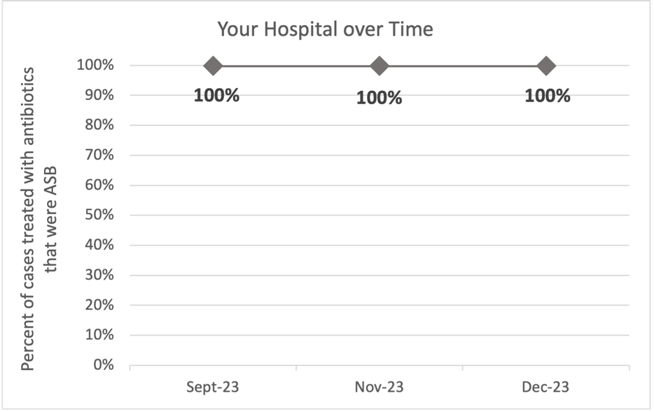
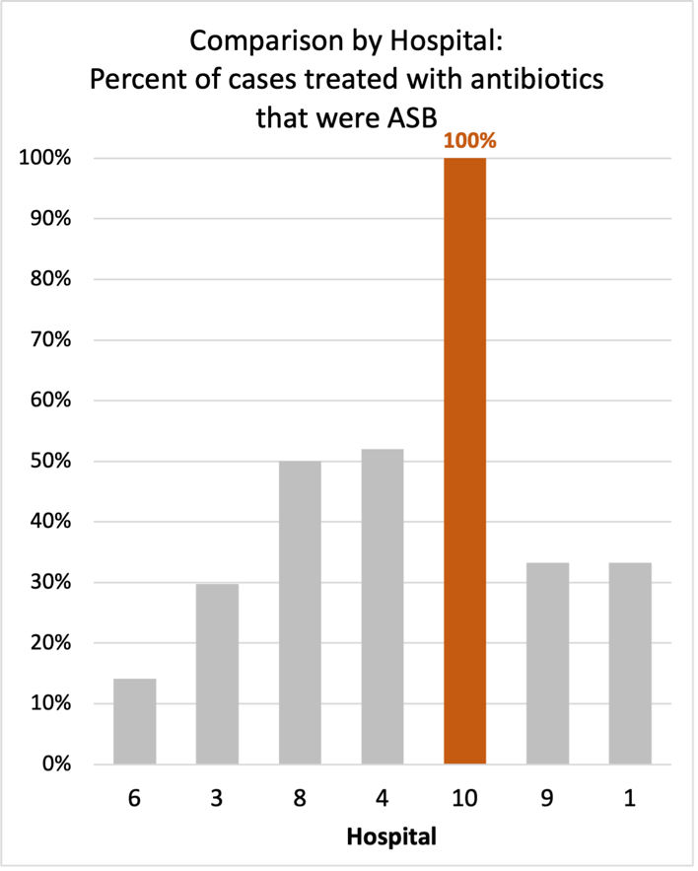
Average across hospitals in cohort: 34.8%; HMS Hospital Average*: 23.2%
Inappropriate Diagnosis of UTI measure: $\frac{Number of patients treated for ASB}{Number of positive urine cultures treated (UTI+ASB)}$
- Goal: lower % = better
- You can lower this number by either reducing unnecessary urine cultures (diagnostic stewardship) or reducing antibiotic treatment when unnecessary cultures are obtained (antibiotic stewardship)
*The HMS hospital average was amongst 46 hospitals in the Michigan Hospital Medicine Safety Consortium that participated in a similar quality improvement study.

Prevalence and Treatment Rate of ASB
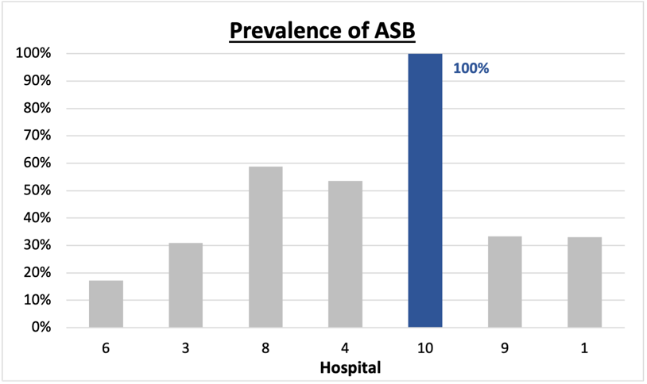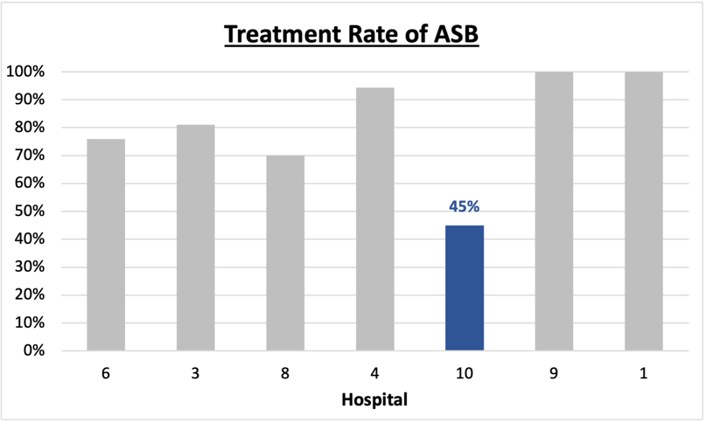
$$\frac{Number of treated ASB cases}{Number of ASB cases}$$
Prevalence of ASB:
$$\frac{Number of ASB cases}{Number of positive urine cultures}$$
Treatment Rate
of ASB:

Data submissions
Total cases (positive urine cultures) included for your site: 11
Cases included per month for your site (median & IQR): 2.5 (1.75-3.5)

Prevalence of ASB
Prevalence of ASB across hospitals: 121 (37.9%)
Prevalence of ASB at your site: 11 of 11 (100%)

Treatment of ASB
Treatment rate of ASB in overall cohort: 101 (83.5%)
Treatment rate of ASB at your site: 5 of 11 (45.5%)
Previous treatment rate at your site (from ASB 101 cohort): 3 of 5 (60%)

Antibiotic Tables
Table 1: Three Most Common Antibiotics comparing UTI & ASB
IV |  | Oral
UTI, n=0 | ASB, n = 2 | UTI, n=0 | ASB, n = 4
 | Ceftriaxone (n=2) |  | Cefdinir (n=2)
 | NA |  | Cephalexin (n=2)
 | NA |  | NA
Table 2: Antibiotic Duration (days) | UTI |  | ASB
Table 2: Antibiotic Duration (days) | Prior, n=0 | This Month, n=0 | Prior, n=9 | This Month, n=2
Total Antibiotic Duration; median (IQR) |  |  | 3 (0-5) | 5 (5-5)
Number of Cases Receiving >7 days; n (%) |  |  | 0 | 0
No UTI cases were submitted

Prior is Sept - Nov 2023 & this month is Dec 2023
Characteristic Tables
Table 3: Characteristics comparing this month to prior n (%) | UTI |  | ASB
Table 3: Characteristics comparing this month to prior n (%) | Prior, n=0 | This Month, n=0 | Prior, n=9 | This Month, n=2
Setting where culture obtained
ED, then admitted |  |  | 1 (11.1%) | 0
ED, then discharged |  |  | 5 (55.6%) | 2 (100%)
Ambulatory care clinic |  |  | 0 | 0
Inpatient |  |  | 1 (11.1%) | 0
Other |  |  | 2 (22.2%) | 0
From reflex test |  |  | 8 (88.9%) | 2 (100%)
Men |  |  | 1 (11.1%) | 0
Age >75 |  |  | 3 (33.3%) | 0
Acute altered mental status changes alone |  |  | 0 | 0
No UTI cases were submitted
Prior is Sept - Nov 2023 & this month is Dec 2023
Table 4: Prescribing Characteristics | UTI,  n=0 | ASB,  n=11
Top 3 Prescriber IDs (if available)
 |  | 18 (n=2)
 |  | 19 (n=2)
 |  | 2 (n=2)
Prescriber type, n (%)
Physician |  | 6 (54.5%)
Physician Assistant |  | 4 (36.4%)
Nurse Practitioner |  | 1 (9.1%)
Contract of prescribing provider, n (%) (if available)
Employed by hospital |  | 1 (9.1%)
Contracted from outside group/locum |  | 10 (90.9%)
Not sure |  | 0

No UTI cases were submitted

Case IDs for the treated ASB cases
"10153721" "10156718" "10157744" "10157552" "10158200"

Key Terms and Definitions
- Positive urine culture: Any growth on culture
  - Prevalence of ASB: A positive urine culture without any documented signs or symptoms attributable to urinary tract infection per National Hospital Safety Network (NHSN) and Infectious Diseases Society of America (IDSA) Guidelines.
- Signs or symptoms of UTI includes:
- Fever (>38°C)
- Suprapubic tenderness
- Costovertebral angle pain or tenderness
- Urinary urgency
- Urinary frequency
- Dysuria
- Altered Mental Status + 2 or more SIRS criteria
- Treatment rate of ASB: antibiotic treatment for ASB

Action items/Insight:
Based on the Inappropriate Diagnosis of UTI Measure, your hospital is a performing worse than average in terms of percentage of UTI cases that were actually ASB. Keep working on collecting cases as low numbers may make your data inaccurate. Additional comments:
- If convincing clinicians to stop prescribing antibiotics for ASB is a challenge at your hospital, it might be easier to convince them to prescribe short durations (eg. 3 days) or less harmful/more narrow therapy (eg. Nitrofurantoin) for patients without symptoms. This might be a compromise or intermediate step to get clinicians comfortable with less antibiotics for these patients.
- All of your cases that were included were for patients that had asymptomatic bacteriuria. If this is the case, would recommend educating clinicians on the appropriateness of sending urine cultures.
- Fluoroquinolone use appears to be low at your site! Celebrate this success!

