Lincoln Hospital District #3 and NBMC Antibiogram: 2018*-2020 Data
(2018 only contains 6 mos of data due to lab remodel)

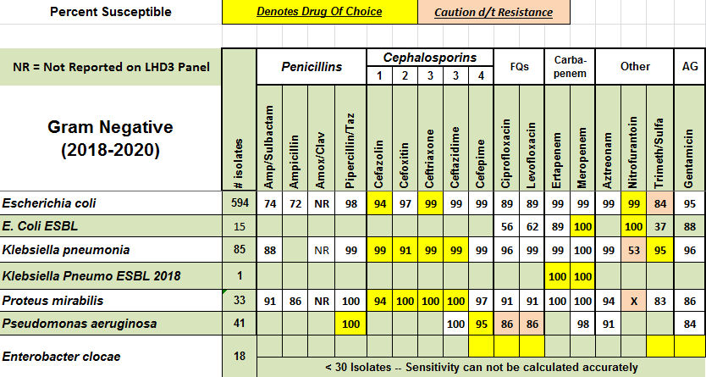
LHD3 MDRO Patterns | 2020 | 2019 | 2018* | 2017 | 2016 | 2015
MRSA% | 34% | 41% | 37.5% | 37% | 33% | 47%
ESBL (TOTAL) | 6 | 7 | 4 | 11 | 11 | 6
VRE (TOTAL) | 0/25 | 1/35 | 0/17 | 2/34 | 2/30 | 0/35
CRE (TOTAL) | 0 | 0 | 0 | 0 | 0 | 0

