CDC/ IDSA COVID-19 Clinician Call June 27, 2020

New guideline recommendation on COVID-19 treatment

-COVID-19 Spectrum
About 80% mild-mod illness. Some may have abnormal imaging, even in asymptomatic or mild patients who are oxygenating fine might have abnormal imaging.
***Pre-symptomatic patients likely drive the spread (time when lots of viral replication takes place), possibly not asymptomatic driving spread as much but questionaiooible- WHO person misspoke and the media ran away w it. (Why everyone should wear a face covering to reduce transmission- data coming in to prove this, lots of misinformation about masks-does not increase CO2 or viral replication- that is false/ fake “science”, etc)
15% Severe illness
5% Critical illness
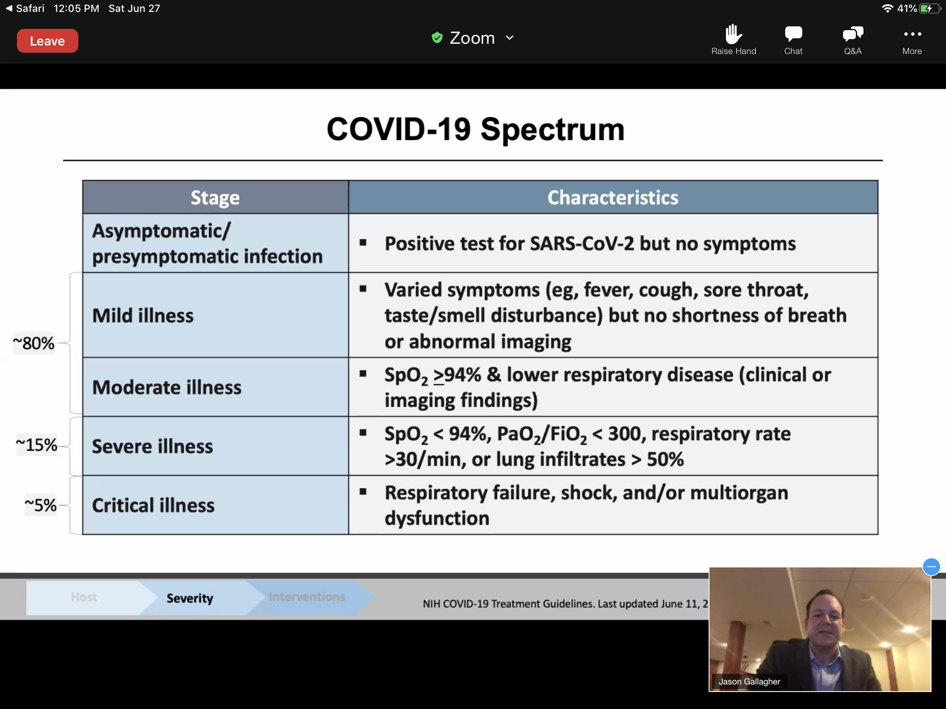

Before exposure: Pre exposure ppx being looked at
Incubation period: Post exposure ppx. Being looked at.
During illness: Treat disease to prevent progression/ complications/ death. Early treatment may prevent transmission: go from viral replication to inflammation.
Potential Intervention: Antivirals, immune modulators.
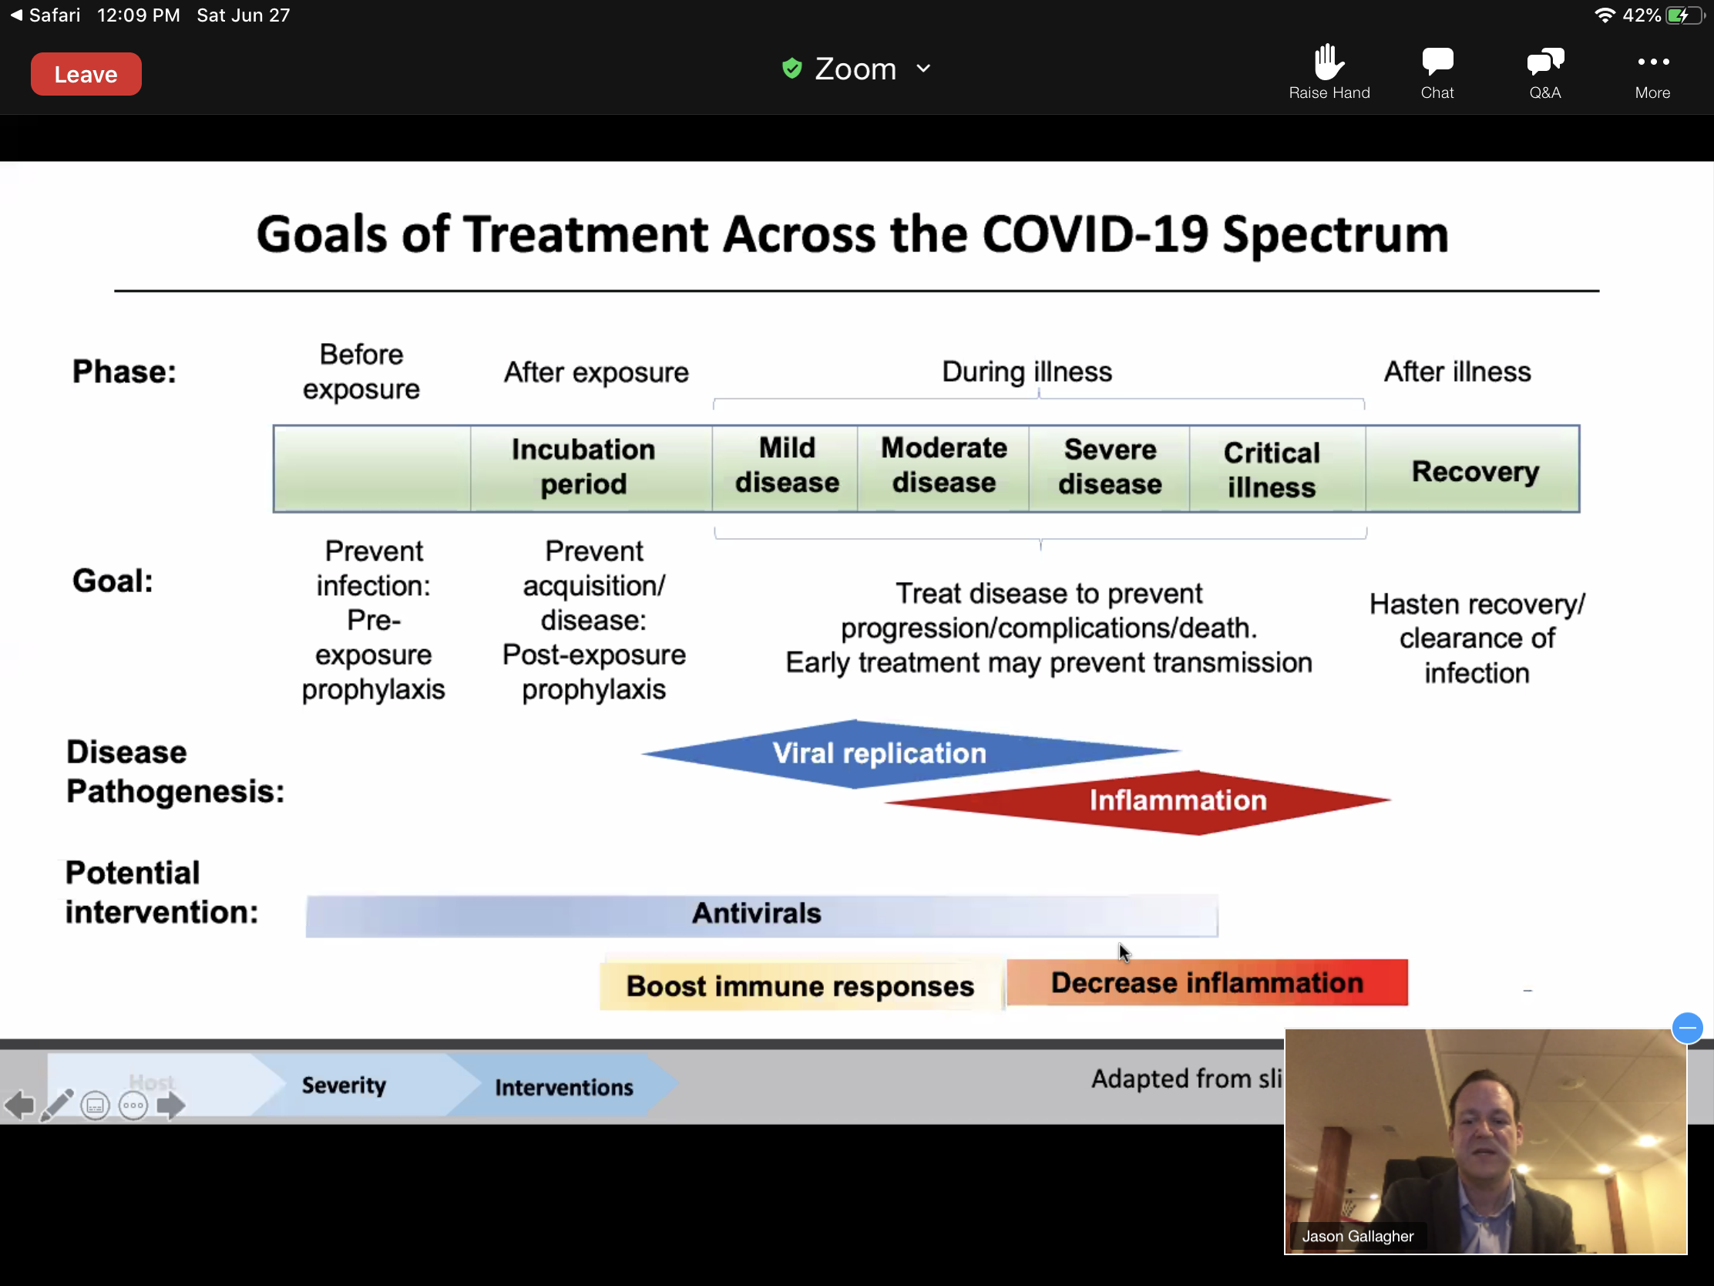

Remdesivir:
-No recommendation for mild or moderate COVID-19.
Median recovery times Remdesivir 11 days vs 15 days placebo
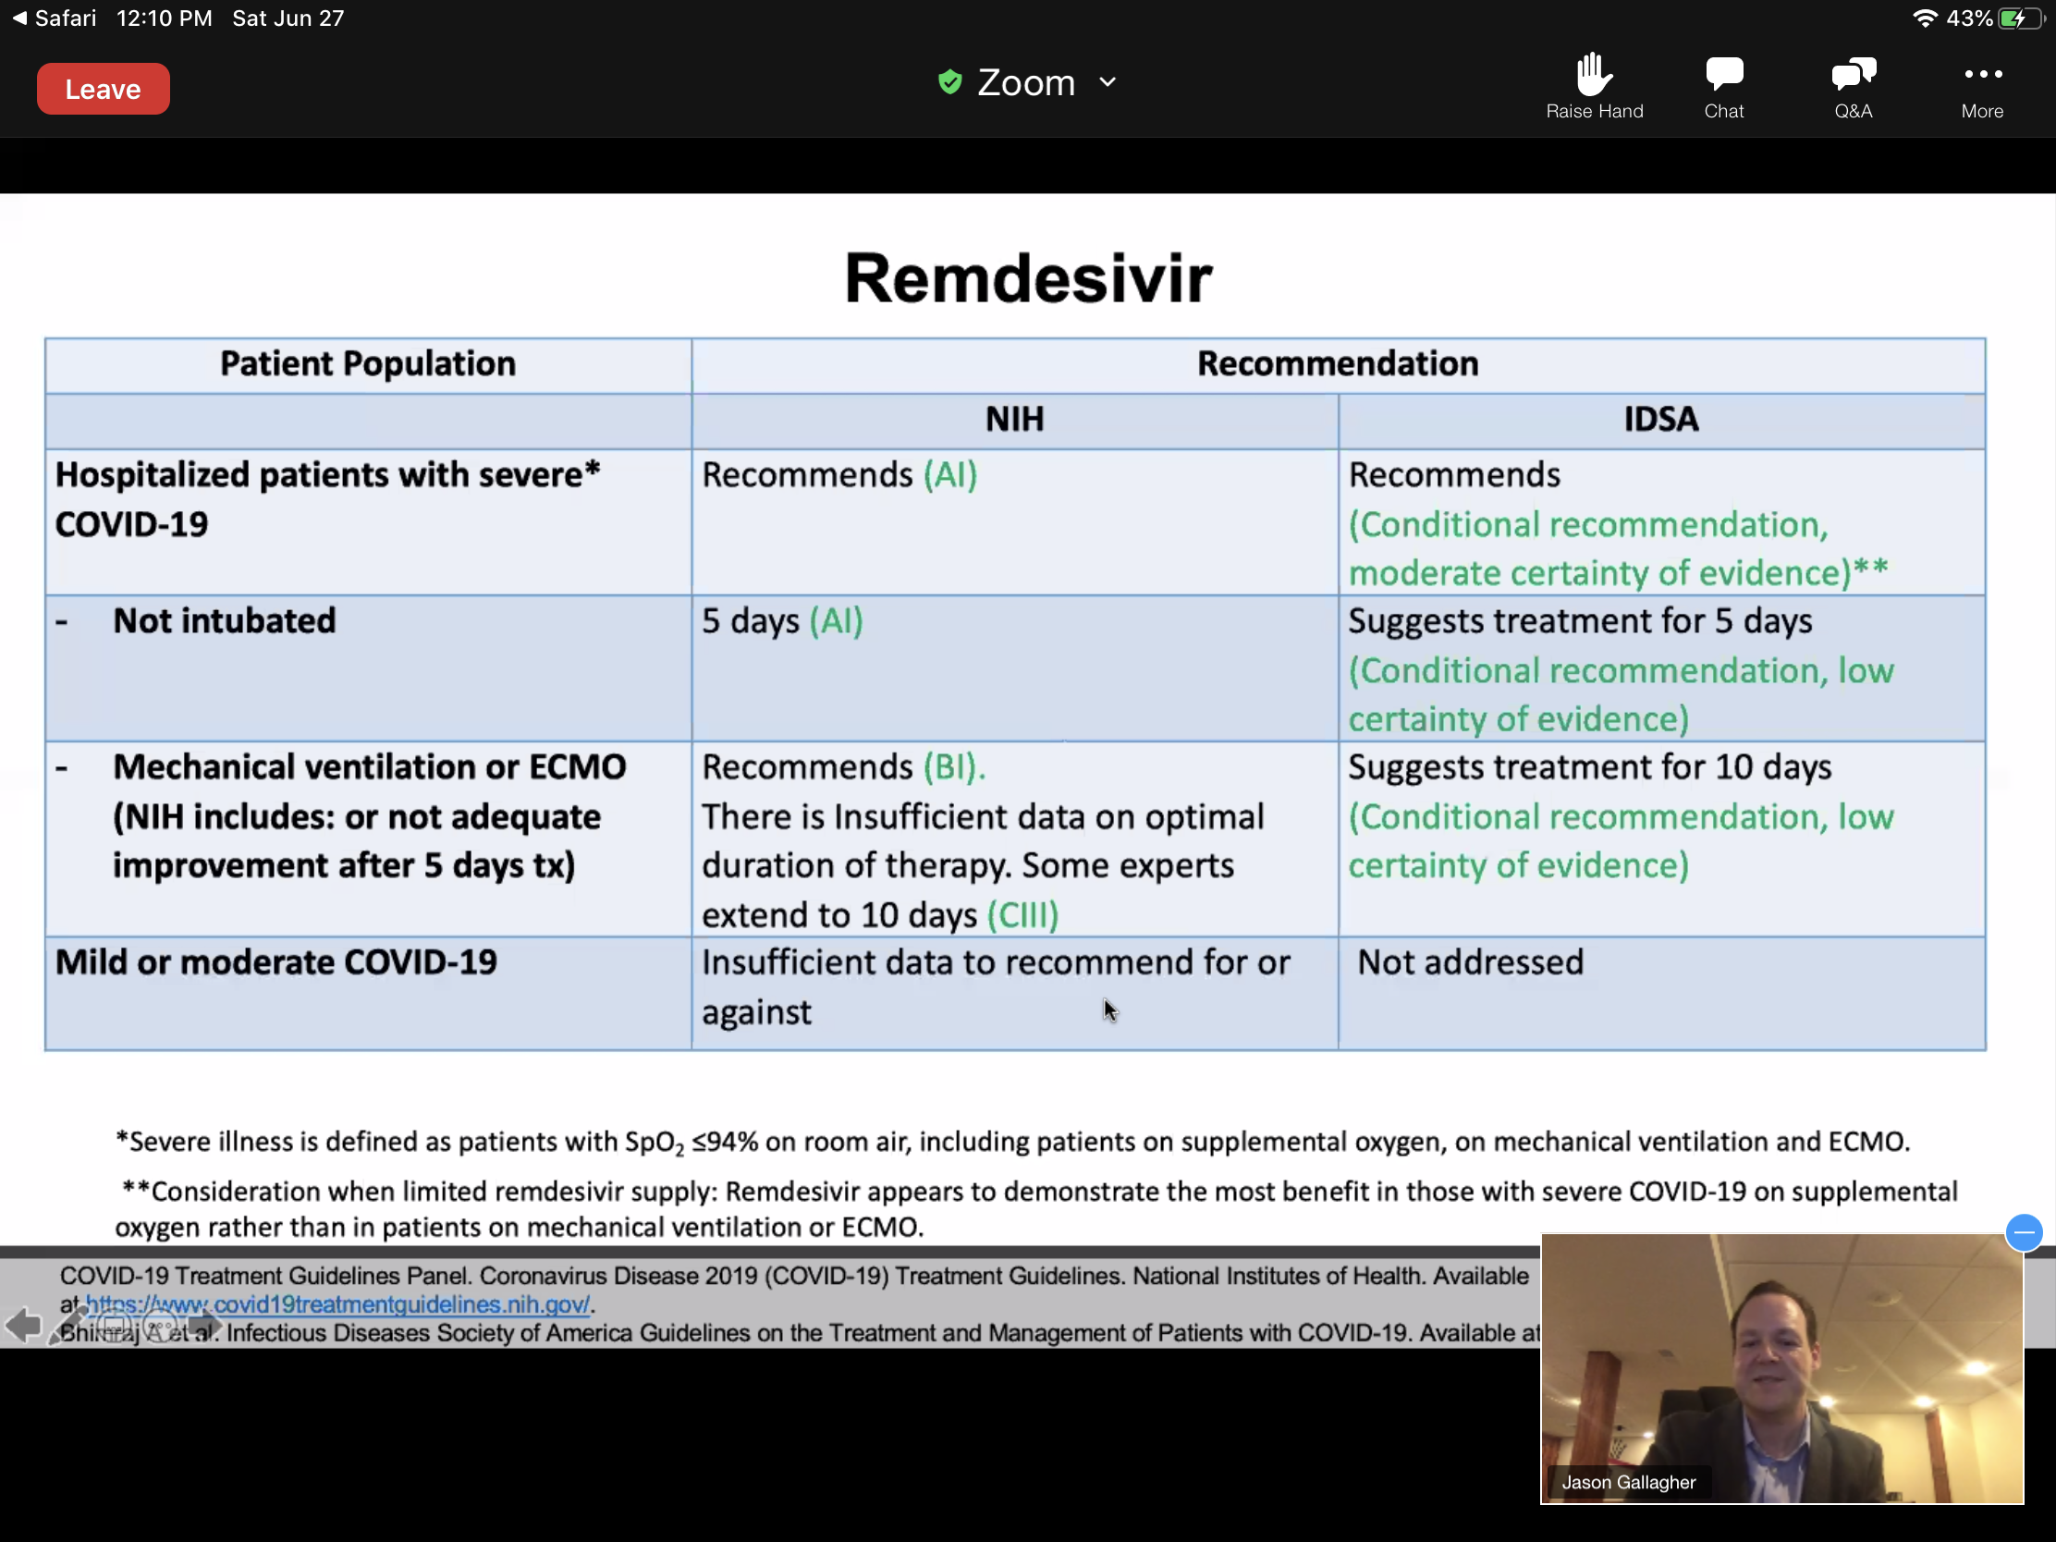

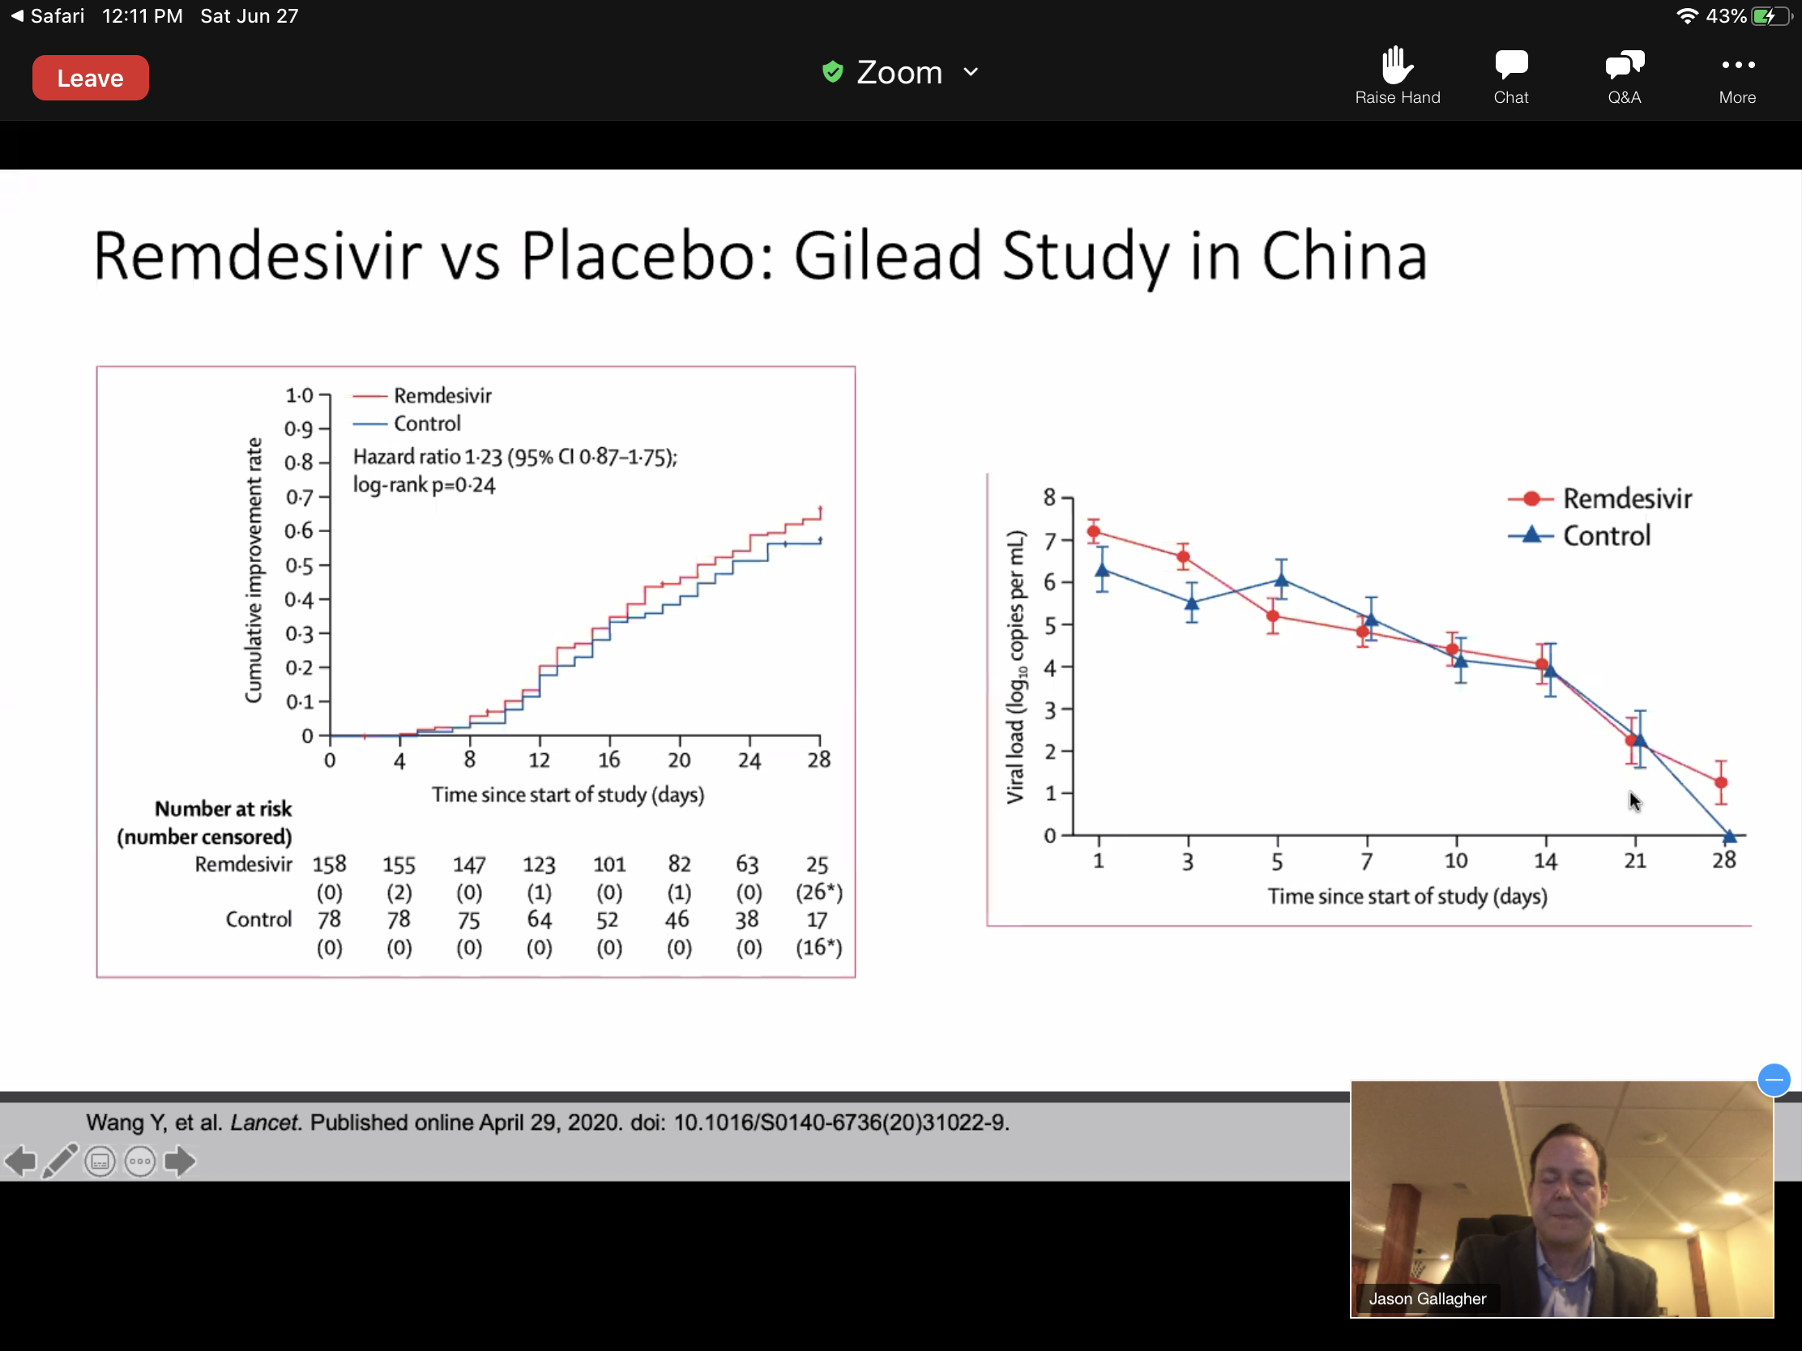
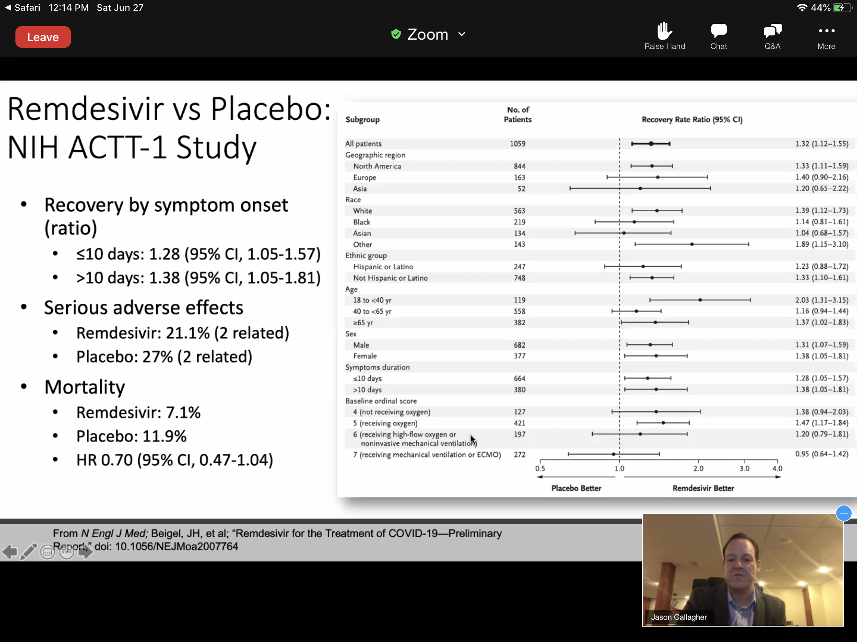
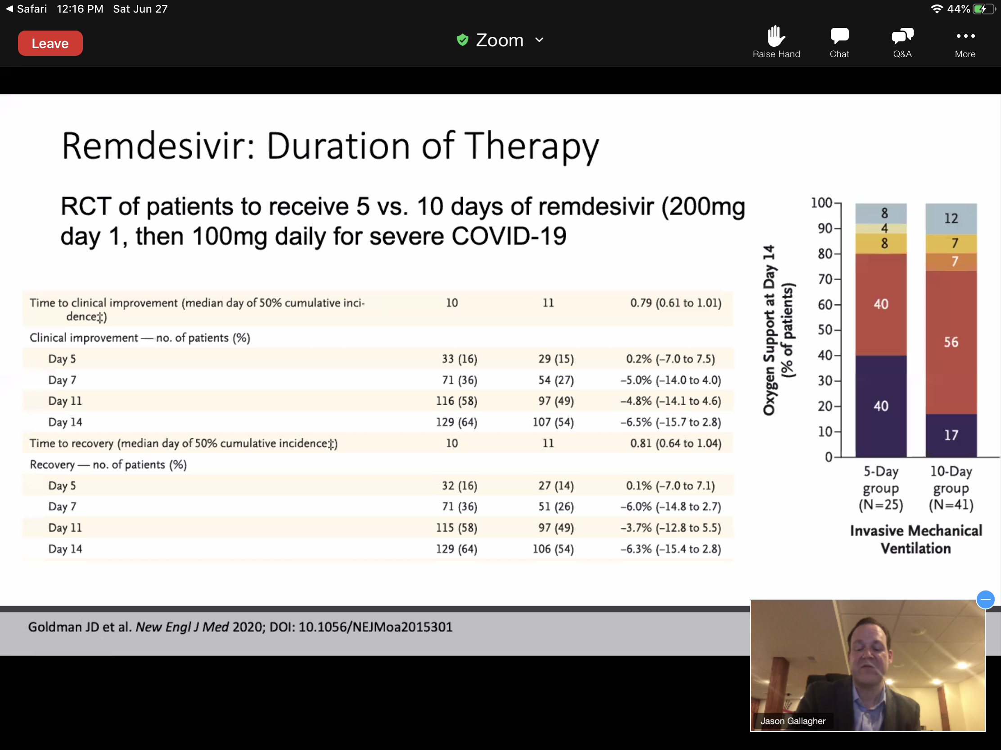

Remdesivir: Implications for Practice
-Shortens time to clinical improvement in patients requiring O2 therapy.
-Possibly no utility in patients requiring HFNC, mechanical ventilator, or ECMO.
-5 Day courses of therapy for most patients.
-Effects on mortality still unknown.
-Shortages are likely.
-Included in the next phase of ACTT trial.

Corticosteroids
-Mech ventilated/ or supplemental O2: Dexamethasone is recommended at 6 mg daily for up to 10 days
-No supplemental O2: Recommends no dexamethasone.
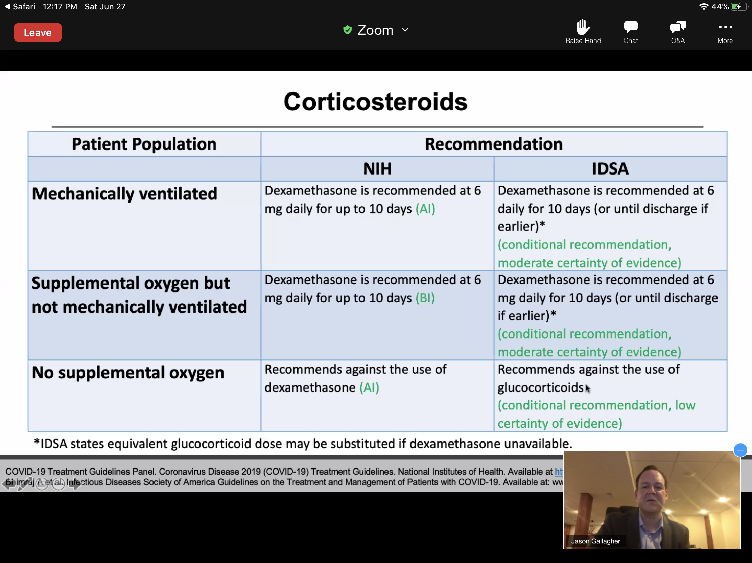
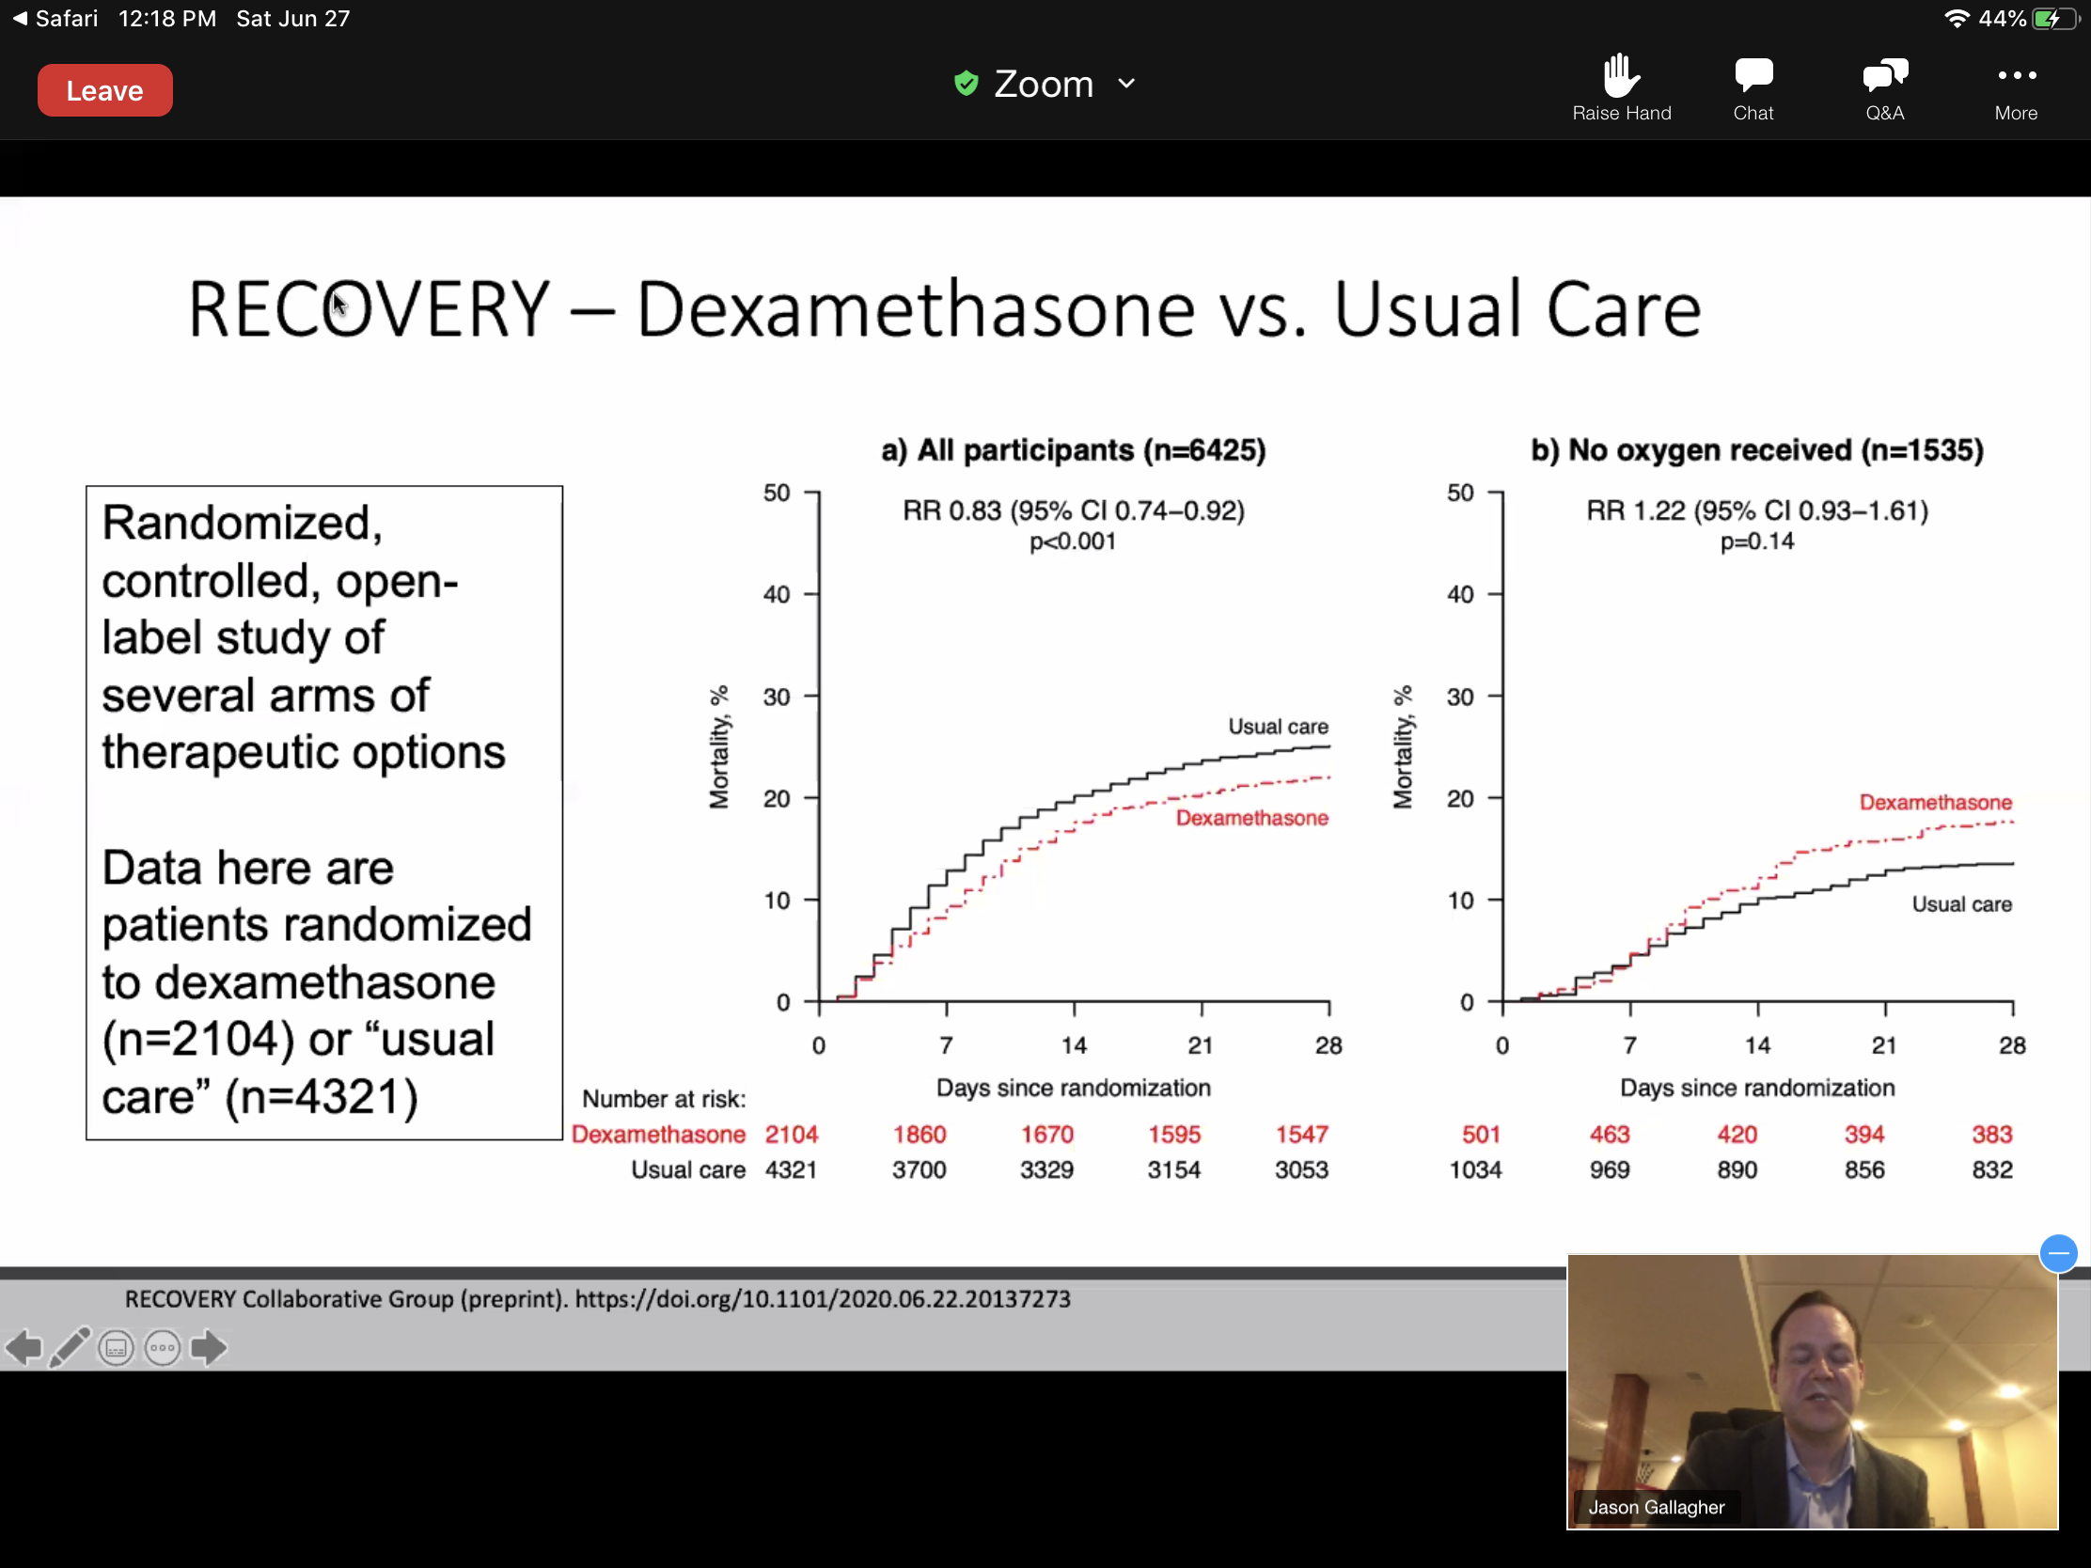

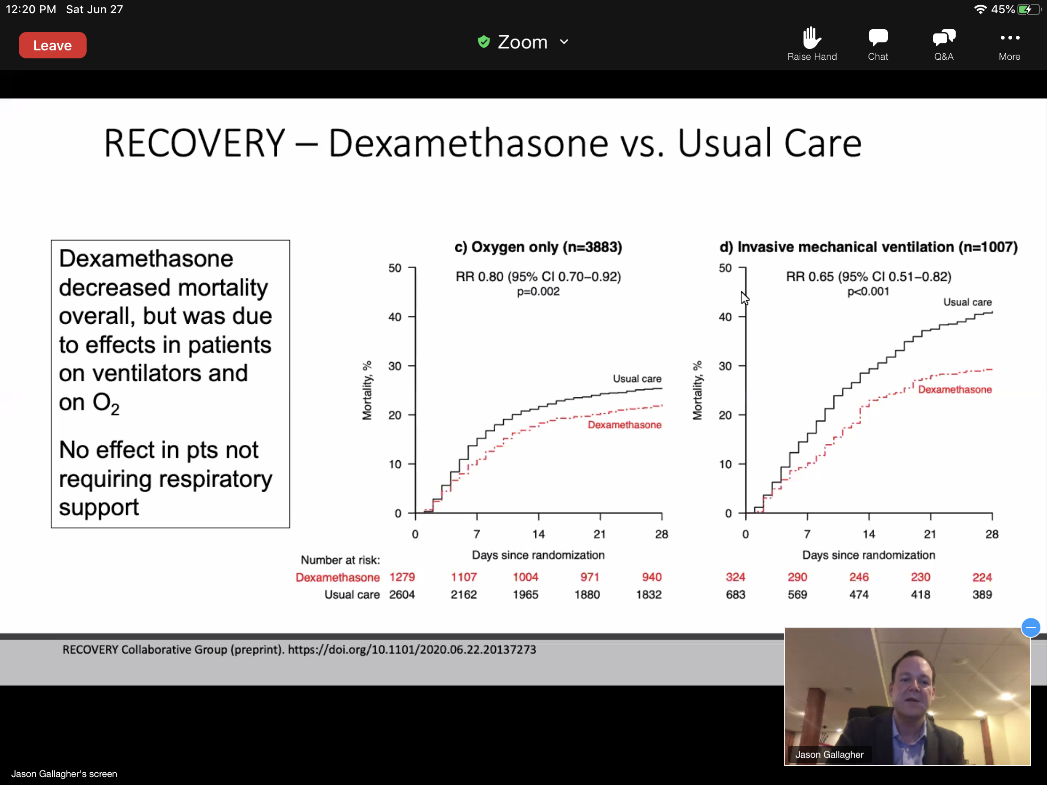

Dexamethasone: Implications for Practice
-First recommended therapy thus far w a mortality benefit.
-Benefits shown only w severe COVID-19 w a trend towards harm in patients not requiring O2
-NOT an outpatient therapy!!!!
-Substitution not preferred, but shortages may necessitate.
-Duration of therapy, 10 days or less.

Famotidine: IDSA Recommendation- Not recommended outside of a clinical trial. Is a randomized trial that is underway.
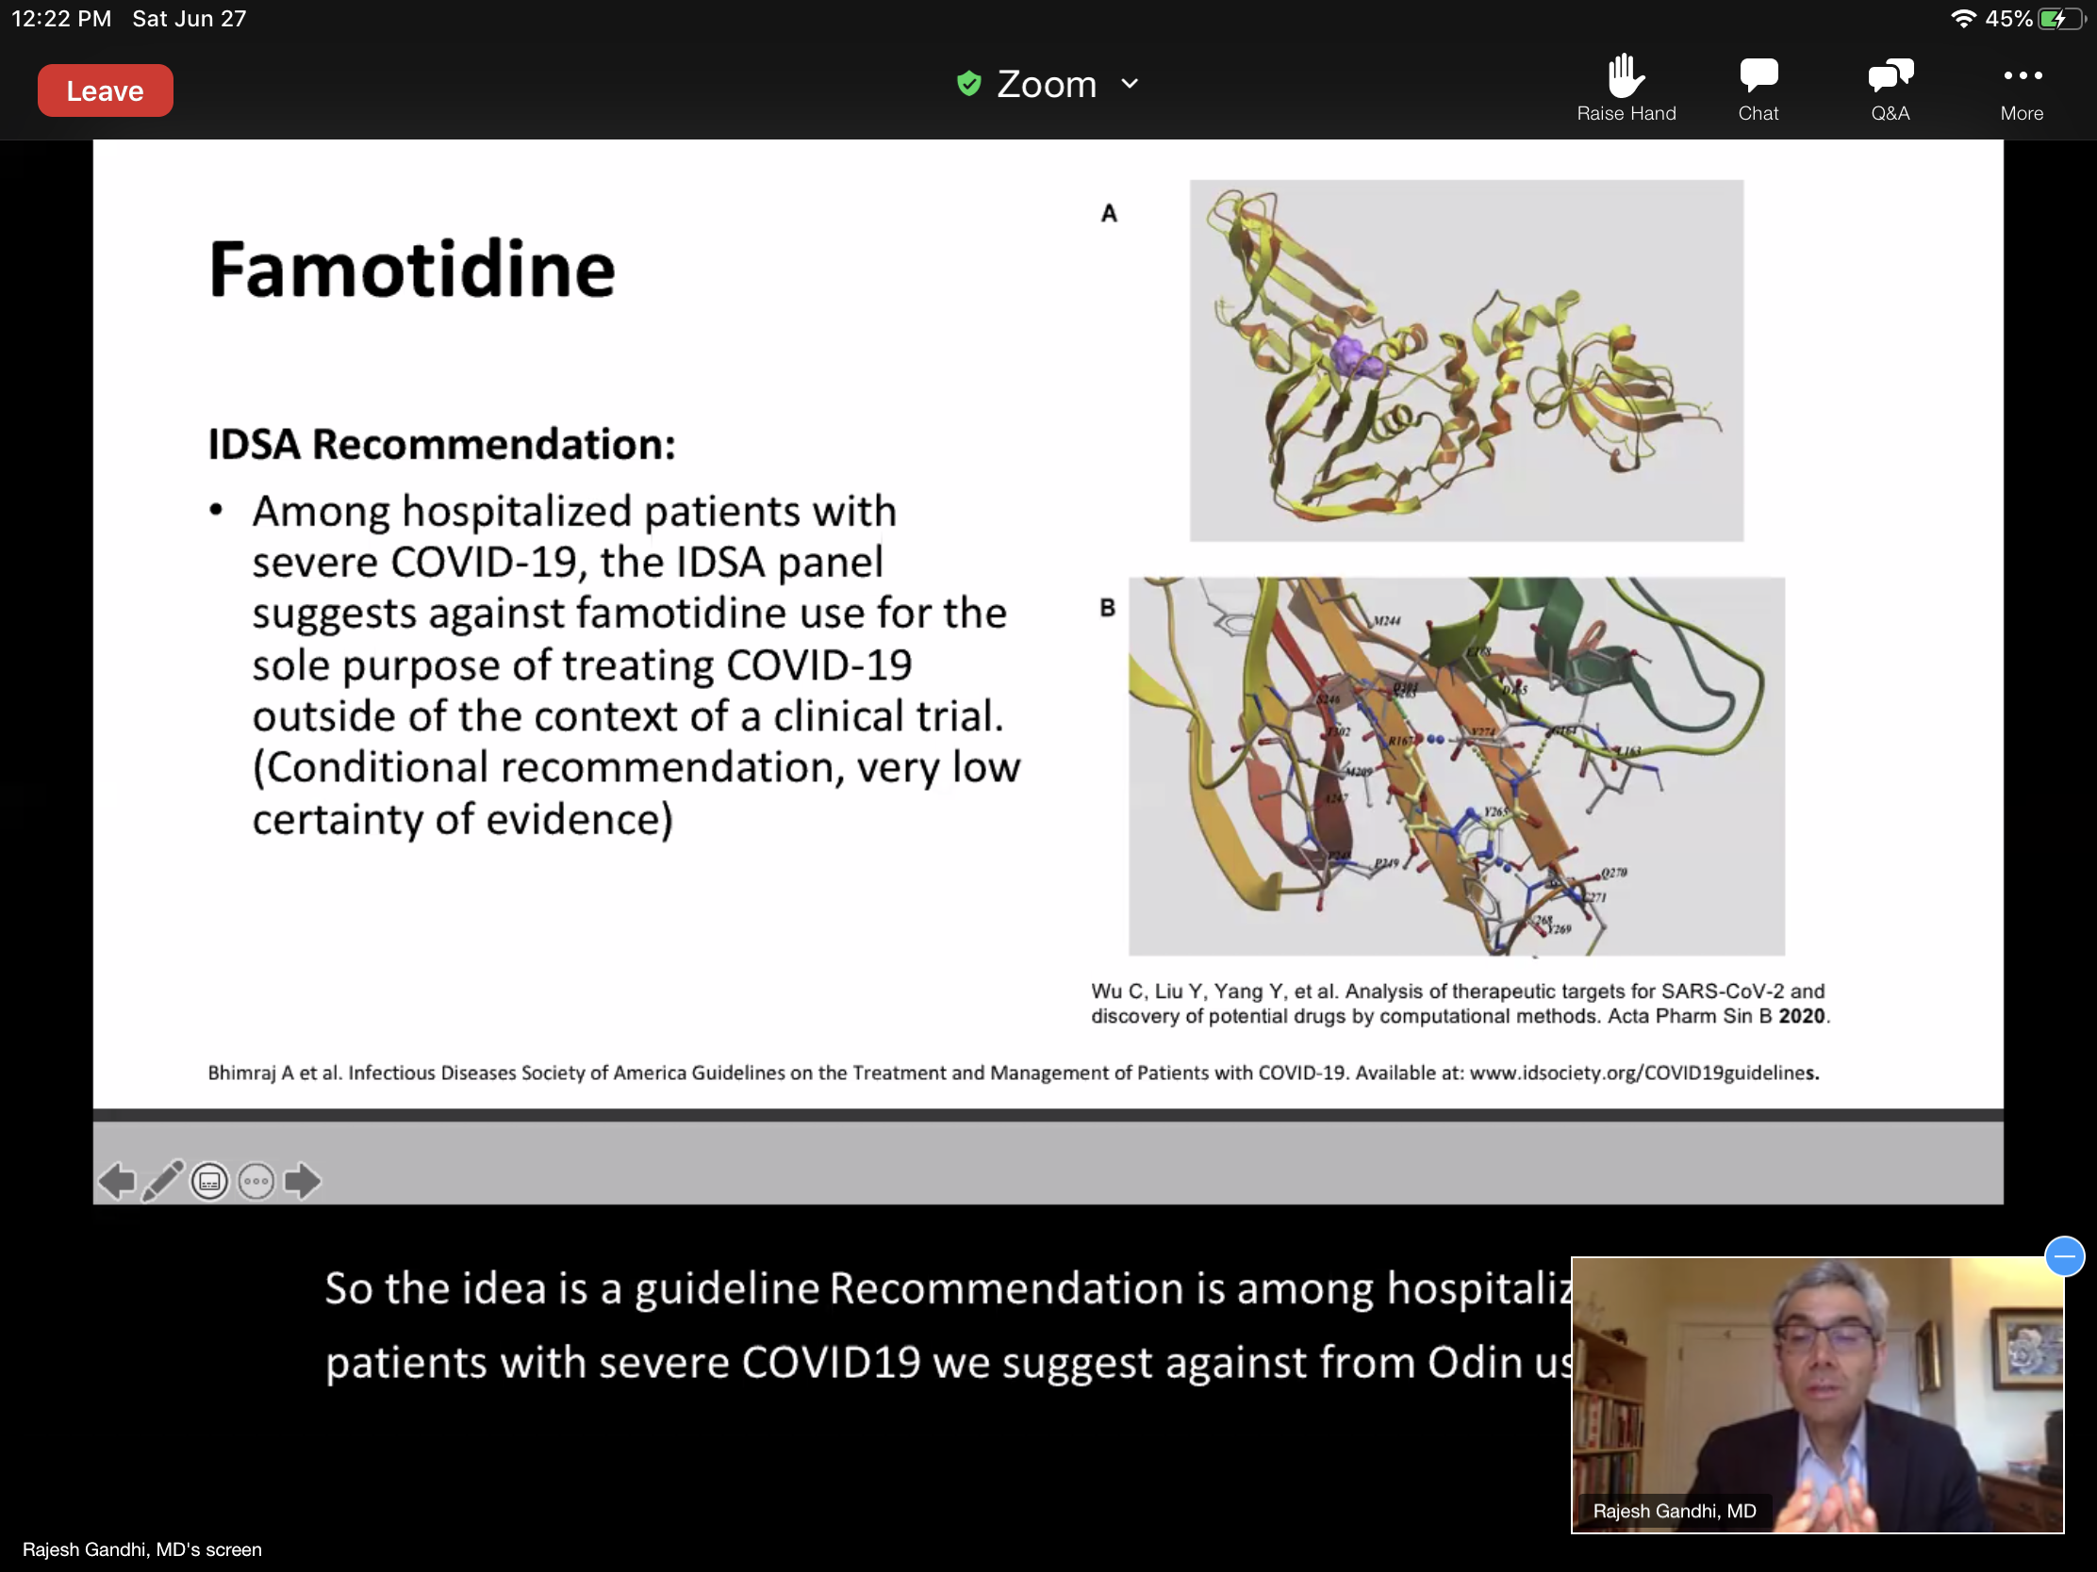
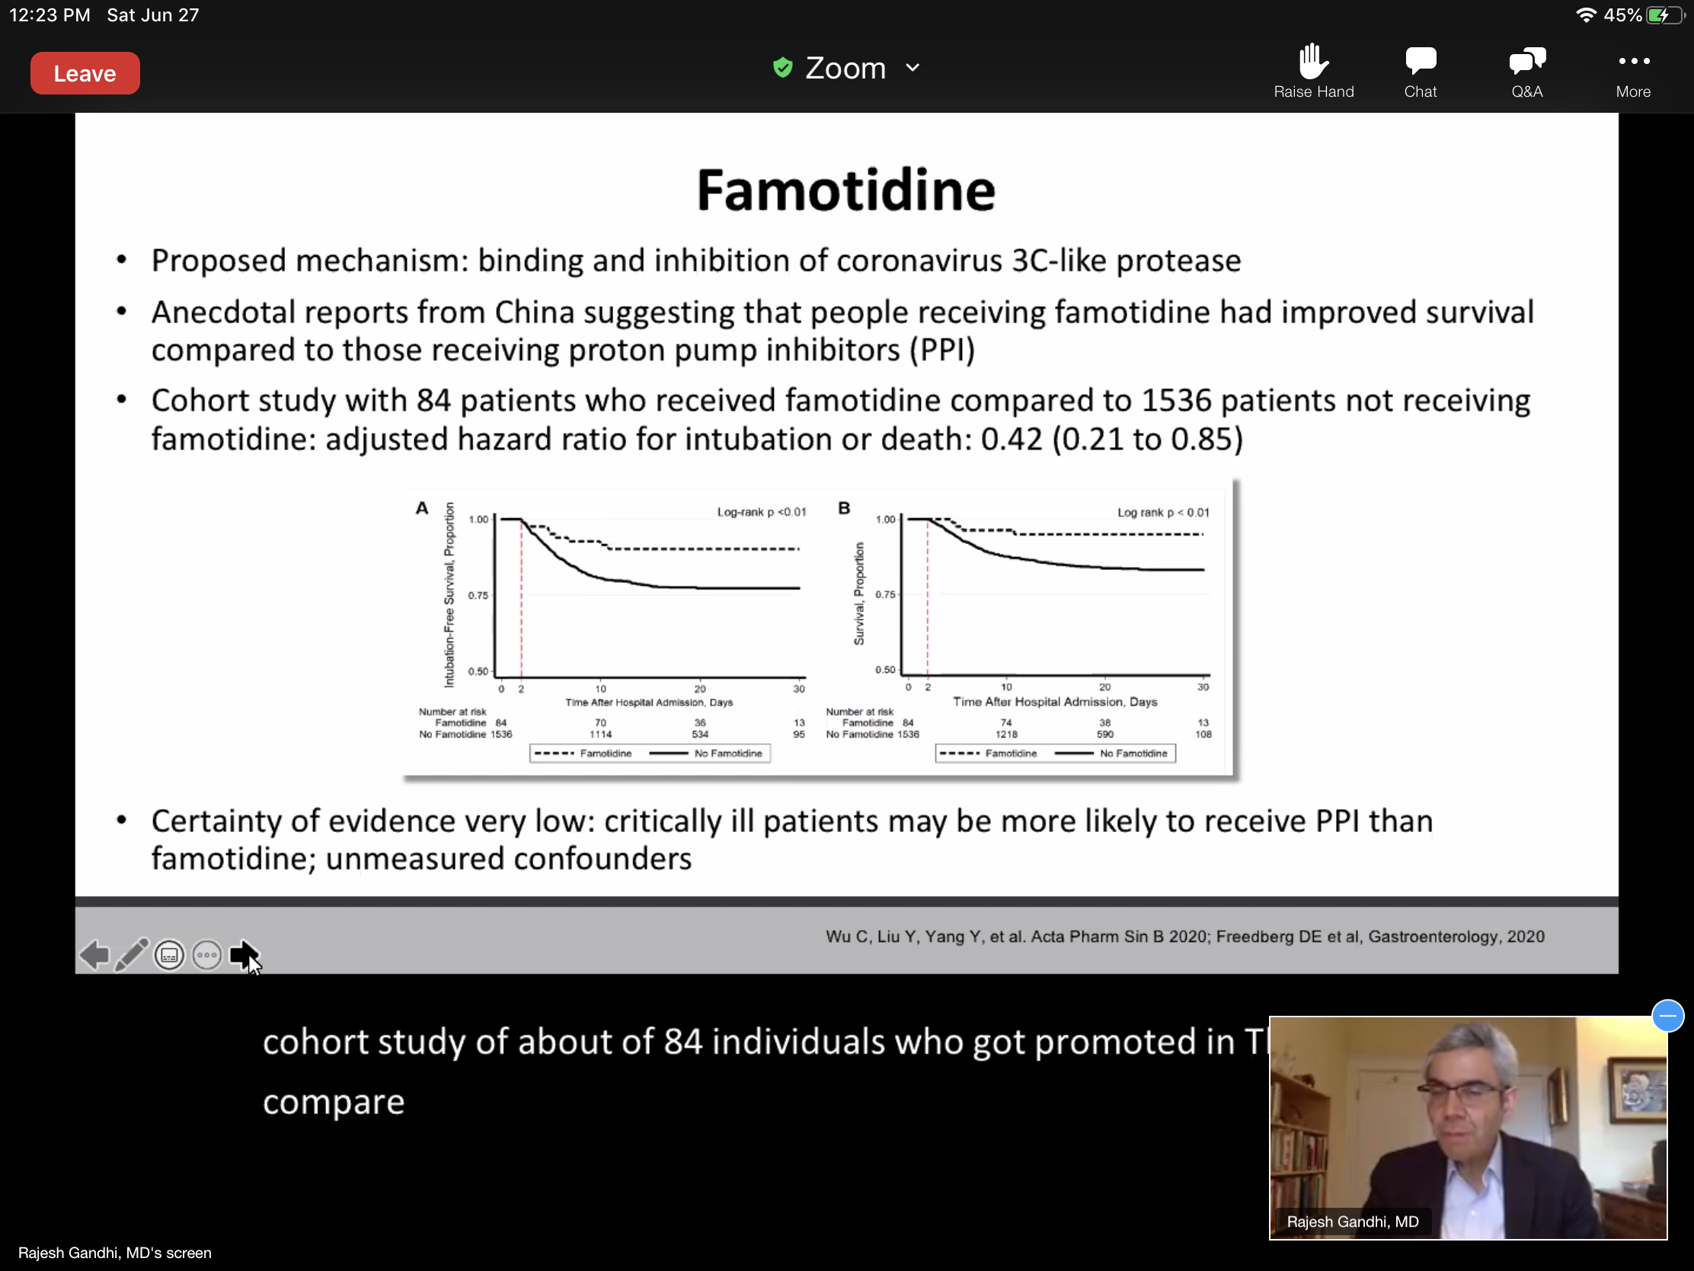

Famotidine: Implications for Practice
-Famotidine should not be used to treat or prevent COVID-19 outside of a clinical trial (randomized trial underway).
-If there is a clinical indication for famotidine, the medication should be given for that indication.
Hydroxychloroquine: Only be used in context of clinical trial
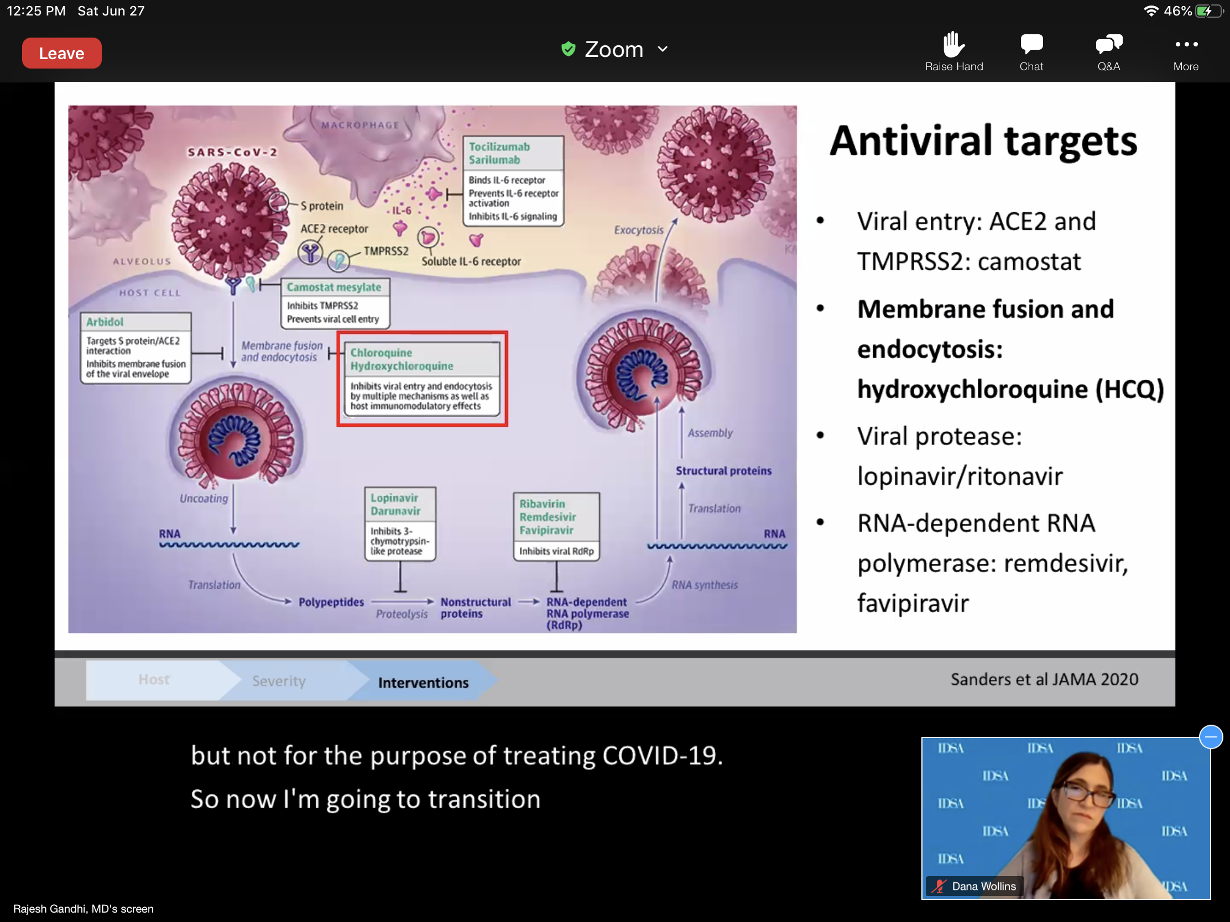
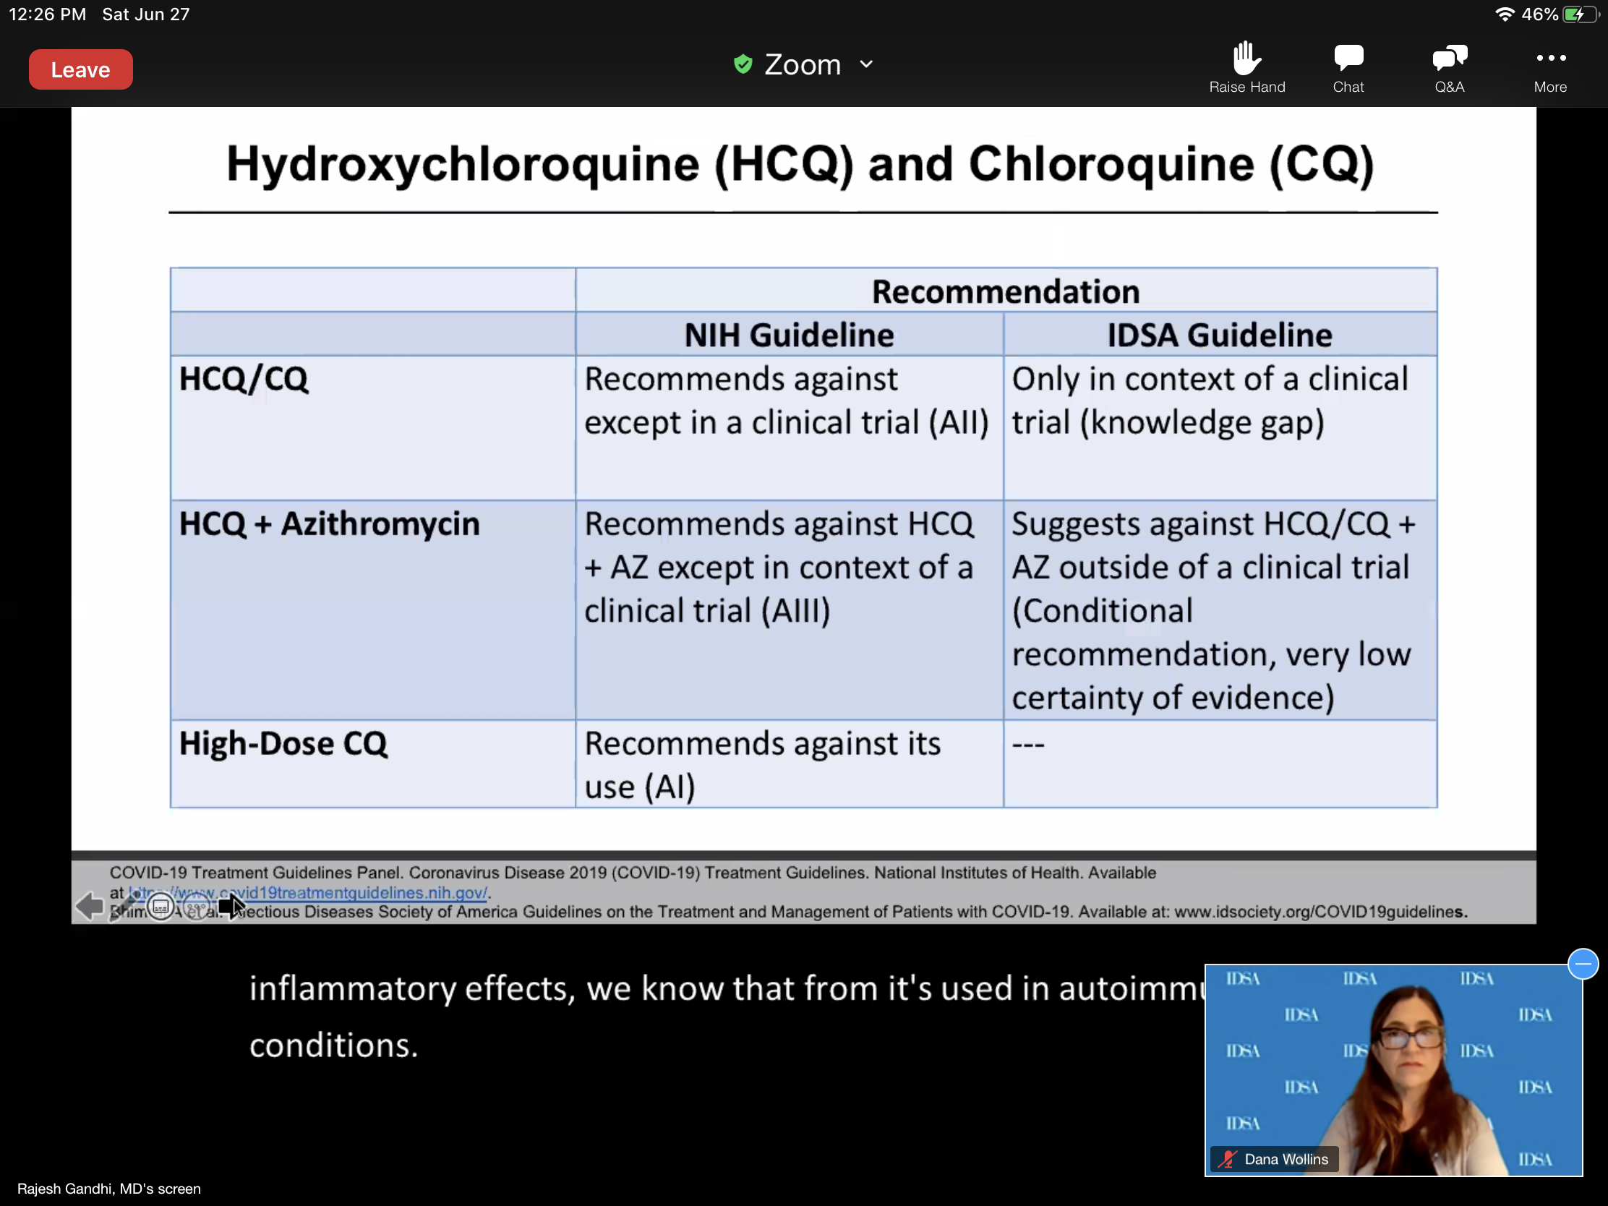
Not recommended AZ and HCQ unless in a clinical trial-low recommendation, very low certainty of evidence.
CQ high dose- NIH recommends against its use.
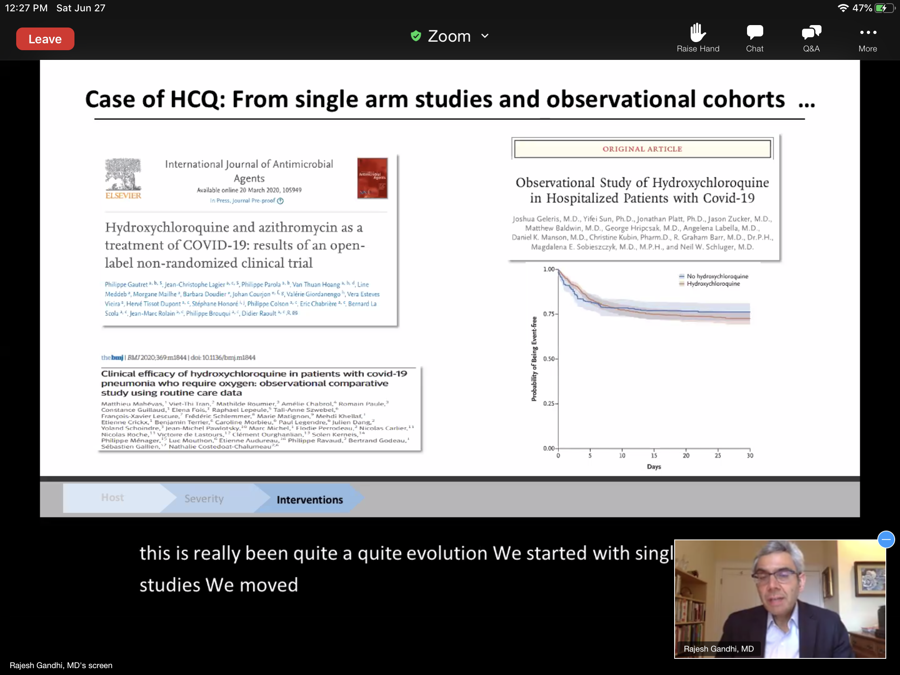
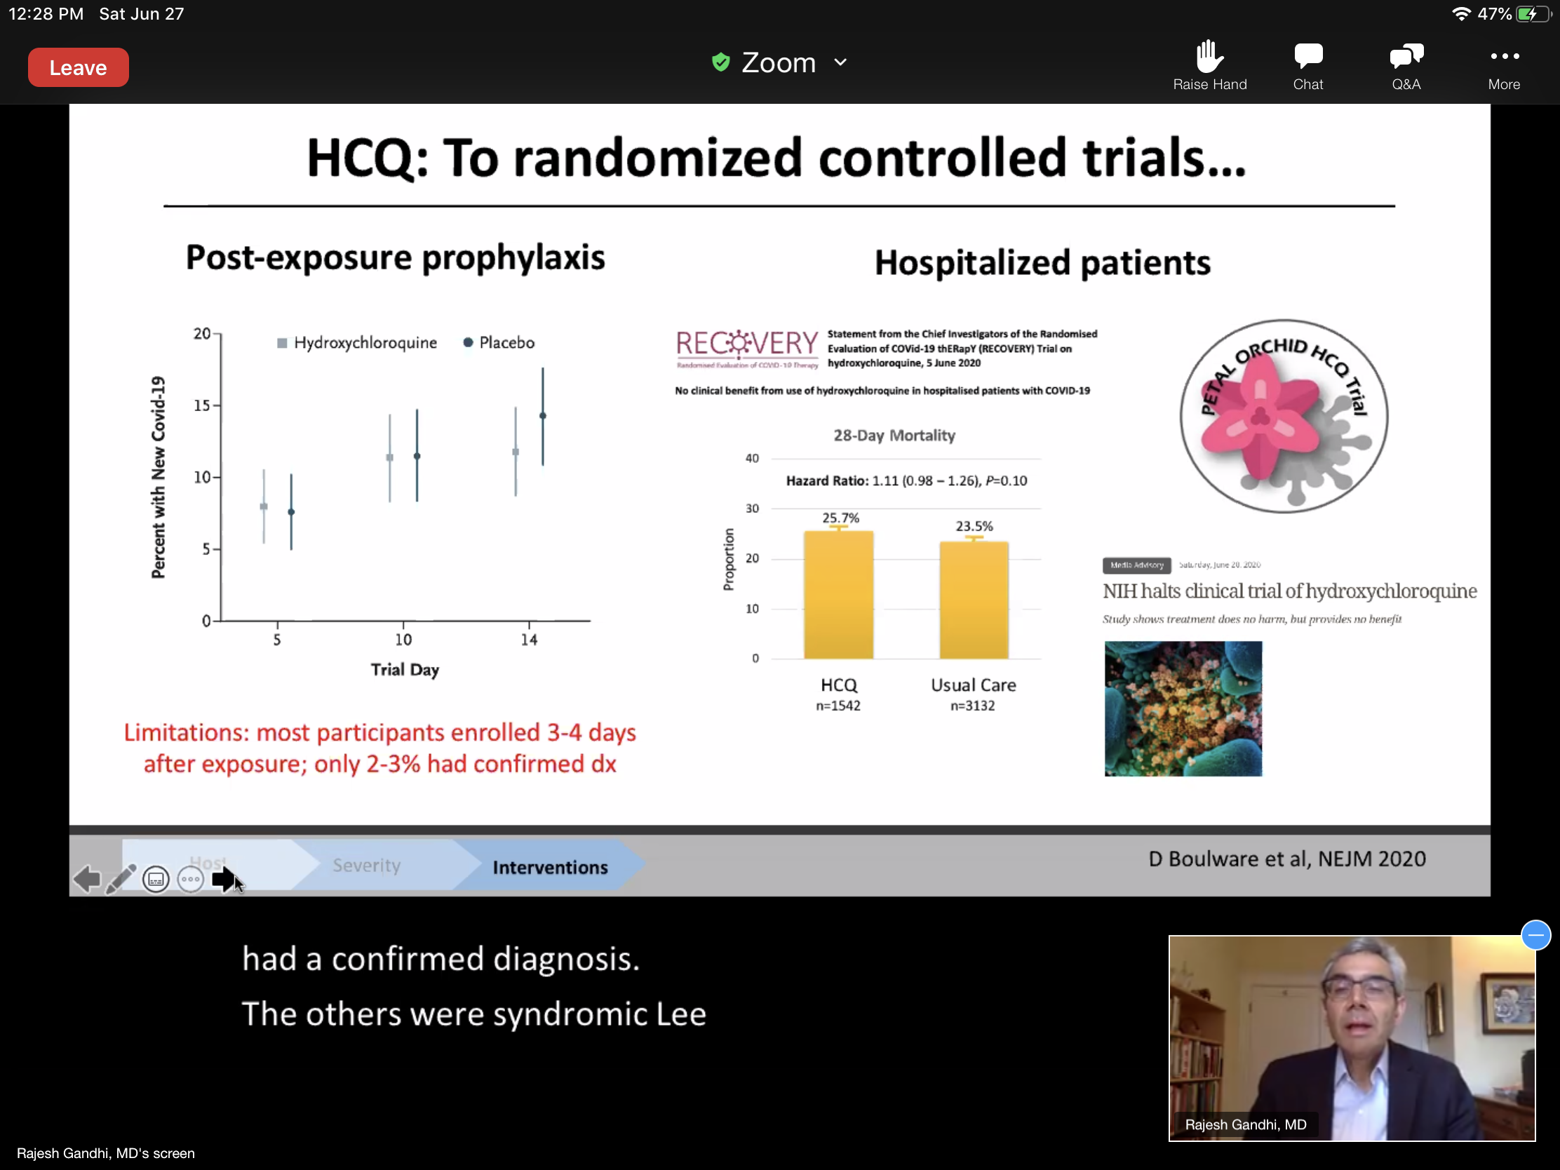
Orchid clinical trial on HCQ was halted.
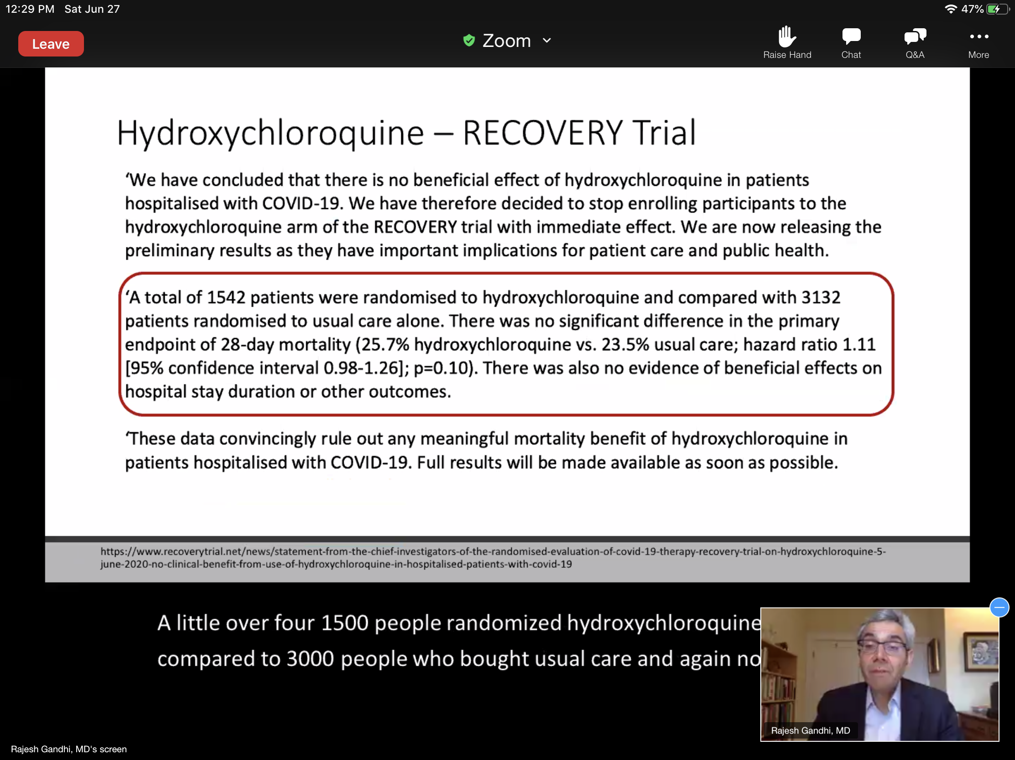
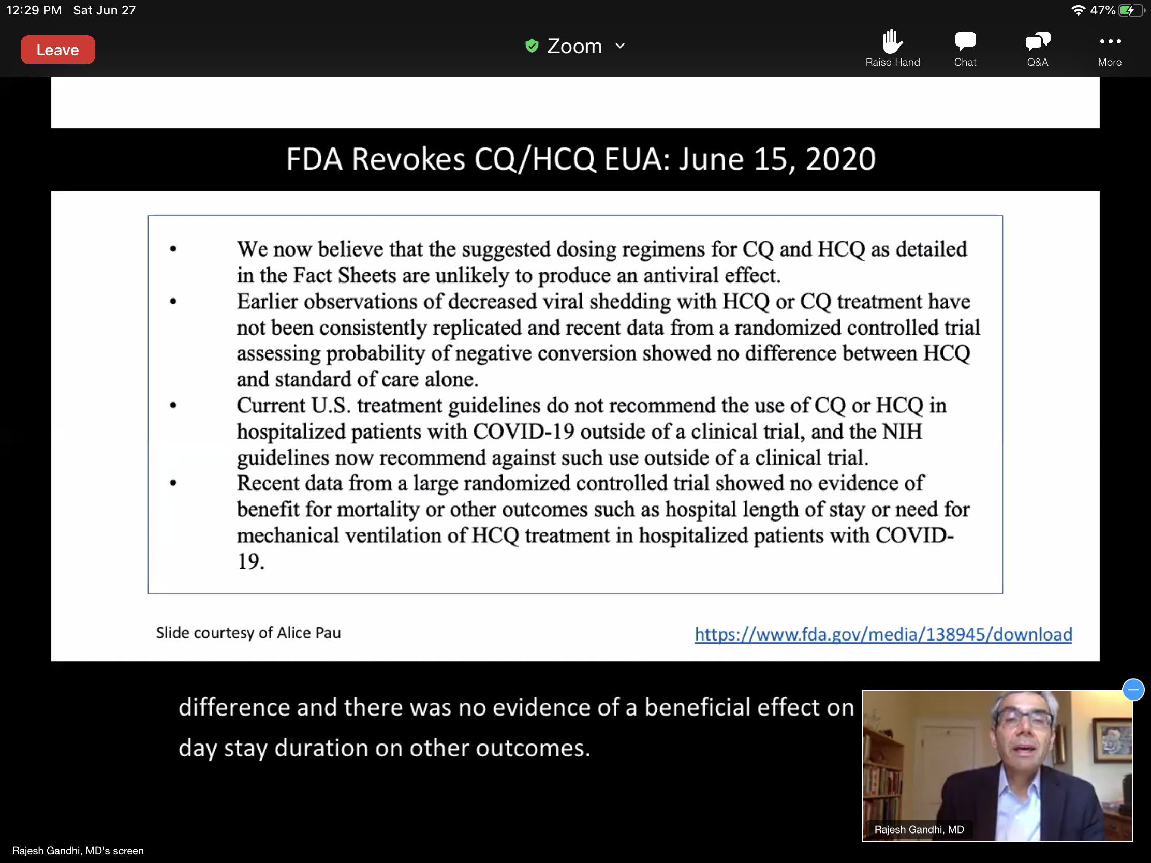
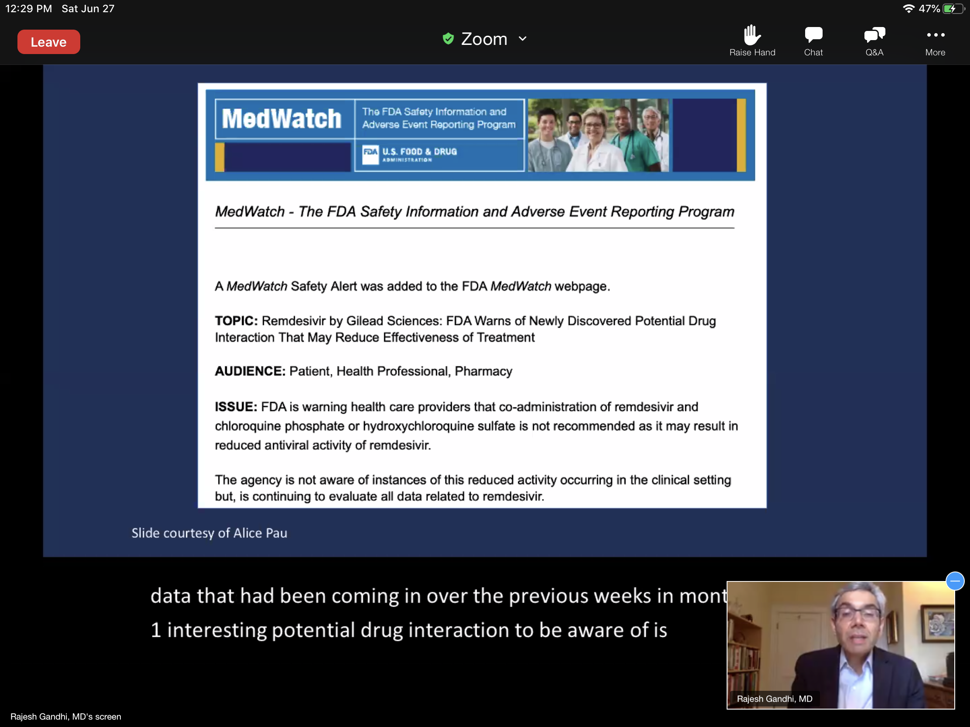
Coadmin of remdisevir and HCQ or CQ not recommended- may result in reduced antiviral activity of remdesivir.

Hydroxychloroquine: Implications for Practice
-For hospitalized patients w COVID-19 use HCQ only in the context of a clinical trial. Awaiting results from randomized controlled trials (RECOVERY, ORCHID)
-For people exposed to COVID-19, one published post-exposure ppx trial does not support use of HCQ (other post-exposure ppx trials ongoing).
-Trials of HCQ for early treatment and for pre-exposure ppx are ongoing. (HERO-HCQ as of this week >1000 health care workers randomized).

Convalescent Plasma: Context of clinical trial
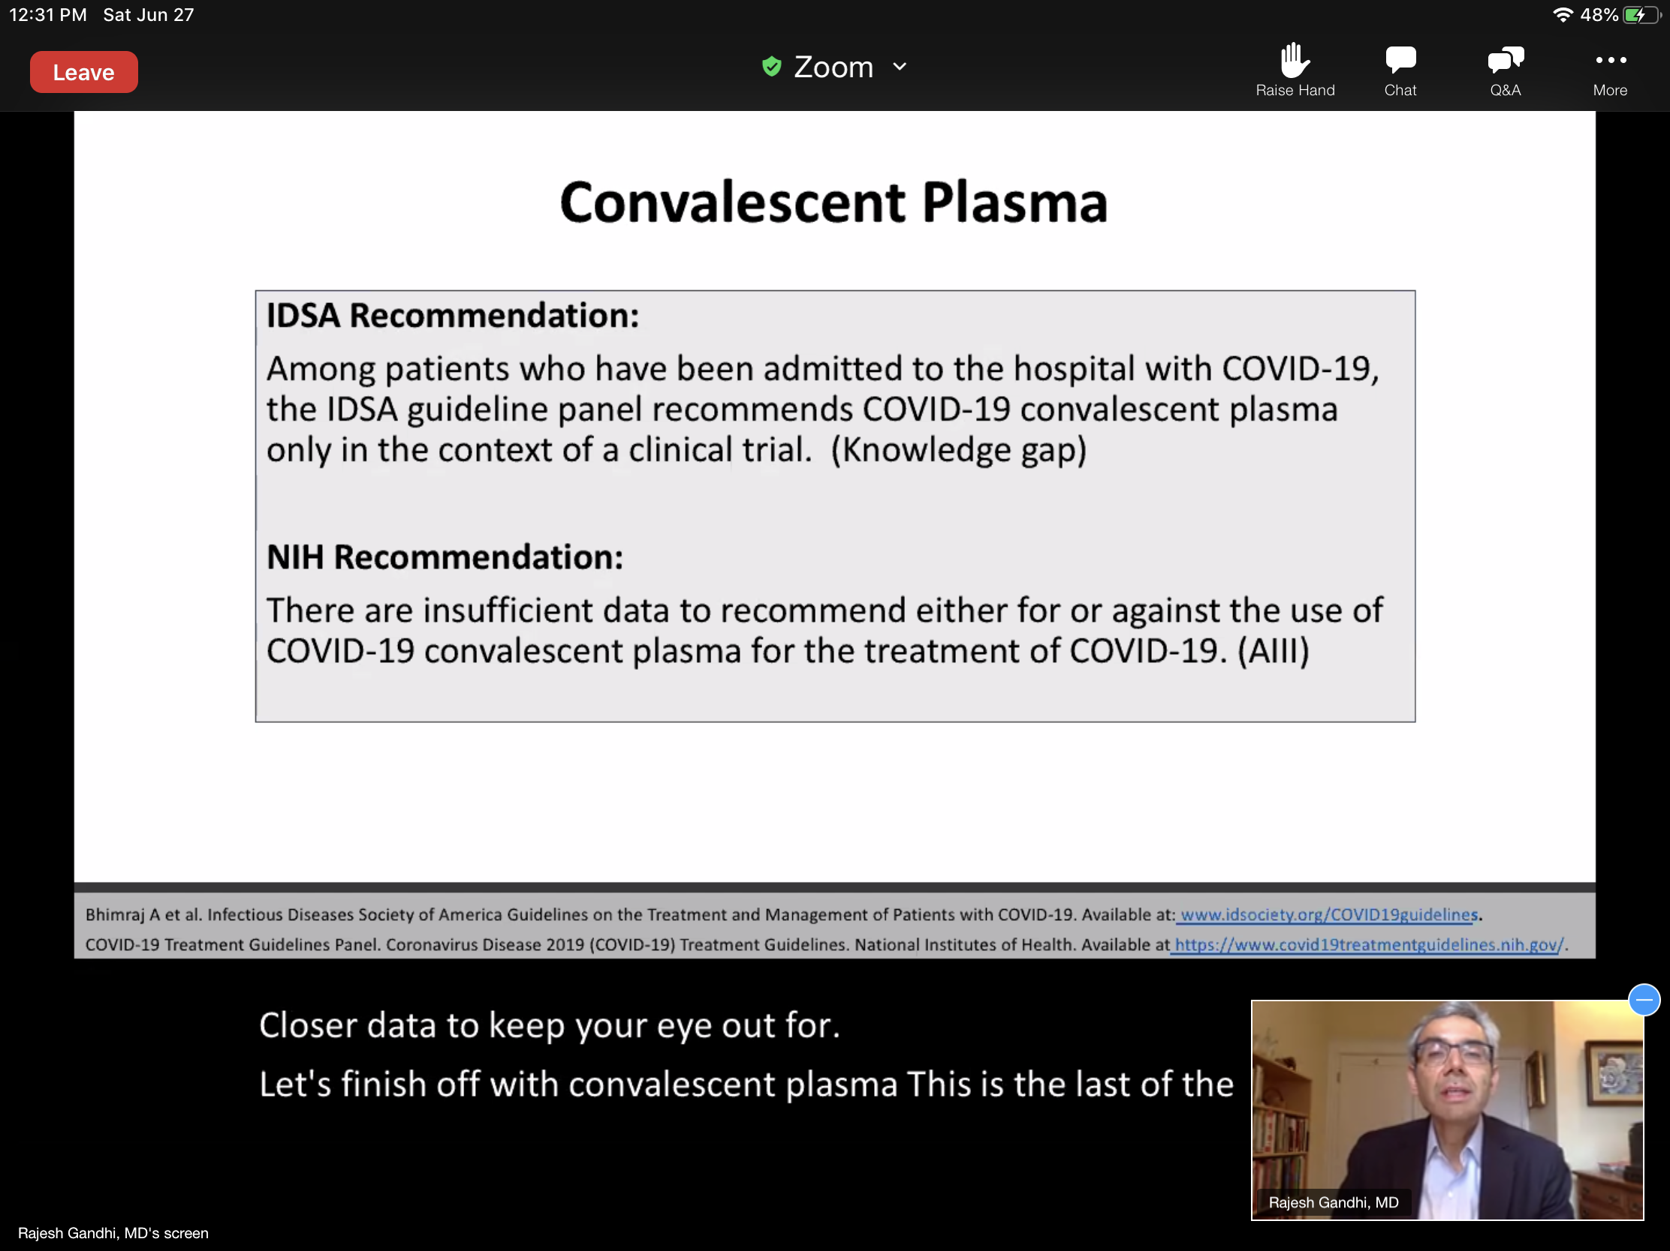
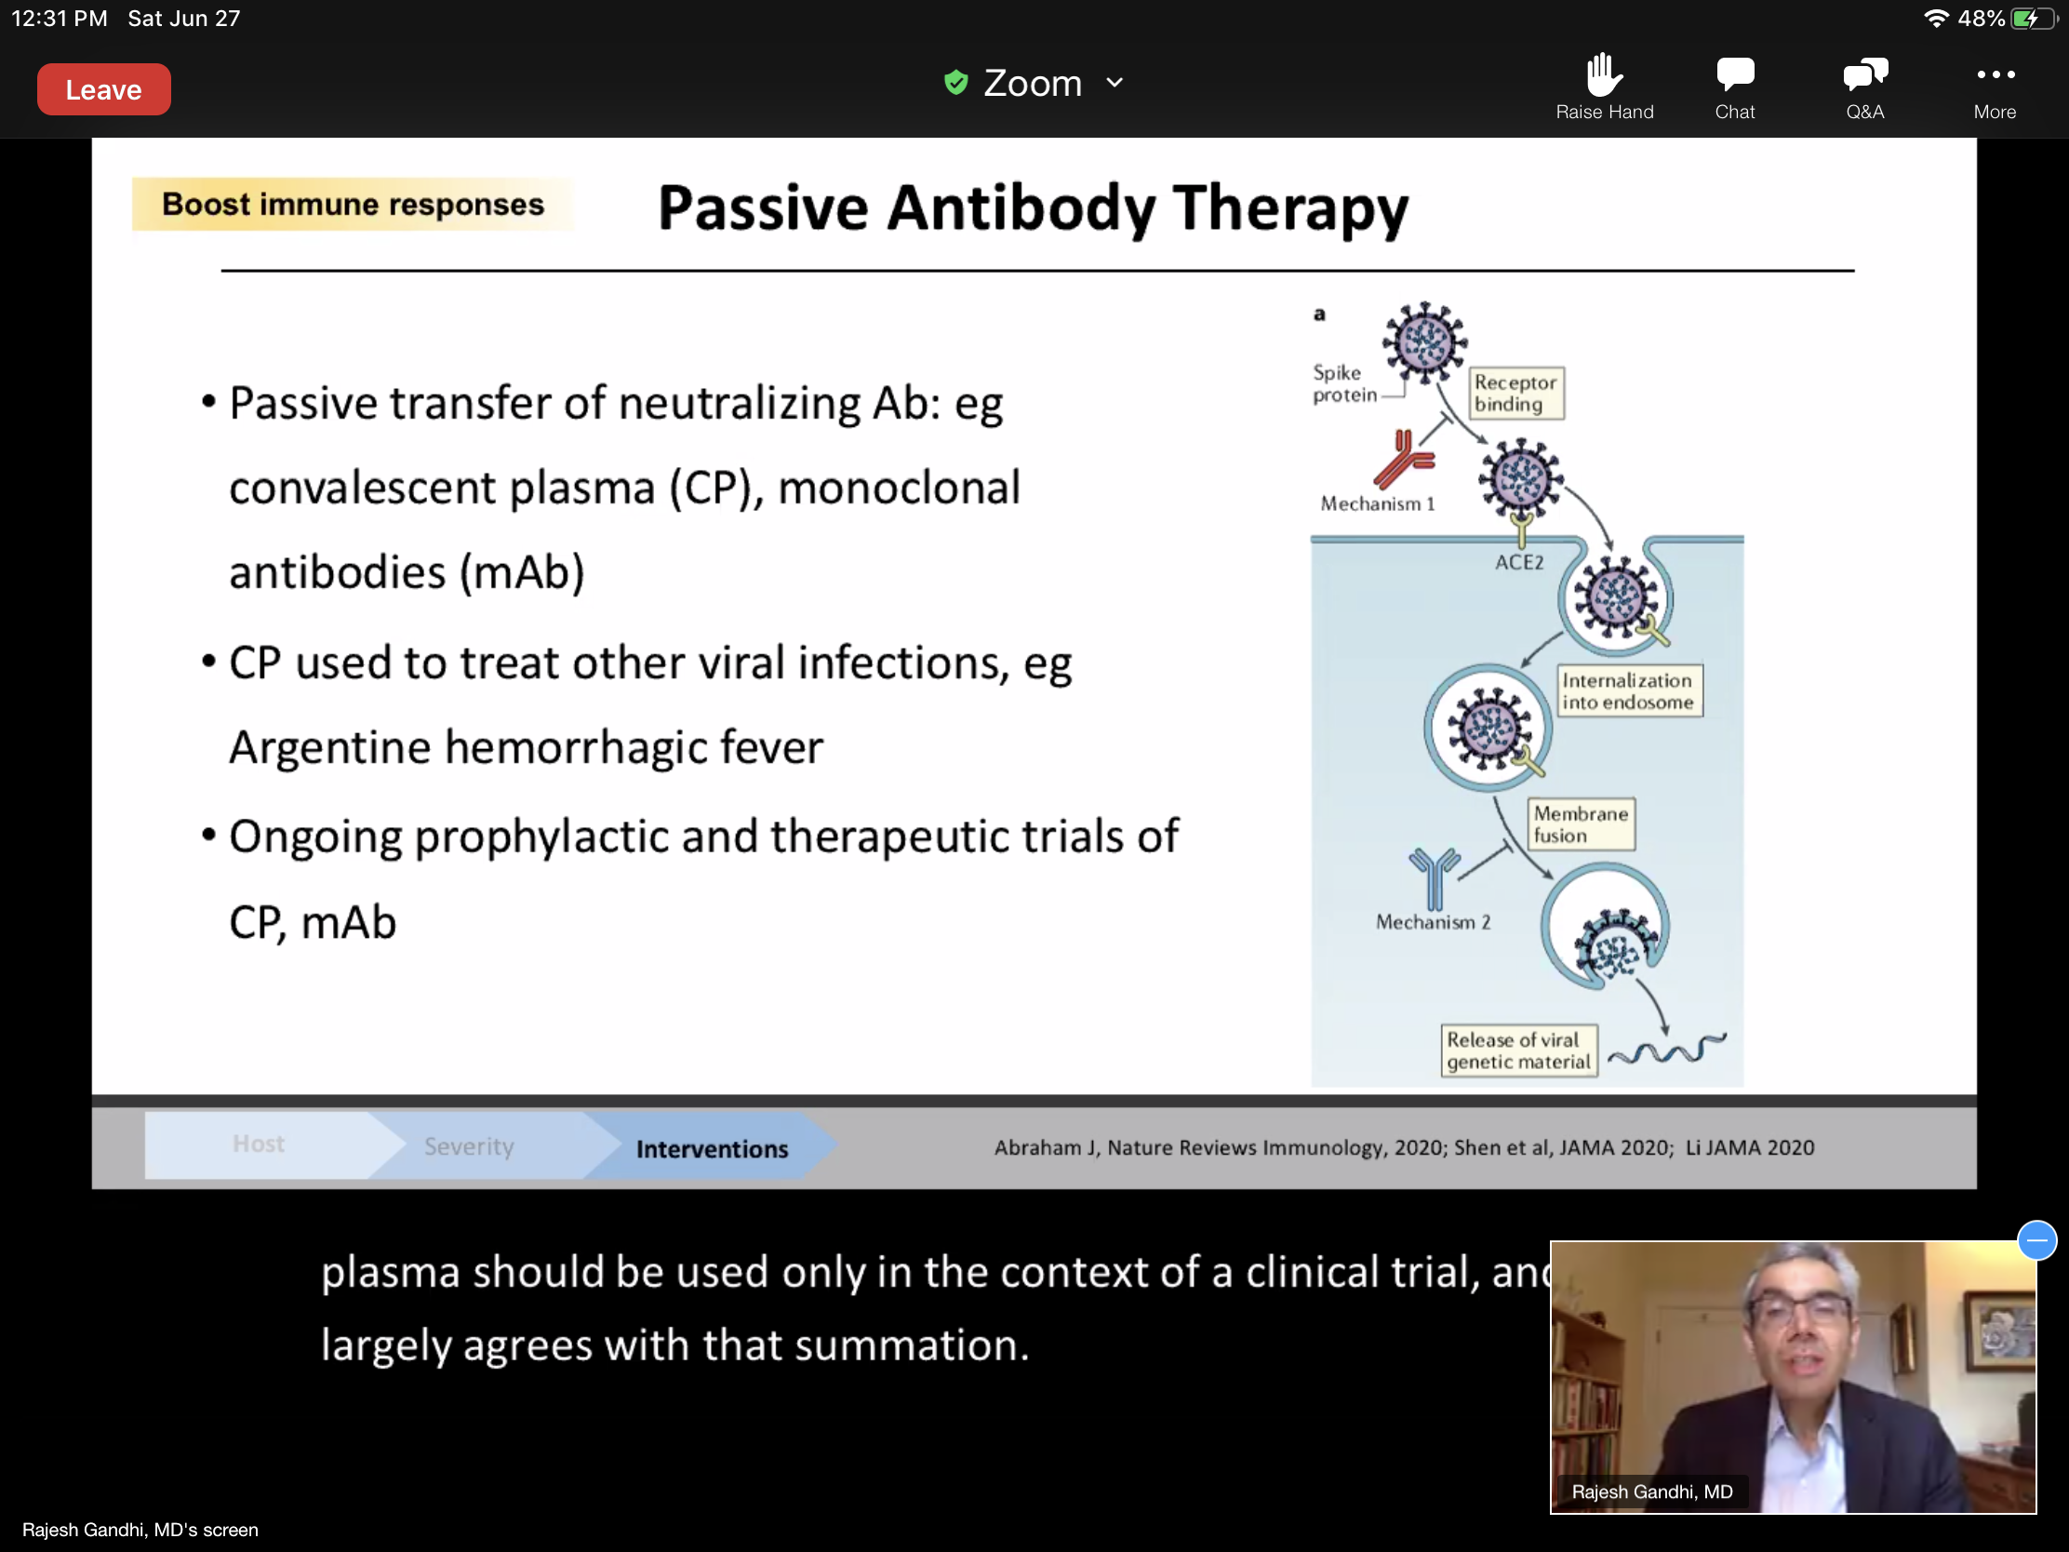
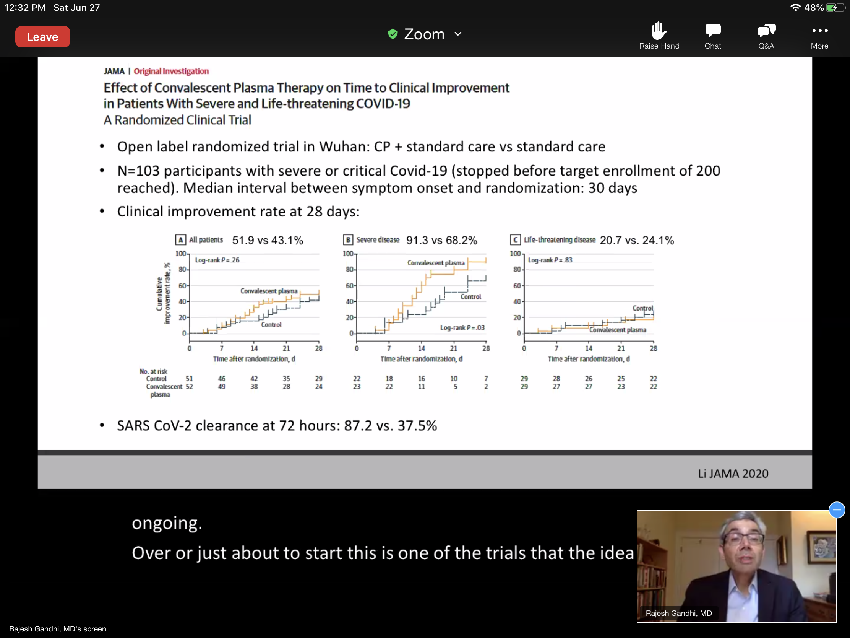
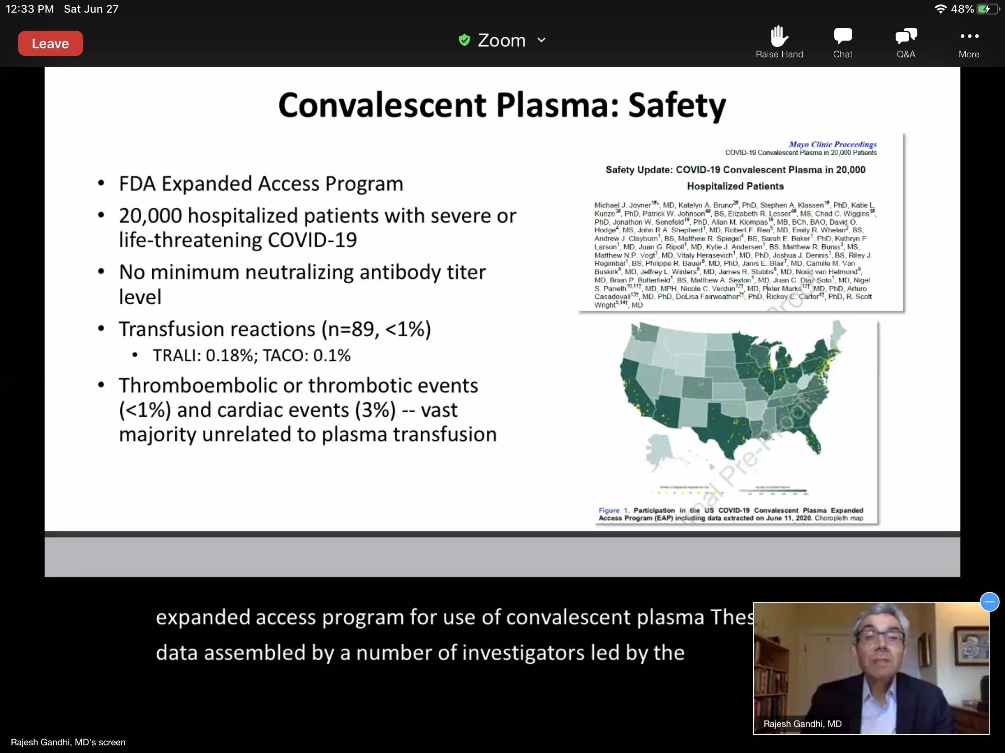

Convalescent Plasma: Implications for Practice
-CP has been given to tens of thousands of ppl w COVID-19 in the US and appears to be safe (low rate of transfusion related complications).
-Ongoing trials to assess whether it is efficacious.

Treatment Across the COVID-19 Infection Spectrum: May be better to treat early and prevent transmission, See more for at risk, exposed and infected.
-IDSA has more suggestions now in their guidelines.
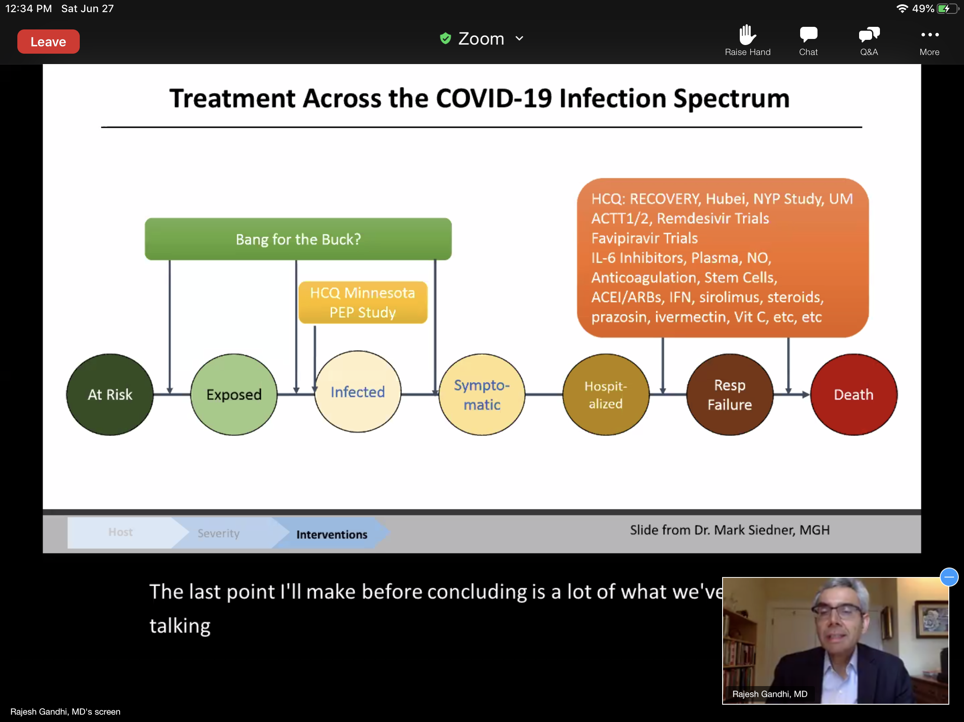
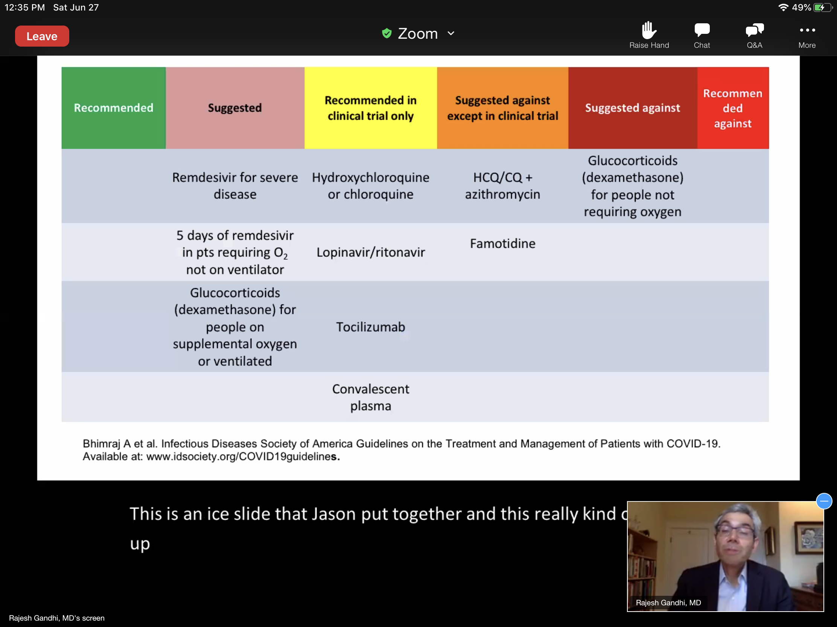
Discussion, Q&A:
- D-dimer on these patients? Gallagher and Gandhi have not seen these reported in the above mentioned studies.
- Mechanically ventilated patients: Combination of dexamethasone and remdesivir? Gallagher, haven’t been studied together but he would give together in the appropriate patient. Gandhi- remdesivir was not part of the recovery trial, don't have data on that. ACTT study didn’t see clear info on co-administered meds. People not yet intubated and on O2 would choose to use both and hope studies will be done of combinations. Because there is no data on combo, they both feel it shouldn’t exclude the use of the combo. Time of symptom onset is really hard to get pinned down.
- Ongoing Placebo RCT studies be stopped since the data has come out on dex? Should both arms be getting dex? Gandhi- mechanically ventilated does not support placebo only at this time. People not on O2- dex could be neutral or potentially harmful, so placebo groups would be best in those people. Gallagher now looks at reviewing data differently now, especially preprint data.
- Use of dex in immunocompromised pts who have been on prednisone, would you use lower doses of dex? Gallagher would use the same doses as in the studies.
- Cytokine storm? Steroid data for ARDS is all over the place, influenza data in steroids are not good. COVID-19 appears to be different, COVID may have a more inflammatory nature than other viral infections like influenza. COVID-19 not a classical respiratory virus, it starts there and causes a whole bunch of other issues throughout the body, affects the cardiovascular system, inflammatory etc. ***COVID-19 is a different beast***
- Betamethasone and methylprednisolone? Makes sense to give the therapy that was studied, get as close to glucocorticoid therapy as studied, but if you can't, use the other options. Why equivalent doses are included by IDSA. Recovery study used methylpred in pg and bf women.
- Assessing for adrenal insuff before using dex? Dr. Janet Lowe who gave a talk on this. Limited course of dexamethasone, risk of adrenal insuff is lower, unless other conditions that can predispose. If know pt has other conditions may want to consider some type of taper. But consensus is would not worry about up to 10 days (in studies average 6 days).
- Major CI for using dex? Uncontrolled fungal infection. DM does not preclude use of dex but monitor closely, COVID itself has effect on glucose control, this can be managed. Look at risk vs benefit, there was mortality benefit, want to use the steroids.
- Convalescent plasma and combo w remdisvir and dex? Convalescent most effective per Gandhi if used early on, boosting the immune clearance of the virus. Eventually like HIV, combinations will be the way to go w COVID.
- Other questions about other meds, will be on future calls.
- Focus on trials treating earlier and preventing people from needing hospitalization is now happening. Antibodies are an exciting new area, monoclonal antibodies specifically against the COVID virus could be in the future.

