CDC/ IDSA COVID-19 Clinician Call: COVID-19 & Thrombosis July 25, 2020

Announcement
CDC-IDSA Partnership: Clinical Management Call Support, Starts this Tuesday
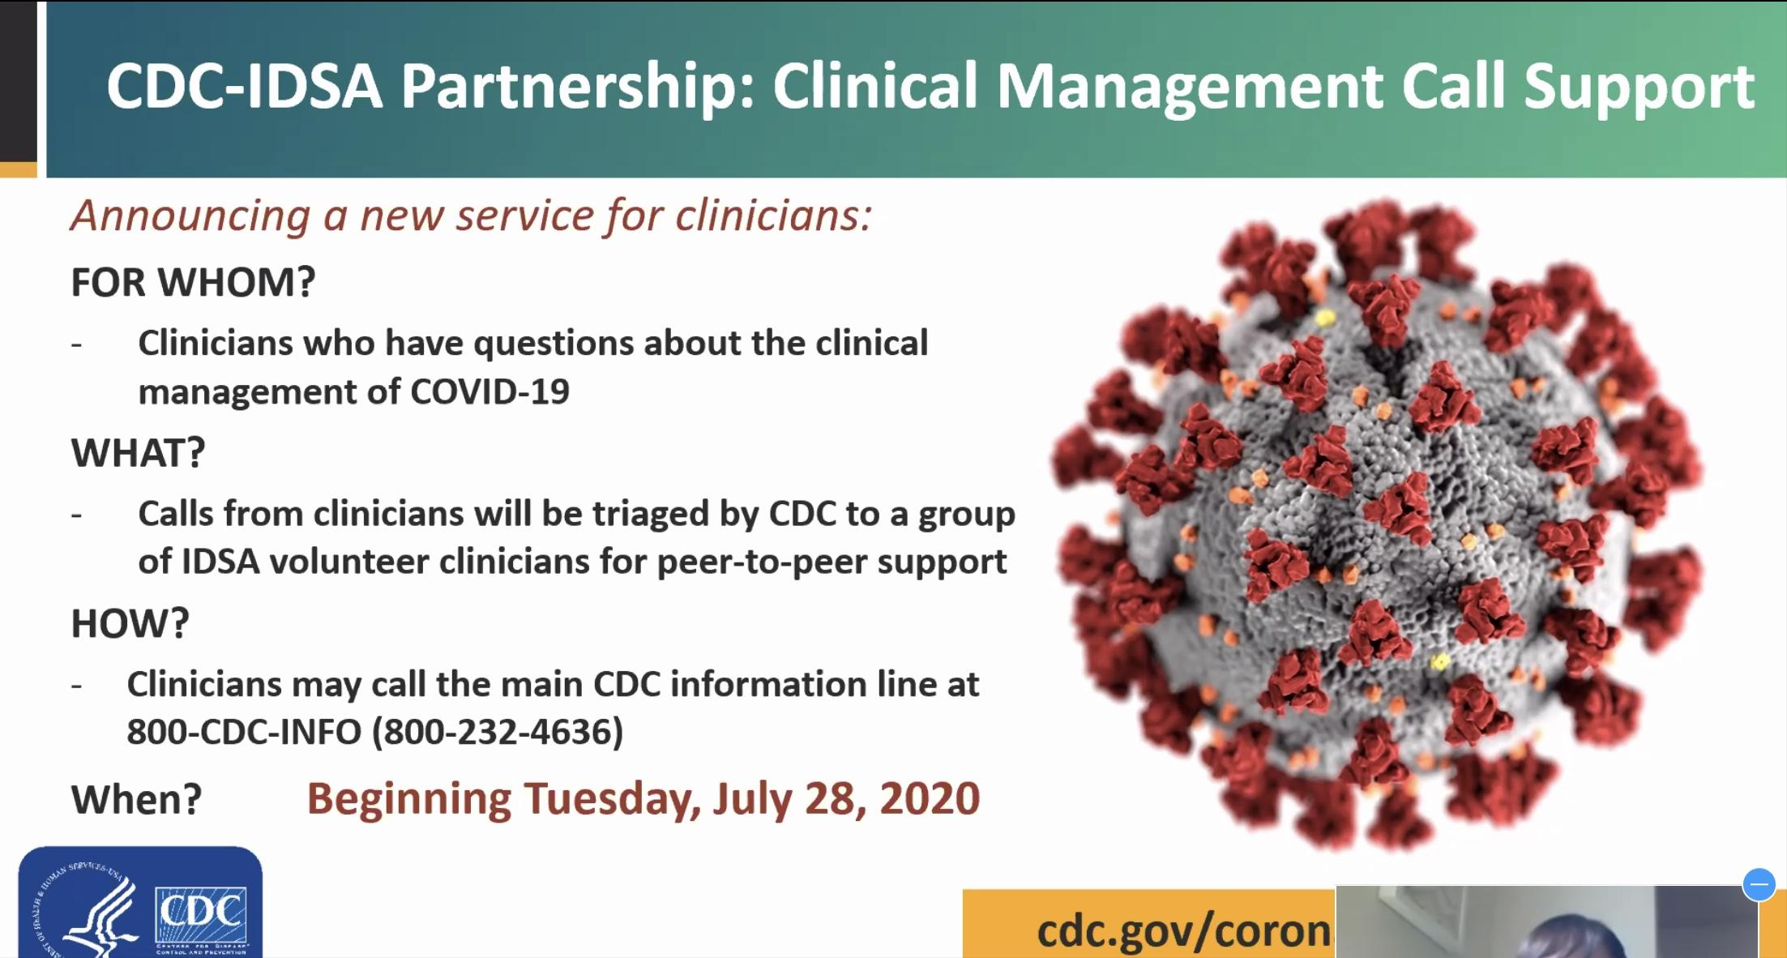

American Society of Hematology is partnering today w CDC and IDSA

Learning objectives
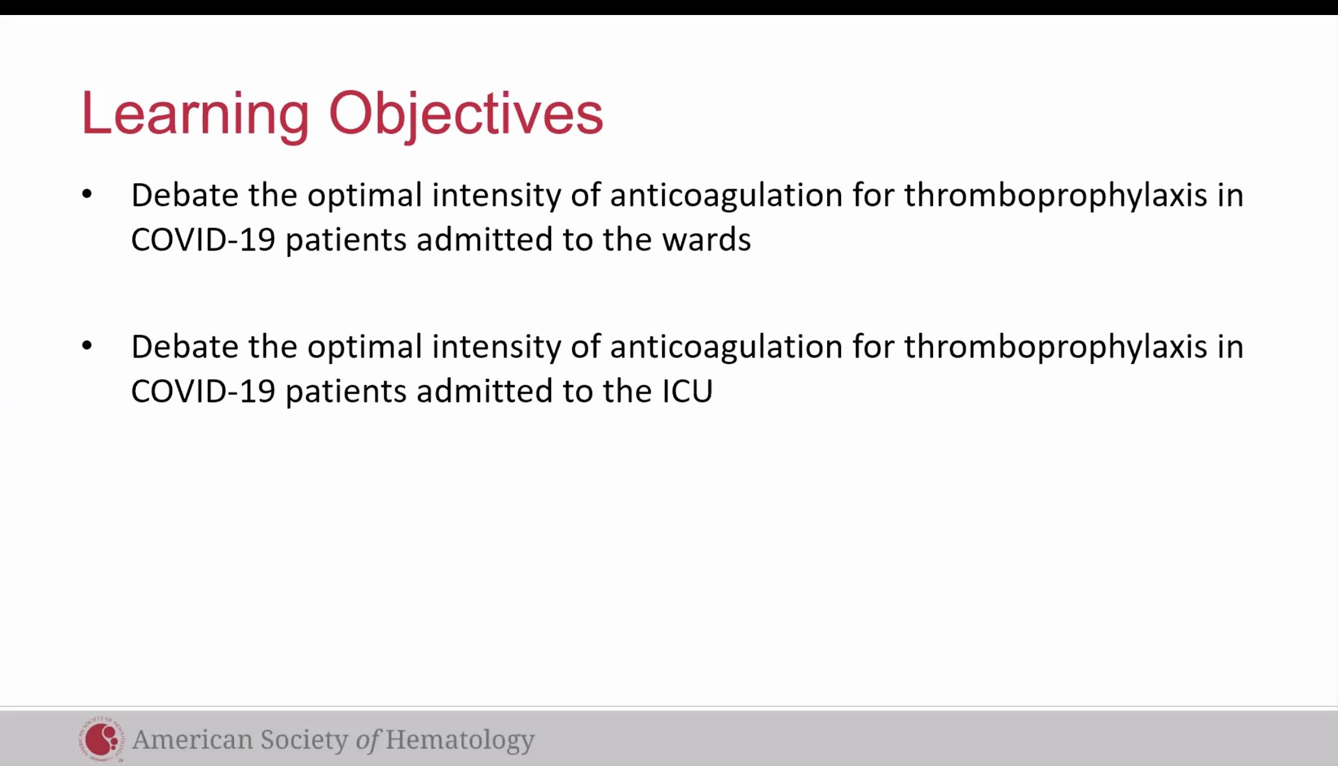

Case based debate today
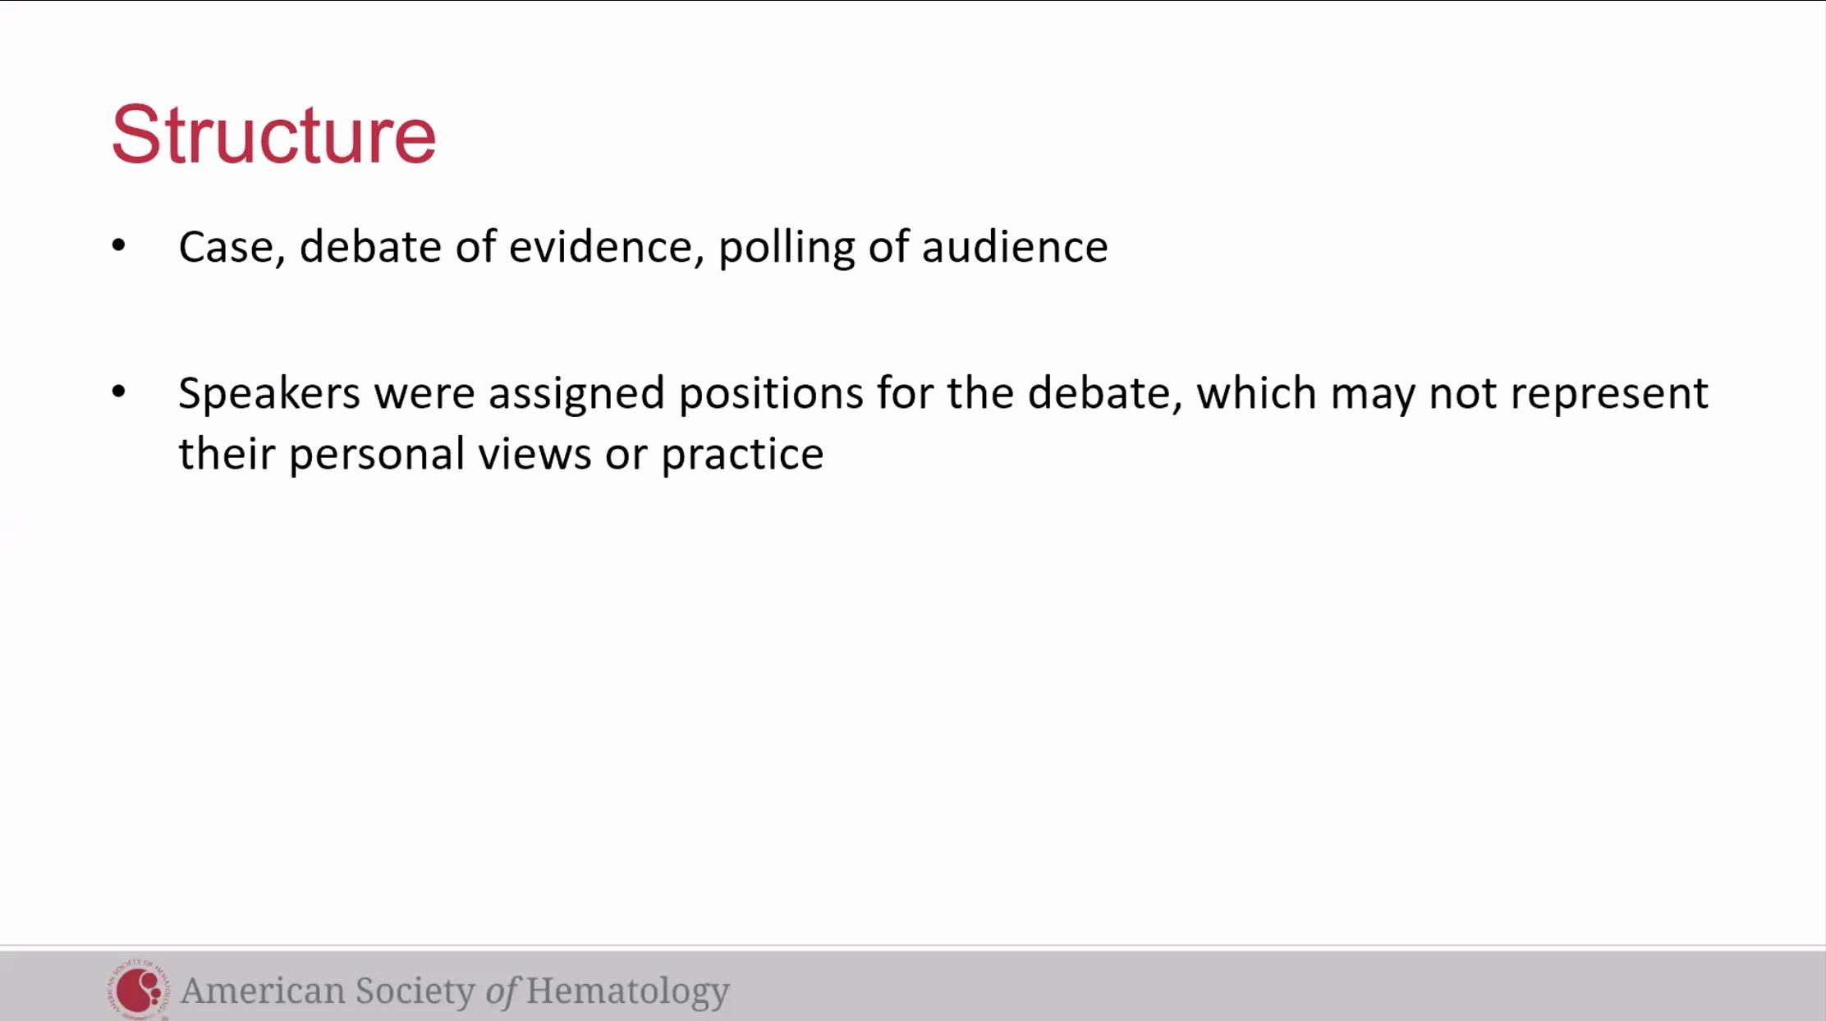

Covid-19 and coagulation: evolution in understanding
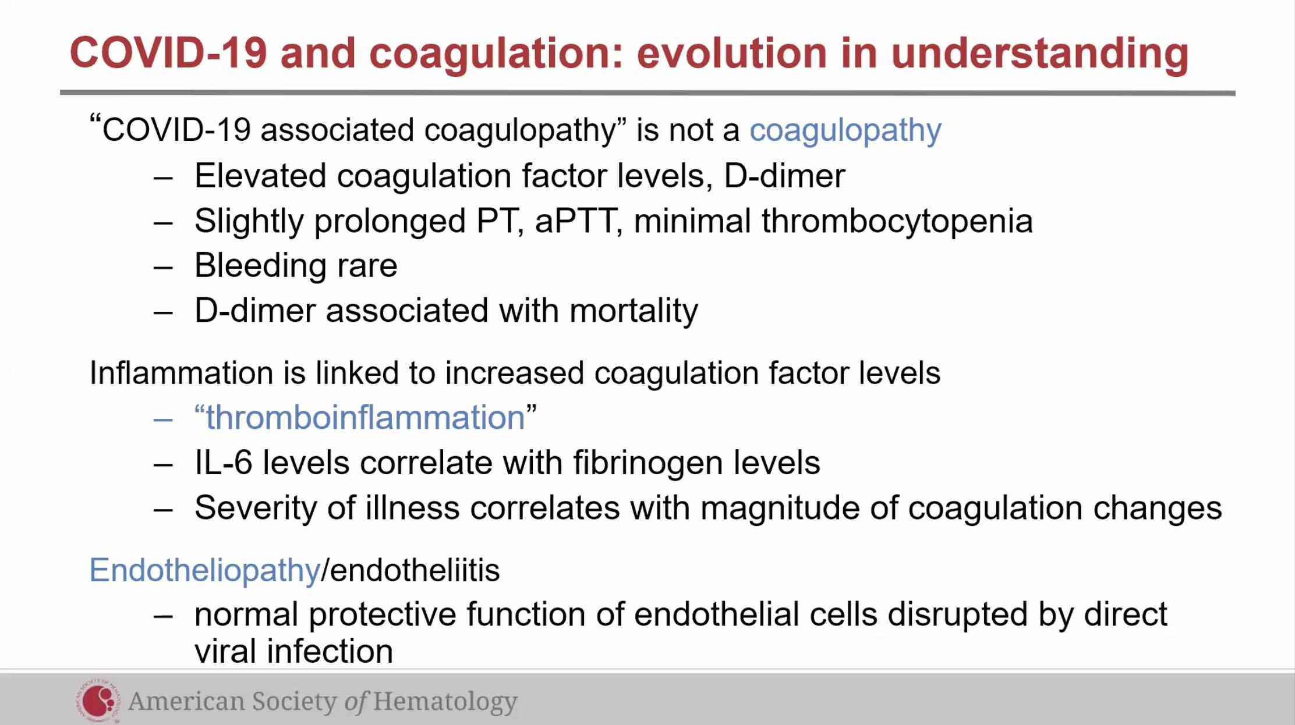
See thrombocytosis and not thrombocytopenia in these patients.
D-dimer also assoc w disease severity.
Normal protective protein-c, s, etc are missing.

Case 1
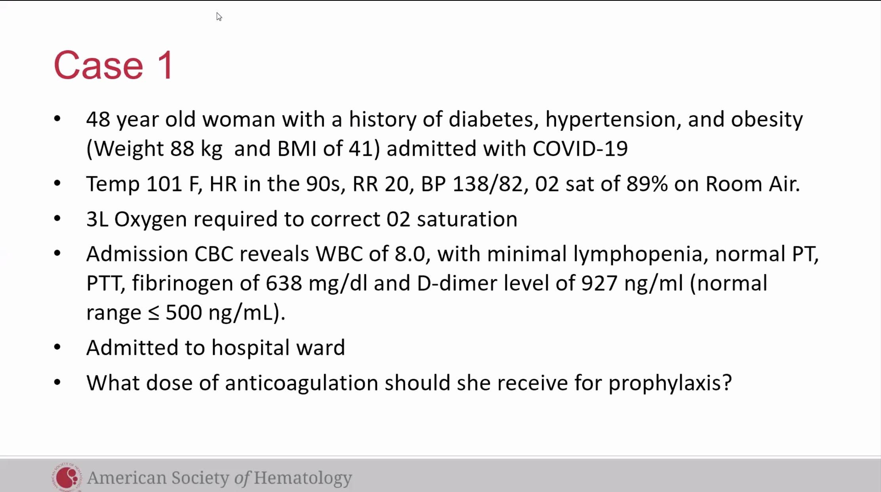
Dr. Lisa Baumann Kreuziger: Argument for prophylactic anticoagulation
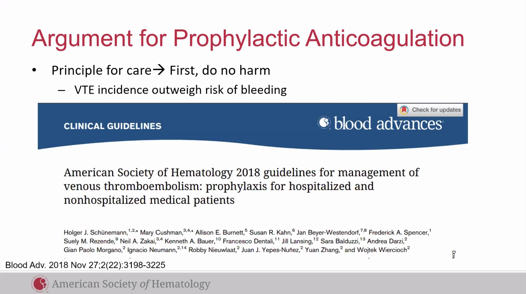
Incidence of VTE & Bleeding Medically ill
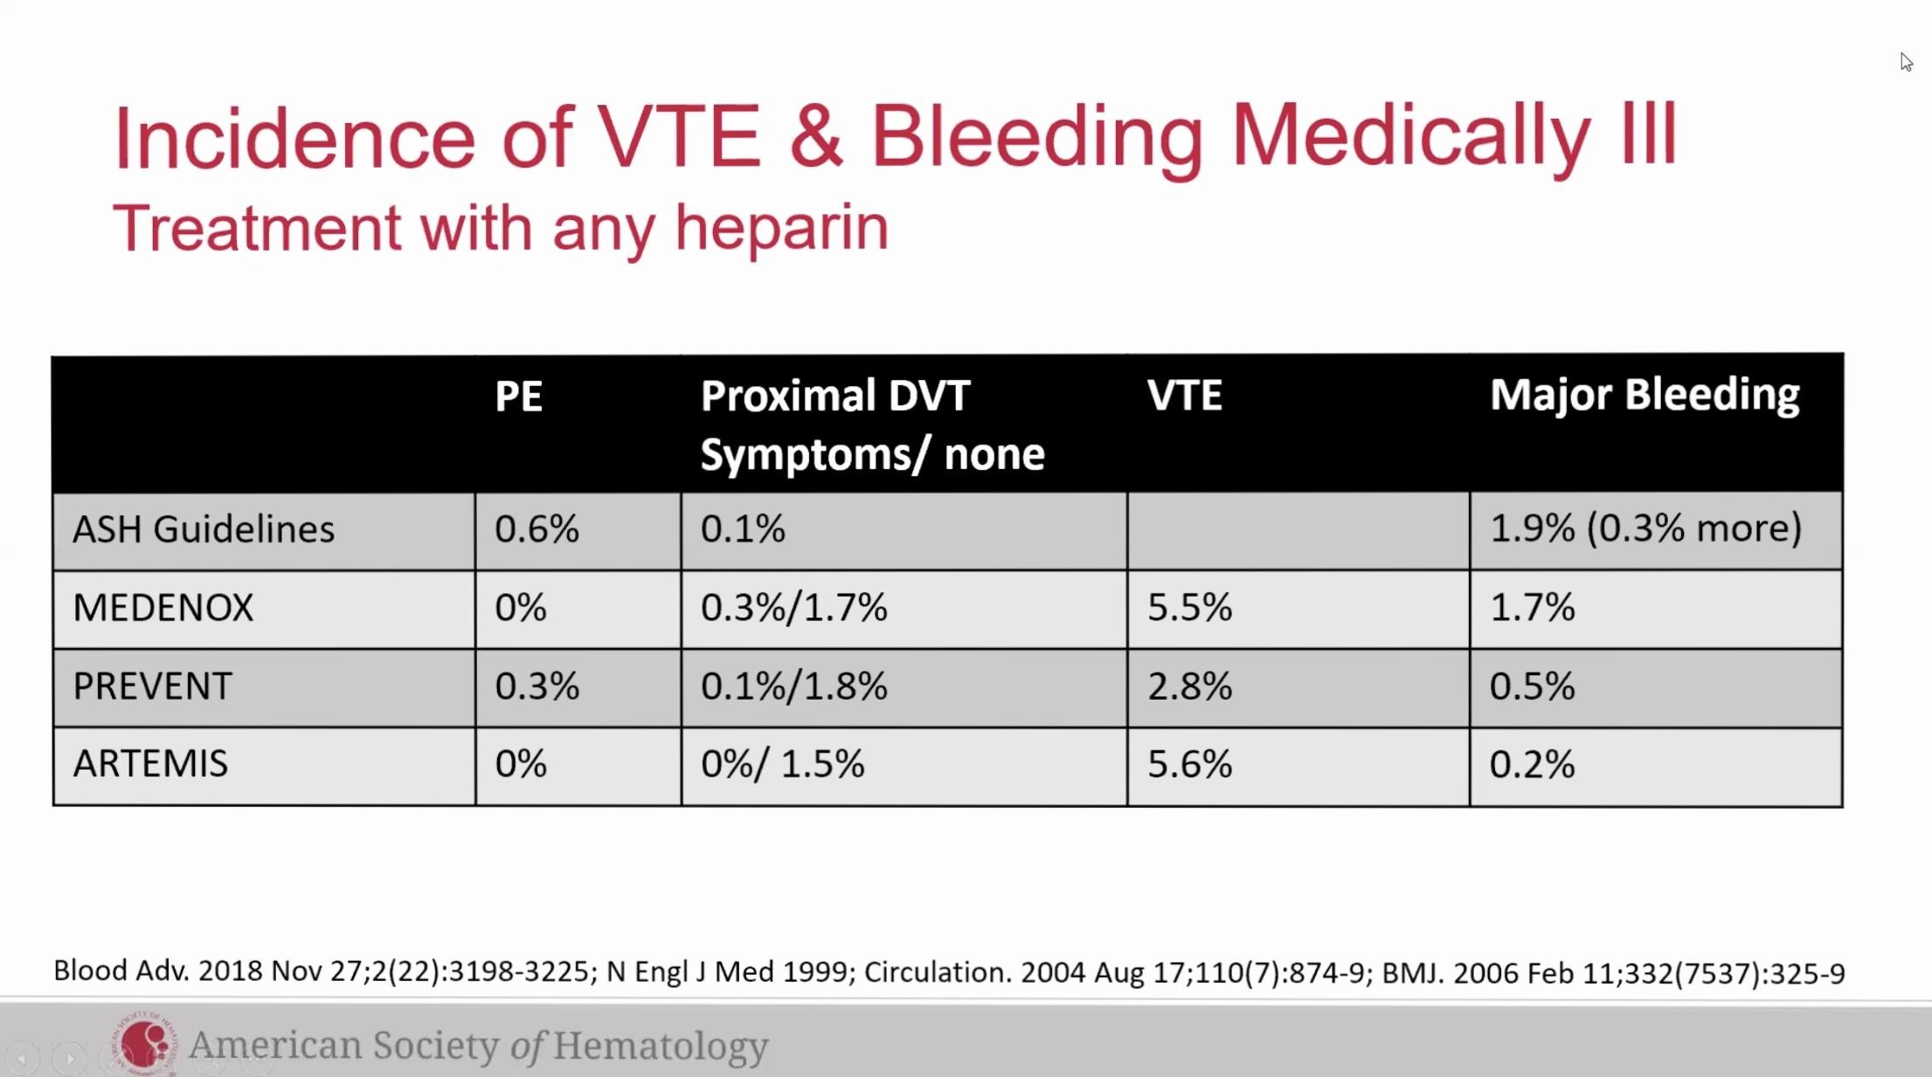

Incidence of VTE & Bleeding in COVID-19
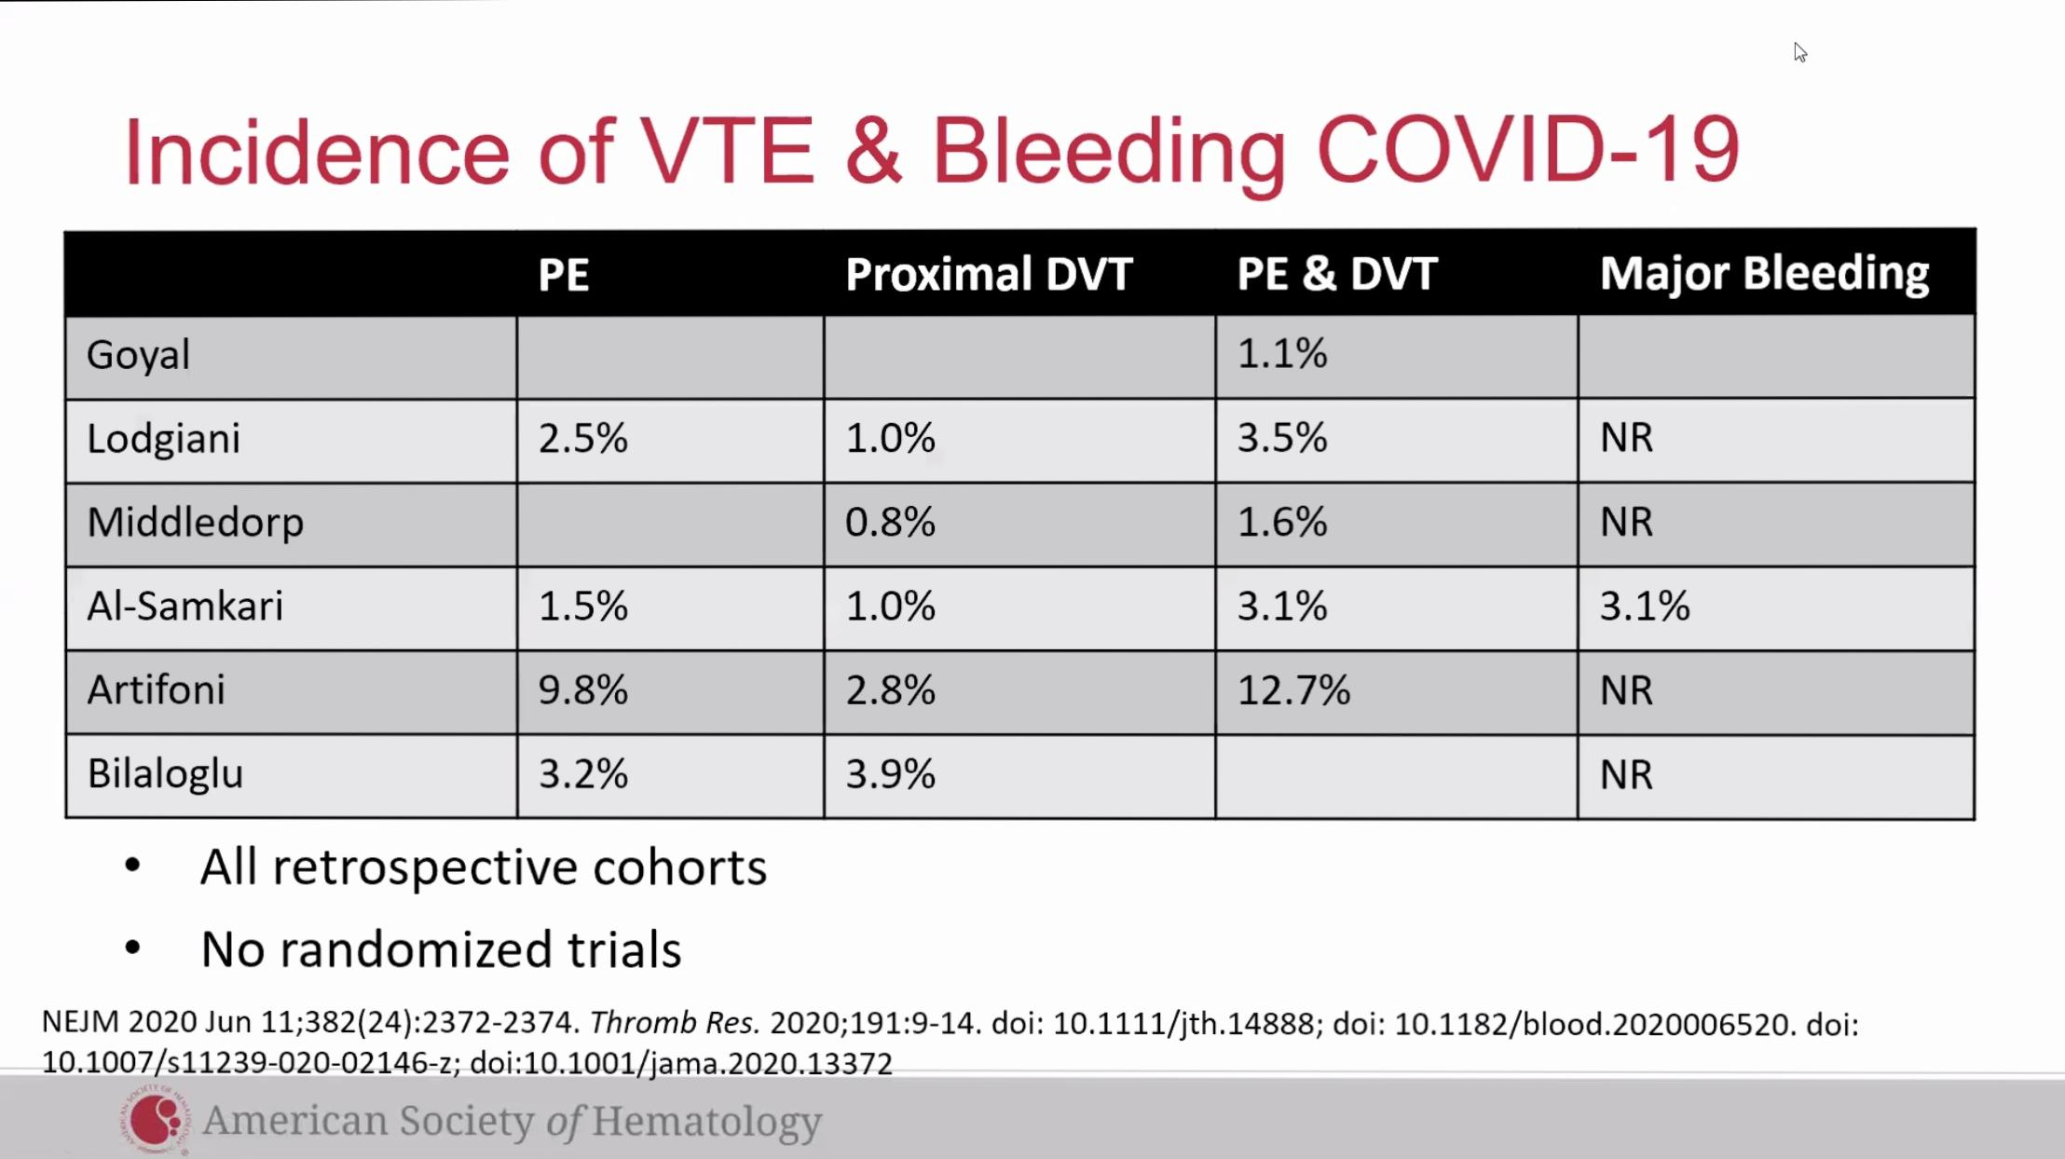
Note: retrospective and no randomized trials yet
Bias present in obs studies
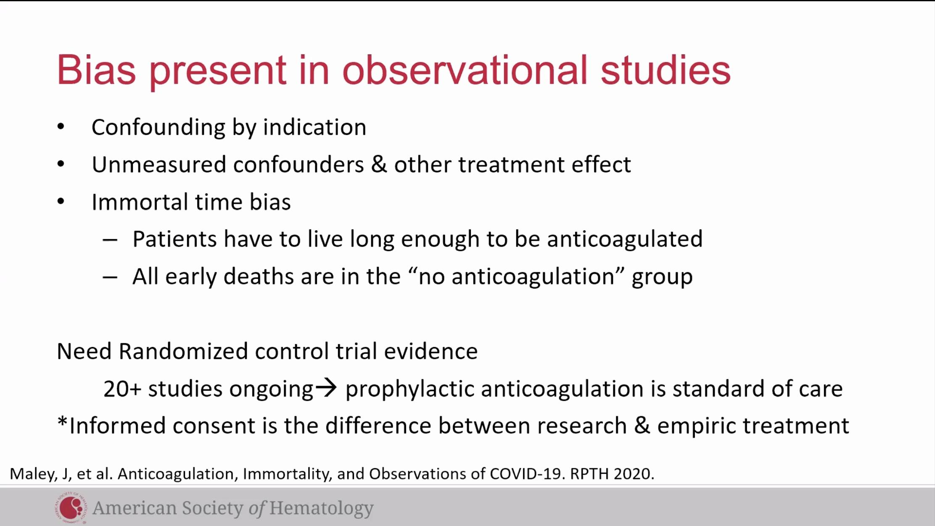
PPX anticoagulation is the control group and currently the standard of care in the 20 trials ongoing.
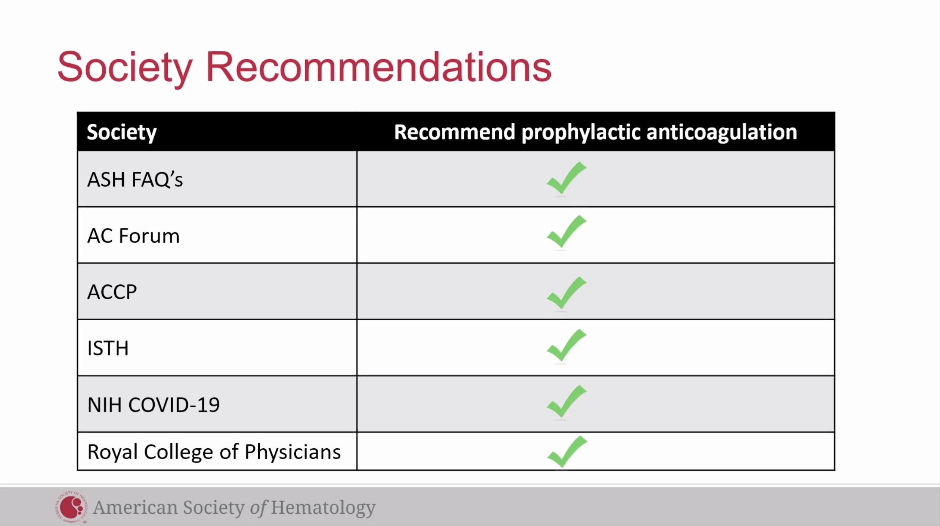

D-dimer in hospitalized patients
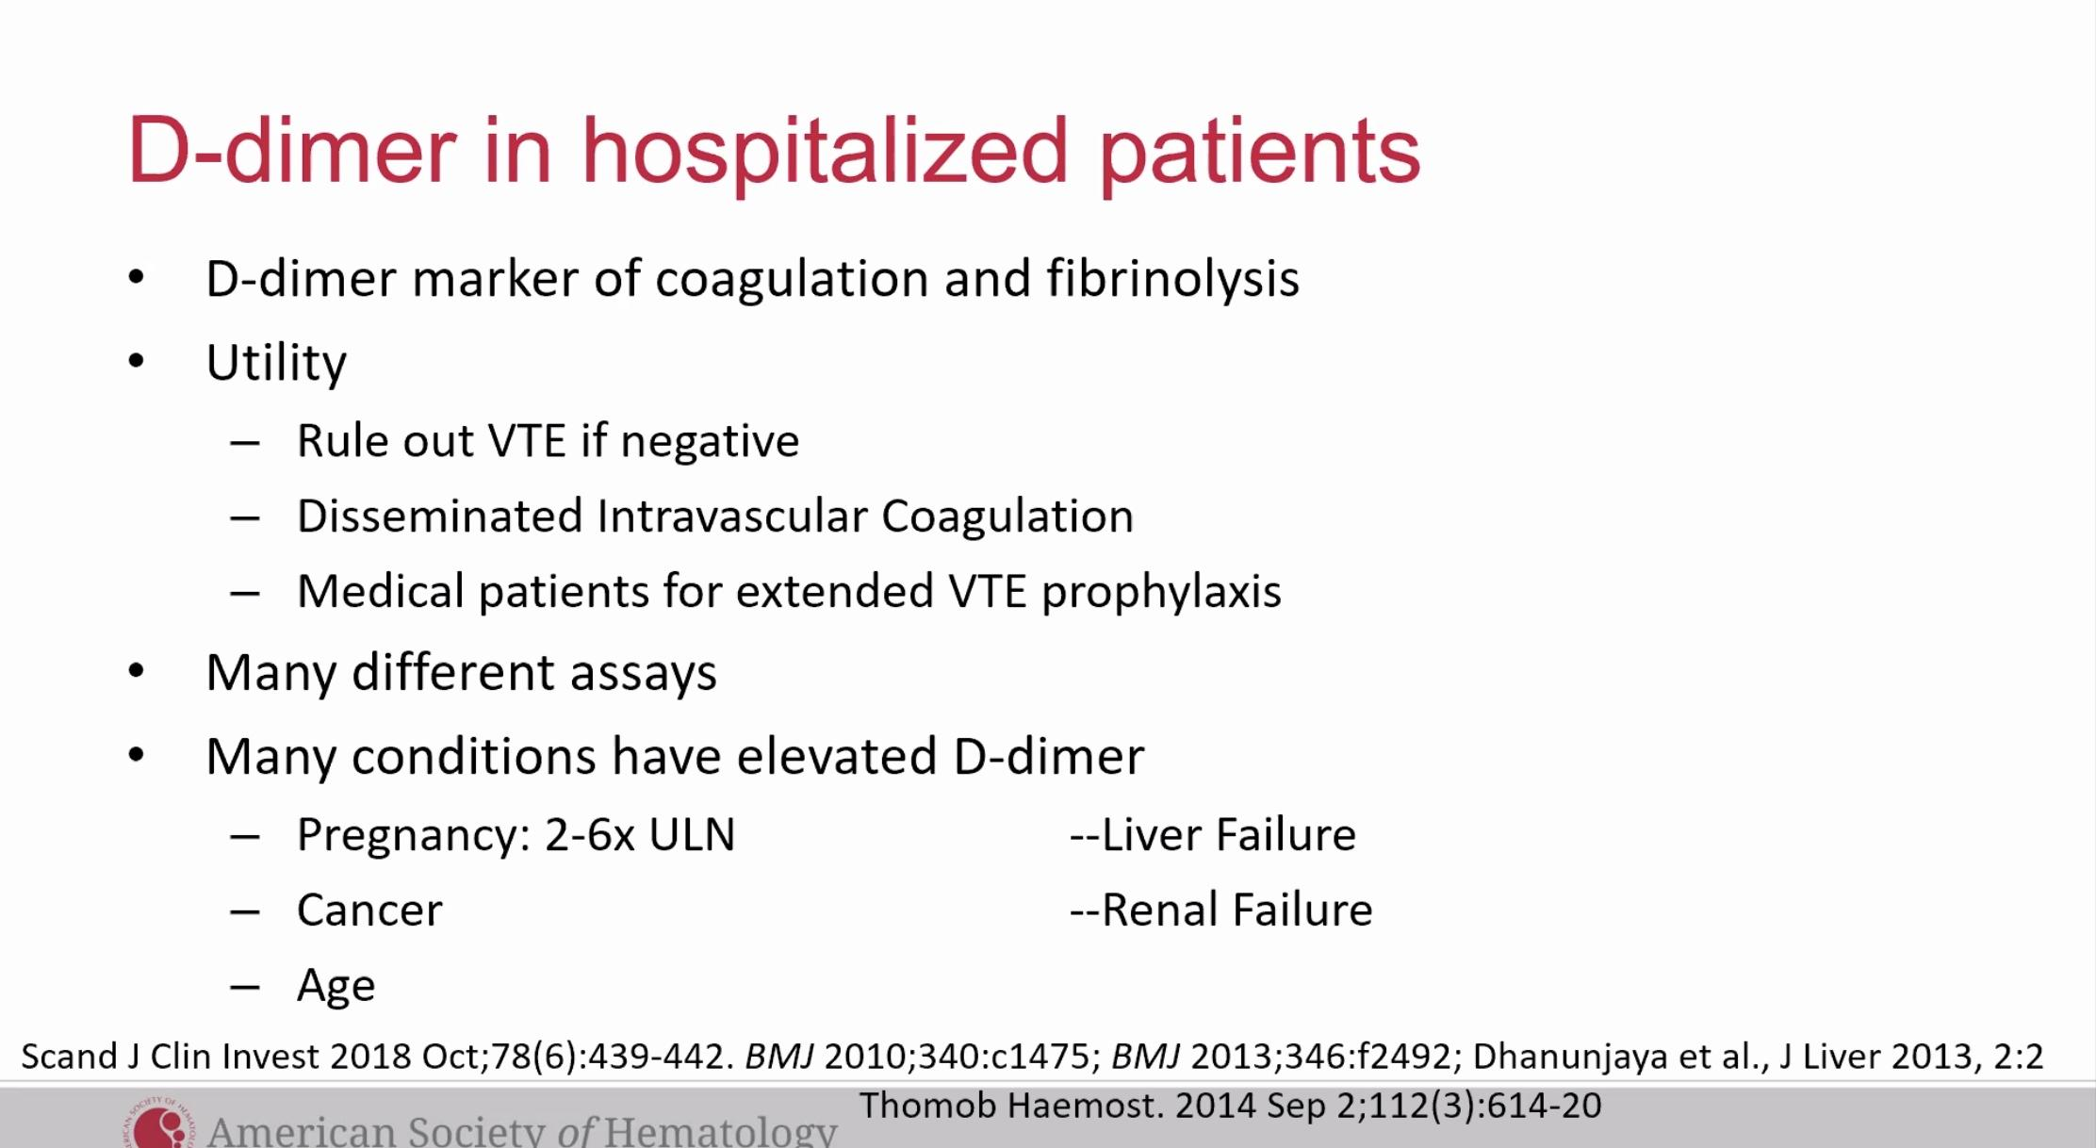
**Control for different assays in these studies
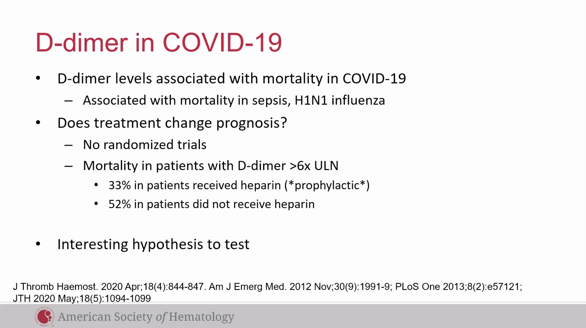

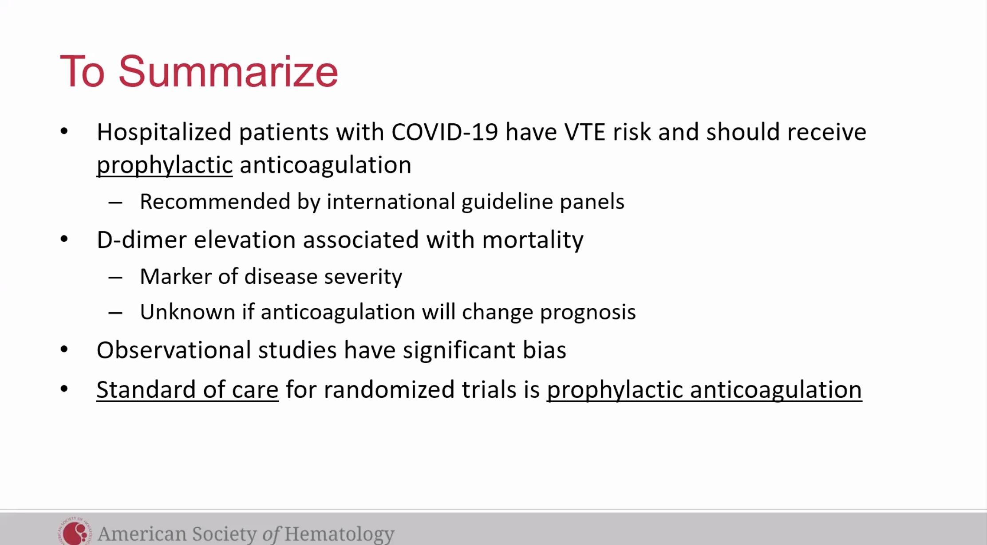
Dr. Adam Cuker ( For this case he would actually do ppx anticoag)
Argument for higher intensity anticoagulation in COVID-19 patients on the wards
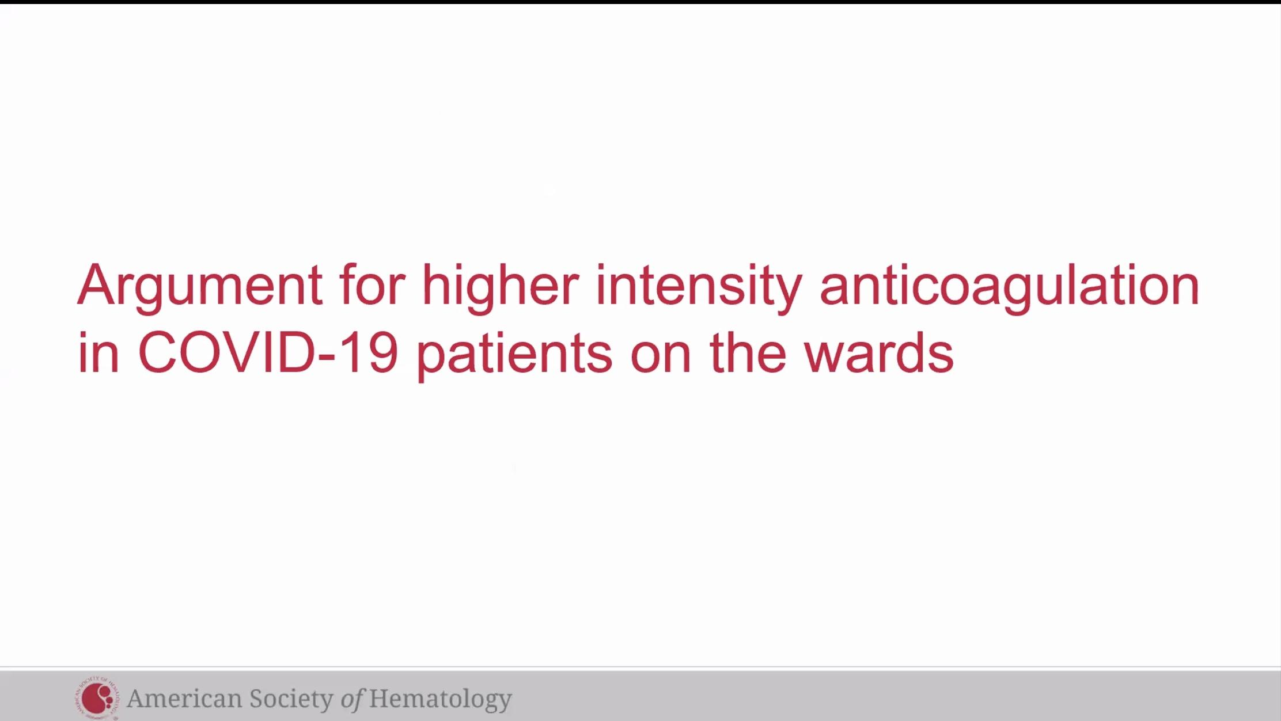

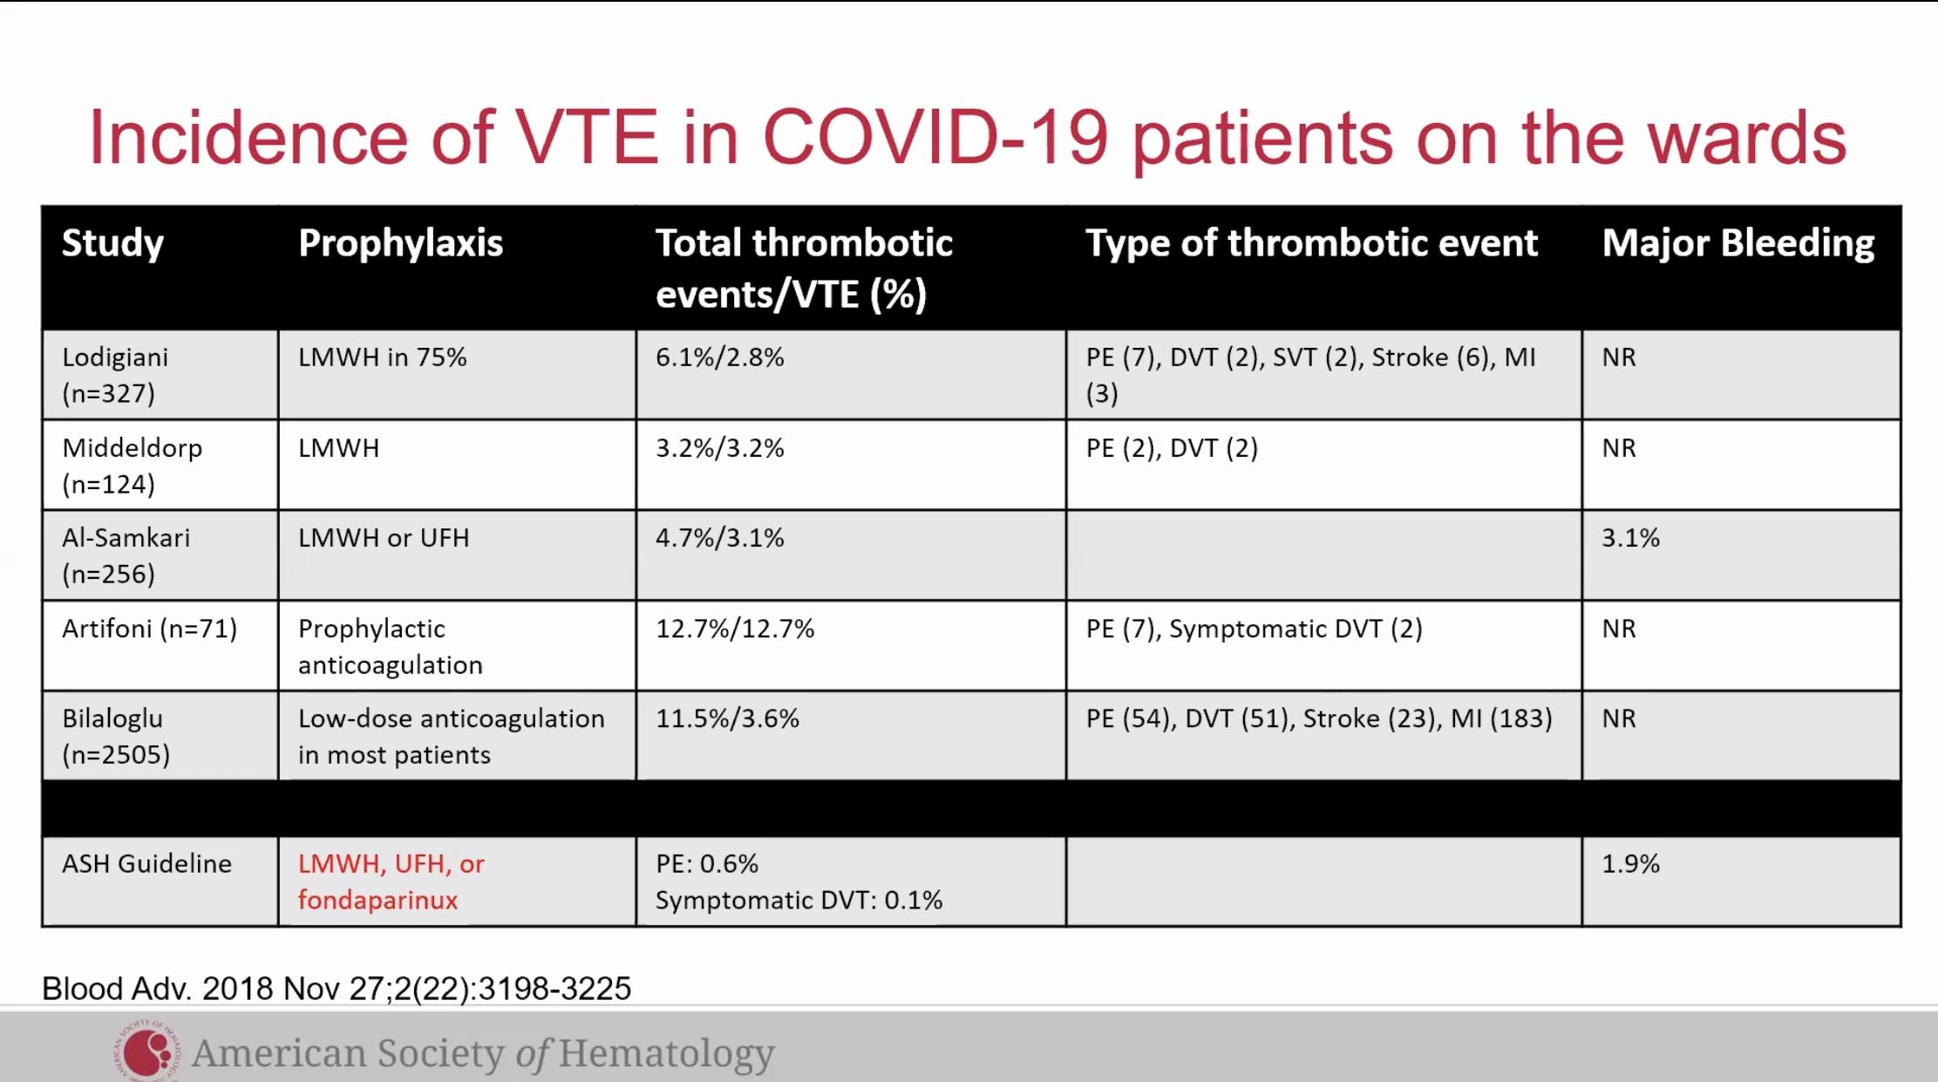 compare rates to ASH Guideline (people w. out COVID), COVID patient thrombotic risk appears to be much higher
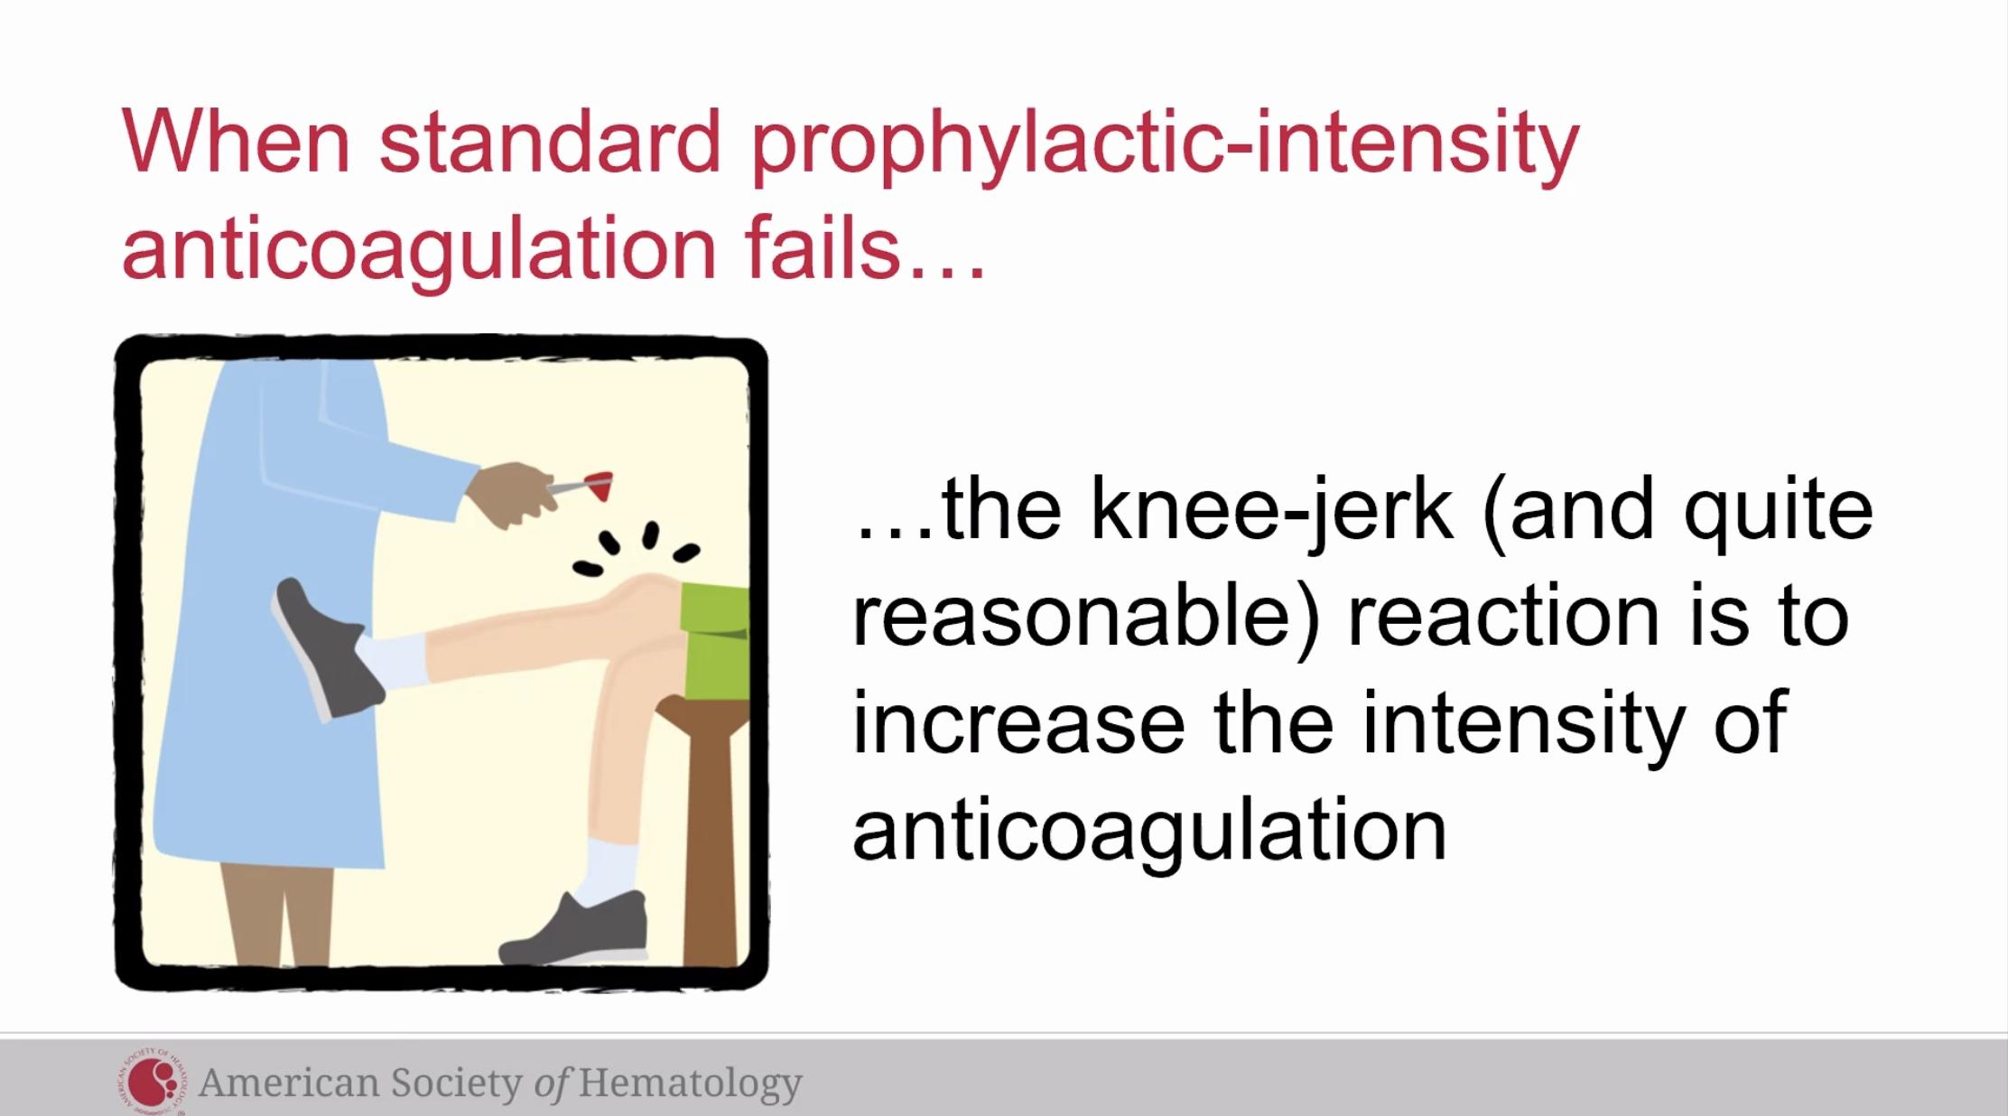

Clinical trials we need
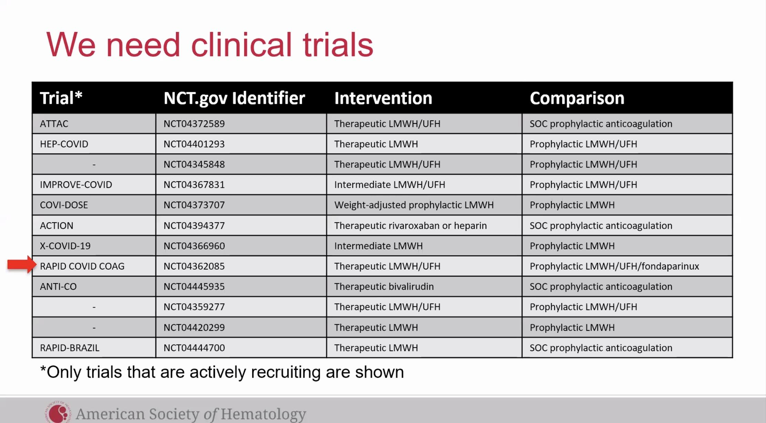
Rapid COVID COAG- major trial

Summarize
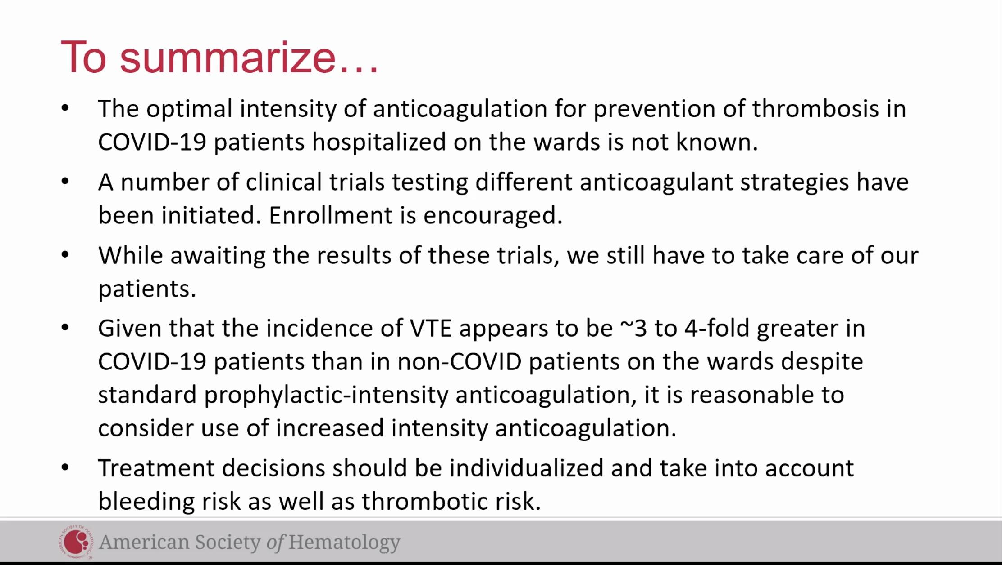
Reasonable to use increased intensity anticoagulation

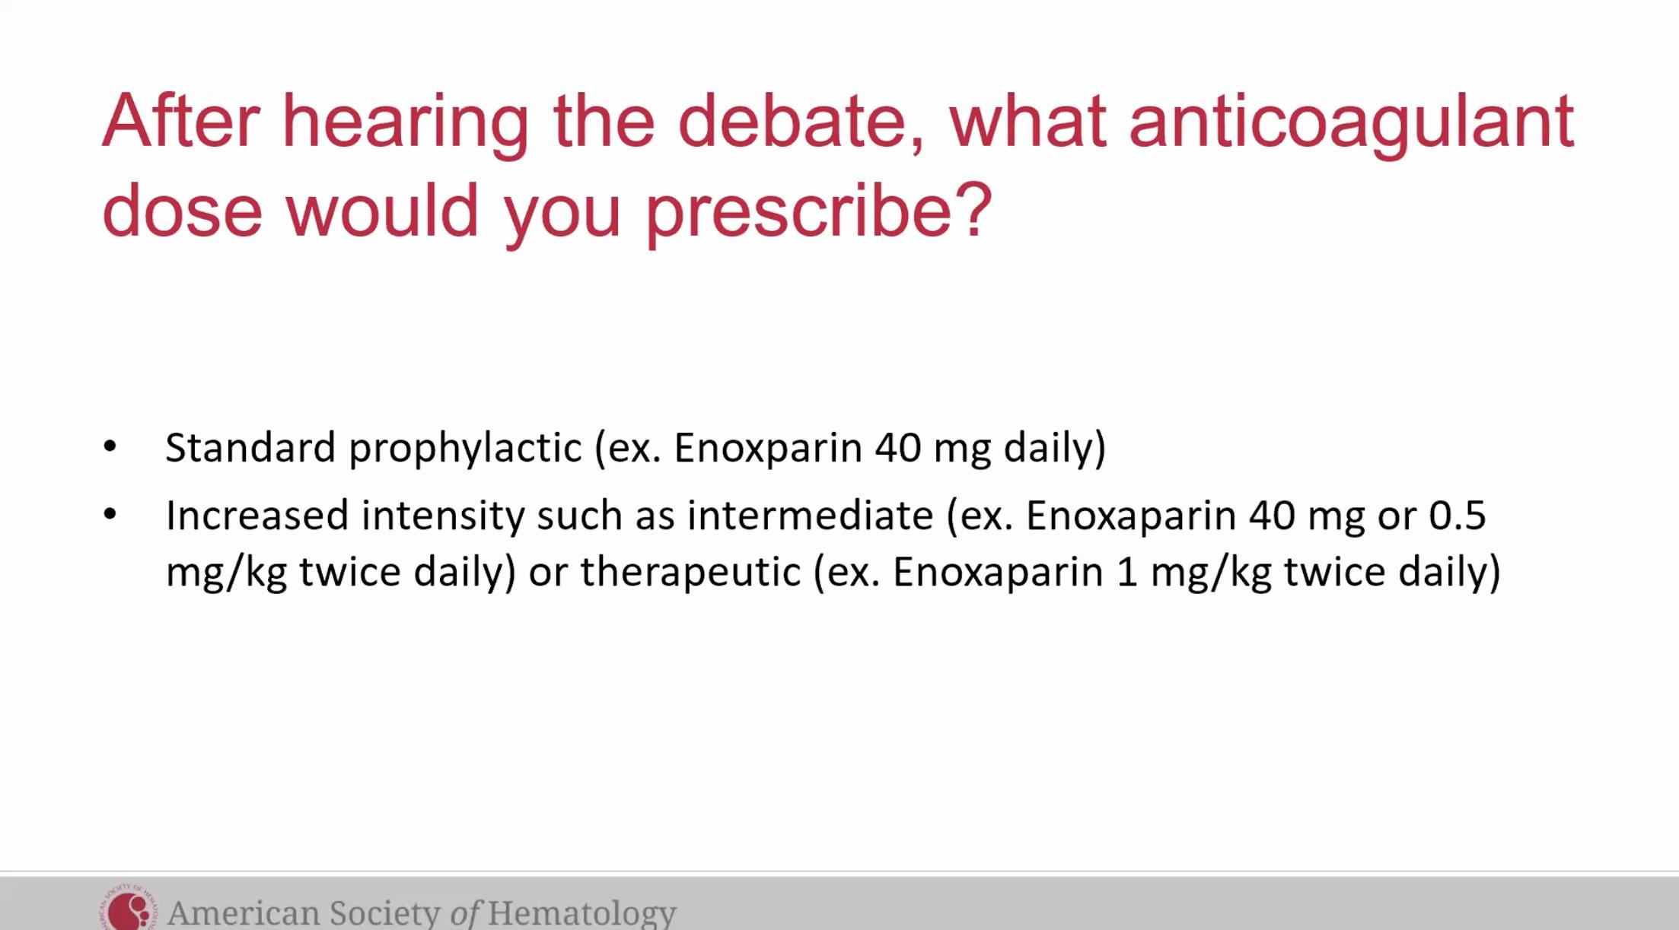
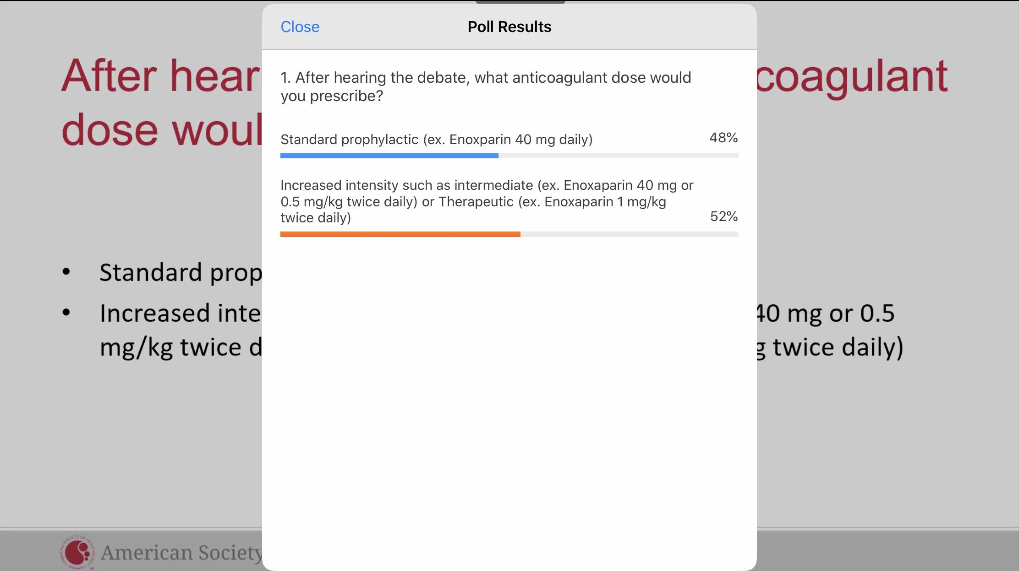
Insert slide polling questions- what anticoagulant dose would you use
Insert slide of poll results

Case 2
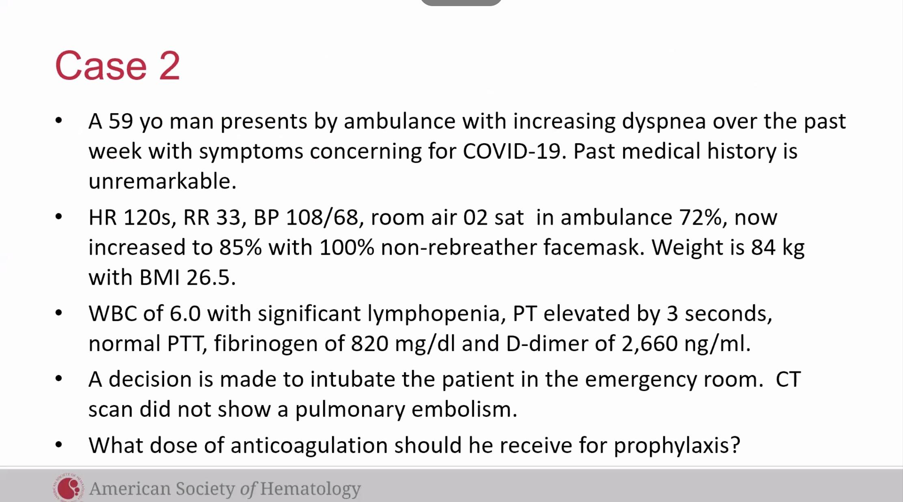

Argument for ppx anticoag, Dr. Lisa Baumann Kreuziger
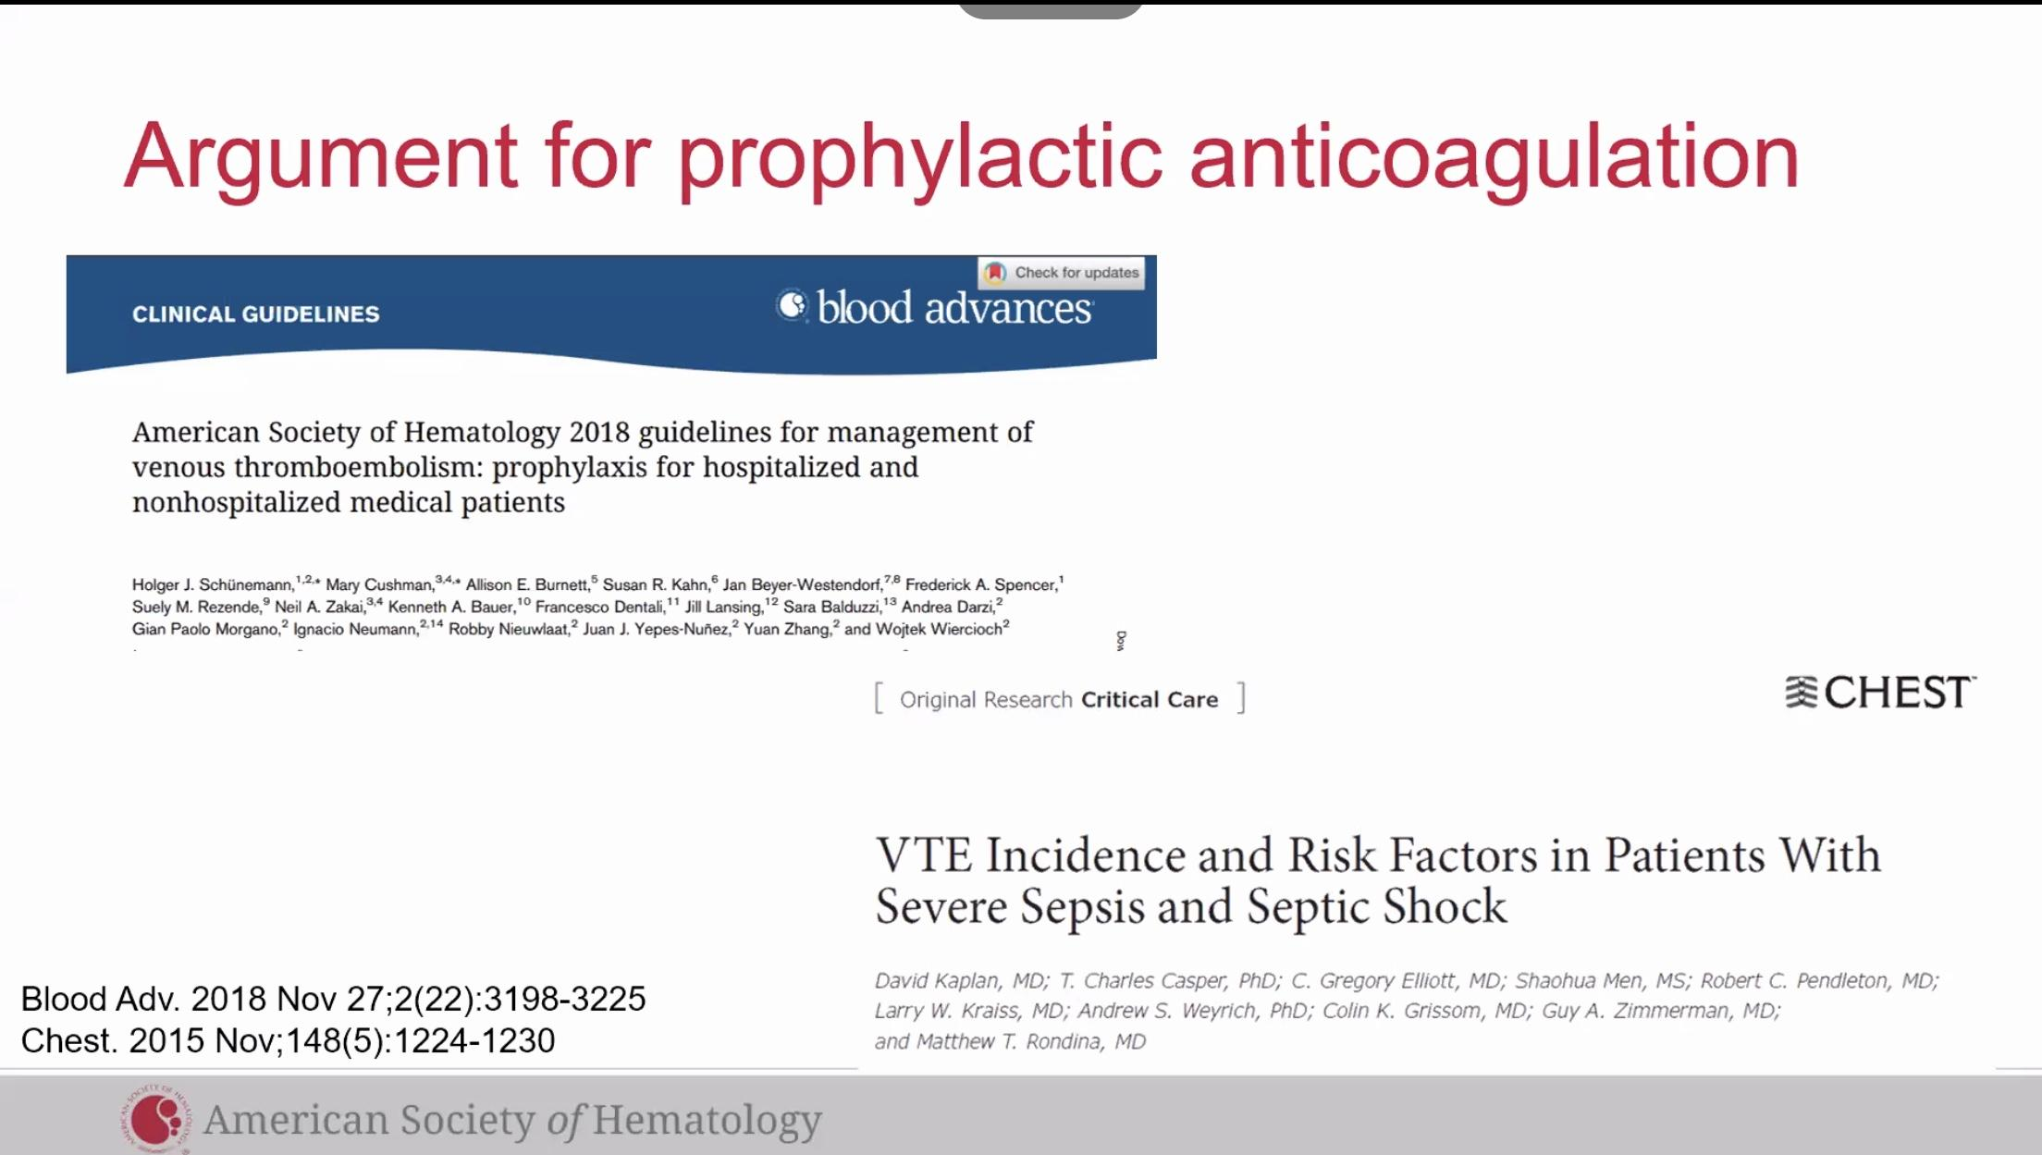

Incidence of VTE & bleeding in critically ill
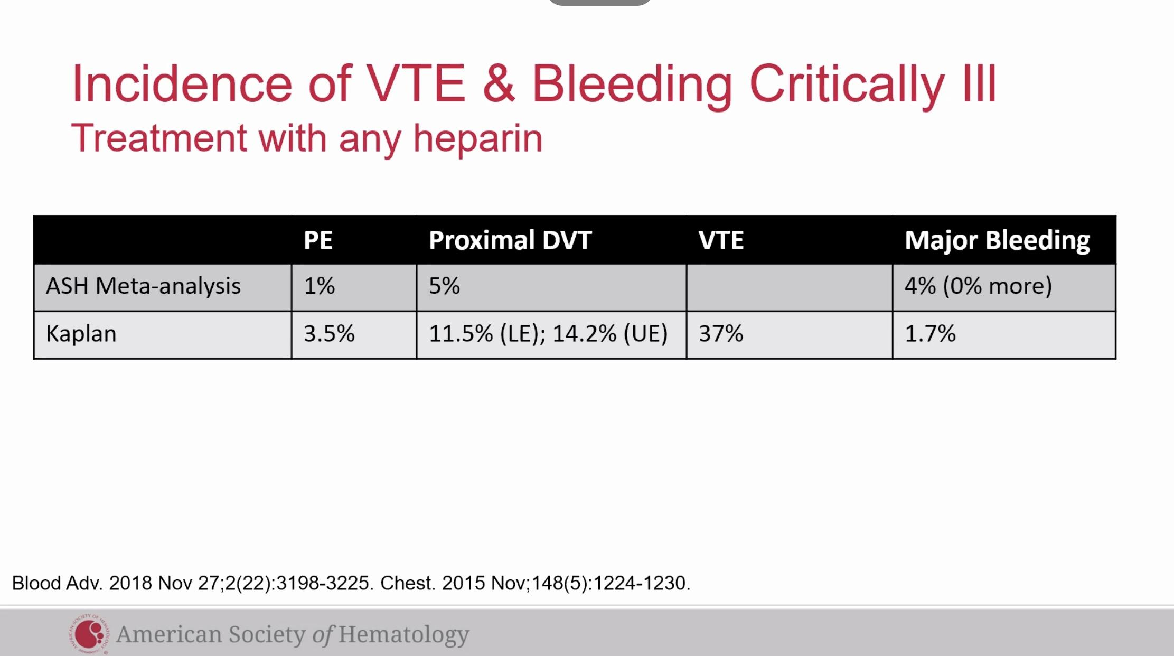

COVID-19 VTE incidence
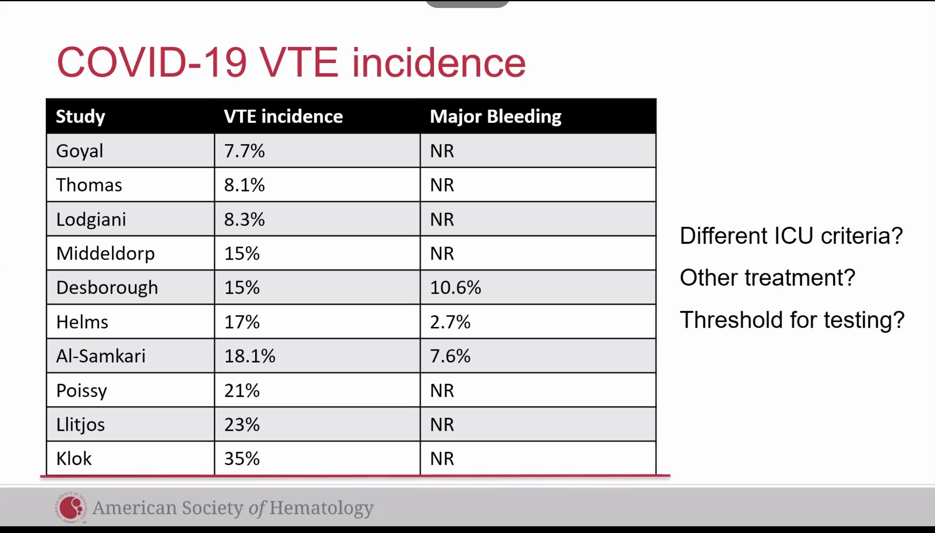
Broad range reported, is there different ICU criteria among different hospitals, what are the other treatments the patient’s receiving (example recovery trial and dexamethasone), what is the threshold for testing among different hospitals?

Society Recommendations
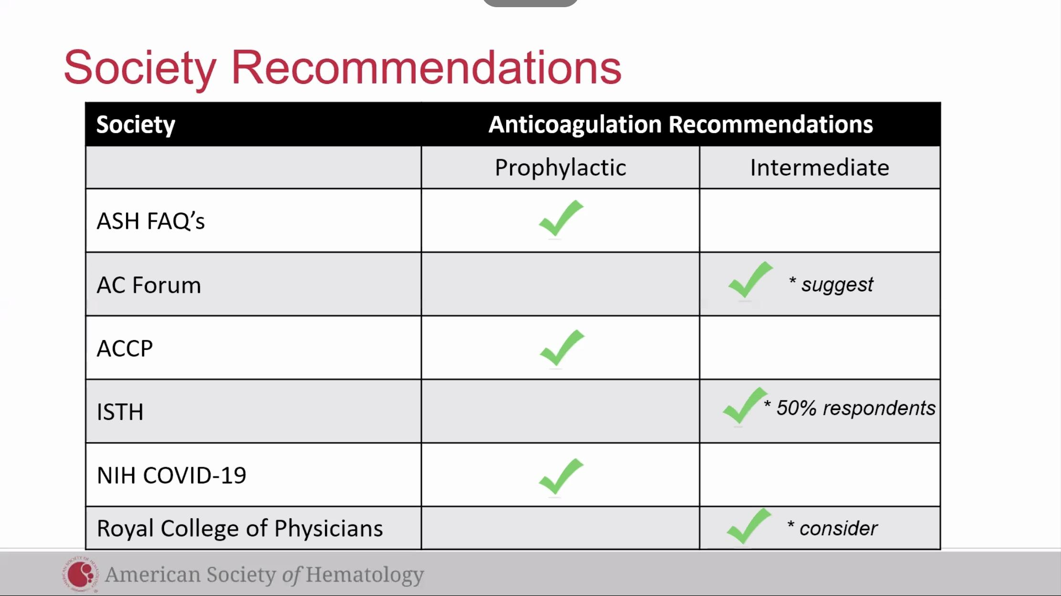

Summarize
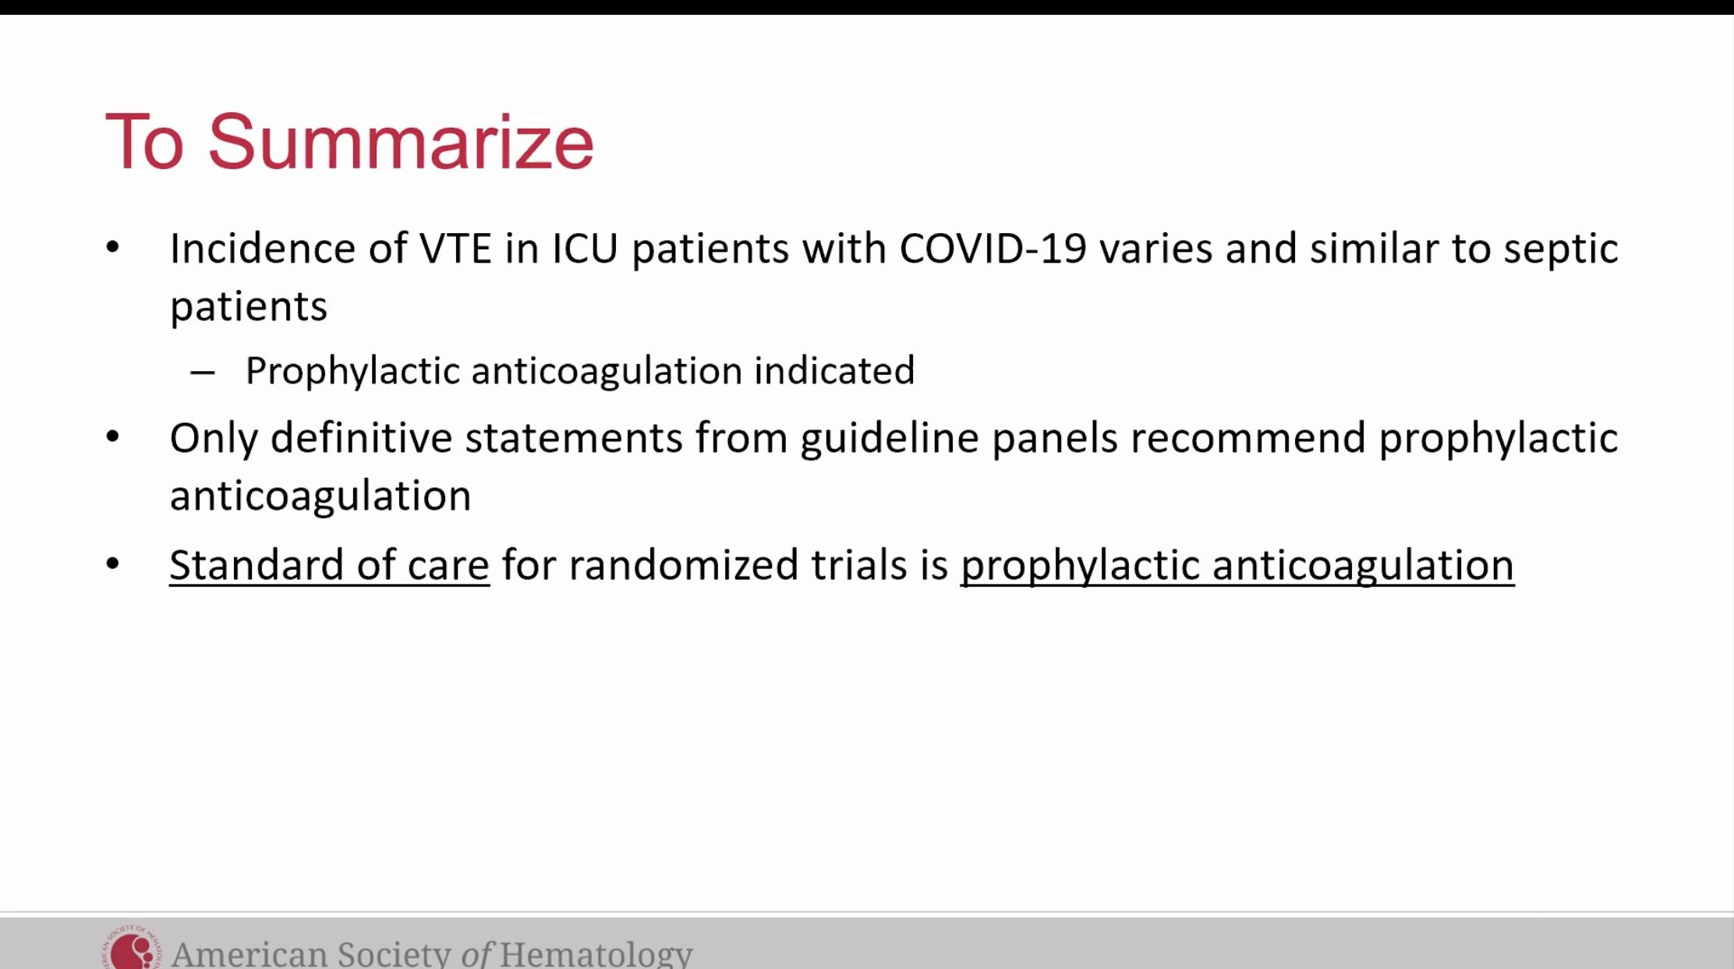

Argument for higher intensity anticoag for patients in ICU- Dr. Adam Cuker
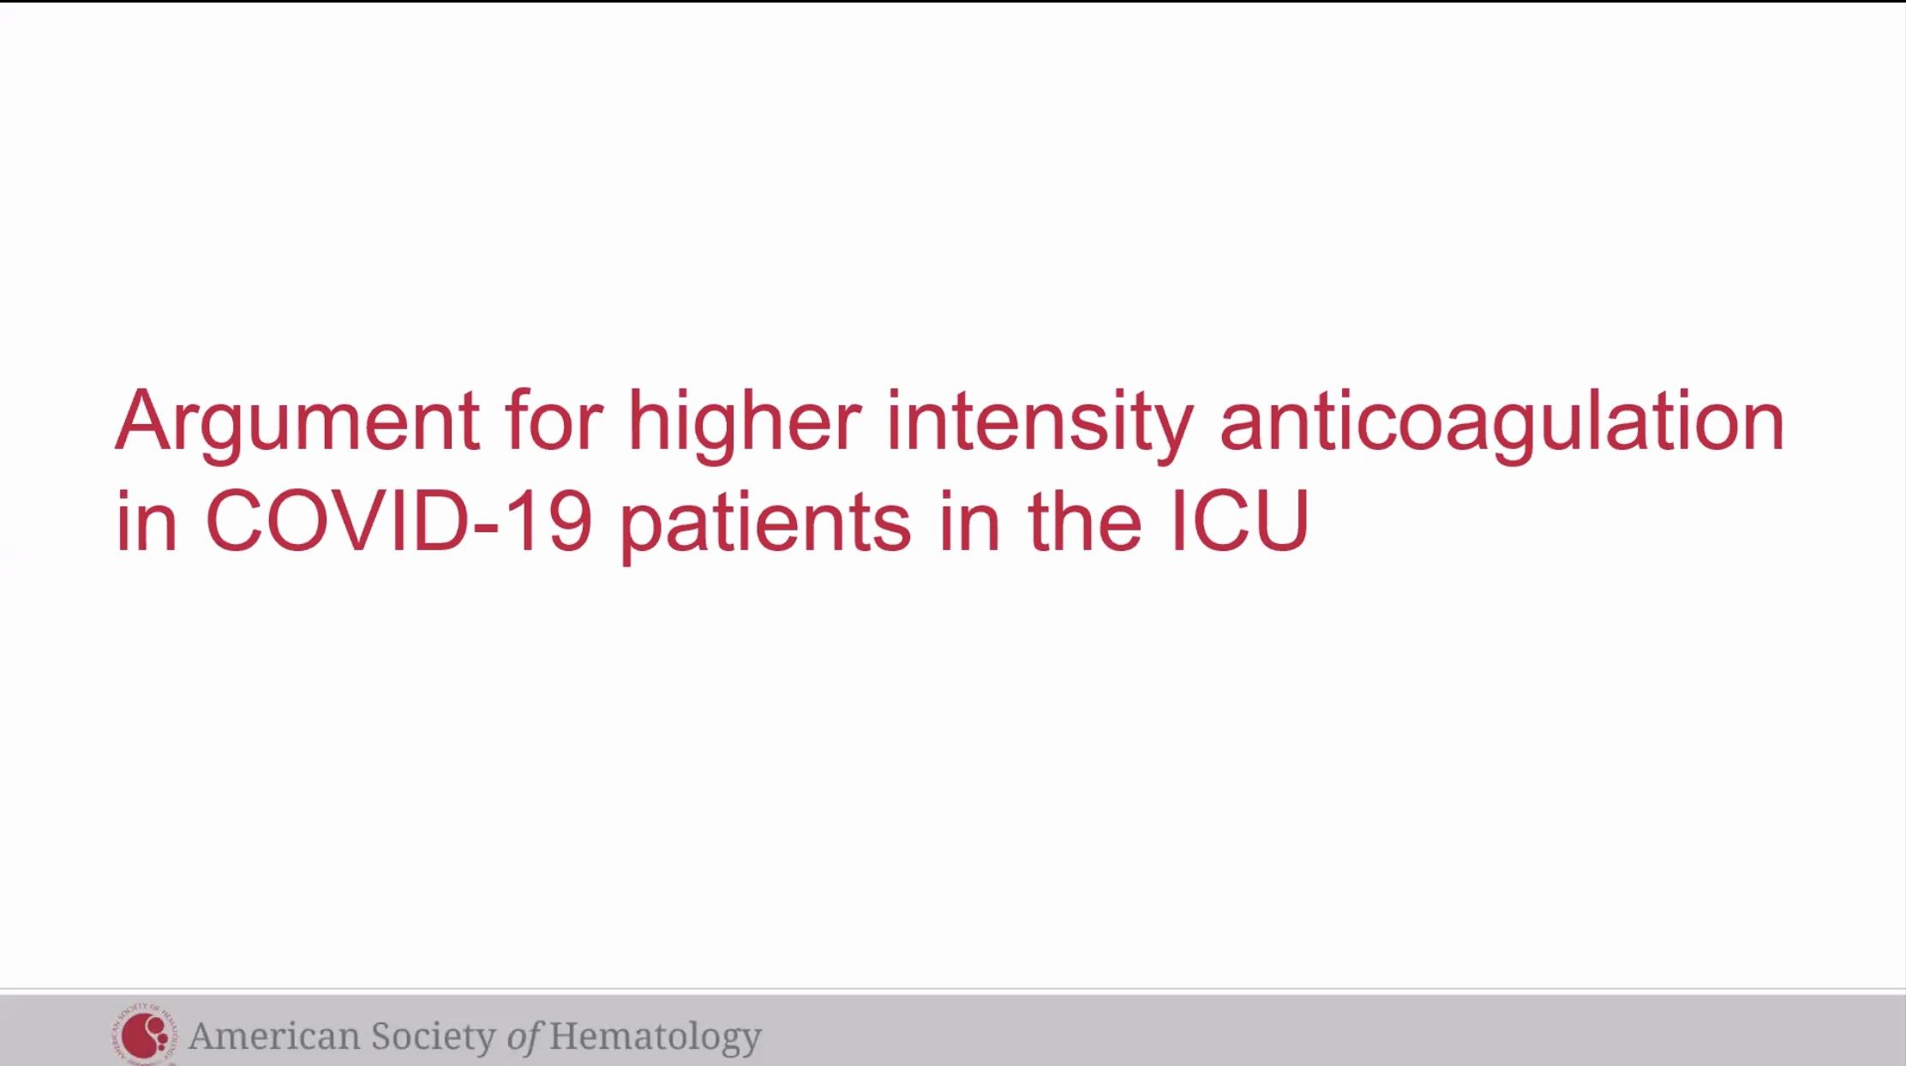

Incidence of thrombosis in the ICU
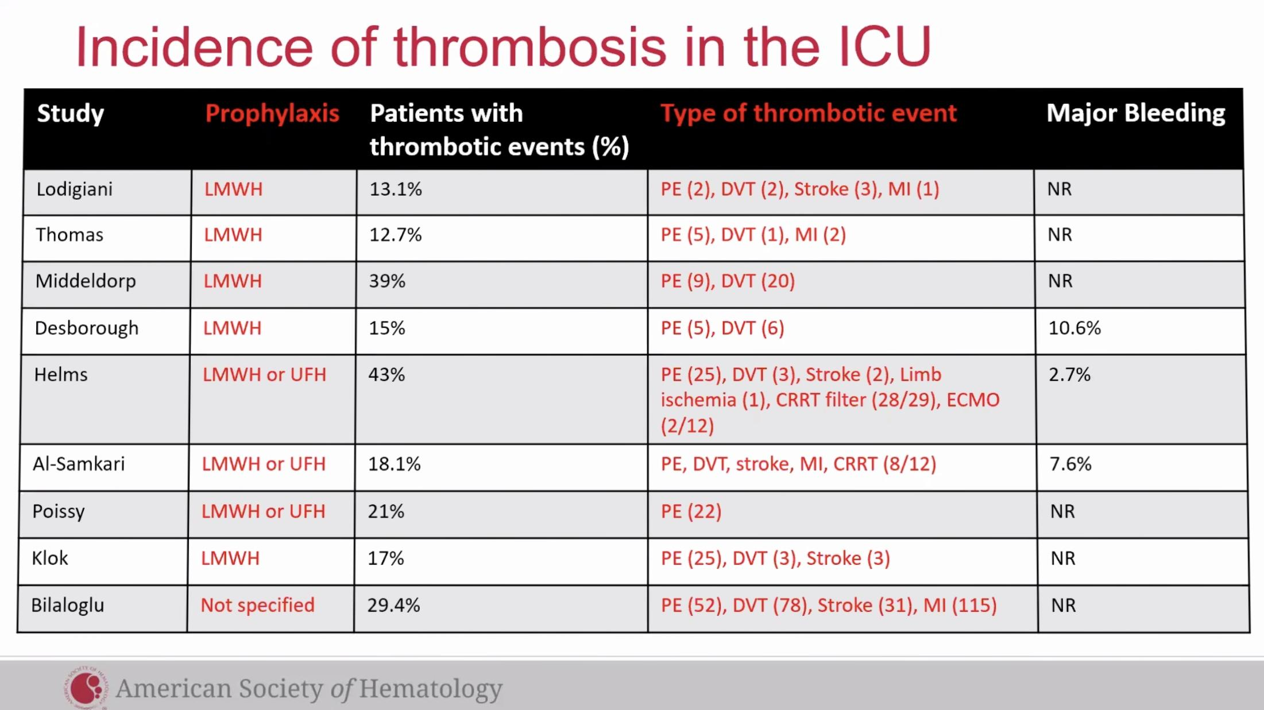
Wide range of thrombotic events

Incidence of thrombosis increased in COVID-19
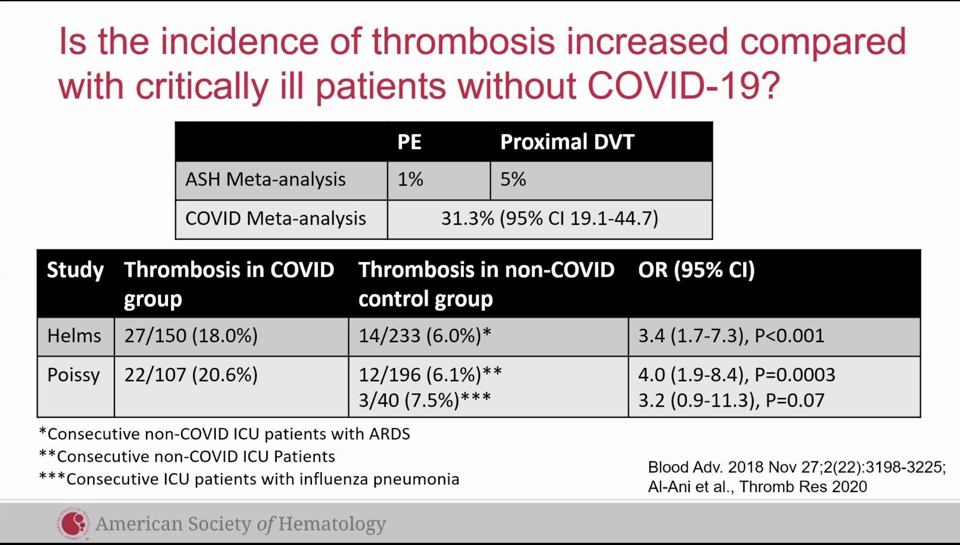 COVID rates much higher of breakthrough DVT after ppx anticoag
-Low quality observational studies, but all the data we have at this time
2 studies that included a non-covid control group. French studies. Helms and Poissy.
Baseline risk might be 3-4 x greater in COVID patients
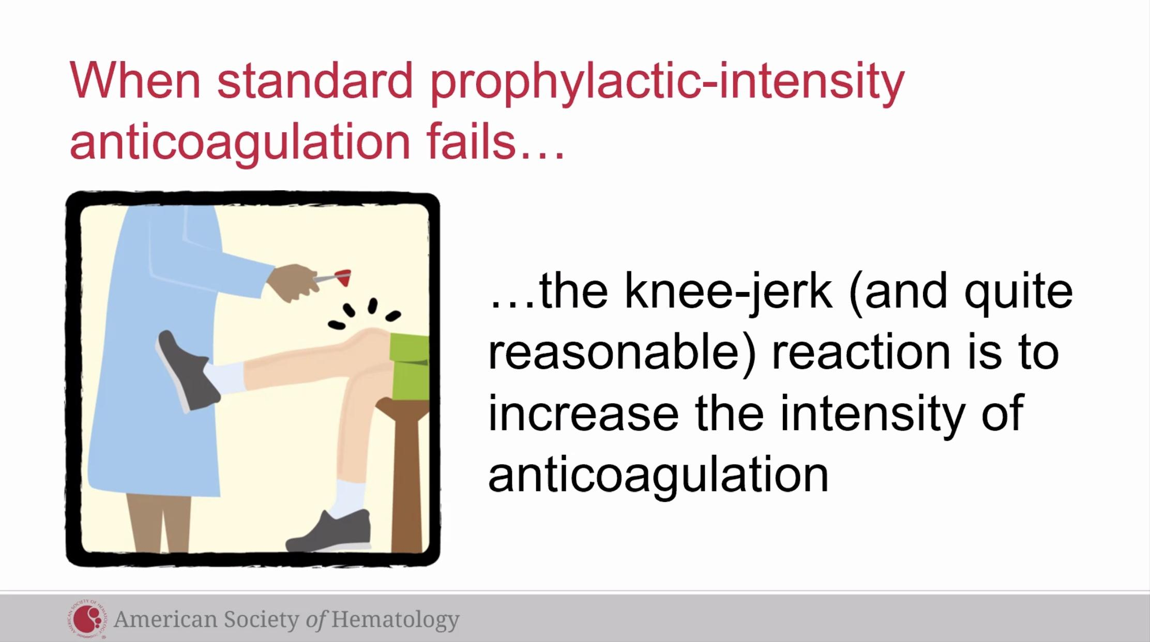

Clinical Trials
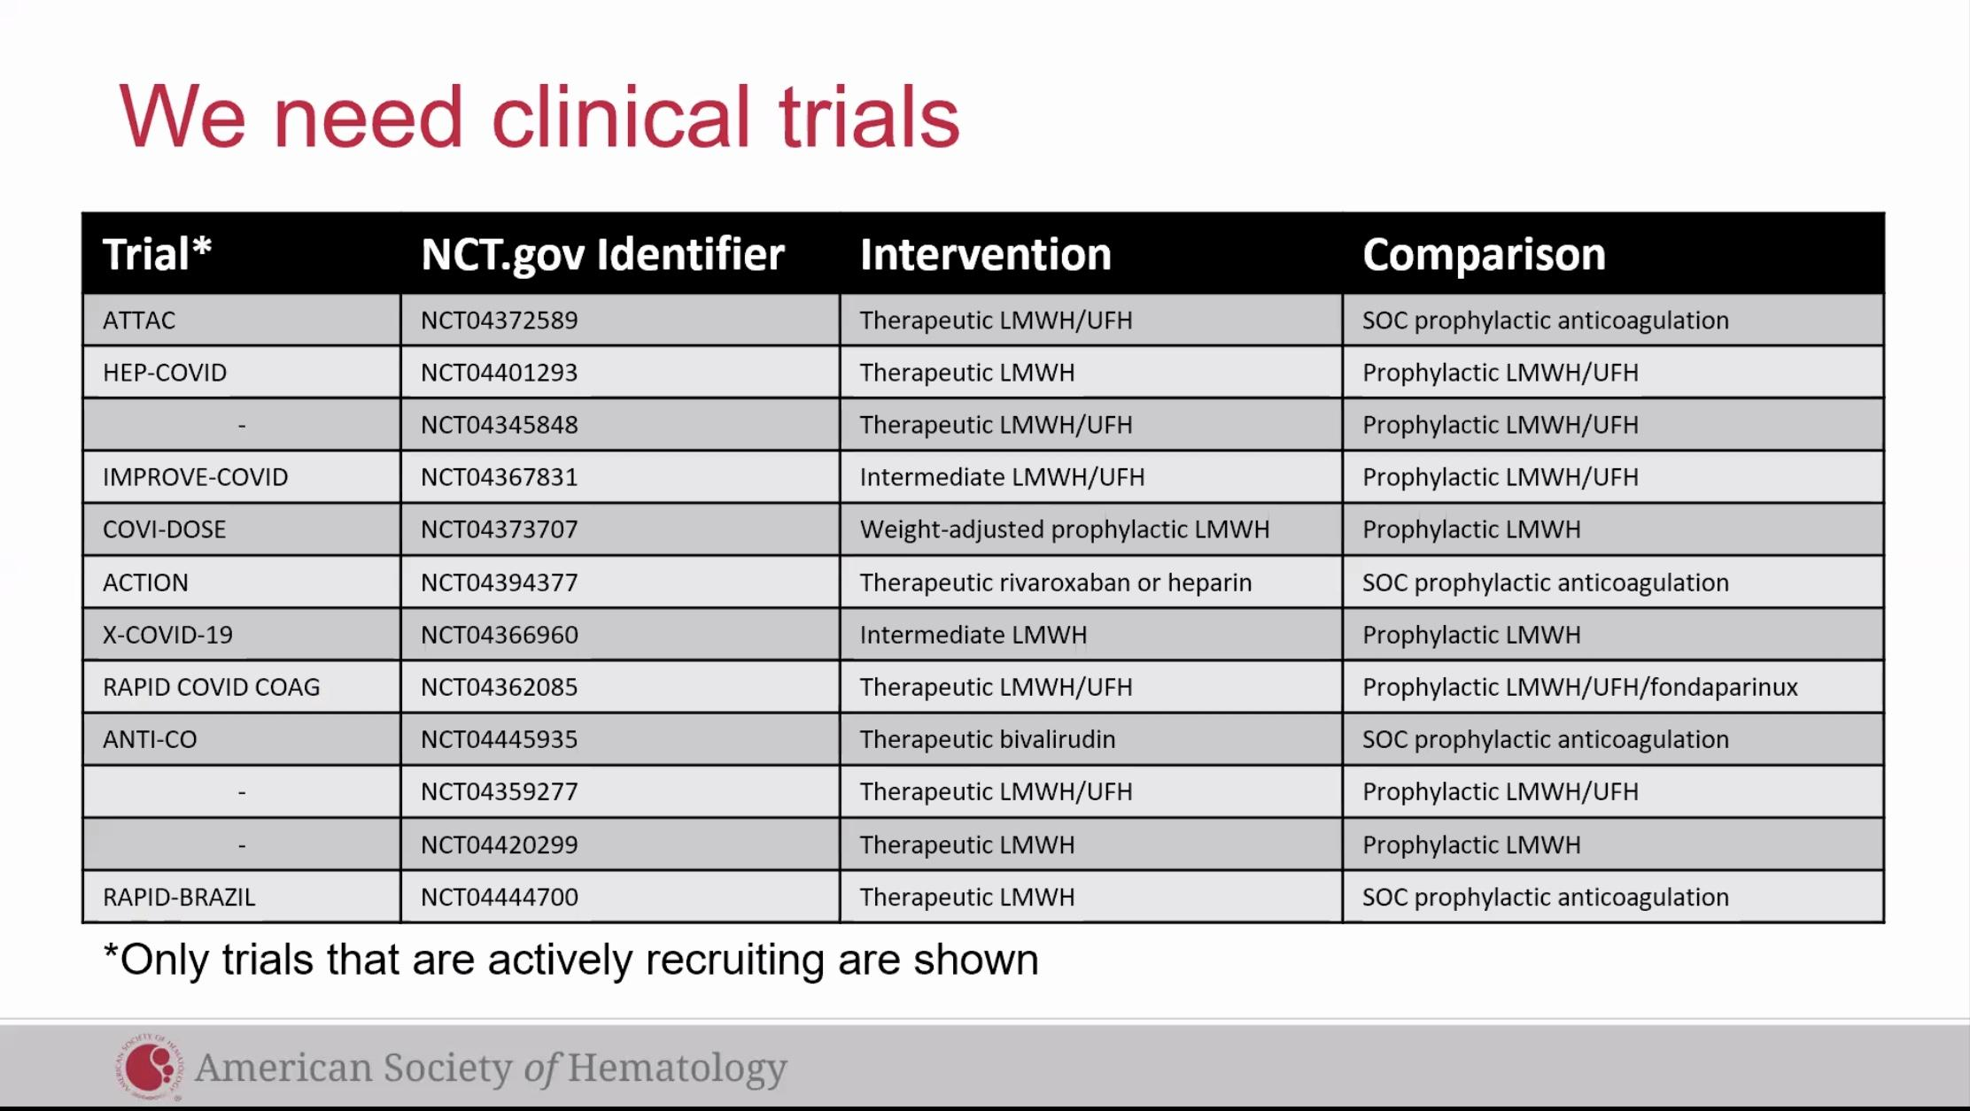

Summarize
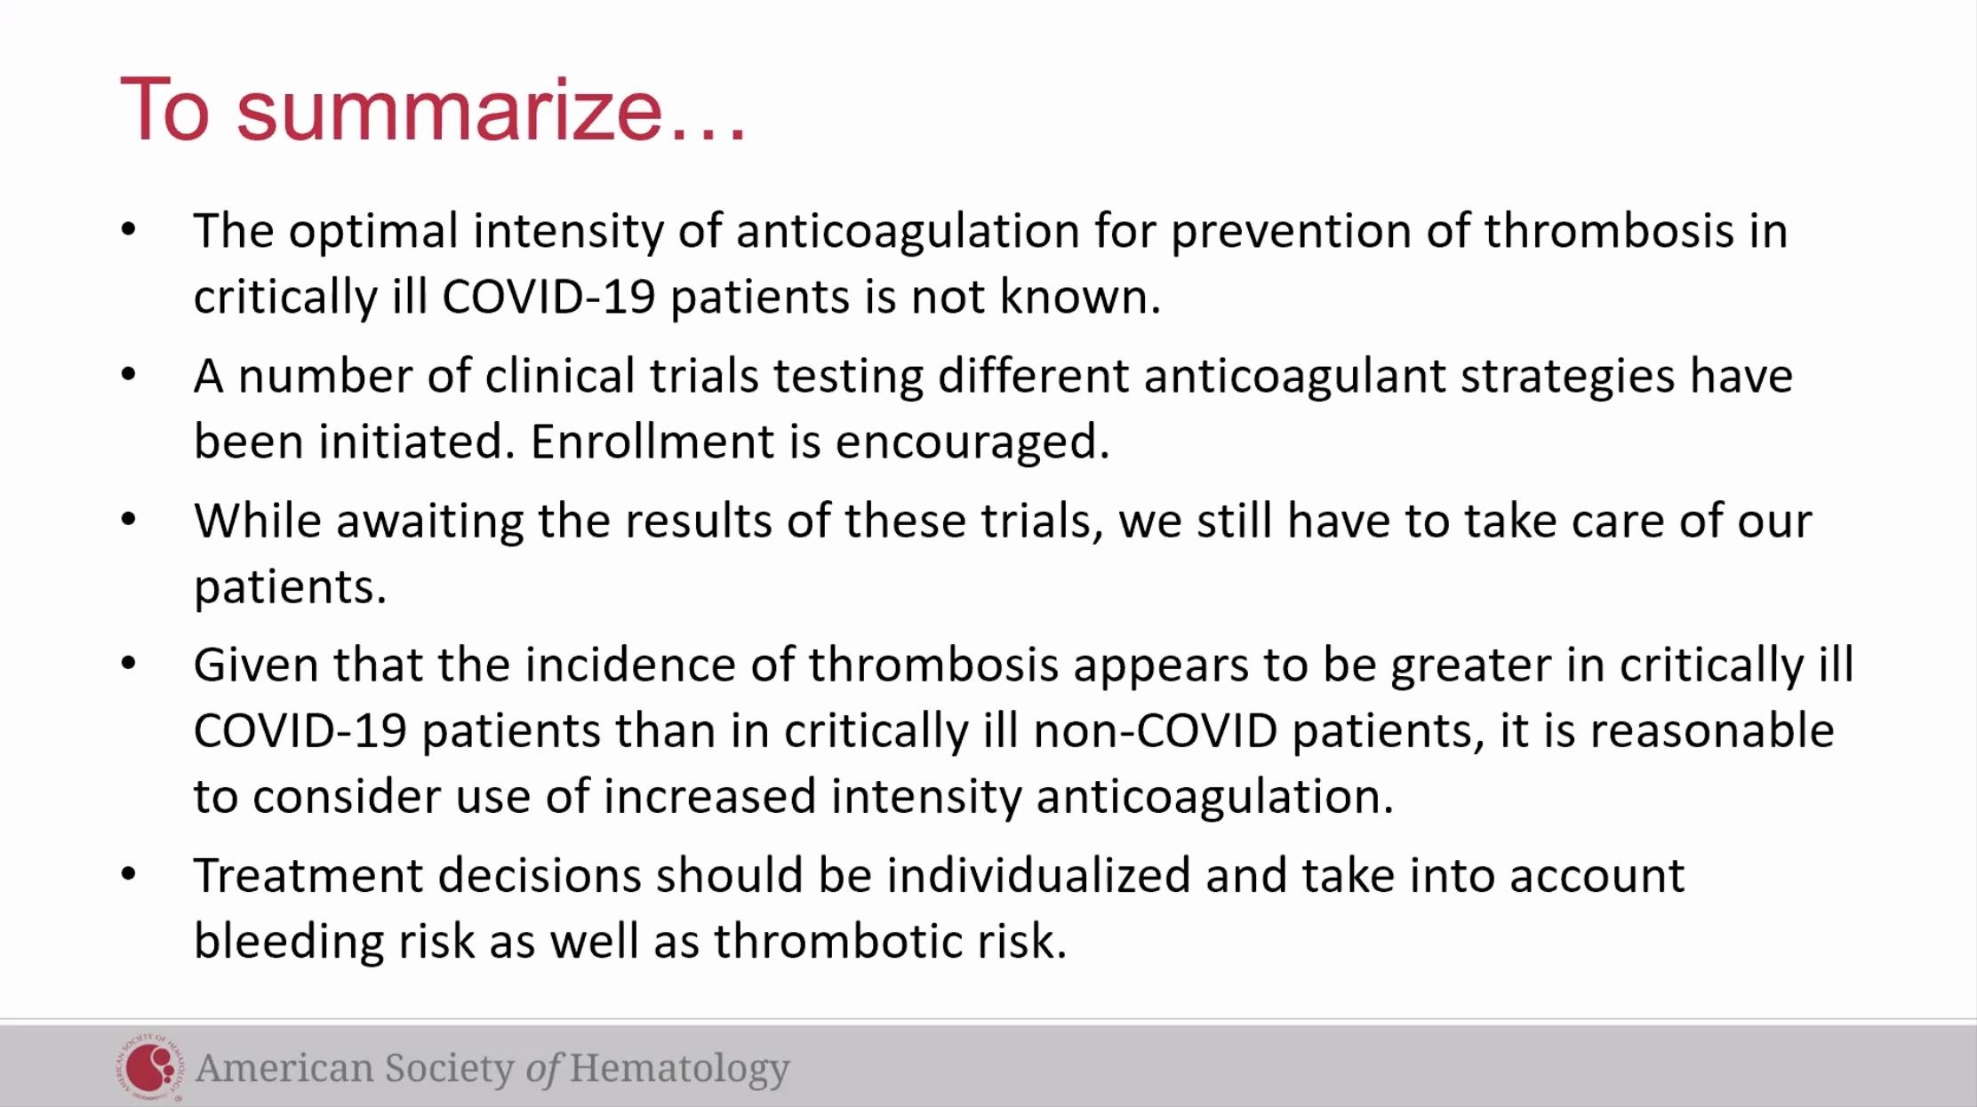

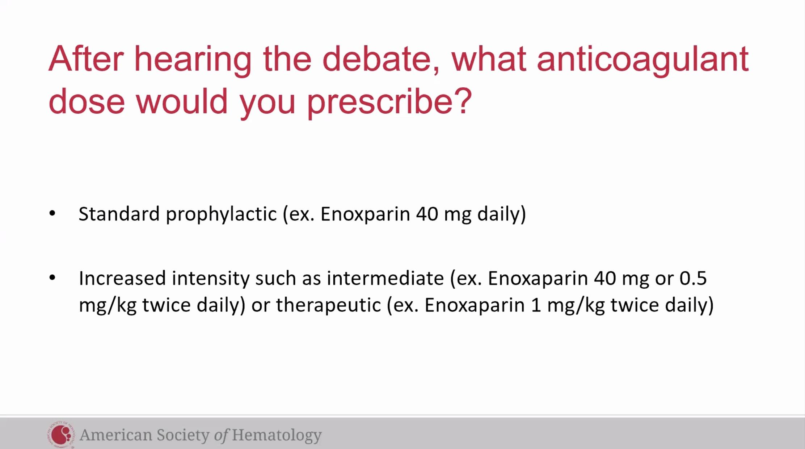

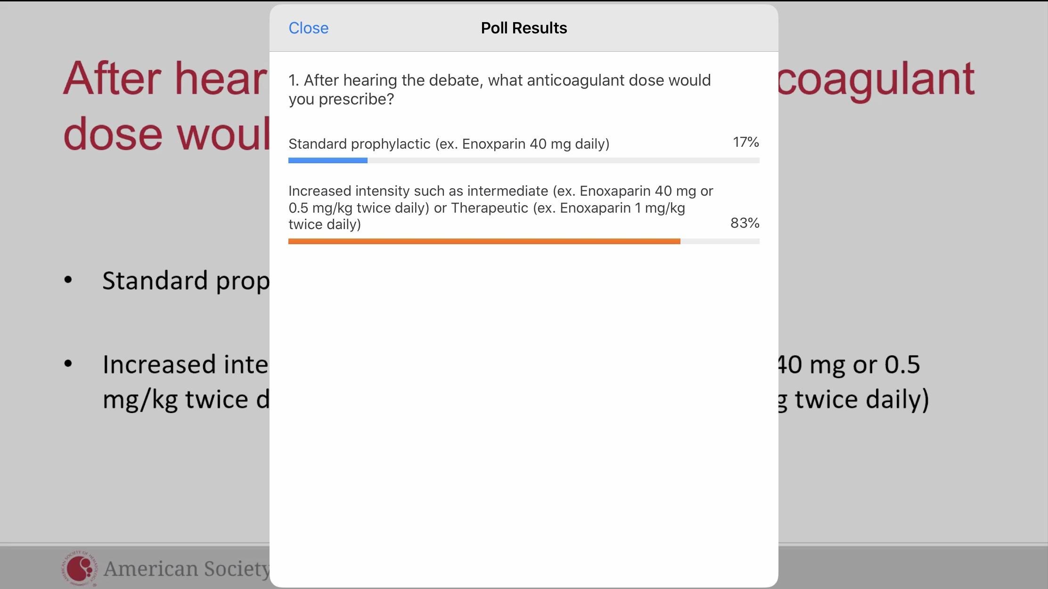

Covid-19 Virchow’s triad
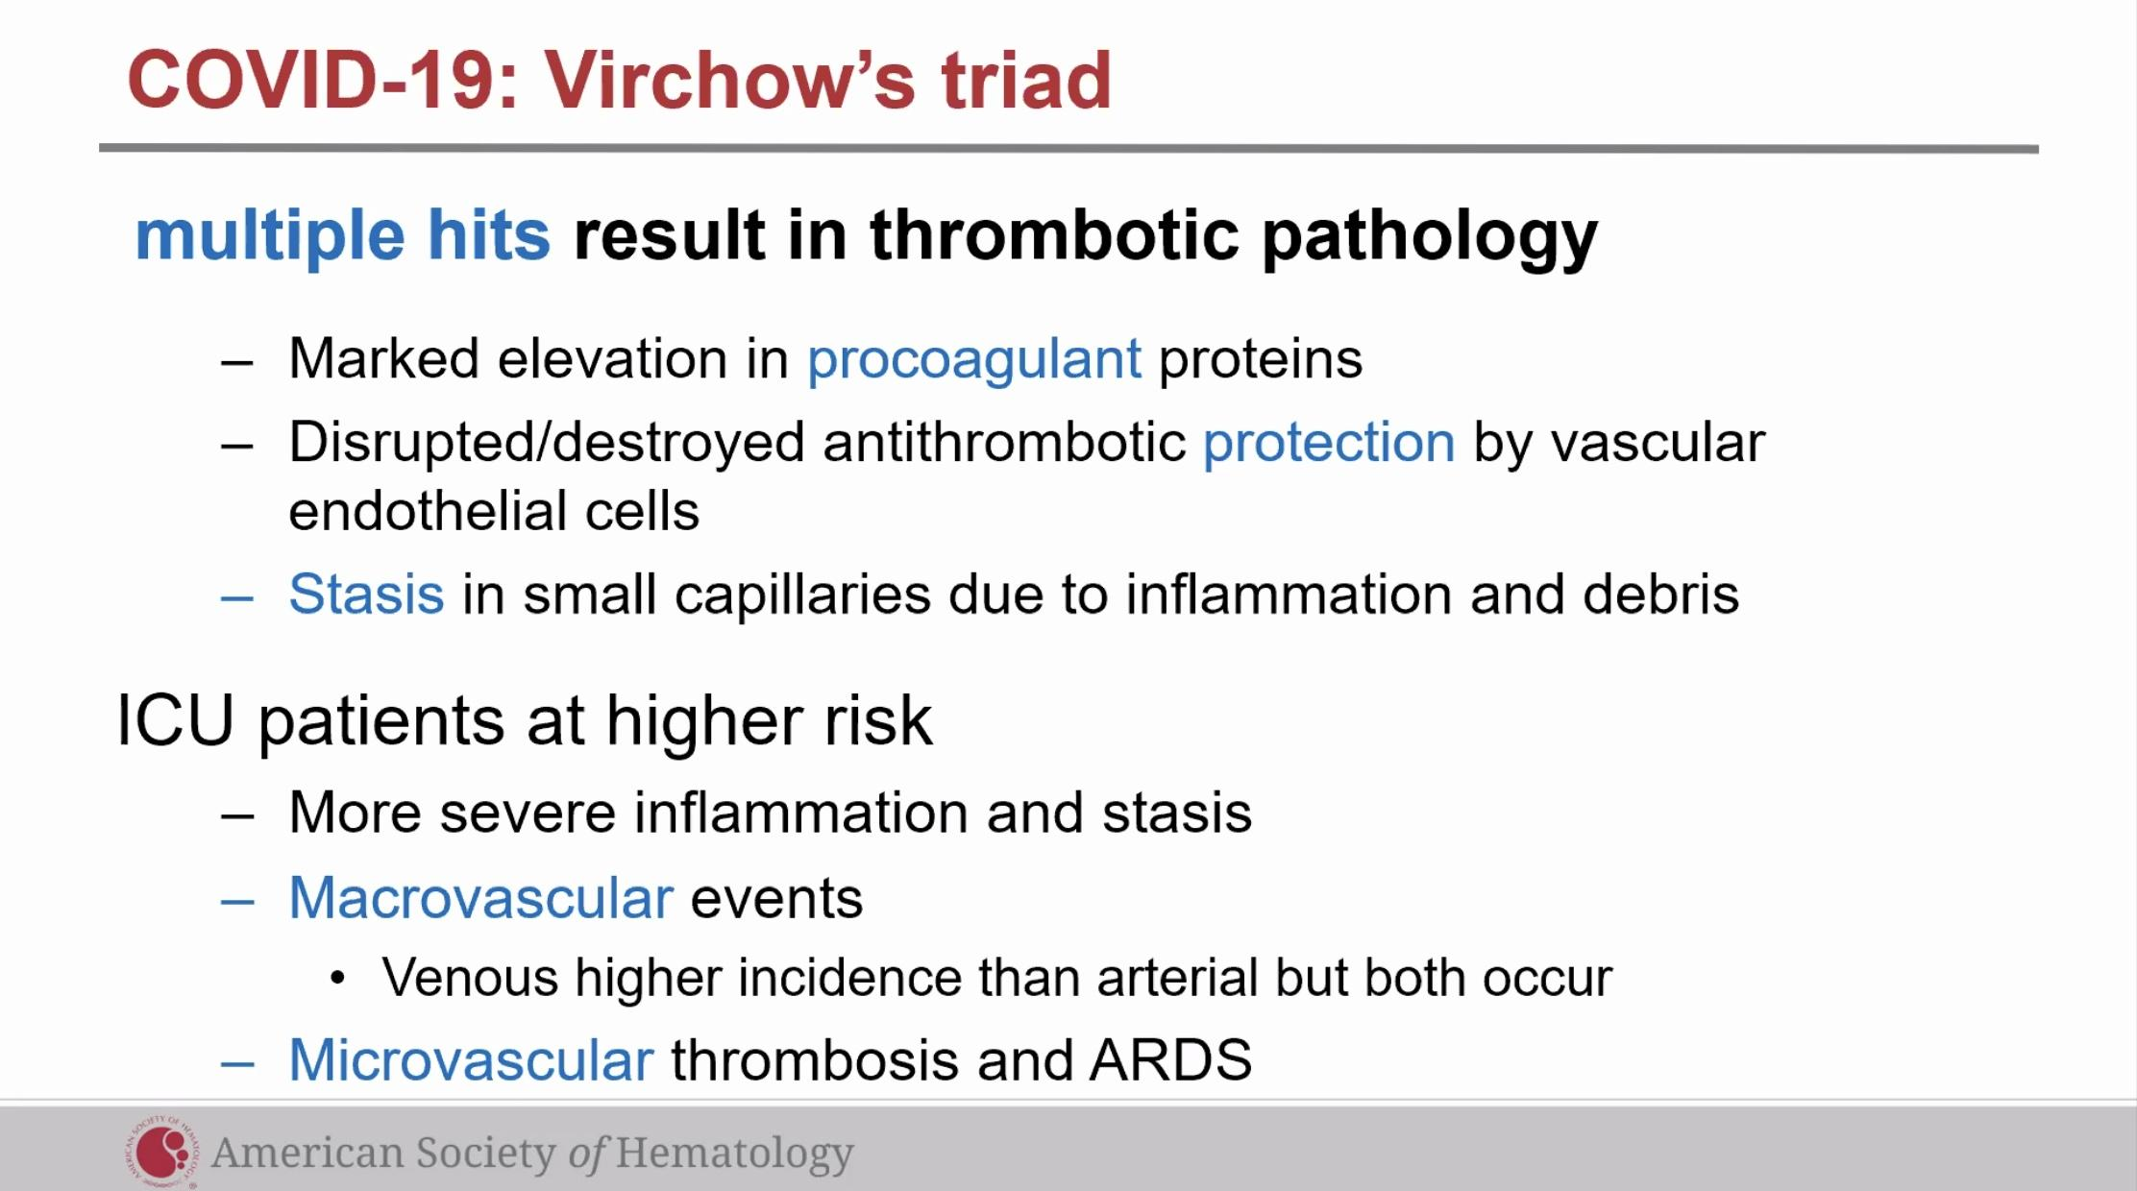
** “Virchow’s triad on steroids” in COVID-19 ** Increase in young patients as well, getting lay attention.

COVID-19 Summary
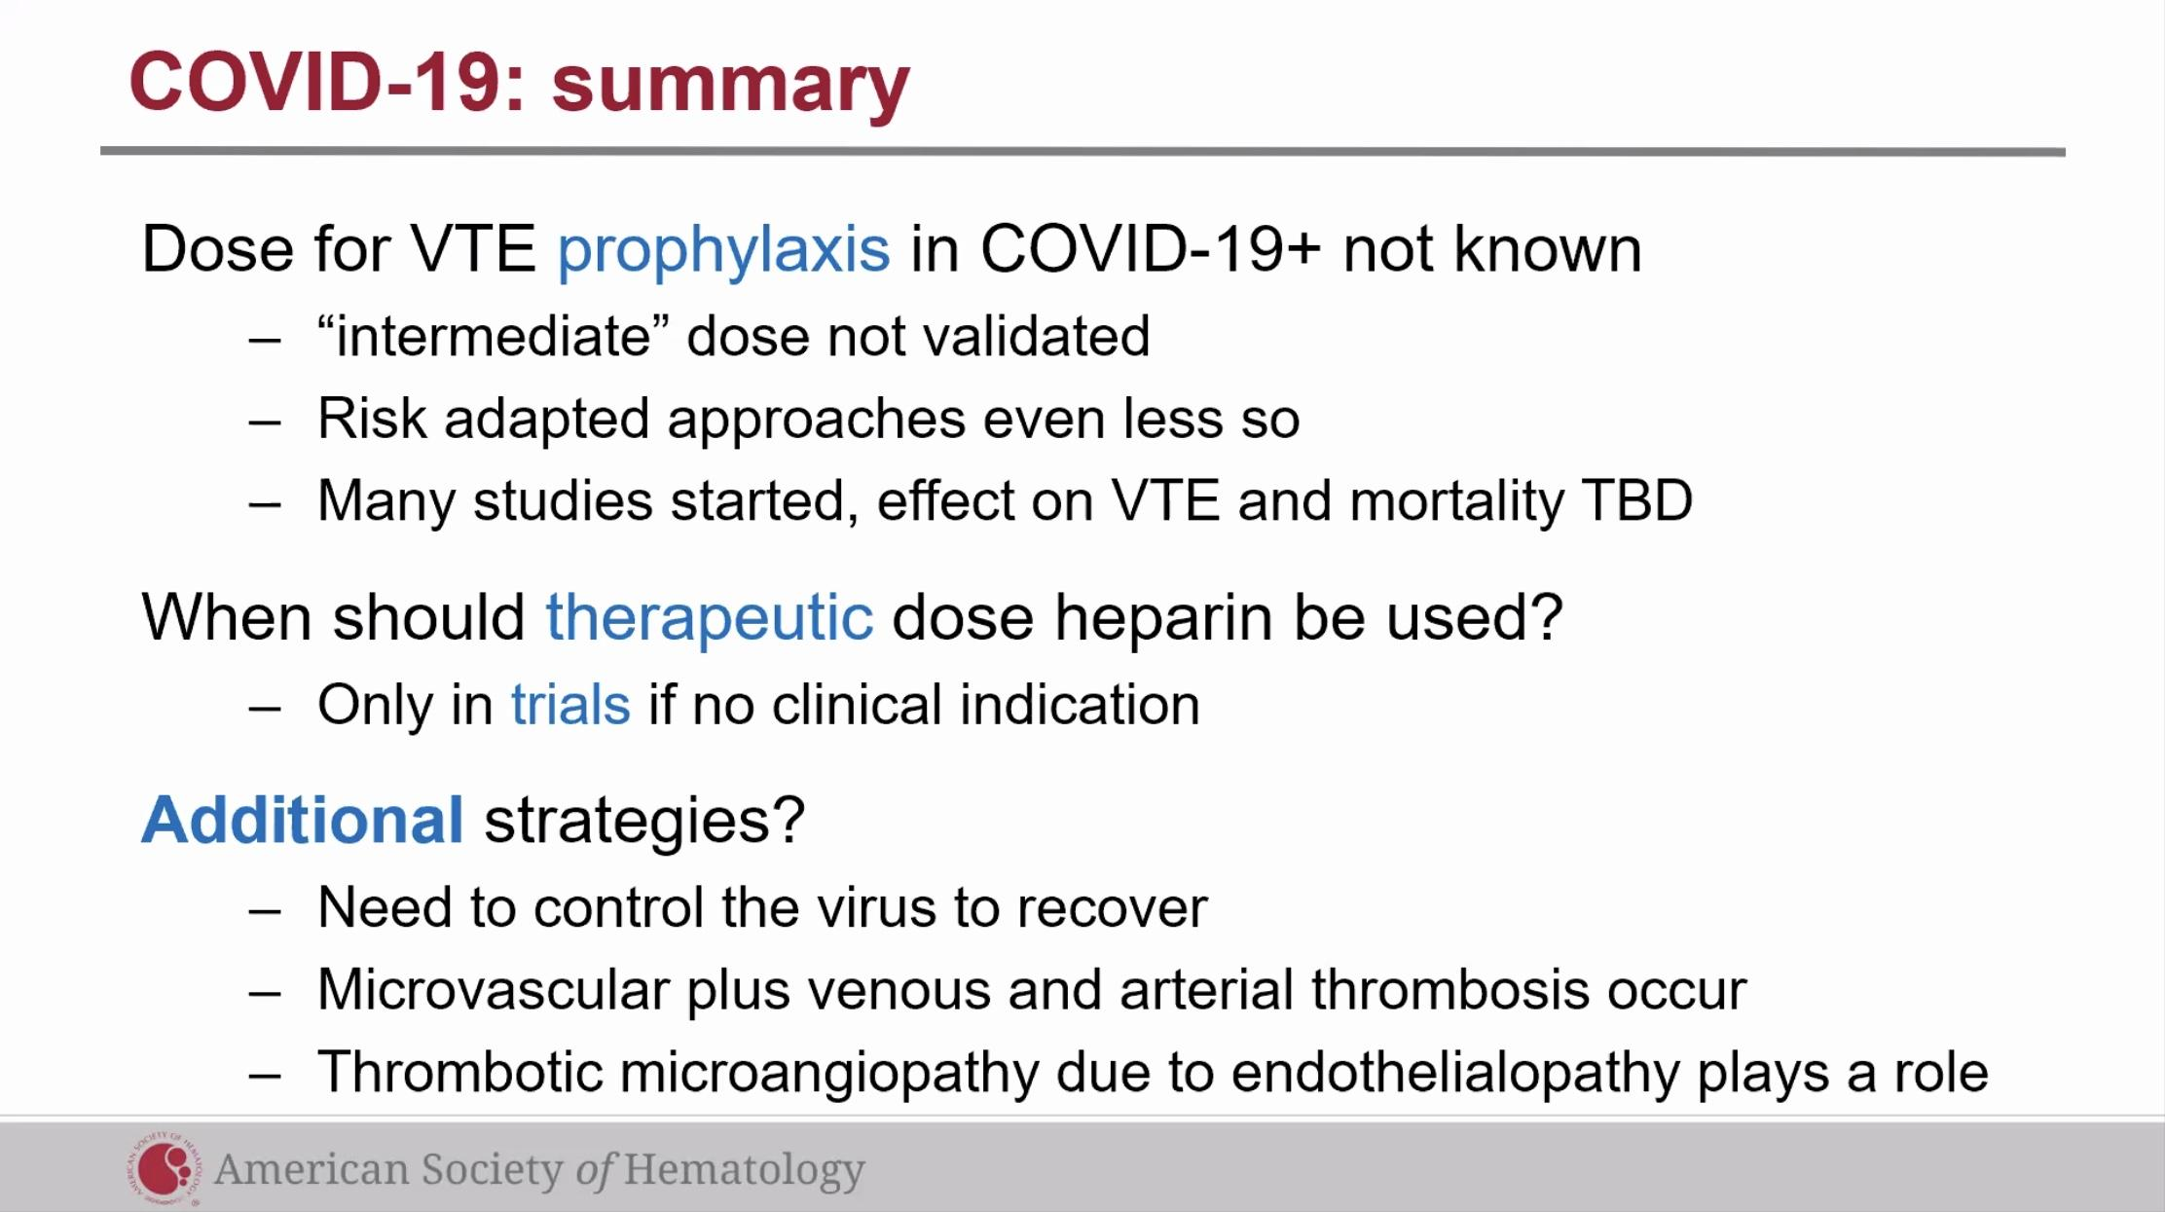
Some institutions using increments of 10 mg/kg approach dose anticoagulation.
We really don’t have enough data, If we want to use a higher amount in patients that don’t have a mechanical heart valve, or DVT please enroll in a clinical trial.
Most important to control the virus, High amounts of willebrand factor released in the damaged cells.

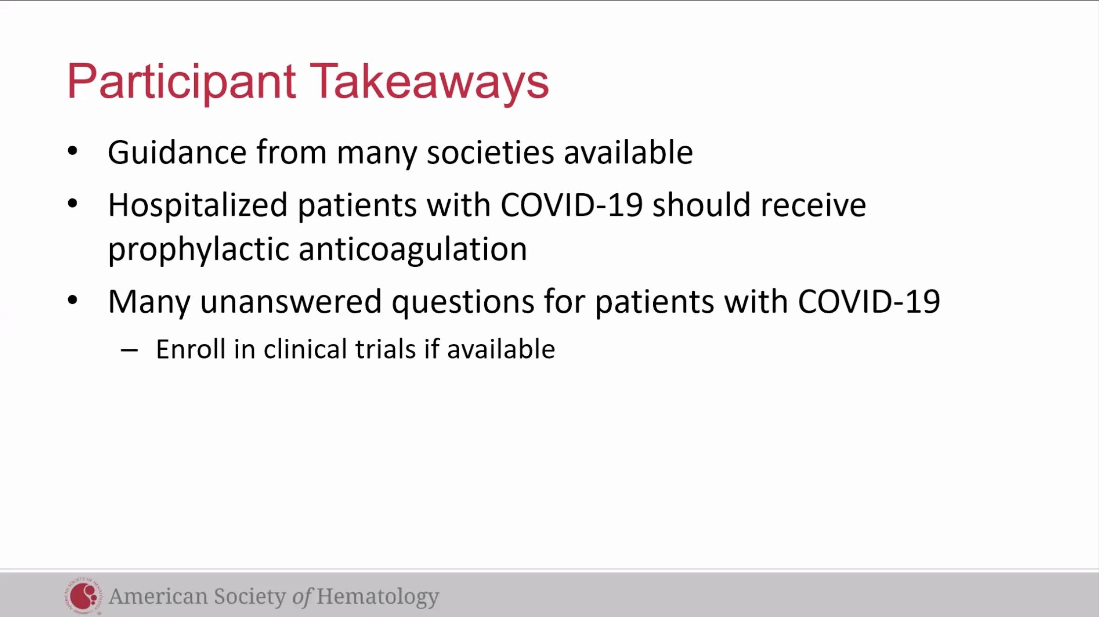

Q&A

Use of Lovenox vs a DOAC?
-Different arguments. No direct head to head comparisons. Dr. Adam Cuker: his preference has been LMWH and UFH in reduced renal function, just because there is extensive evidence in non-covid patients.
-Can’t say it would be wrong to use a DOAC though.

What to do w patients already on PO anticoags?
-If already on anticoag, should be maintained on what they are currently taking. If they can’t take PO or absorb them then switch to full dose therapeutic parenteral anticoag.

Molecular difference in COVID-19 vs influenza that causes increased inflammation?
-No prior exposure to COVID-19 in humans at all, (however there are 4 different coronaviruses that can cause the common cold, there has been some theorizing that people who have previous exposures w these may have some innate immunity and why do better when infected w covid-19). With influenza most have some sort of innate immunity from previous infections/ or vaccination. Also possibly a genetic component among different people.

What to do with a discharged patient that is COVID +?
If patients hospitalized and develop a DVT- recommend 3 months full anticoag at discharge. Same for non-covid patients.
Patient discharged and not had any thrombotic events?
Dr. Lisa Baumann Kreuziger: One study that looked at post dc ppx, there are scores you can calculate to identify a higher risk population in patients who have had a previous VTE who potentially could be a higher risk for a clot. Dr Adam Cuker: same thing at his institution, extrapolating in non-covid patients who have additional risk factors. In hard hit areas had been discharging patients that are still pretty ill in order to admit sicker patients, he would have a low threshold in initiating home VTE PPX for those patients.
-Individualized risk assessment.

COVID patients not admitted to hospital, getting people into trial who they think might have increased inflammation, based on D-dimer, CPR, and they randomizing to ASA, Eliquis, etc.

If you get COVID-19 diagnosis, still continue your normal medication routine (oral contraceptive, tamoxifen) unless you become very ill, contact your health care provider about what you should do.

