COVID-19 Updates #5 Dr. Souvenir

7/10/2020

State of ID as 0fJuly 7, 8539 cases. Total hospitalization 4.6%. Last 3 weeks 3%, 6% and most recent 9% positive testing.
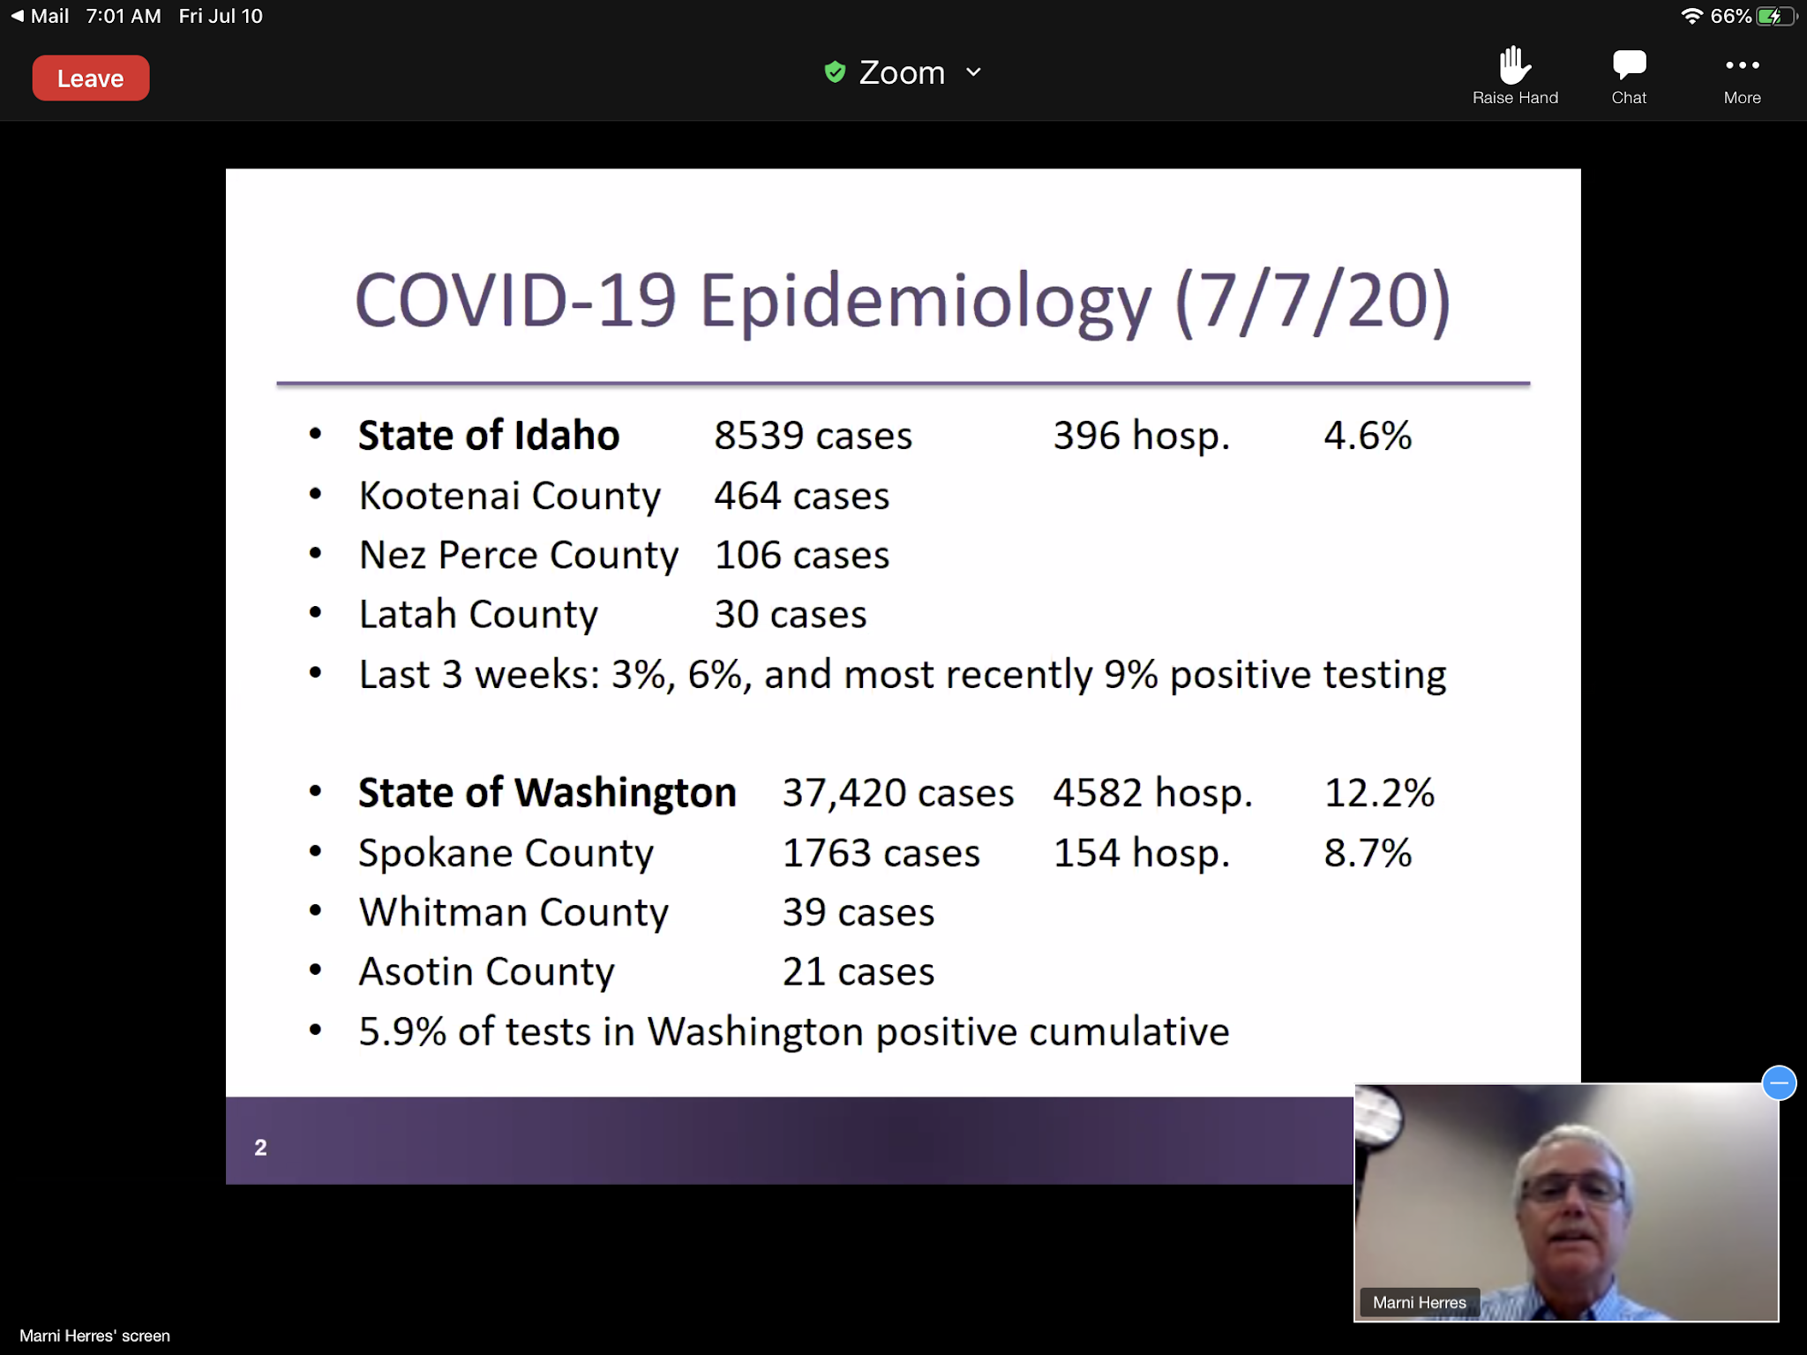
State of WA 37420 cases, 4582 hospitalization, 12.2%

ID State Daily Case Count
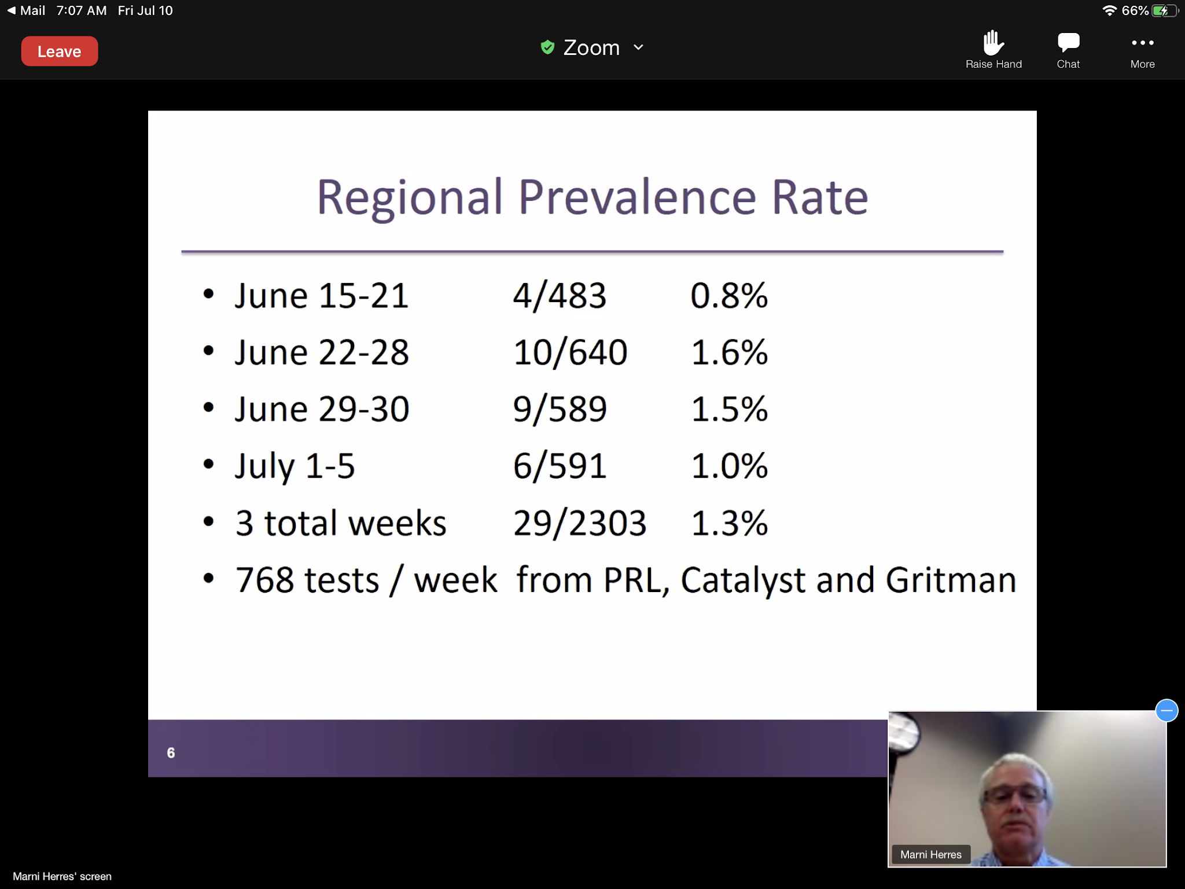
-Have increased testing in our region of symptomatic and asymptomatic
-Once reach 2% start testing all patients that go to St Joes
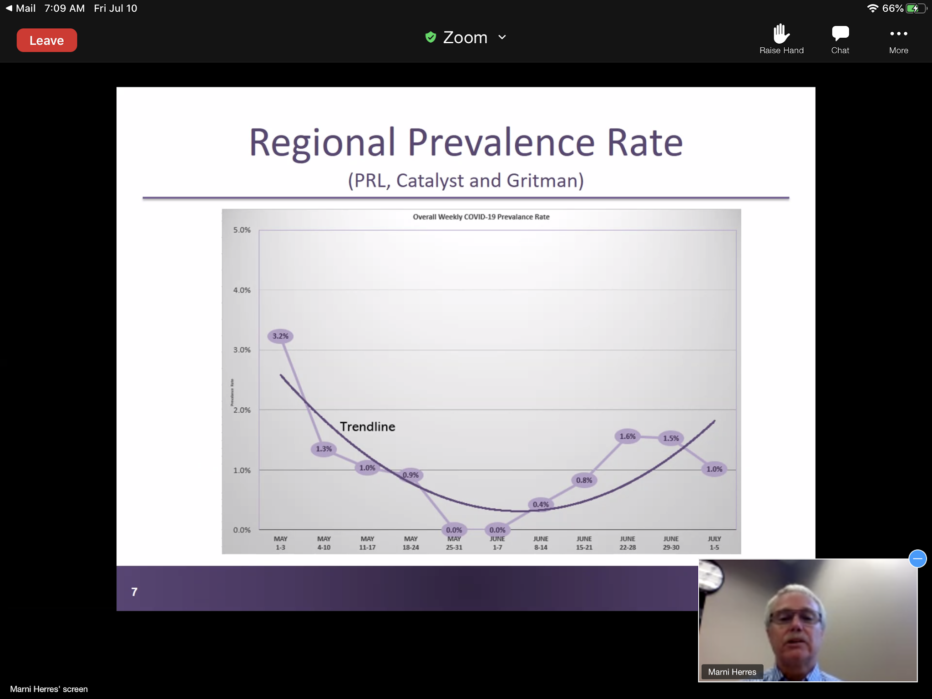

COVID vaccinations
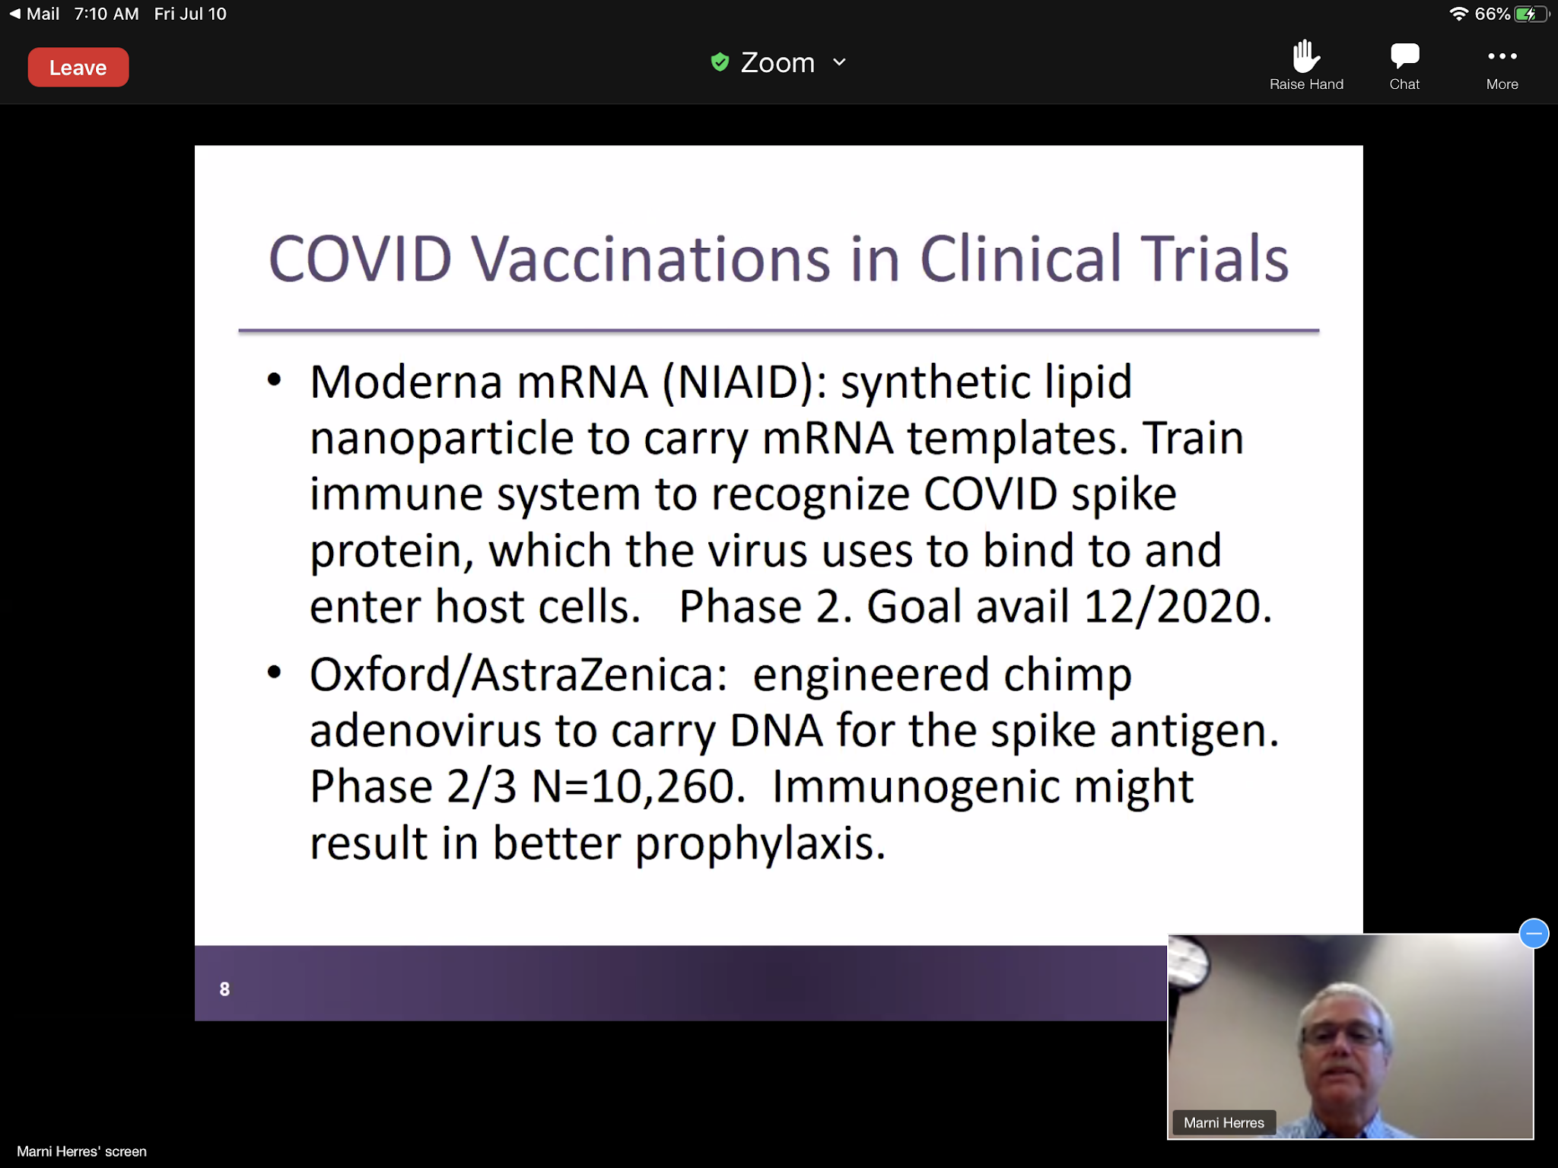
* furthest along
-10 vaccinations in clinical trials
-Lofty goal of 12/20 to have a vaccine out
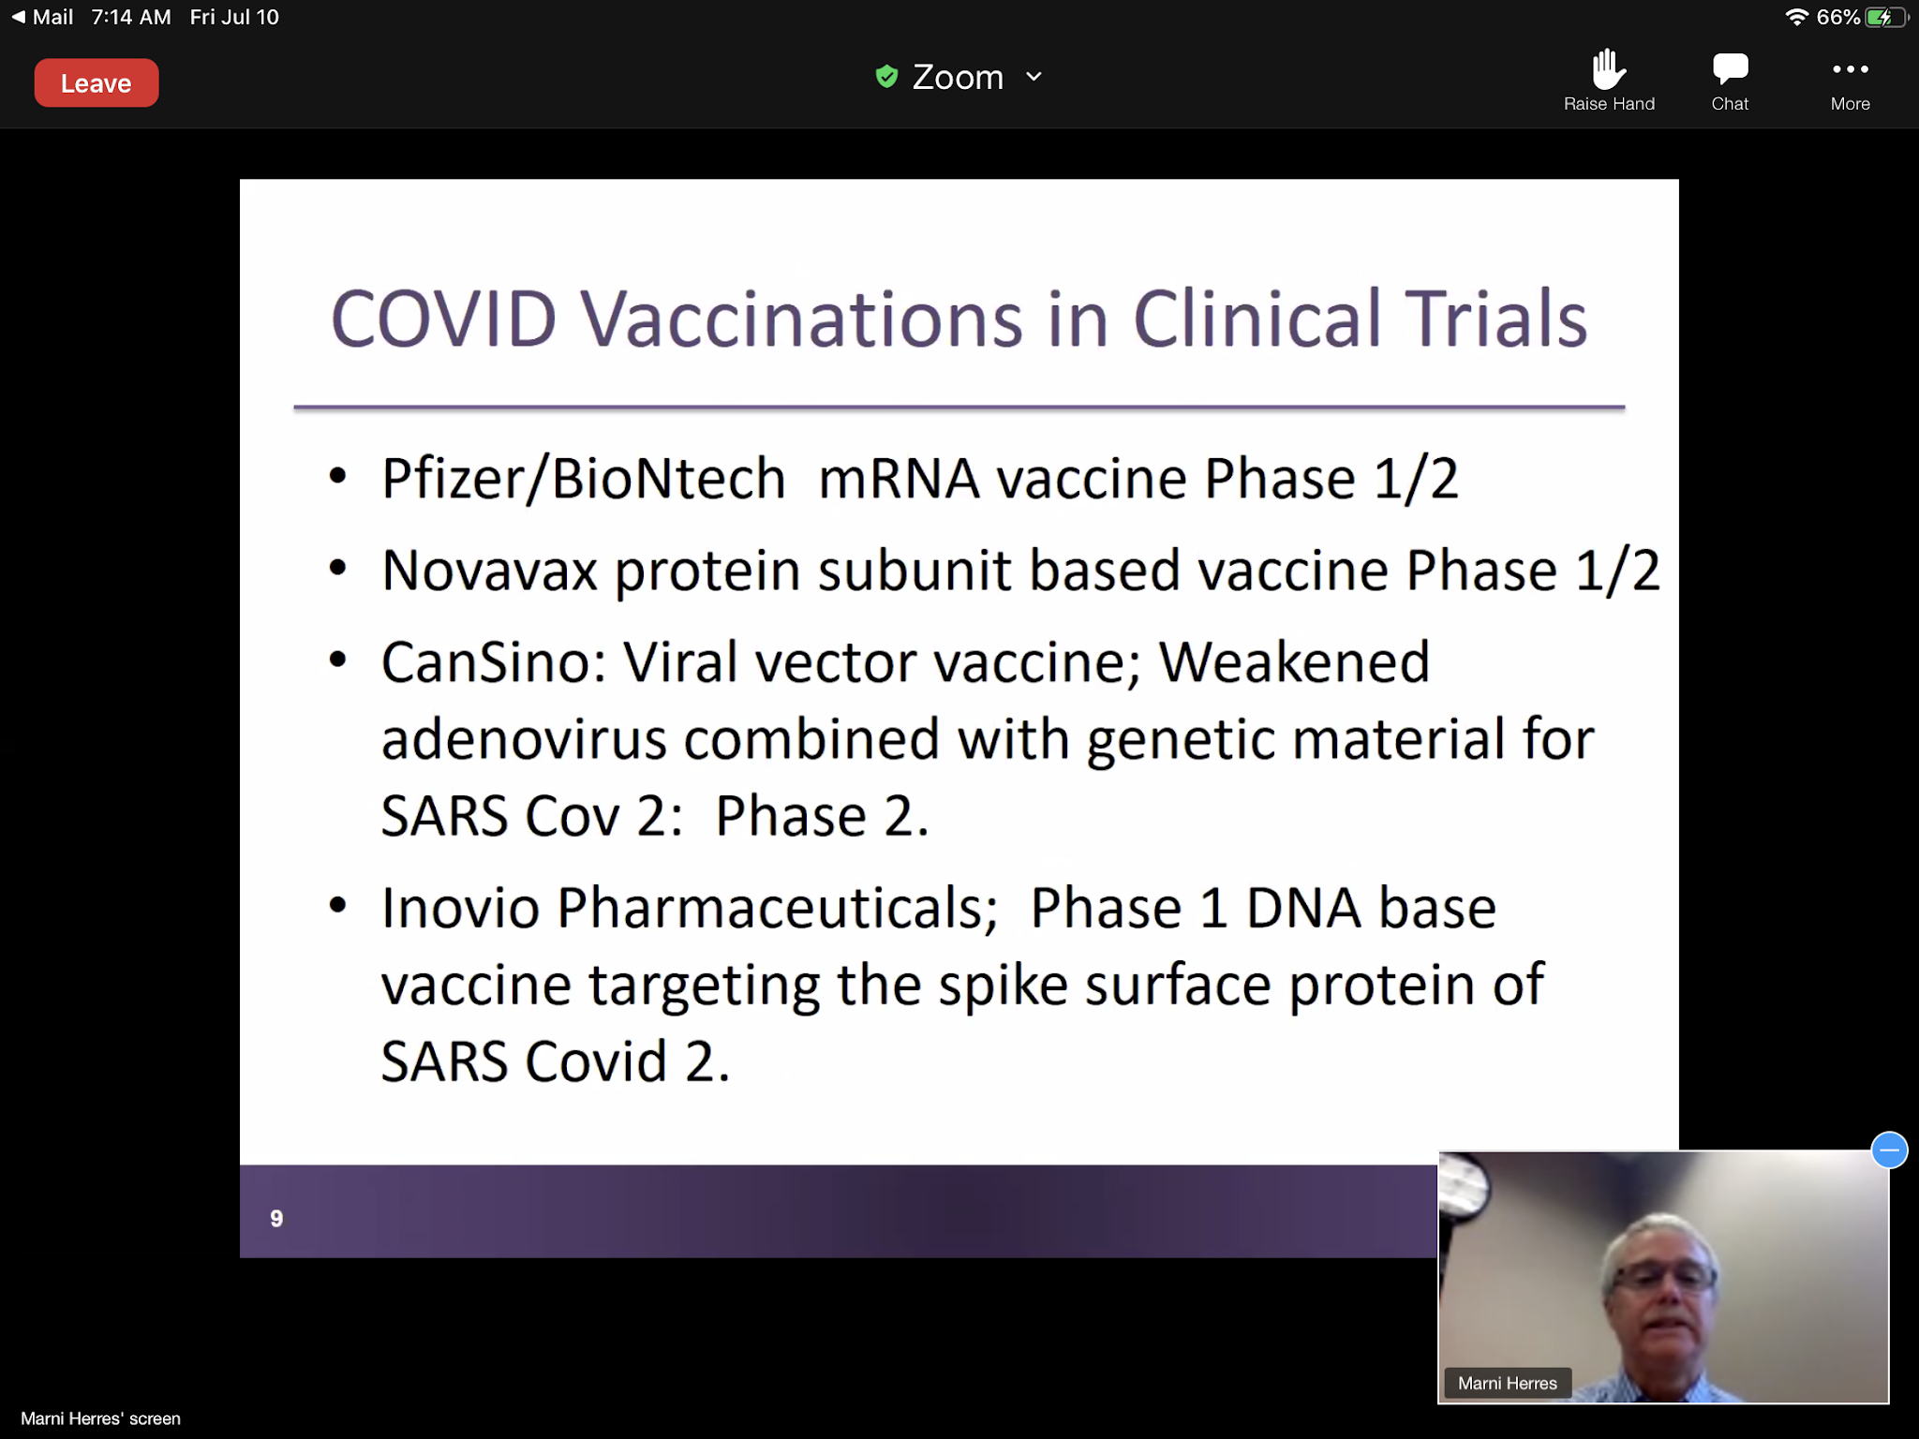
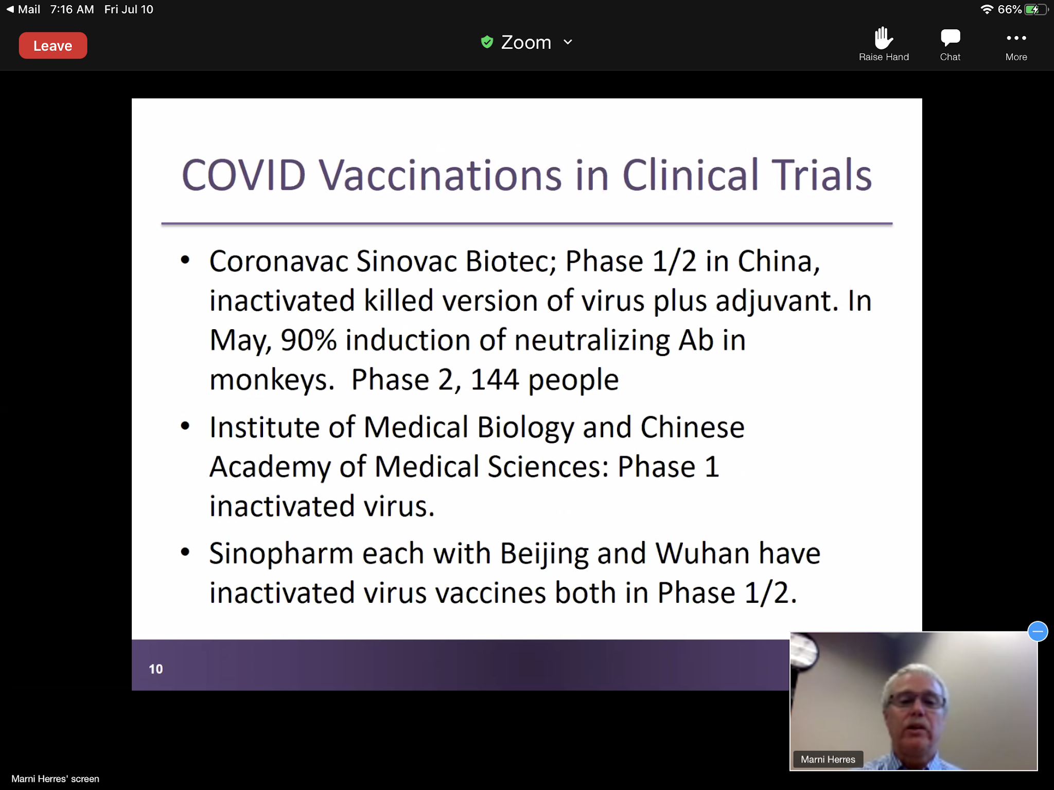

COVID Vaccines
-Safety and Efficacy
-Global Availability
-Adjust your expectations

The Lancet Infectious Diseases (6/28/20)
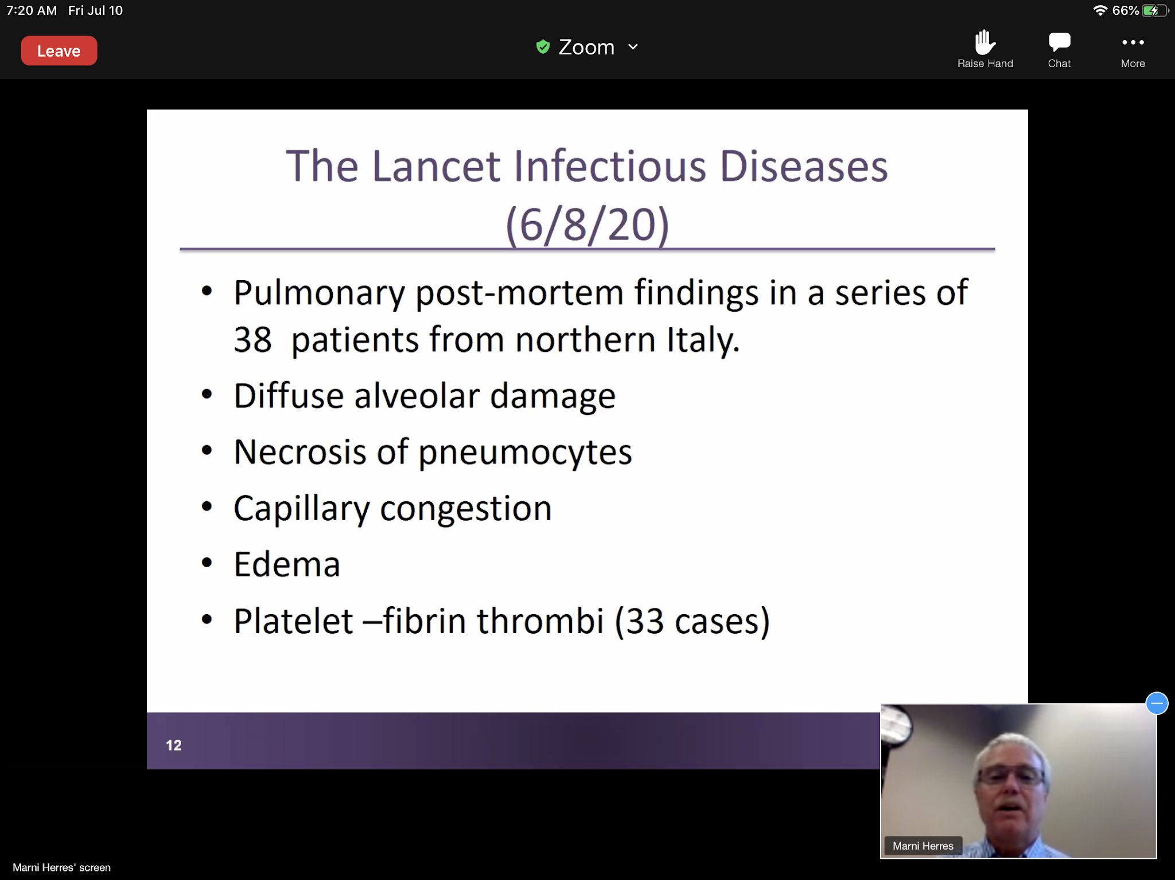
**COVID can do a lot of damage.

Recommendation for VTE PPX in COVID-19 pts (4/18/20)
-Insert slide

Recovery Trial Oxford University- 6/16/20
-Insert slide
IDSA Guidelines on the Treatment and Management of Patients w COVID-19 (6/25/20)
*Insert Slide
NIH What’s New in the Guidelines (6/11/20)
- Insert slide

COVID Testing at SJRMC
*Insert slide
Alaska requires testing within 3 days of arrival- they are doing the rapid test.
Hawaii also requires 3 day testing- they do not accept the rapid Abbot test- needs to be PCR test.

MRSA Contact Precautions
*Insert slide- only for colonized patients, not infected patients. Mask for MRSA or VRE pneumonia.
Insert Bullet slides
Next COVID talk not set-up yet.

