Dr. Souvenir SJRMC COVID-19 Updates 8/14/20
Covid-19 Epidemiology 8/12
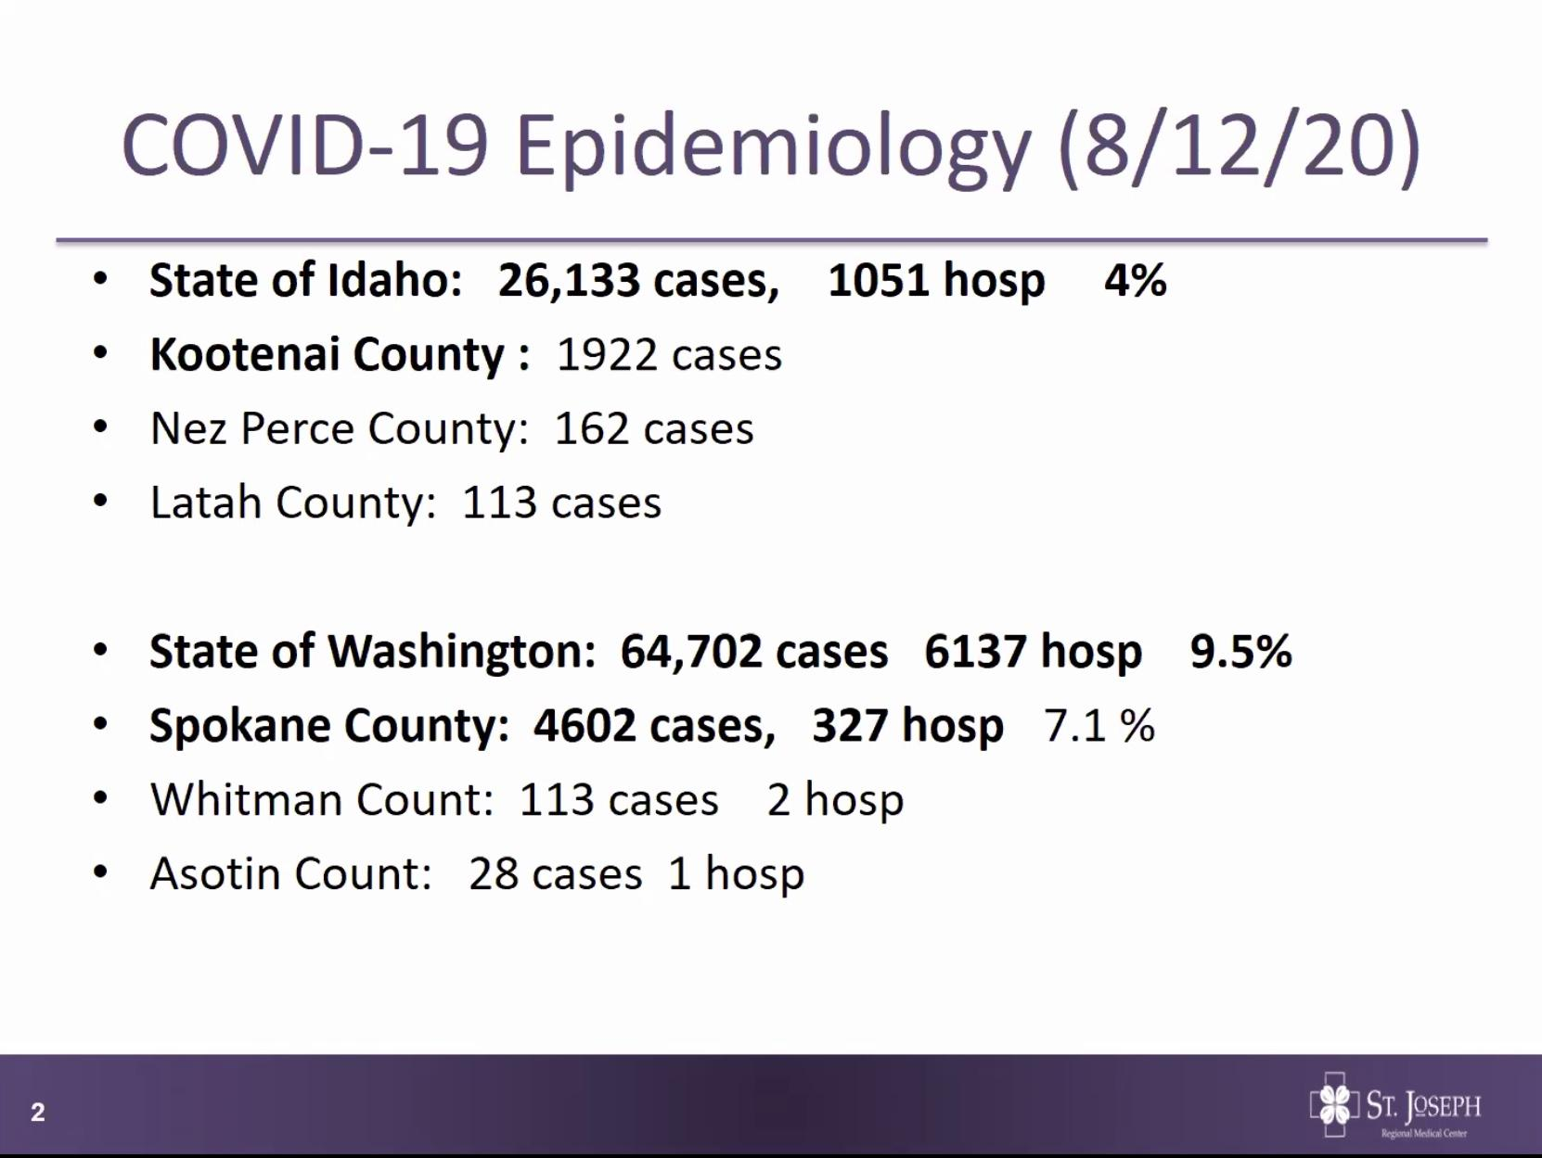
WA higher rate of hospitalization
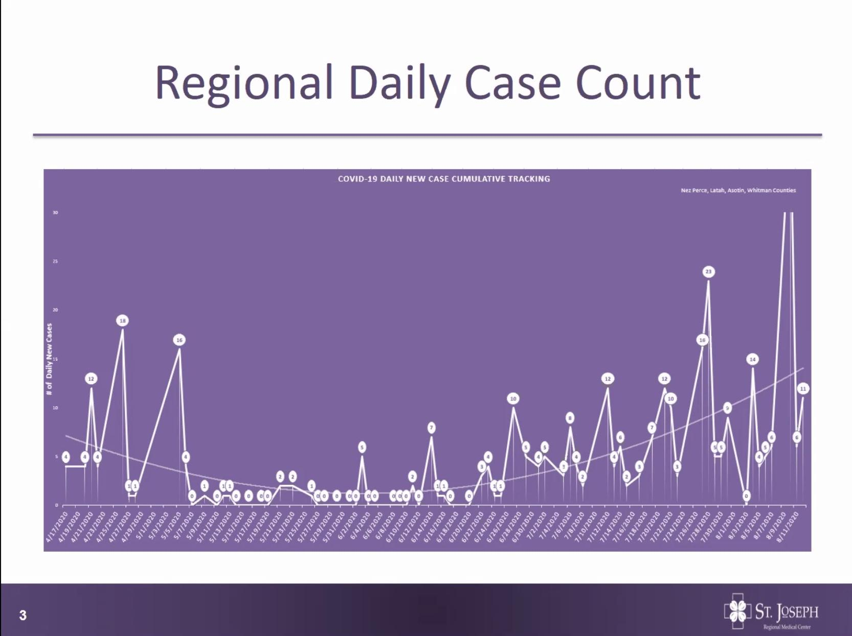 trendline for our 4 counties: Whitman, Asotin, Latah and Nez Perce
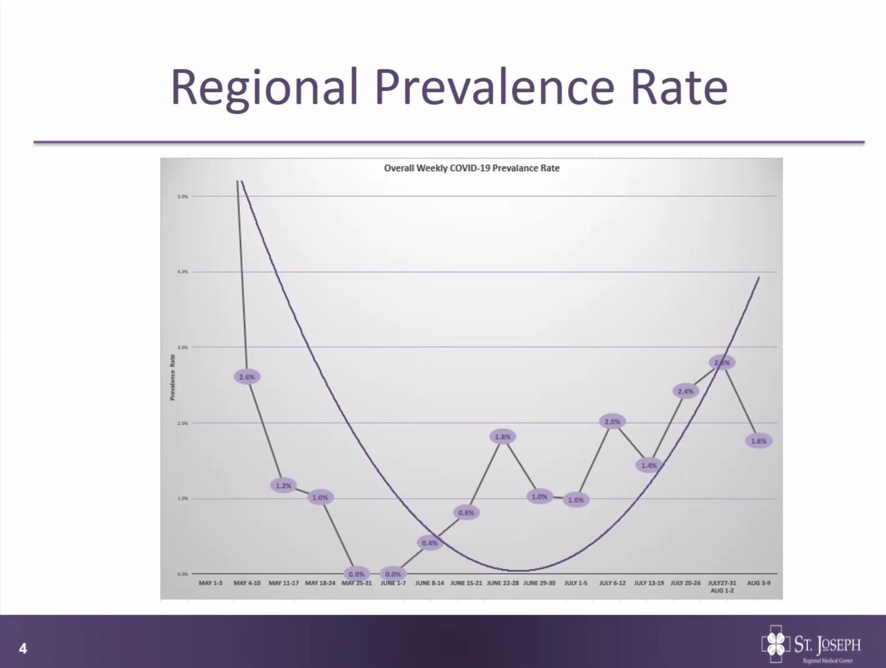 Regional Prevalence rate- Steady increase in prevalence
Denominator diluted by UI students (the 1.8% in the last week) LC valley def above that number.

Duration of Isolation and Precaution for Adults w COVID-19- CDC update 7/22
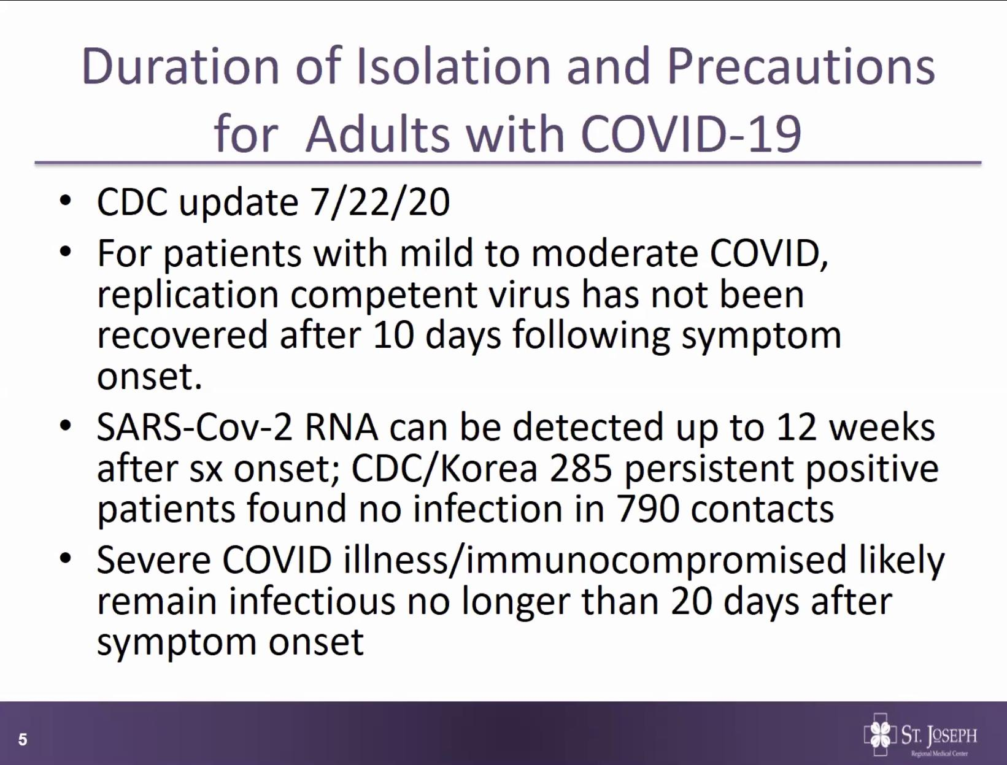Constantly being updated-Severe COVID illness pt about 20 days remain infections, immunocompromised unknown- see more further on
*Reinfection w SARS CoV-2 has not been confirmed- thought maybe can be reinfected after 90 days
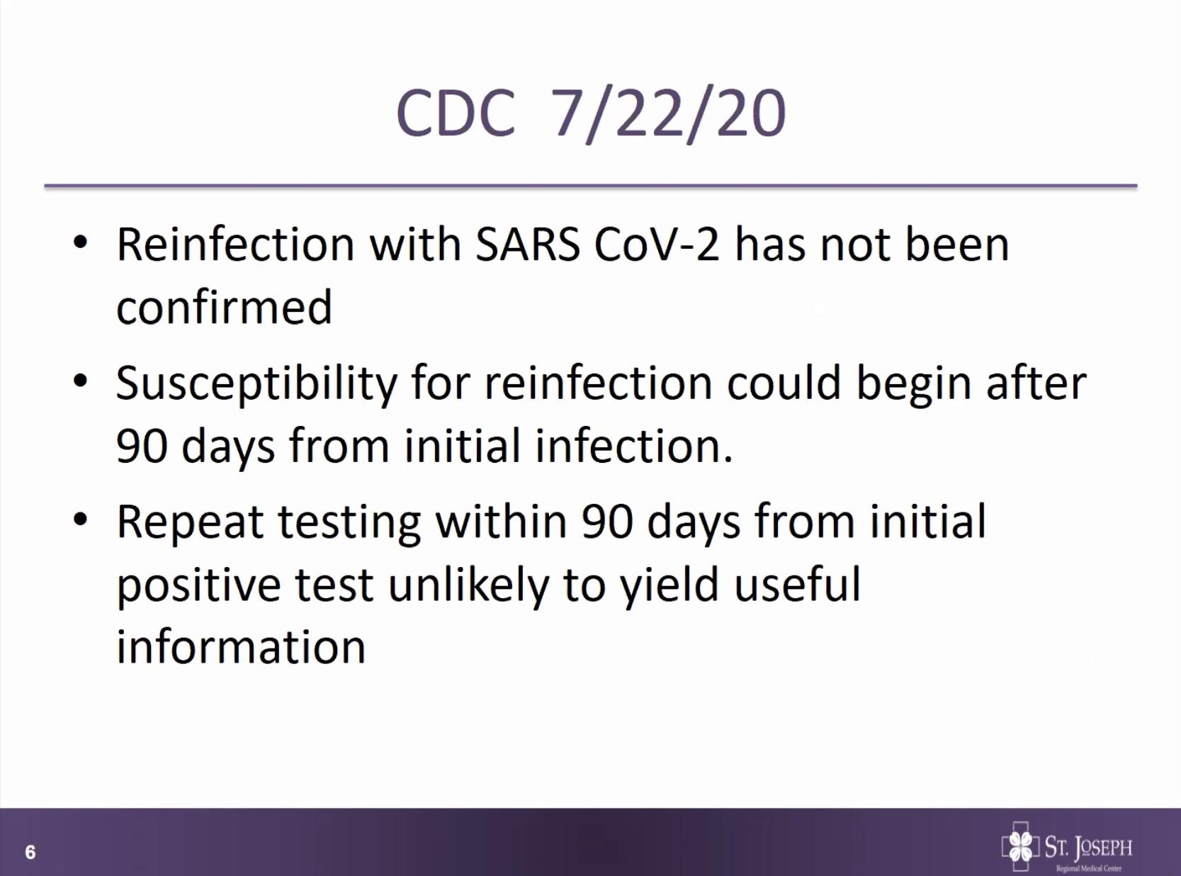
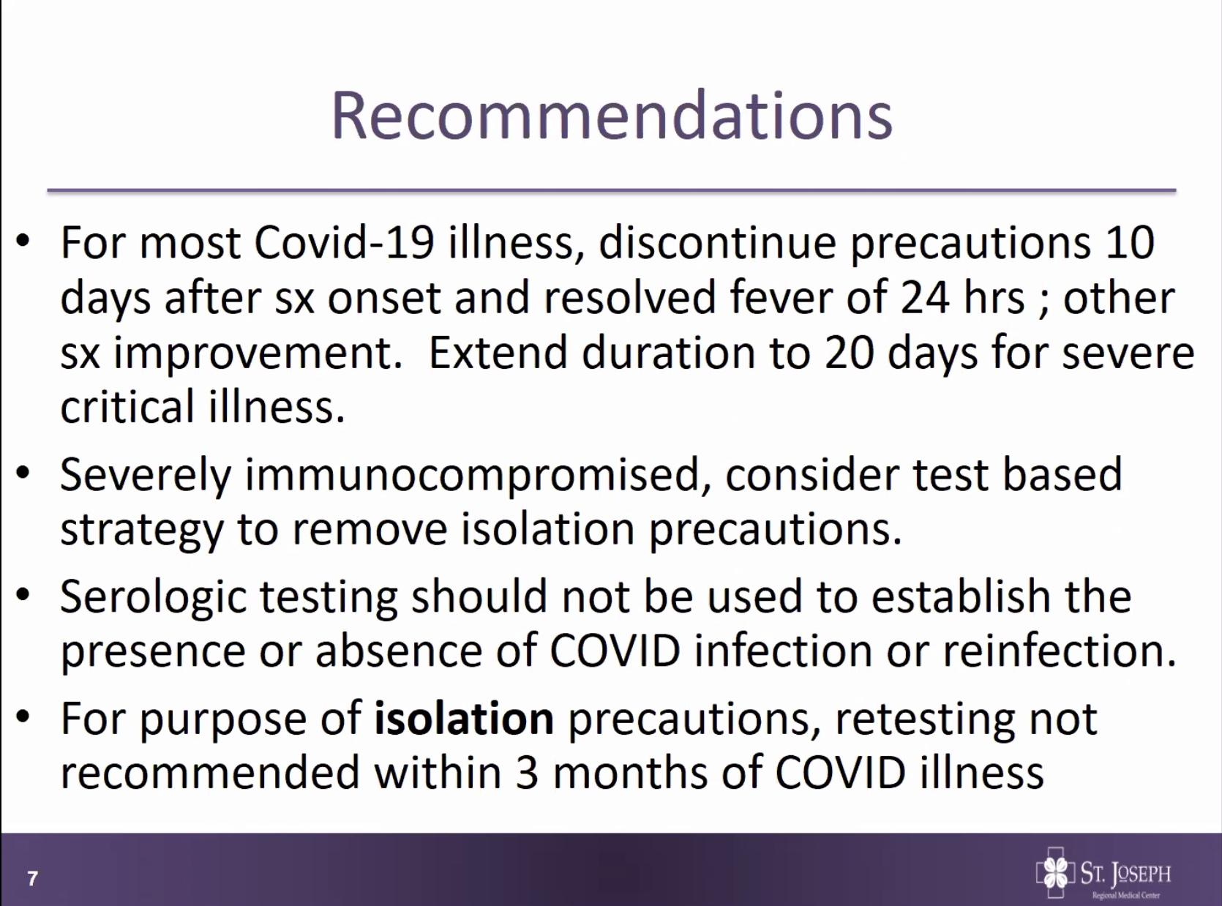
***Immunocompromised- consider test based strategy to remove precautions**
Serologic testing more beneficial in kids

COVID testing at St Joe
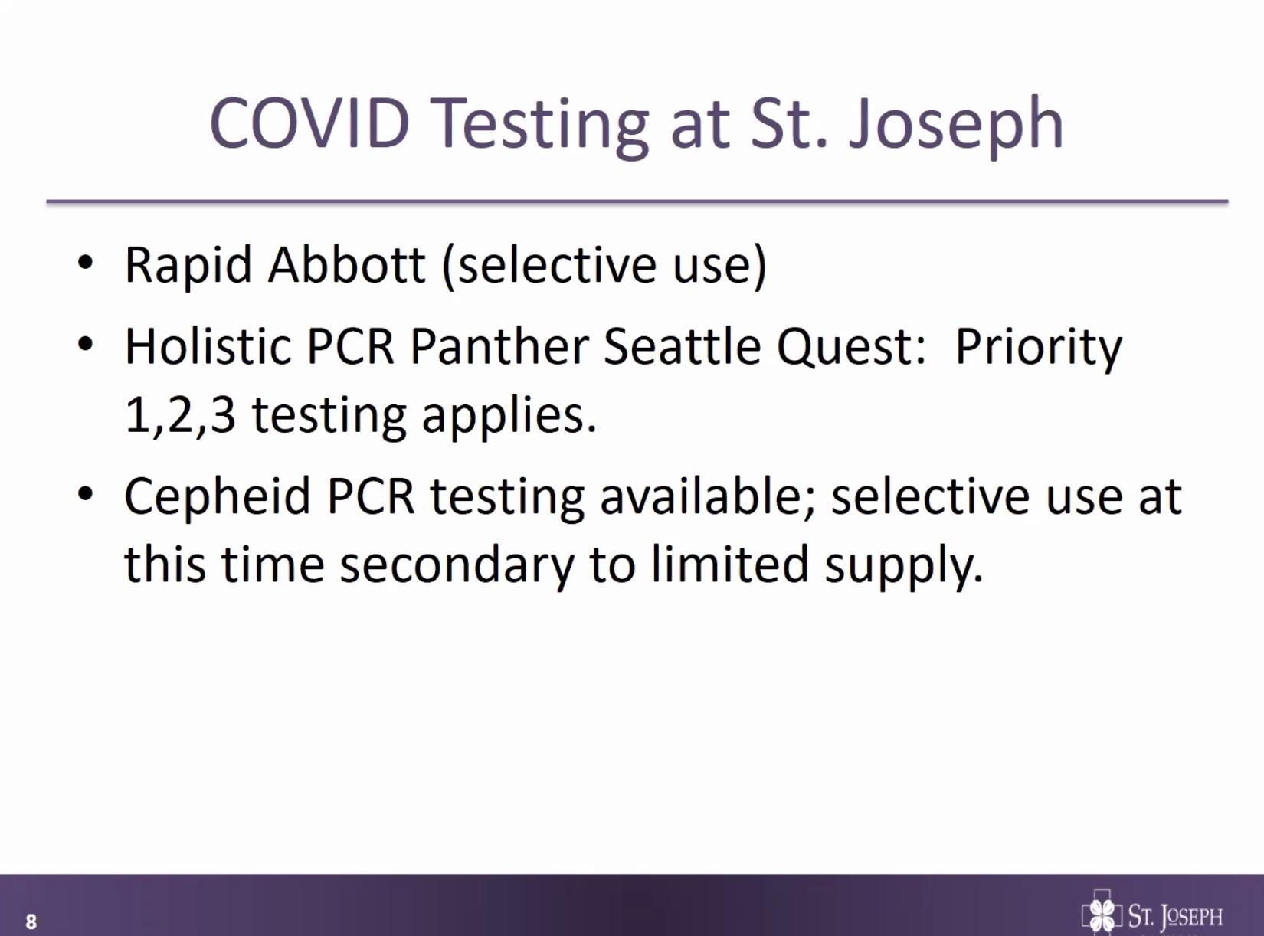
Phasing out Abbott test (lower sensitivity)- Using for Alaska travel
Moving to Cepheid platform (about 2 hr turnaround time)- selectively using for hospitalized symptomatic patients, emergency surgeries, contact testing, term PG who have not previously received any testing. Supplies for Cepheid are limited.
Send out test to PCR Panther- Priority 1 symptomatic patients in the hospital, patients going to surgery, for symptomatic health care workers.

COVID testing options at St Joe
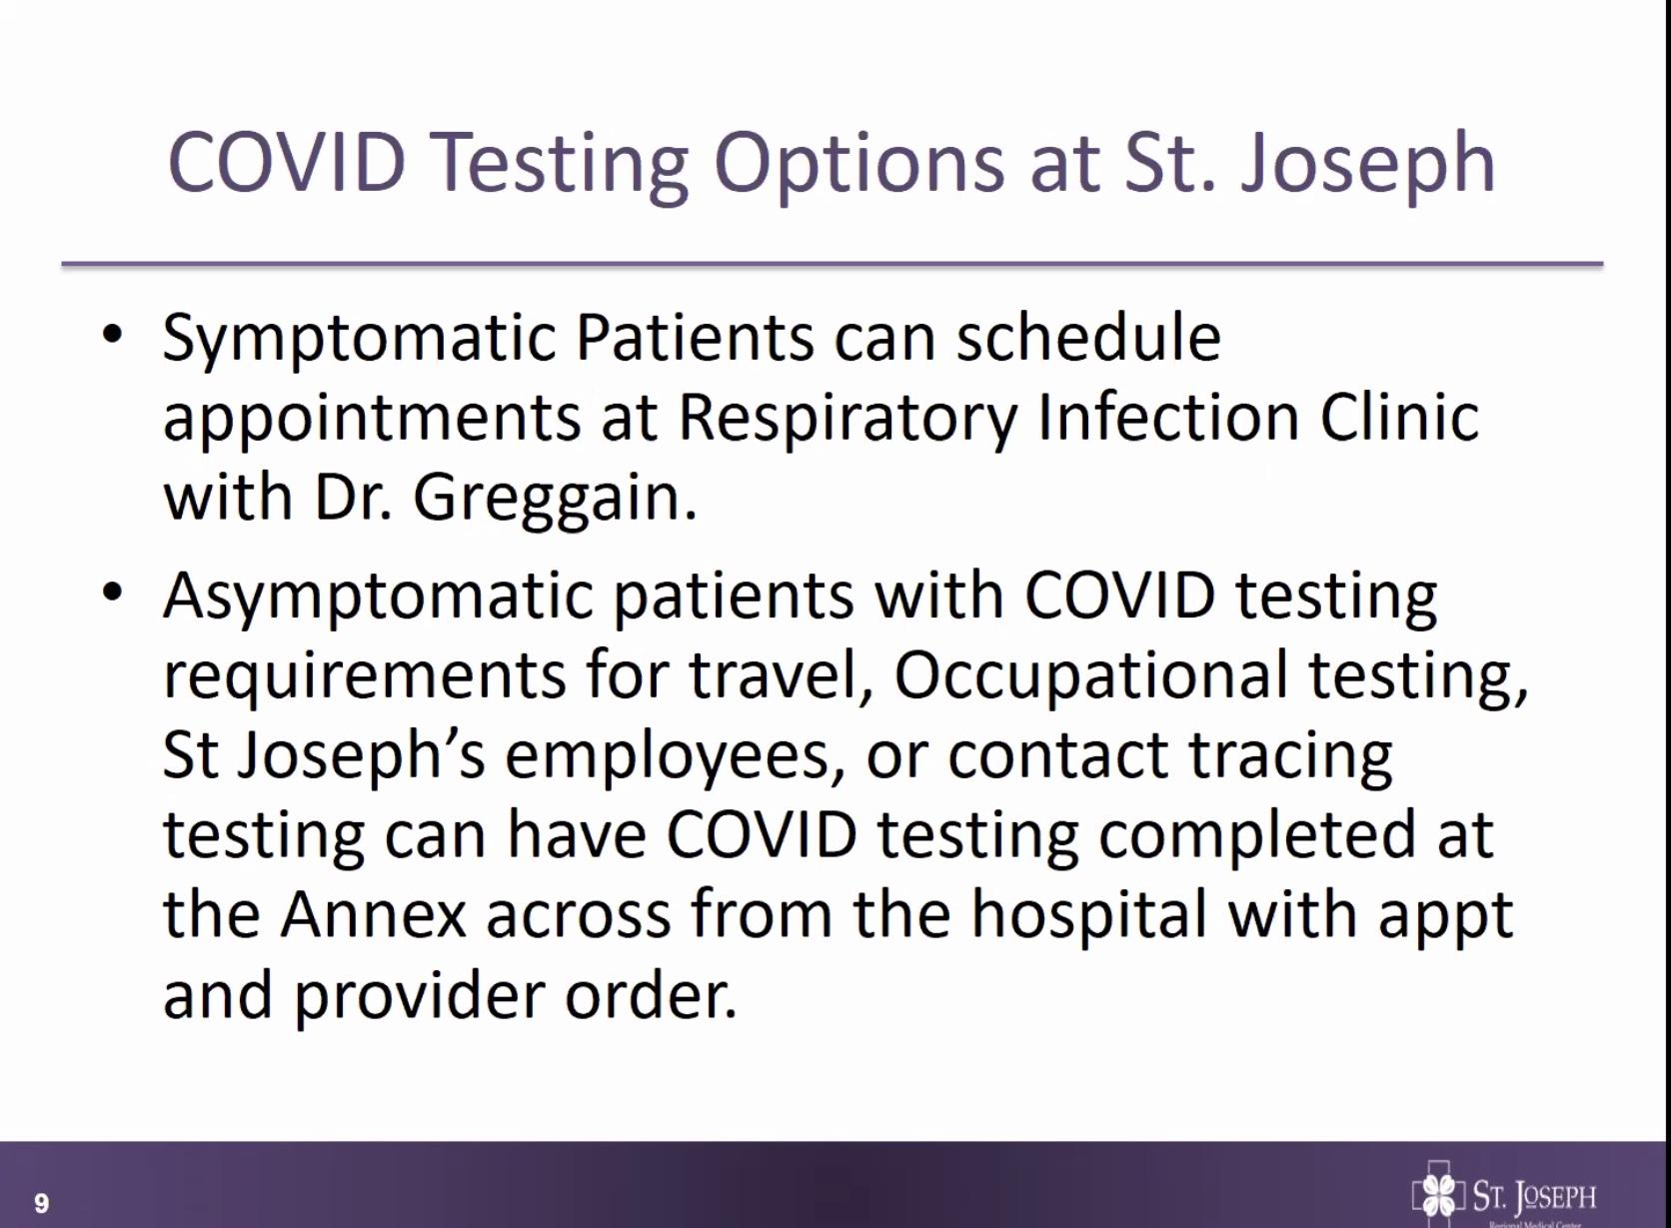

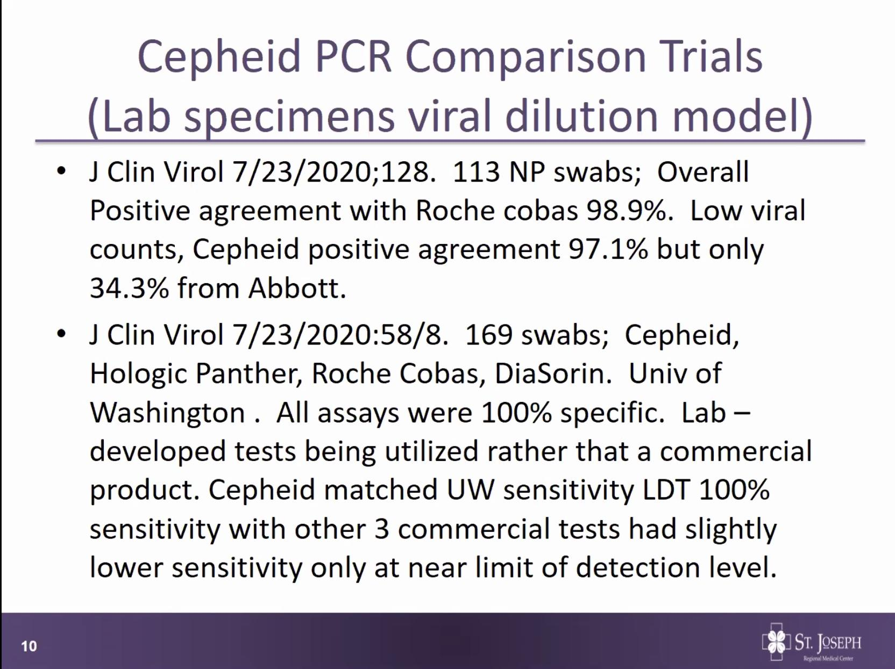
Cepheid PCR Comparison Trials
-Compared Cepheid platform to the Roche platform- overall similar
-Cepheid, Roche and Abbot compared- Abbot drops off in sensitivity.
-Second article also tested DiaSorin- Cepheid matched UW sensitivity
***This is all based on laboratory modeling*** Different than a clinical setting

COVID Review Article from JAMA
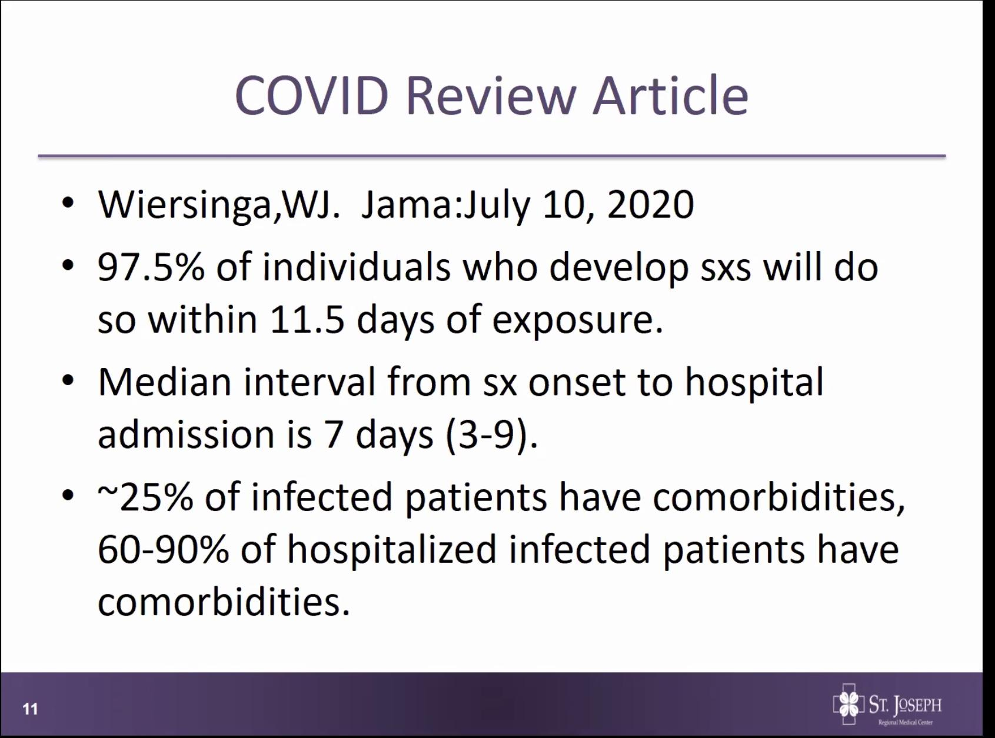
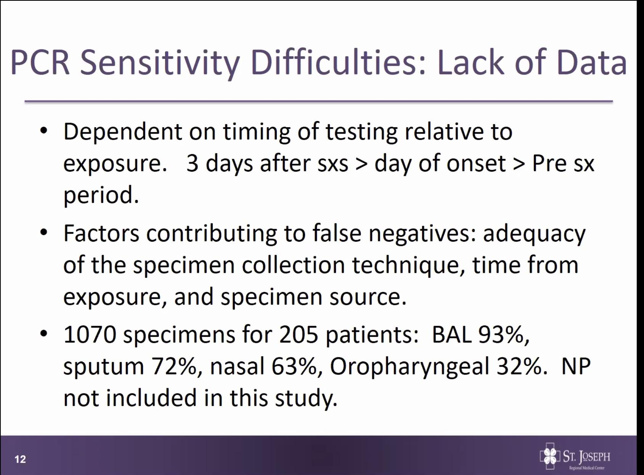
Sensitivity Difficulties: Lack of Data
-Clinical setting the timing of testing to exposure varies- Usually about 3 days after sxs onset
-BAL high sensitivity, nasal swab only 63% and the oropharyngeal only 32%. NP not included, Souvenir thinks about 80-85%.
Mask Contamination
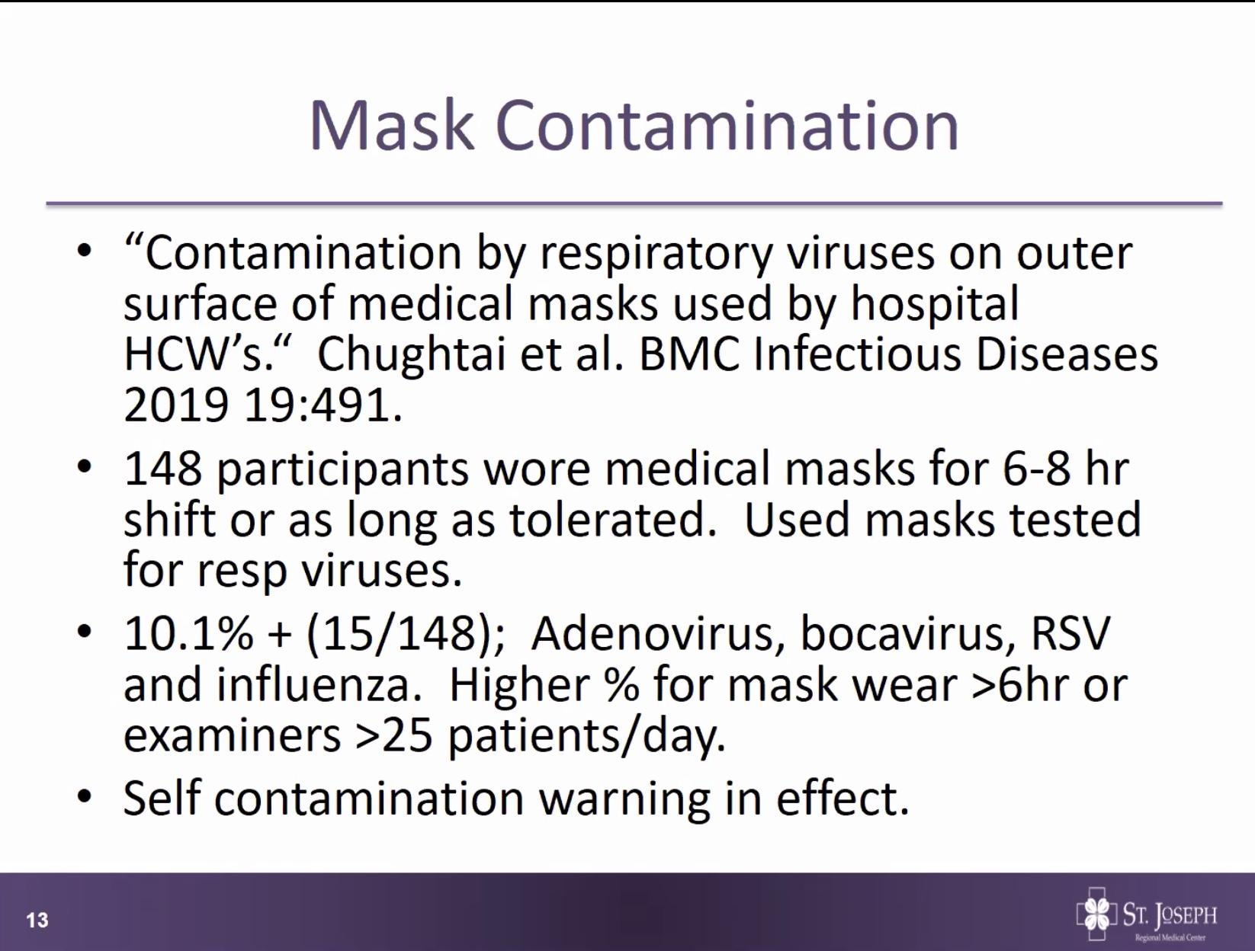
-Prior to COVID
-Know masks to get contaminated, why masks intended to be single use, but for PPE preservation extended to a shift, just be aware of self contamination, also reminder for cloth masks need to be washed on a daily basis, store in a paper bag, don’t lay masks around.
Pediatric stats
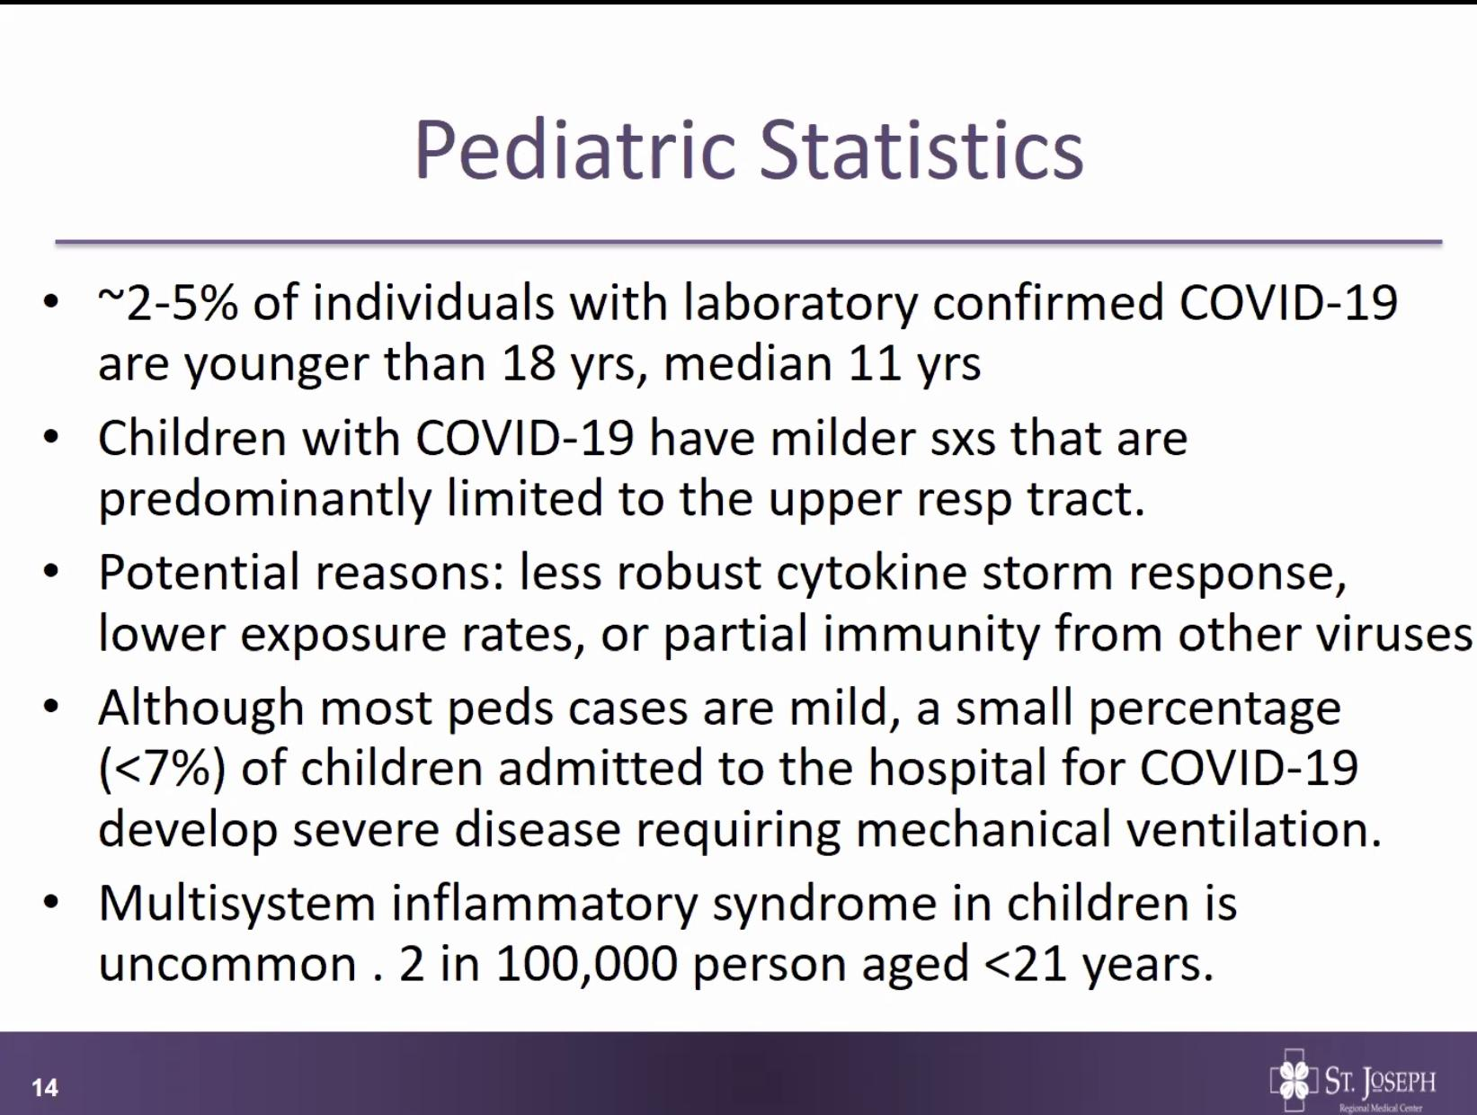<7% admitted to hospital for COVID-19 develop severe lung disease and require mech ventilation
MMWR 8/7/20
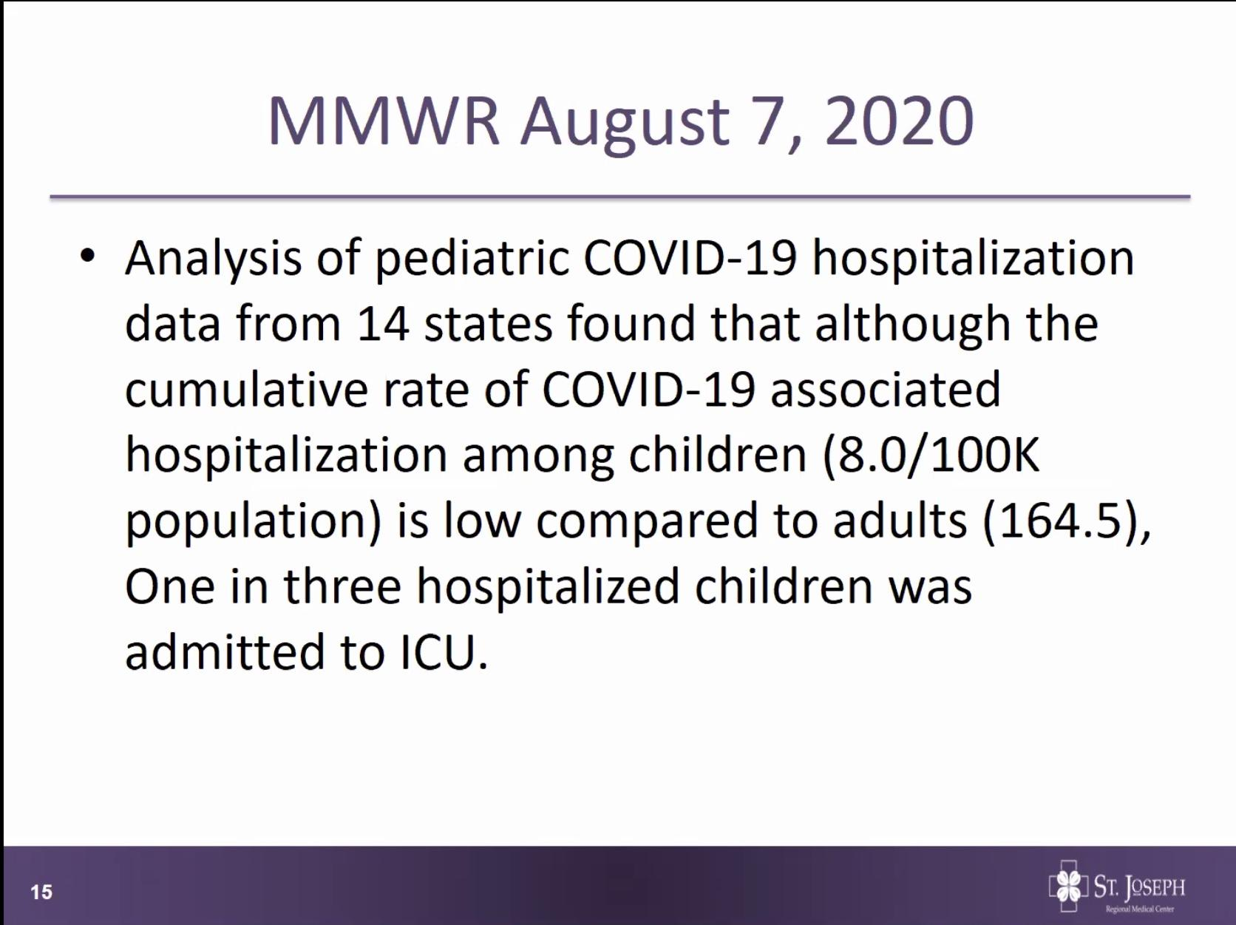
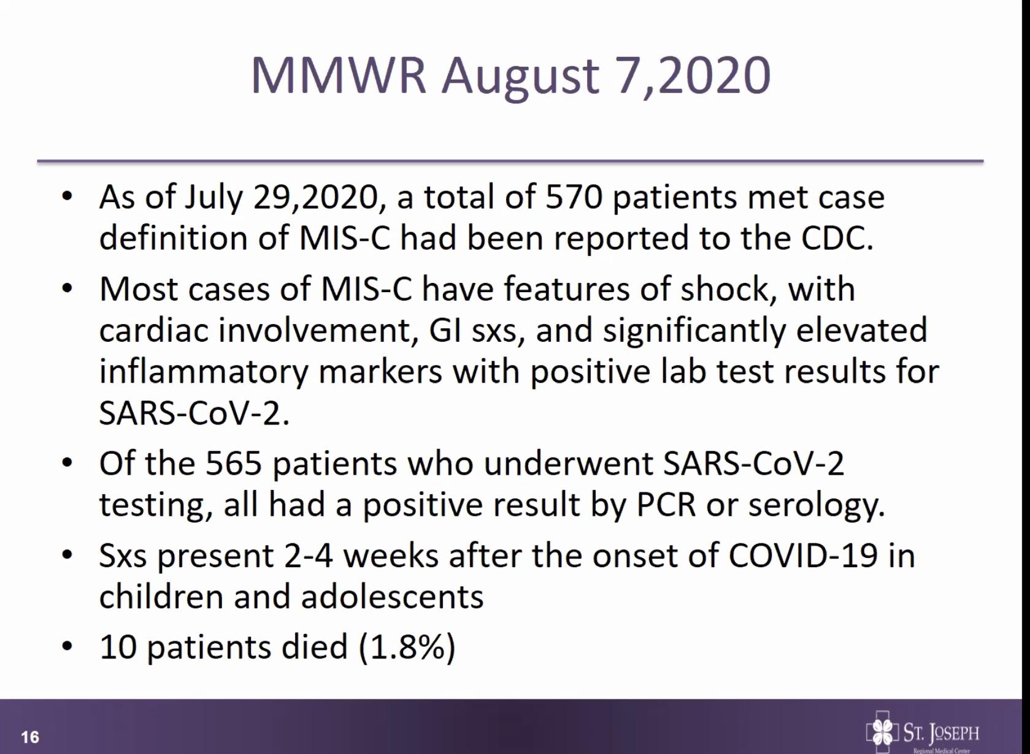
-Lower hospital association w kids, but when admitted high percentage going to ICU
***Pt population where serology testing can be helpful to make the diagnosis of MIS-C***
About 1.8% dies from MIS-C

MMWR 7/24 COVID Prolonged illness
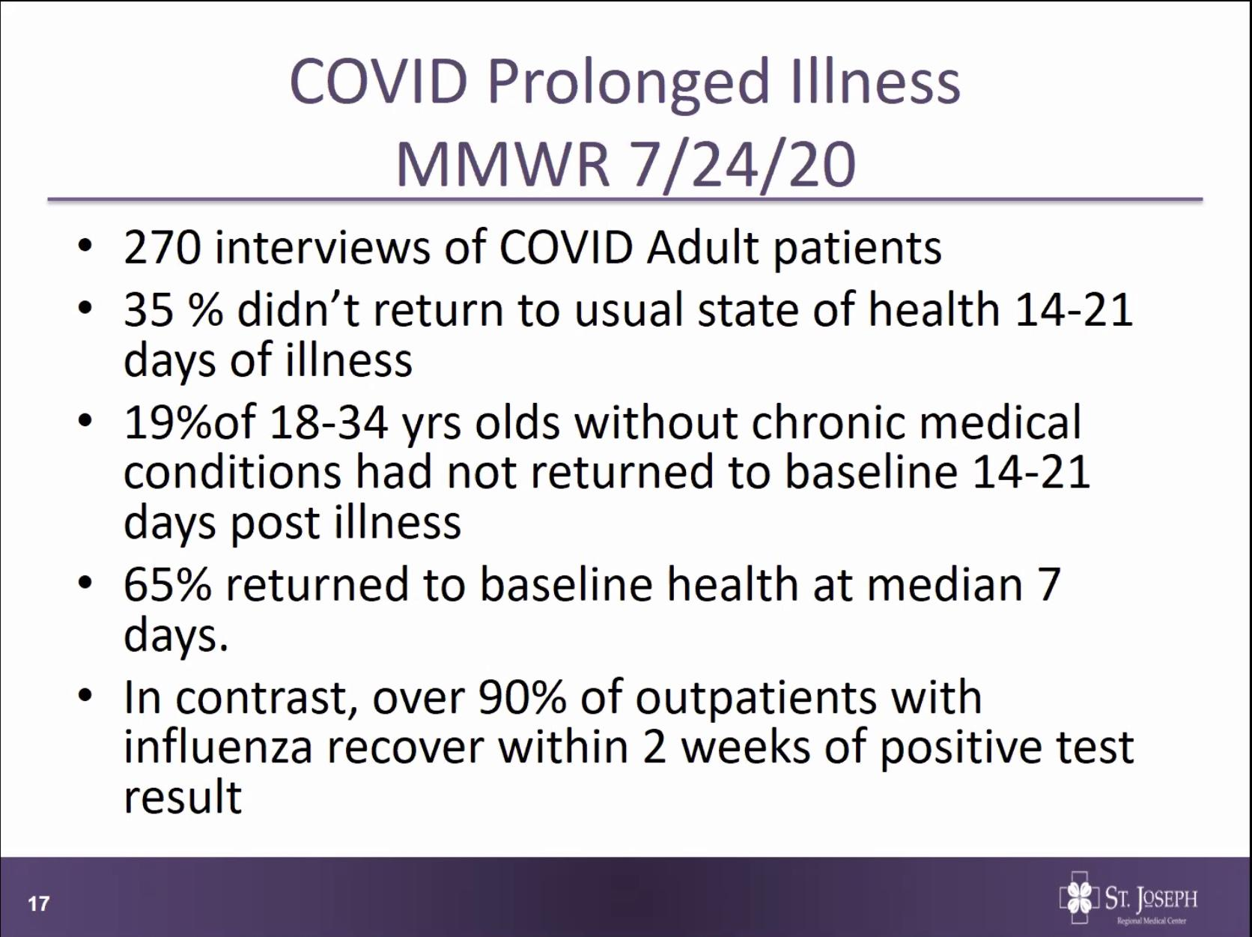
-Will need further study*** Note contrast to influenza***
Community Development
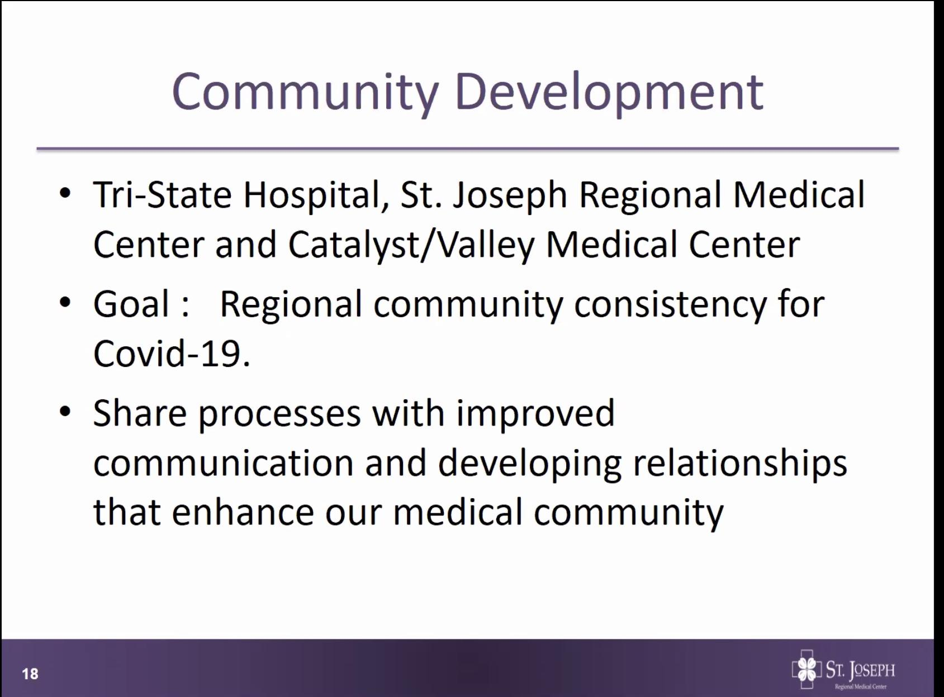
Sharing processes will be beneficial in fight against COVID-19, Souvenir applied for privileges at Tri-State

Next lecture 9/18/20 0700
