UW TASP 7/28/2020

Outpatient Stewardship: Lessons Learned Case Discussion

269 million abx rxs per year-2015


Resp infection major driver of unnecessary abx
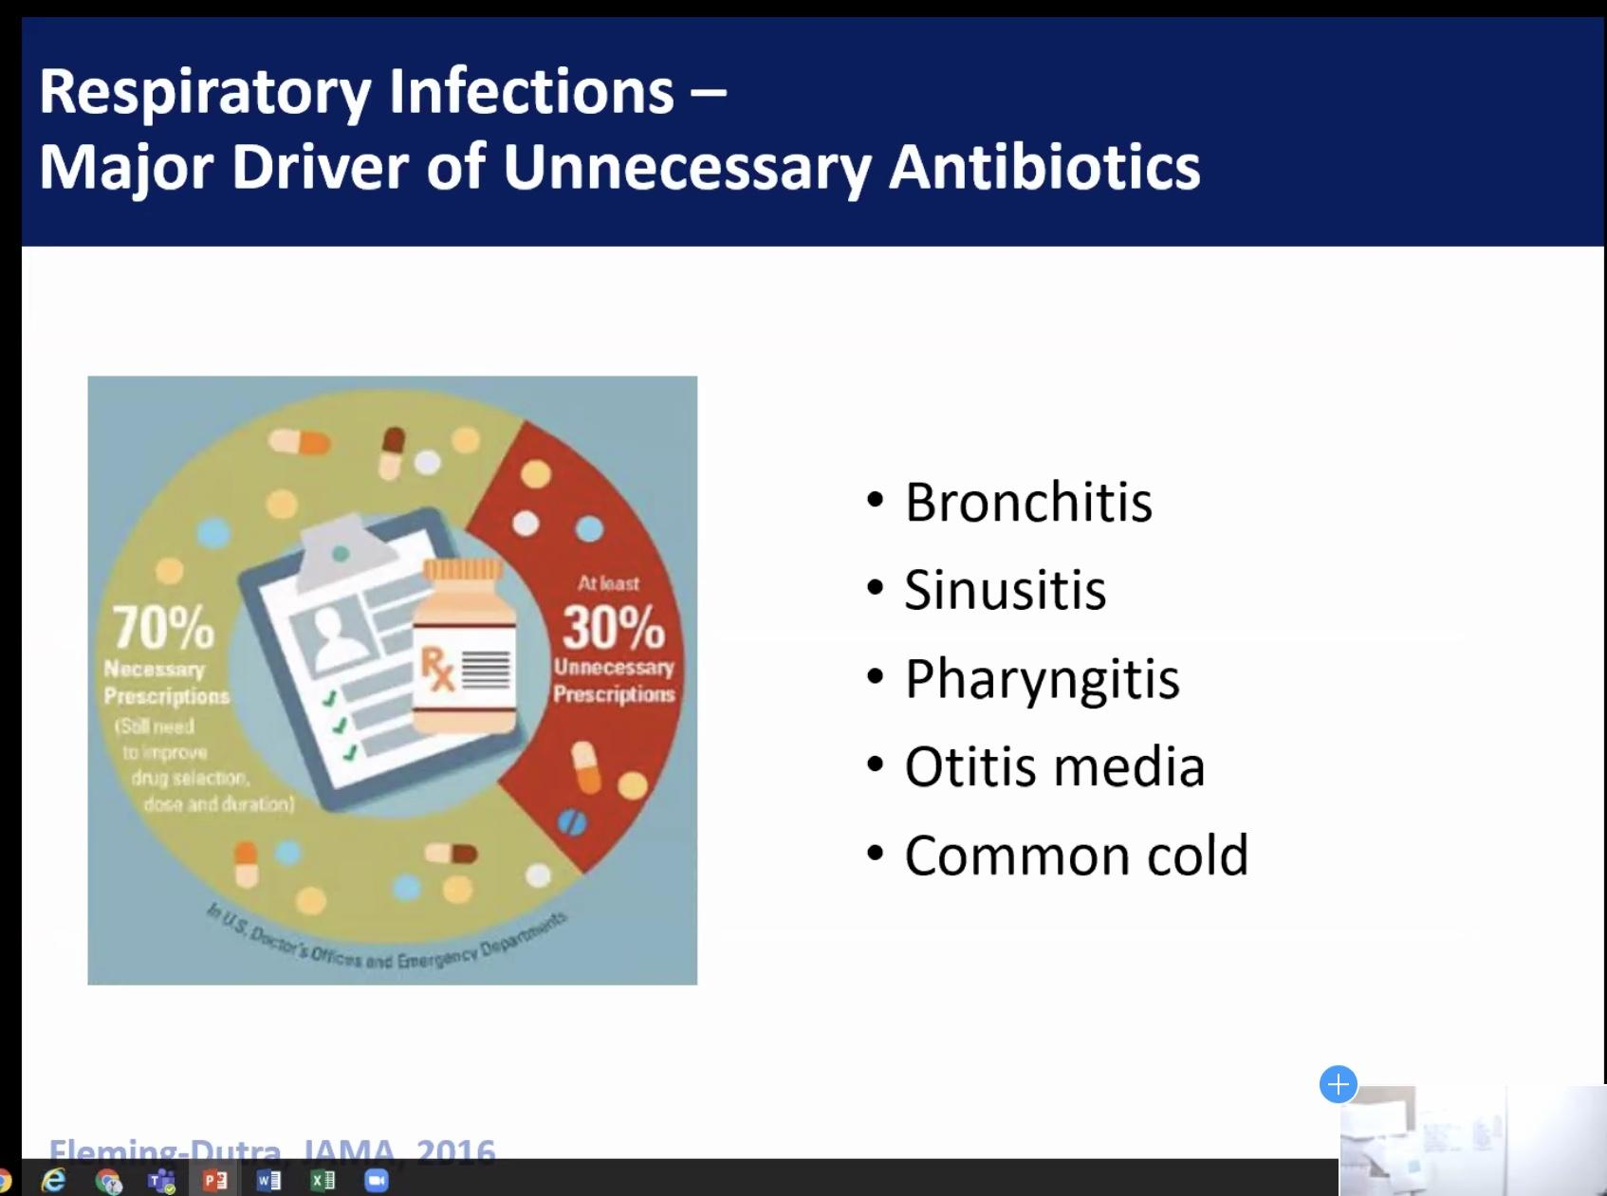

Why Care about outpt stewardship
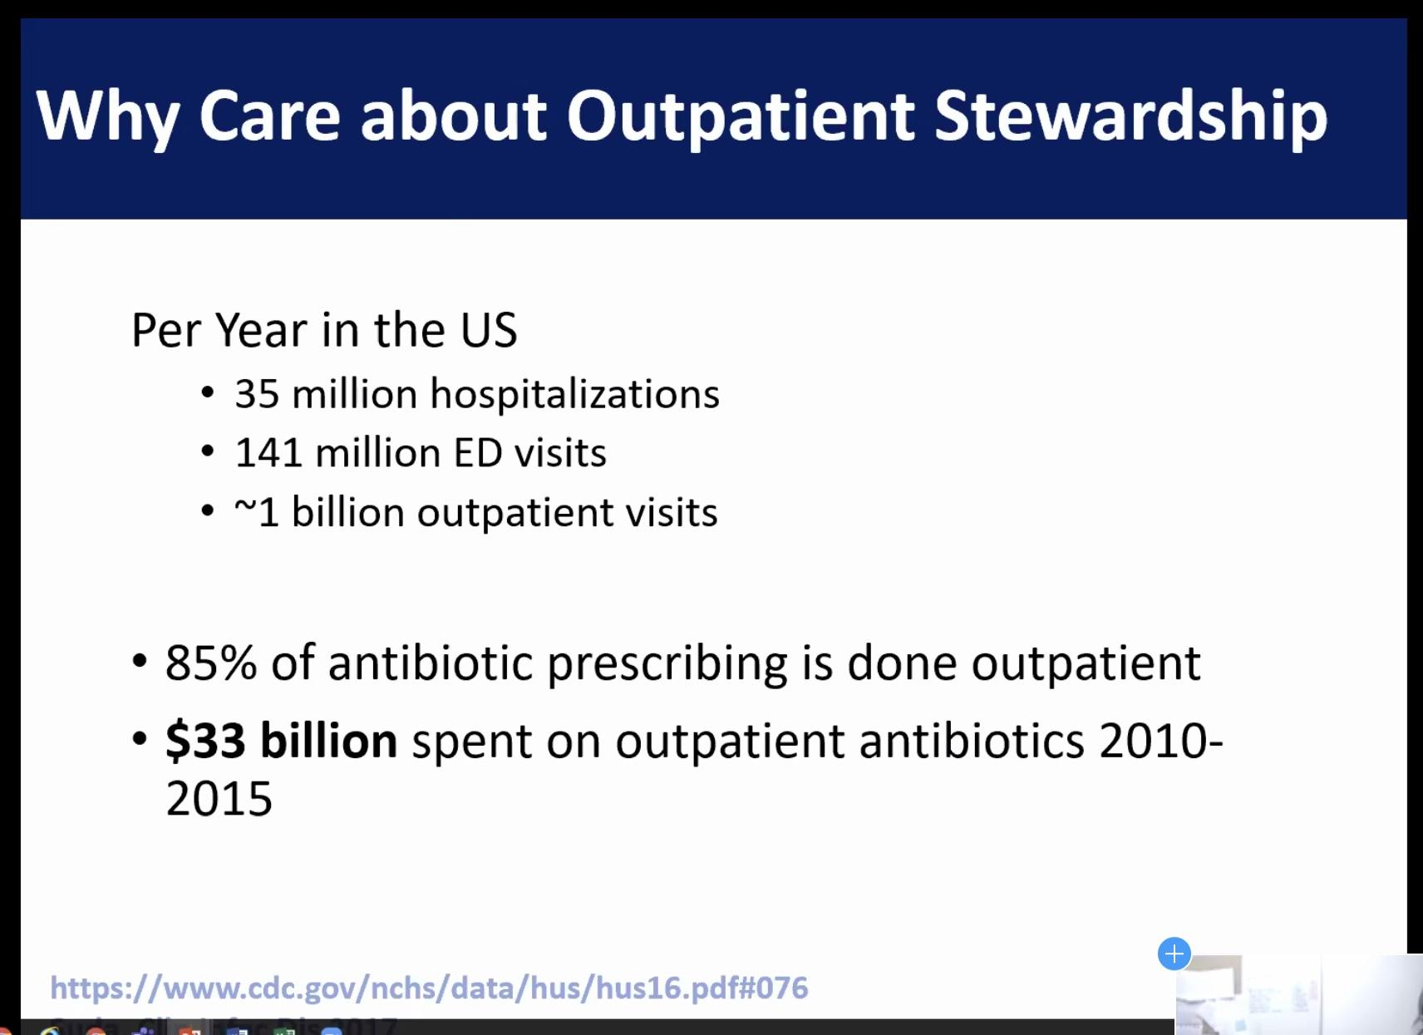
Outpt stewardship
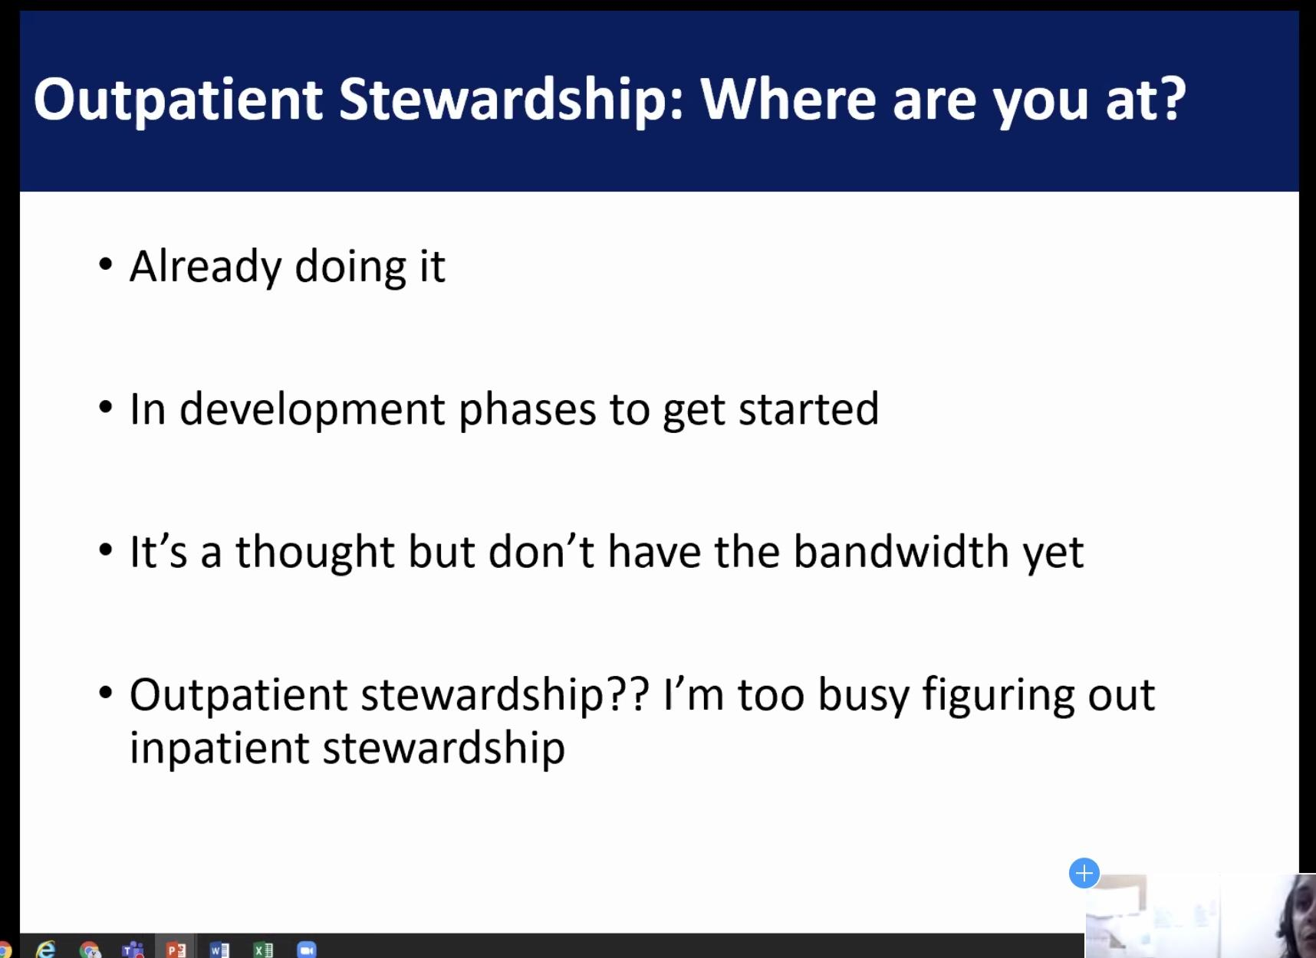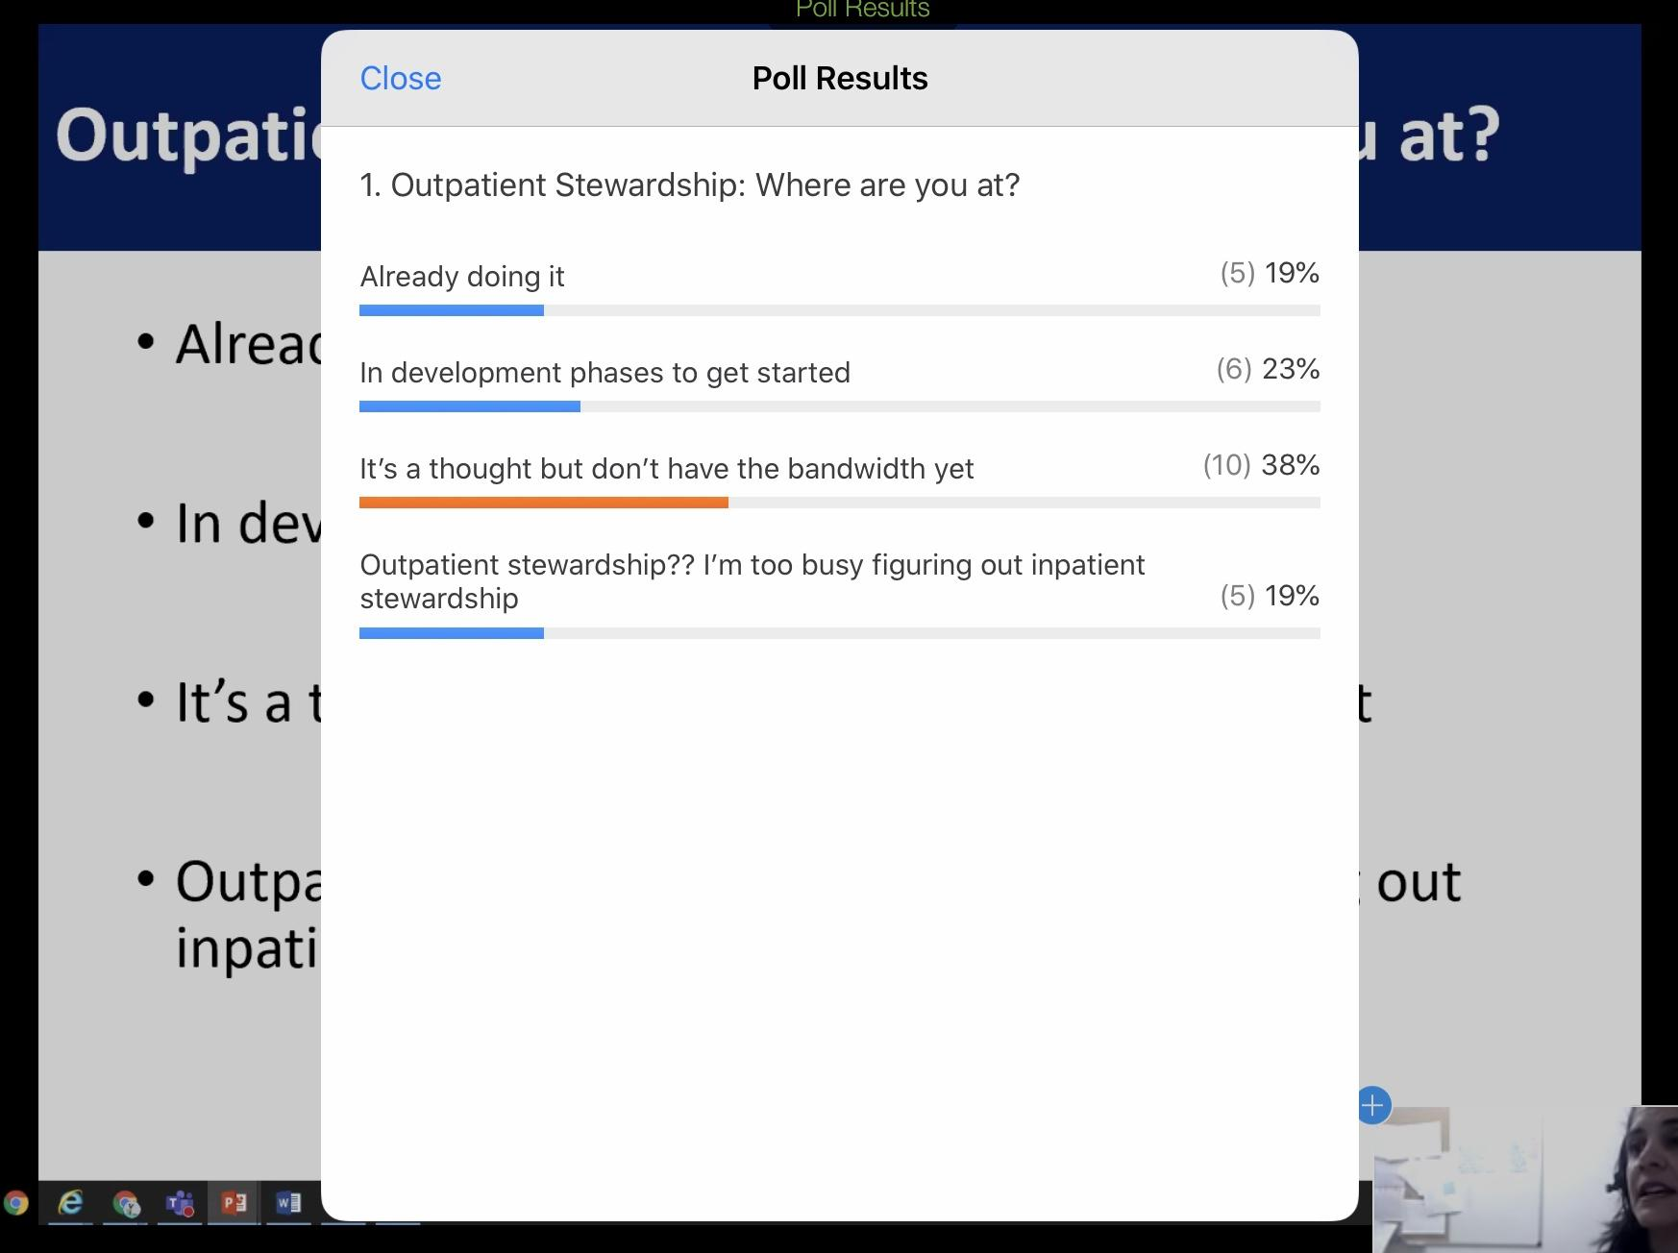
Steps to address unnecessary antimicrobial usage
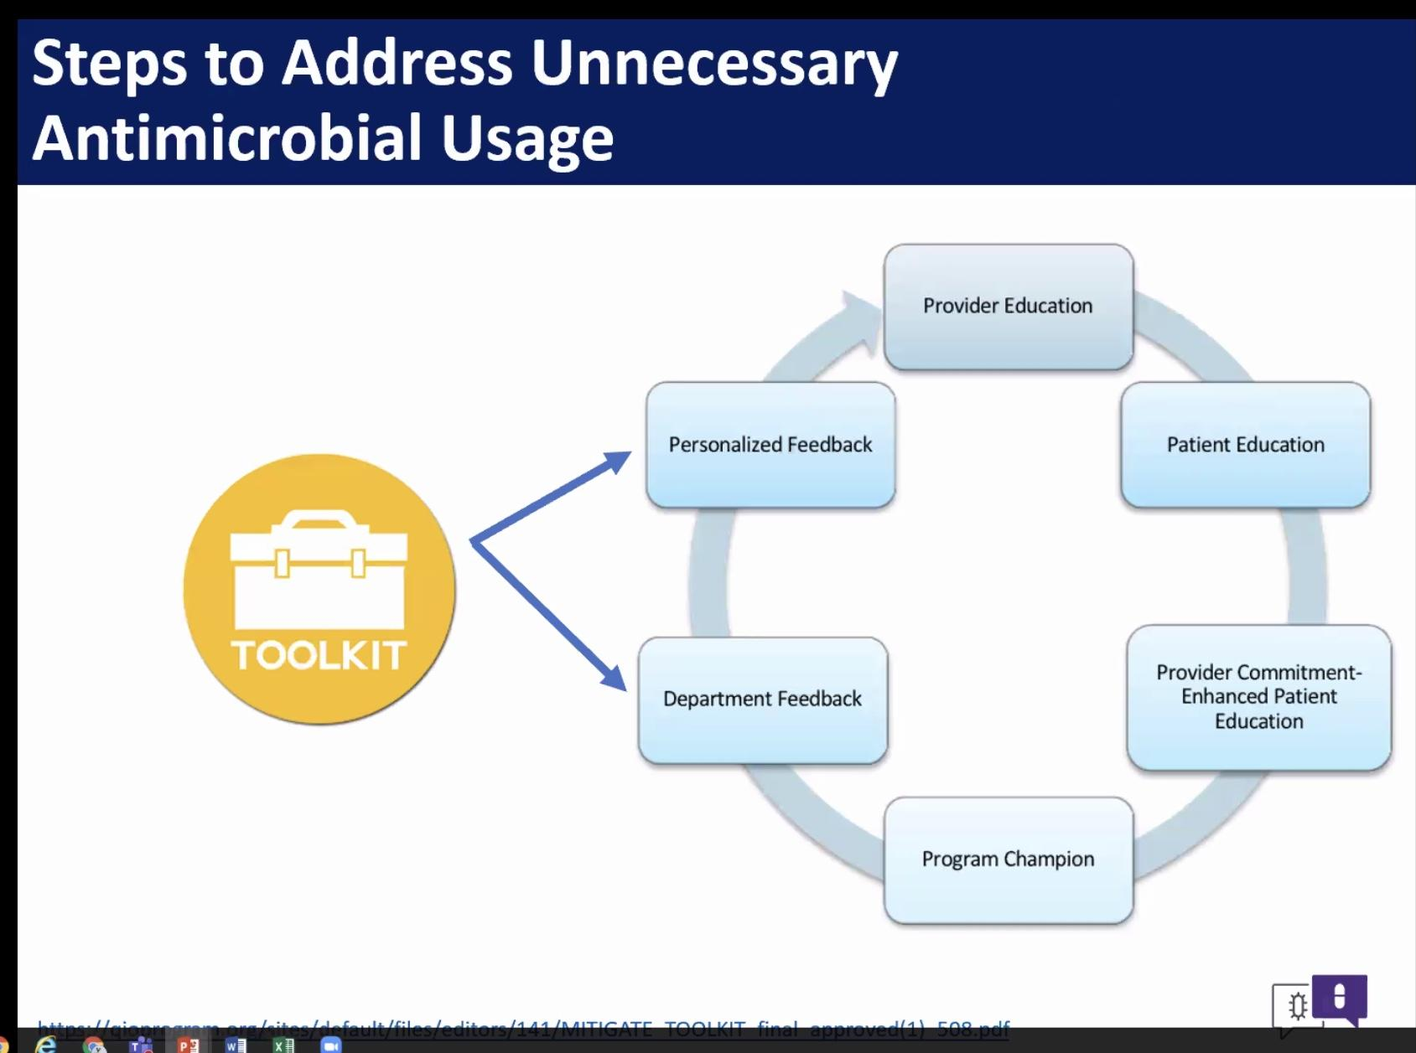
Mitigate toolkit published on the CDC
Public commitment letter, Post in exam room where patients are being seen
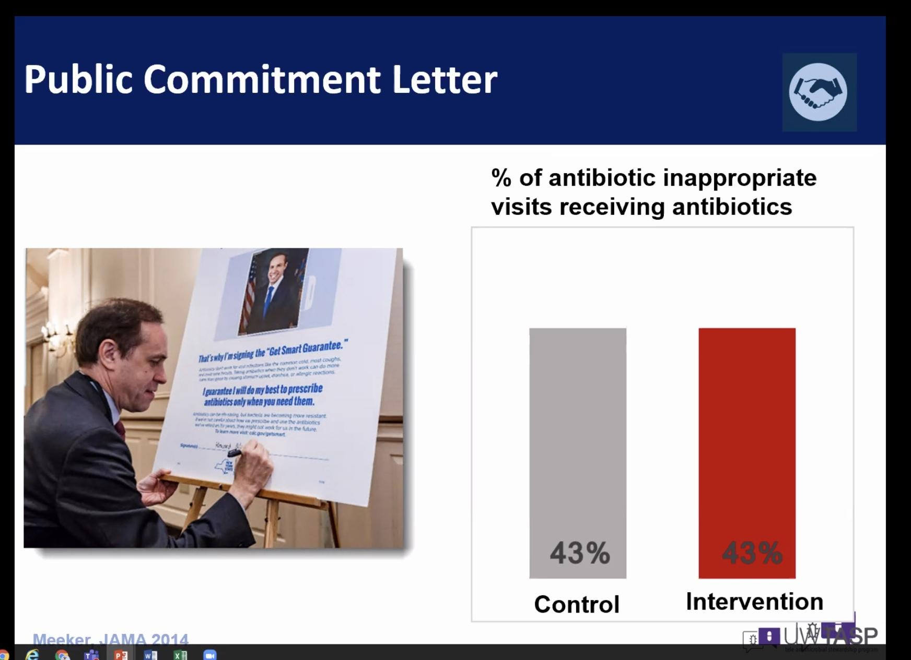
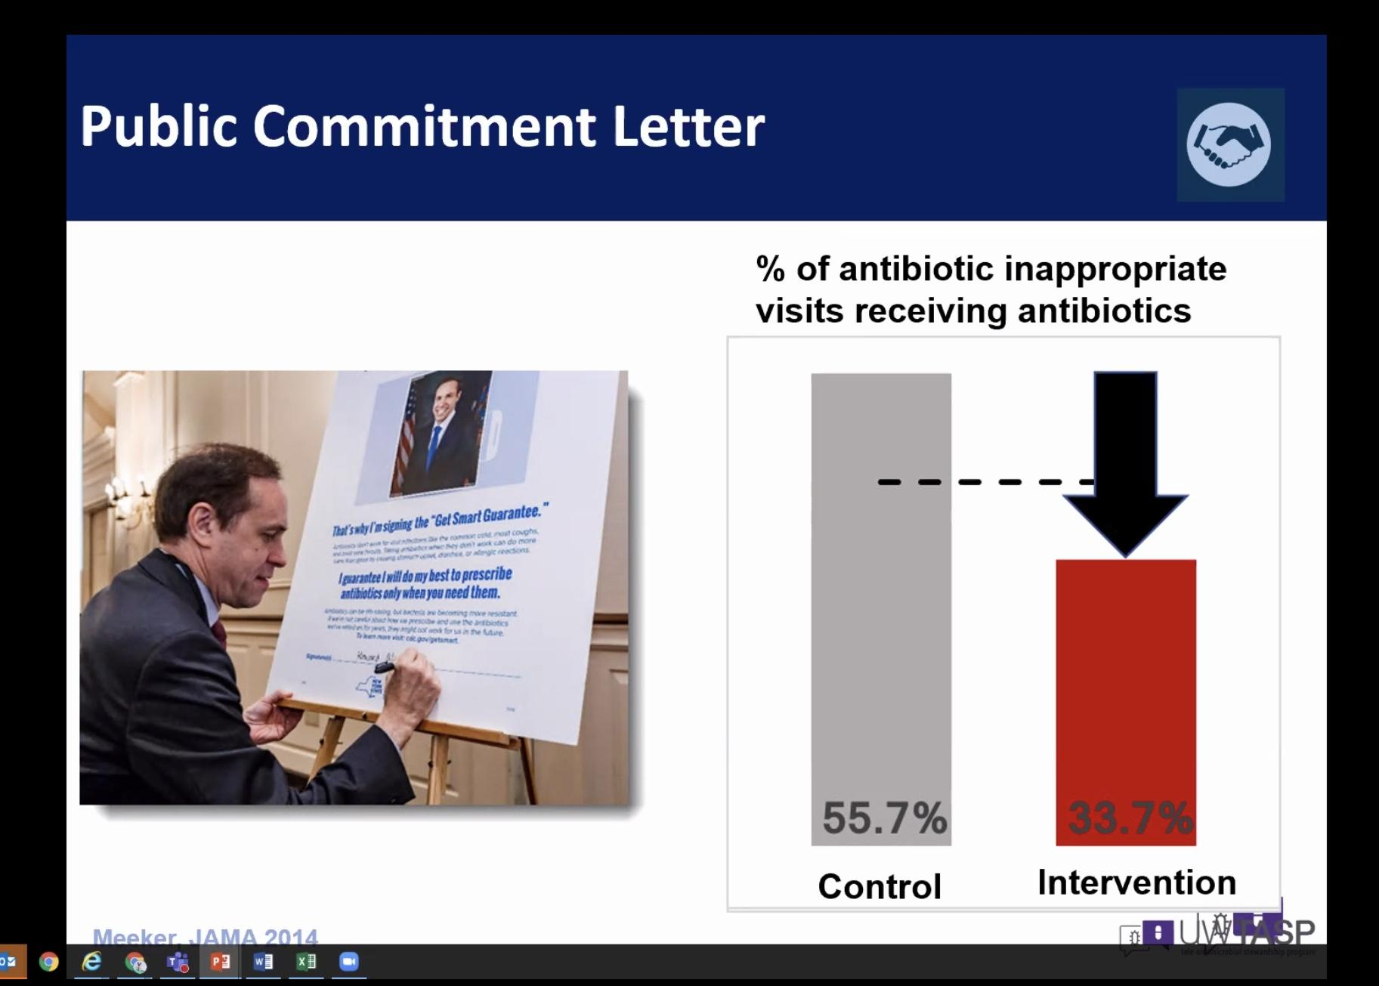Note difference once a poster was posted.
Letter of commitment to our patients about antibiotics
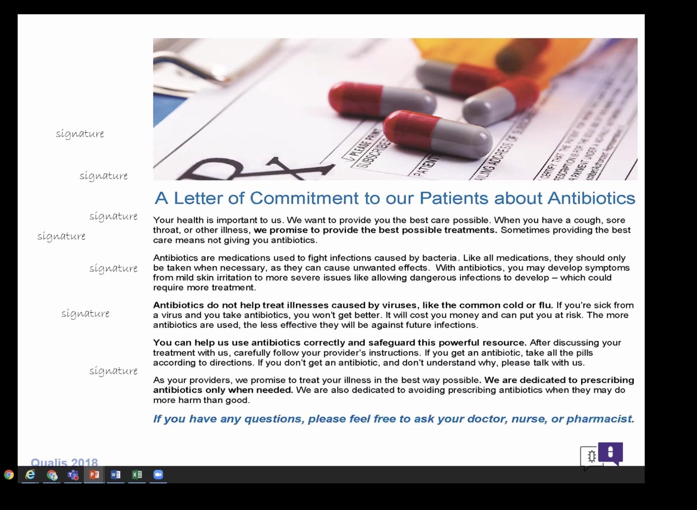
Abx commitment posters
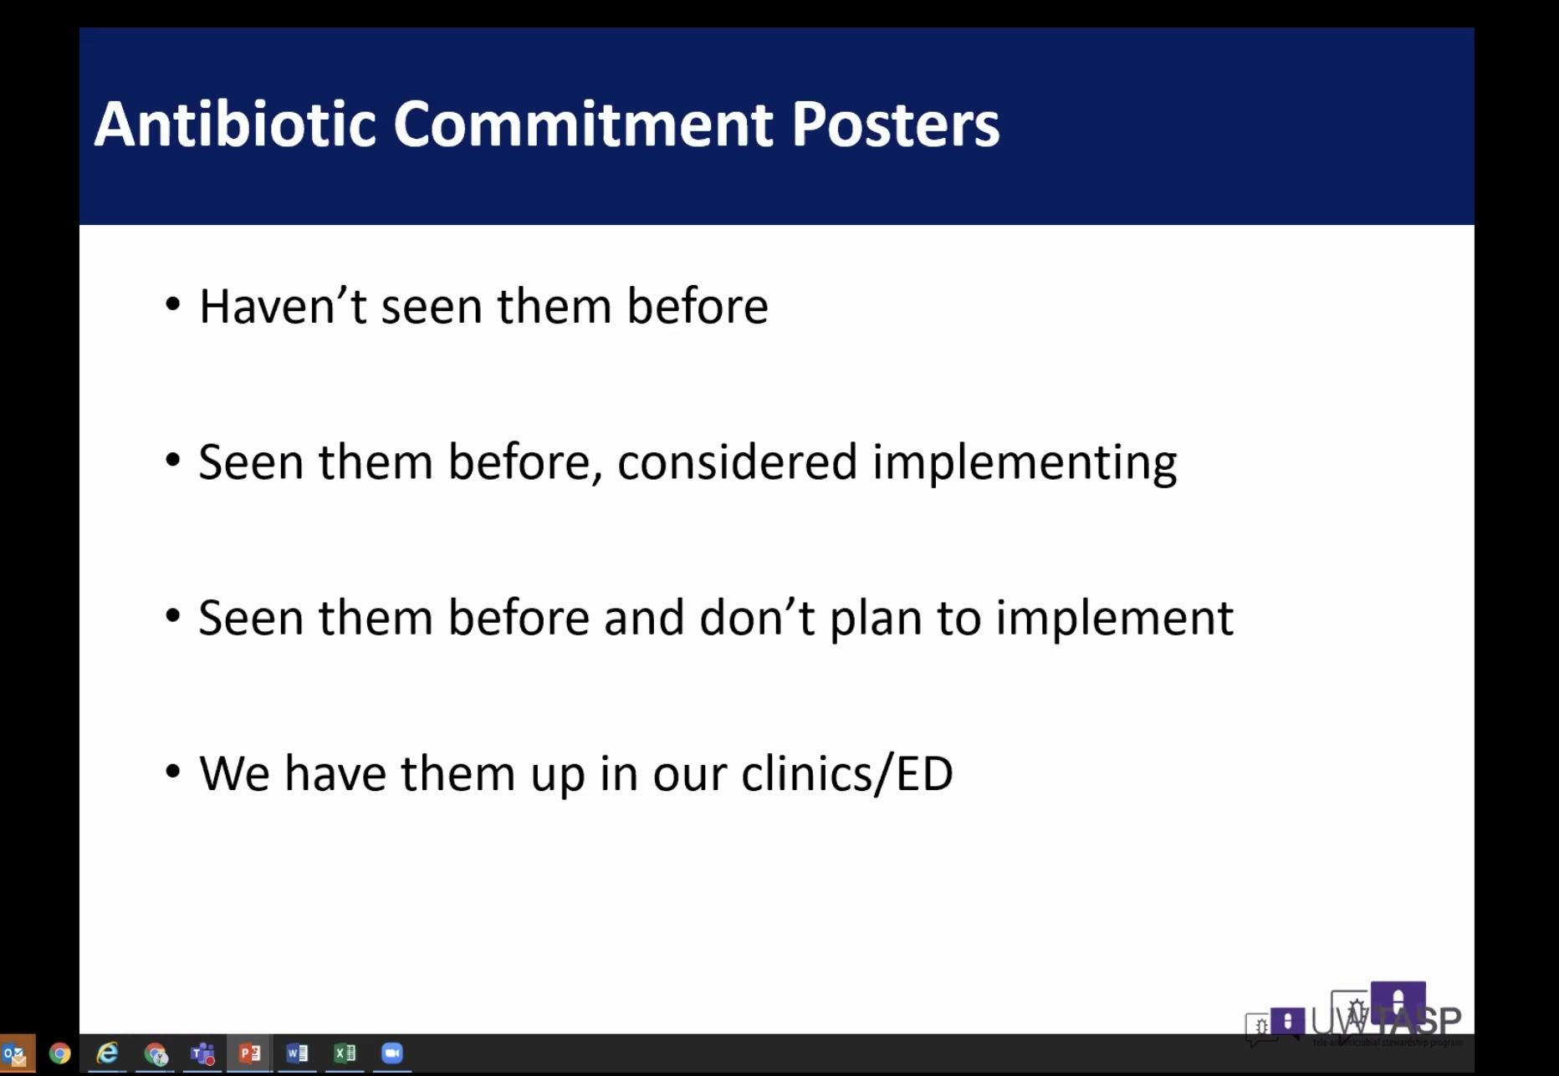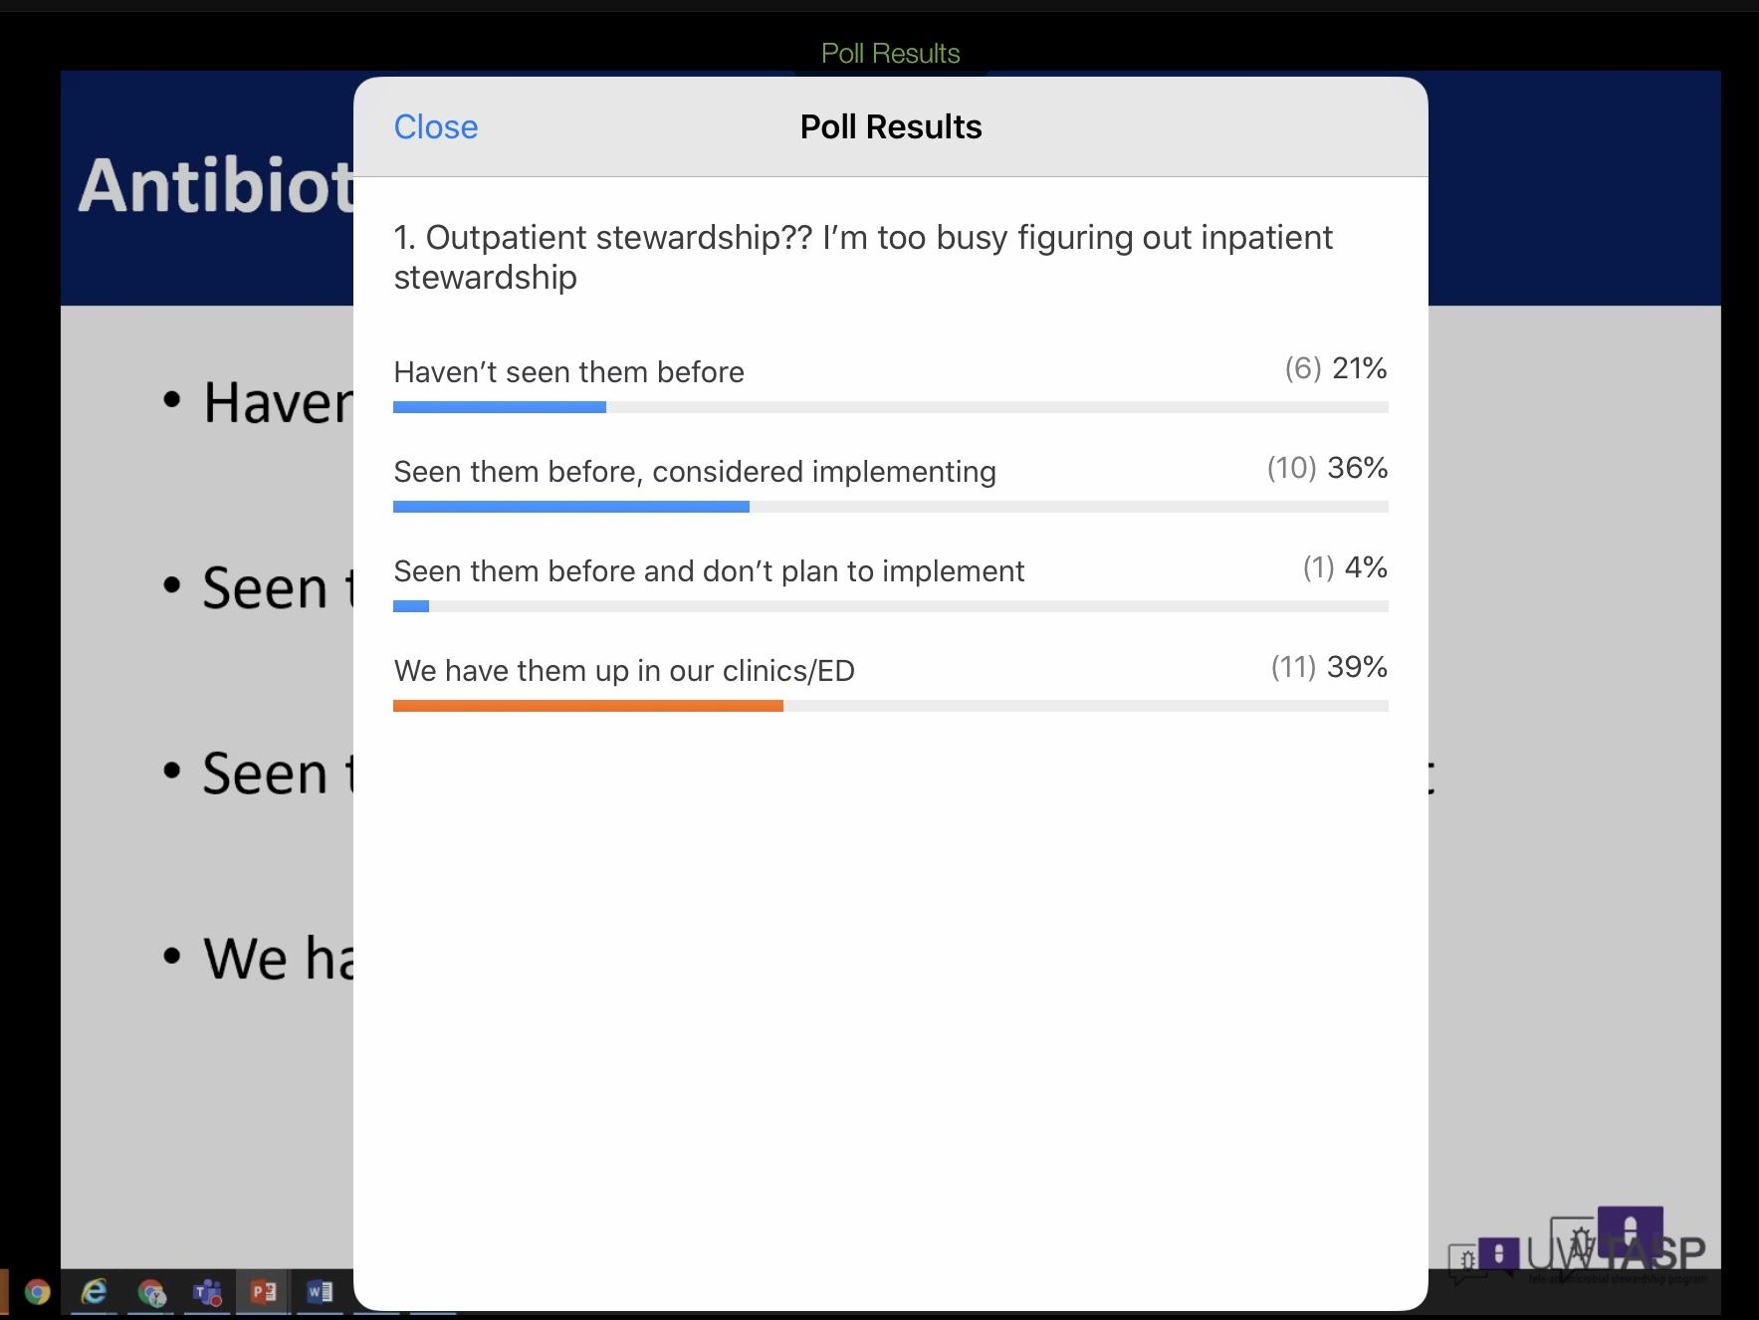

Peer comparison
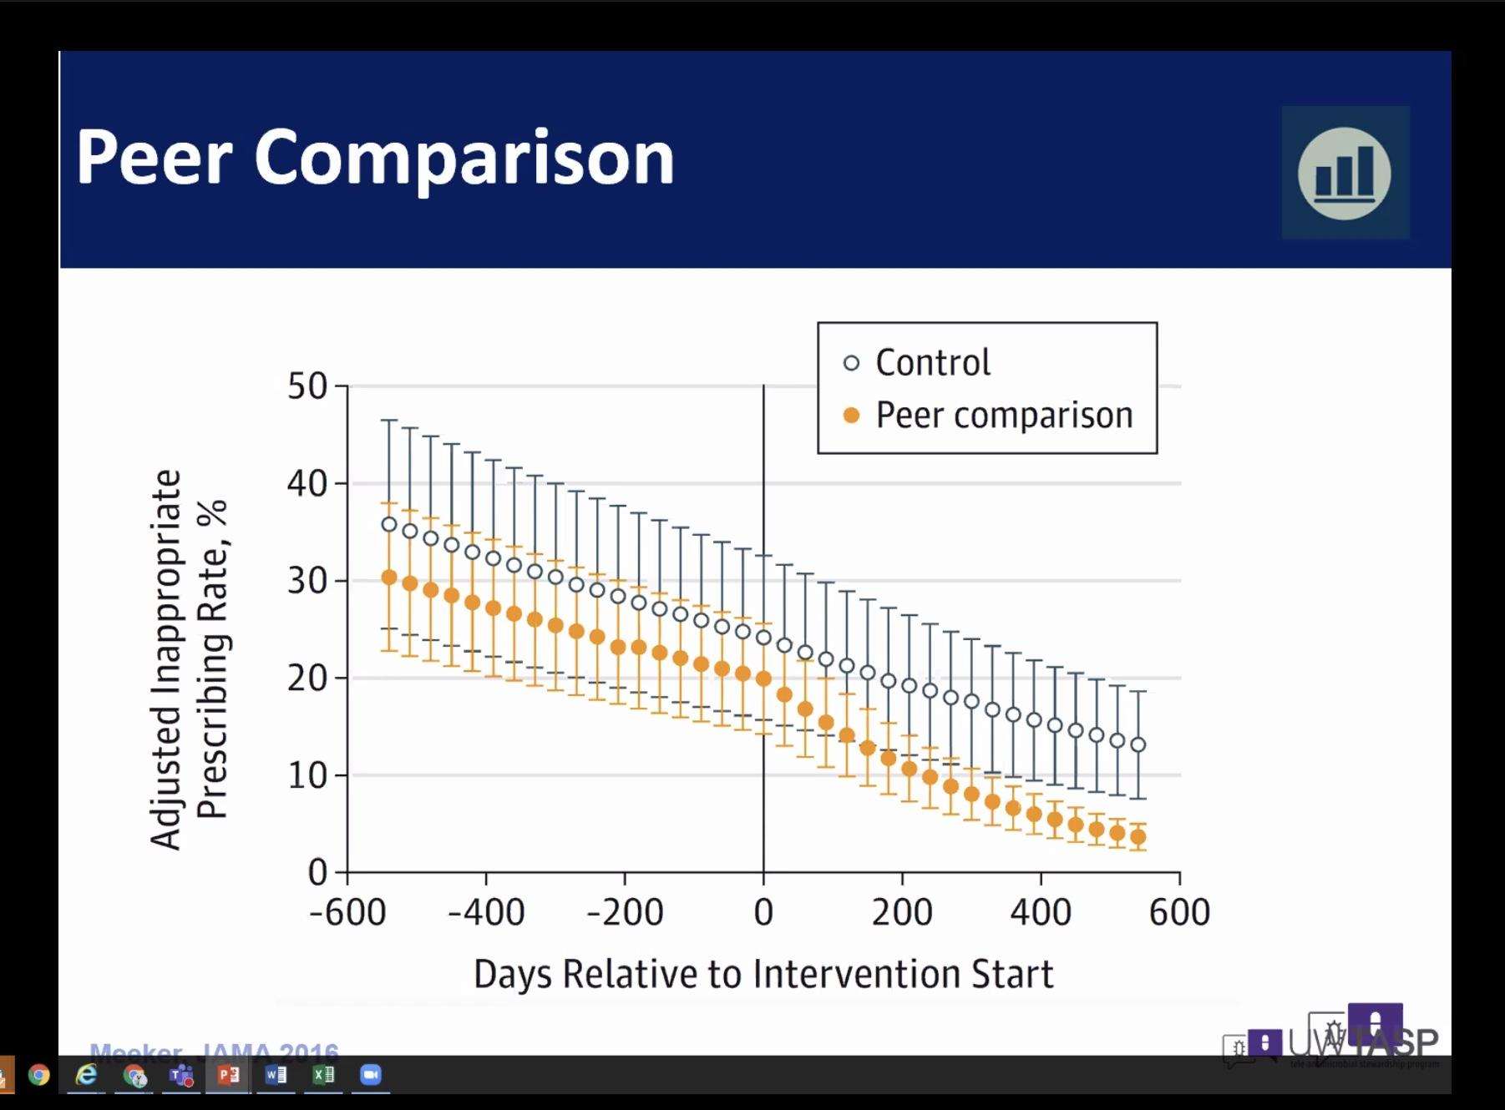
The orange dots went down lower after they received peer data

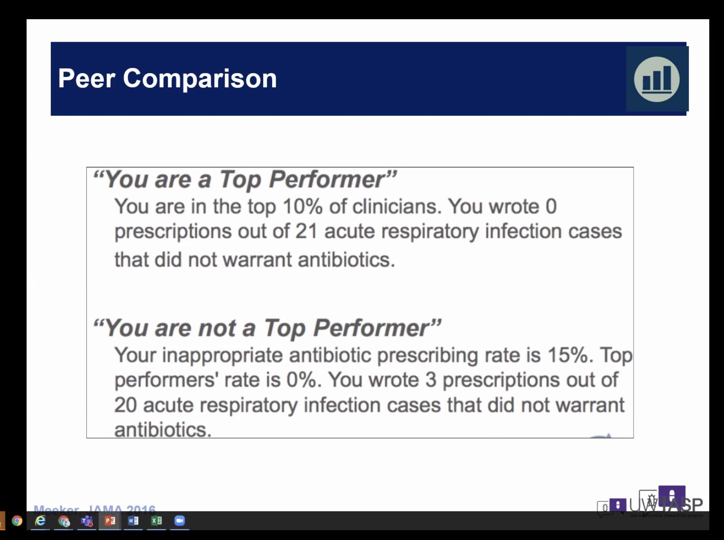 how often are you prescribing antibiotics when they are not indicated- email saying top performer or not atop performer (your inappropriate rate of rxs are at least 15%)

Peer comparison may be Perceived as Punitive
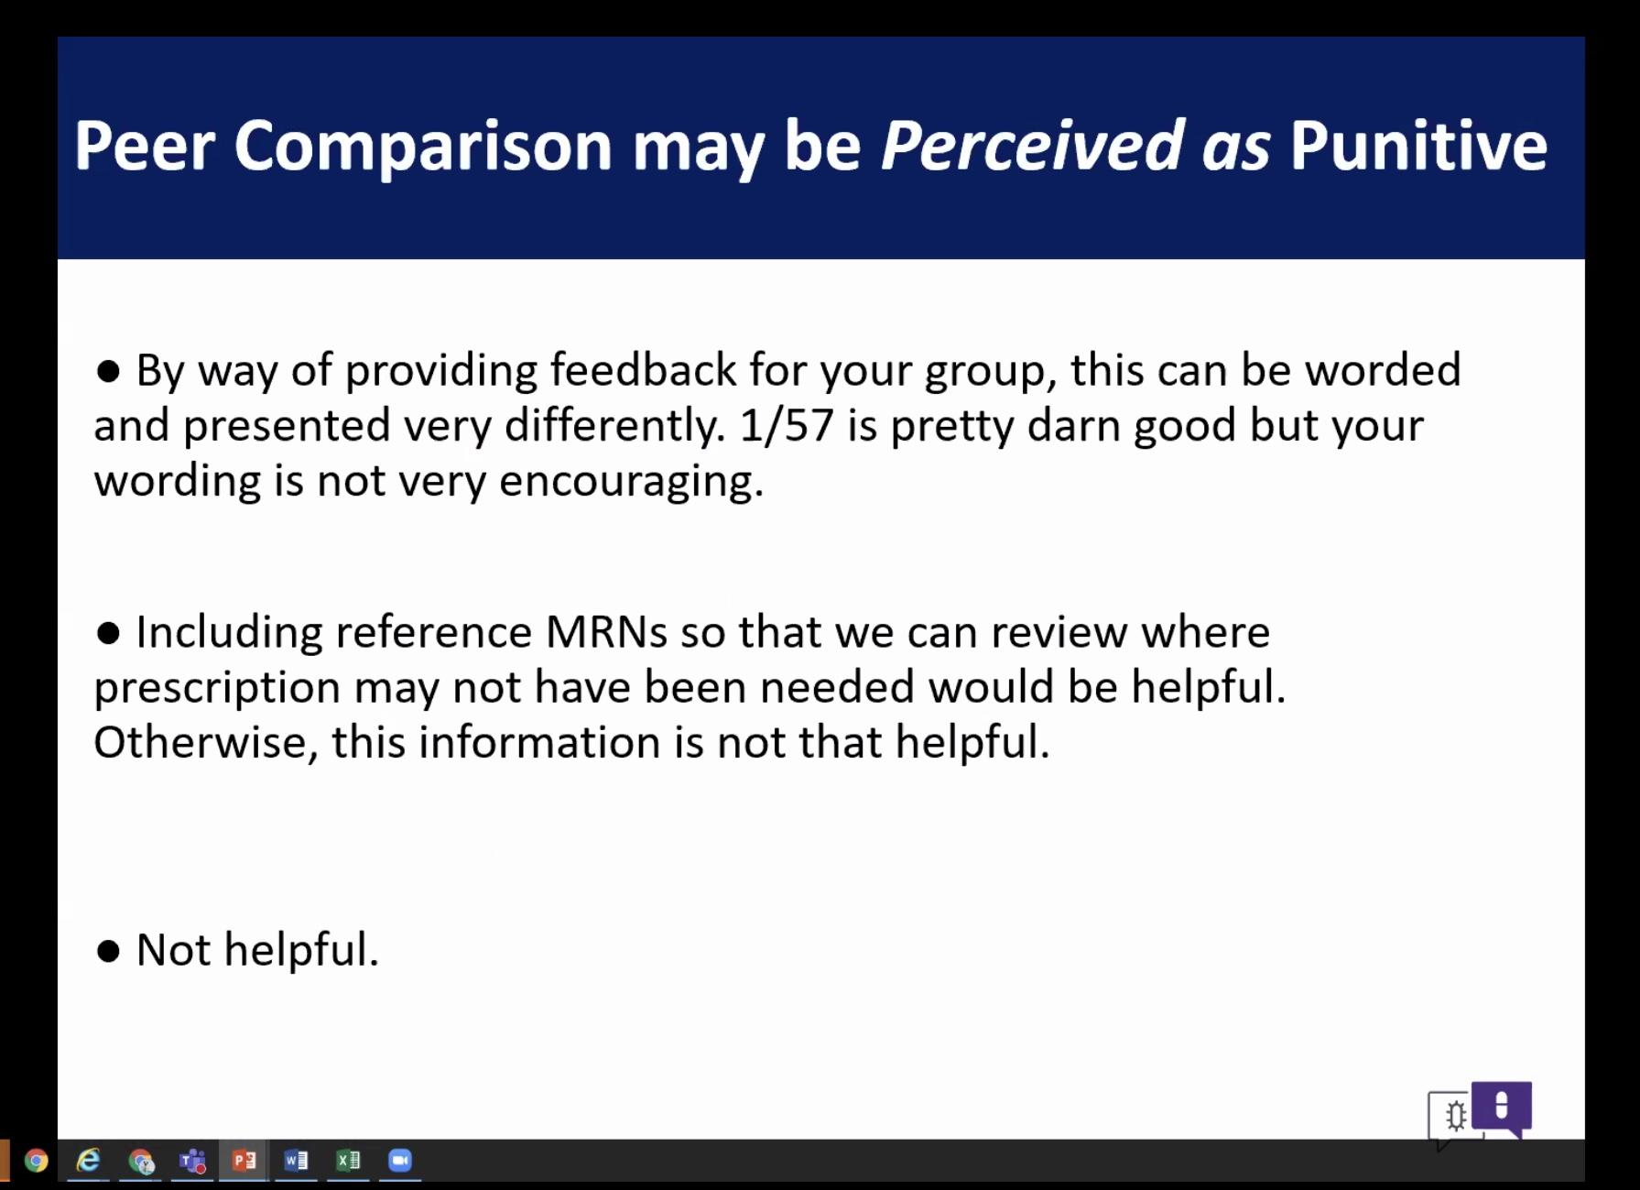
Make Peer comparison the START of a Conversation
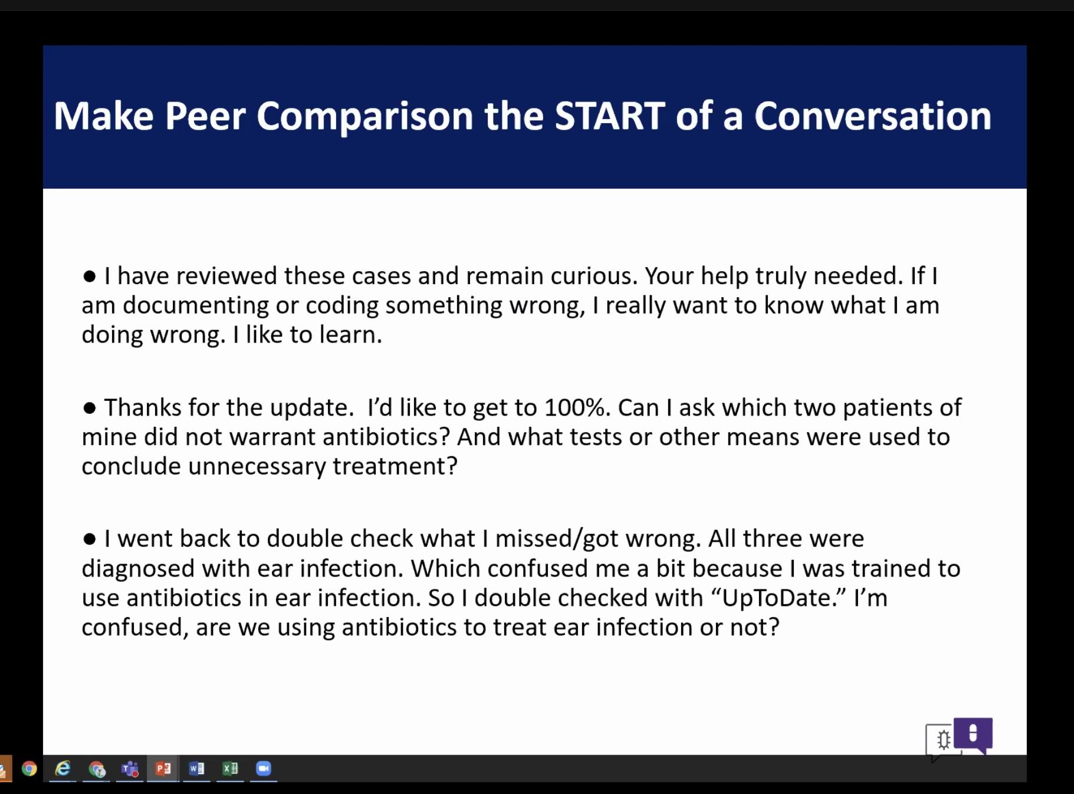
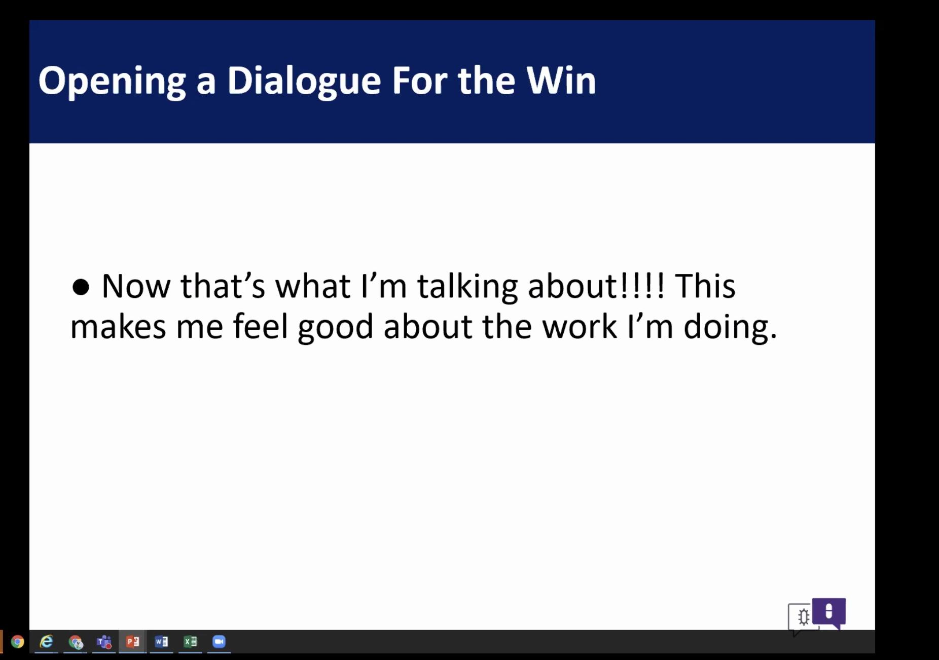
MITIGATE ICD-10 Algorithm
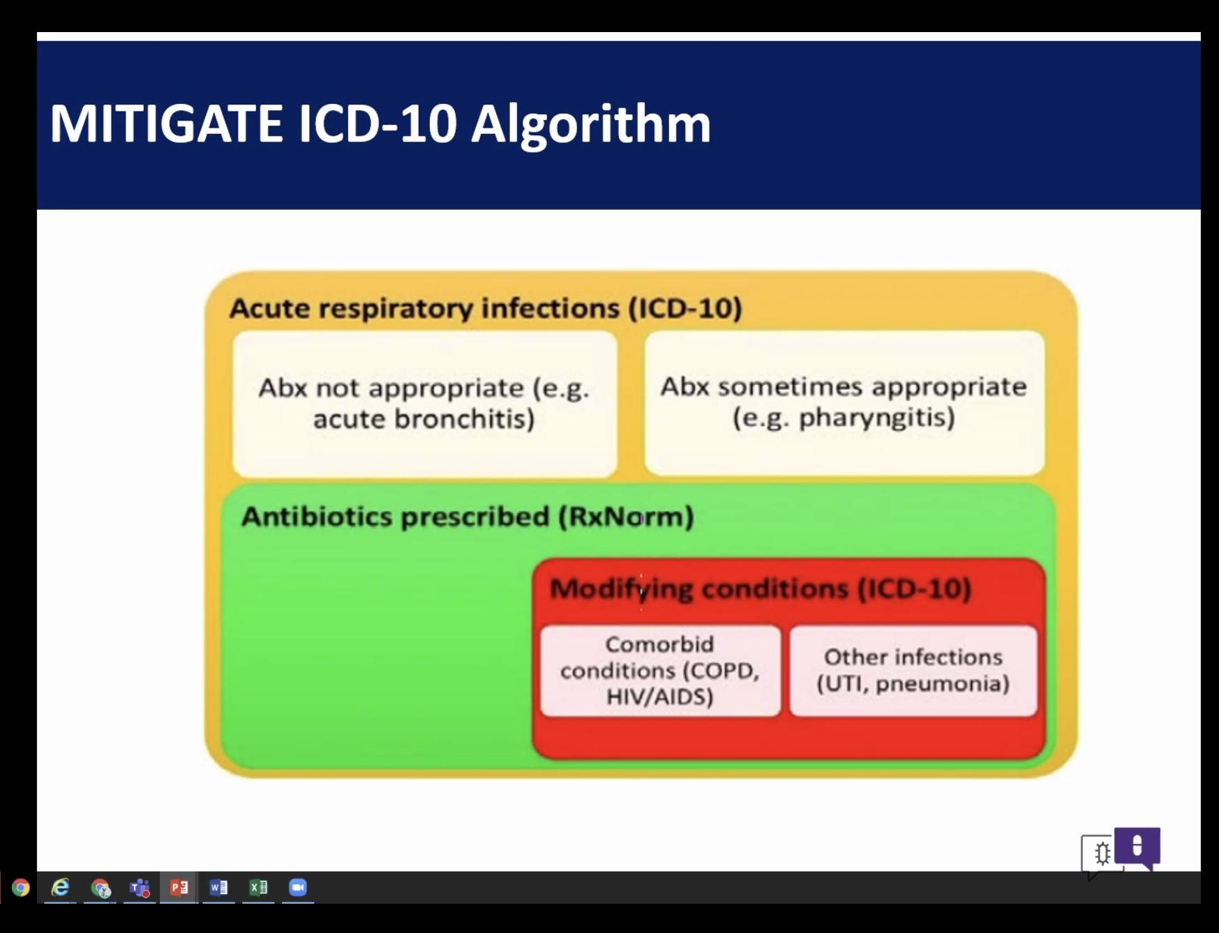
Peer Review is Effective but getting the data sucks
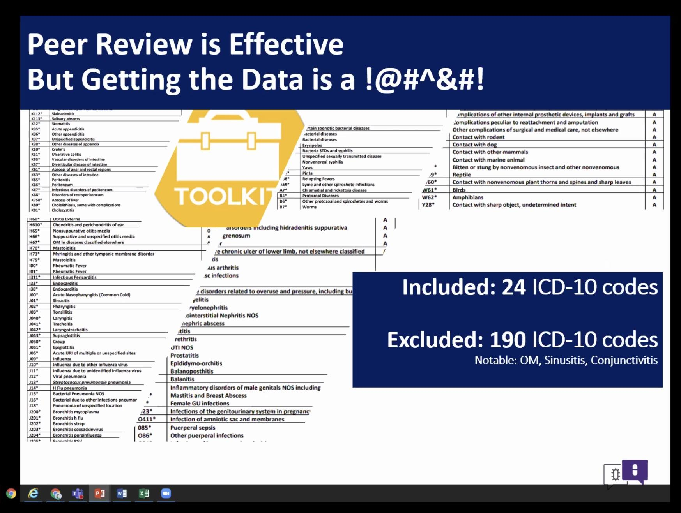

Alternative to Massive Data build: Focus on 1 diagnosis or 1 antibiotic
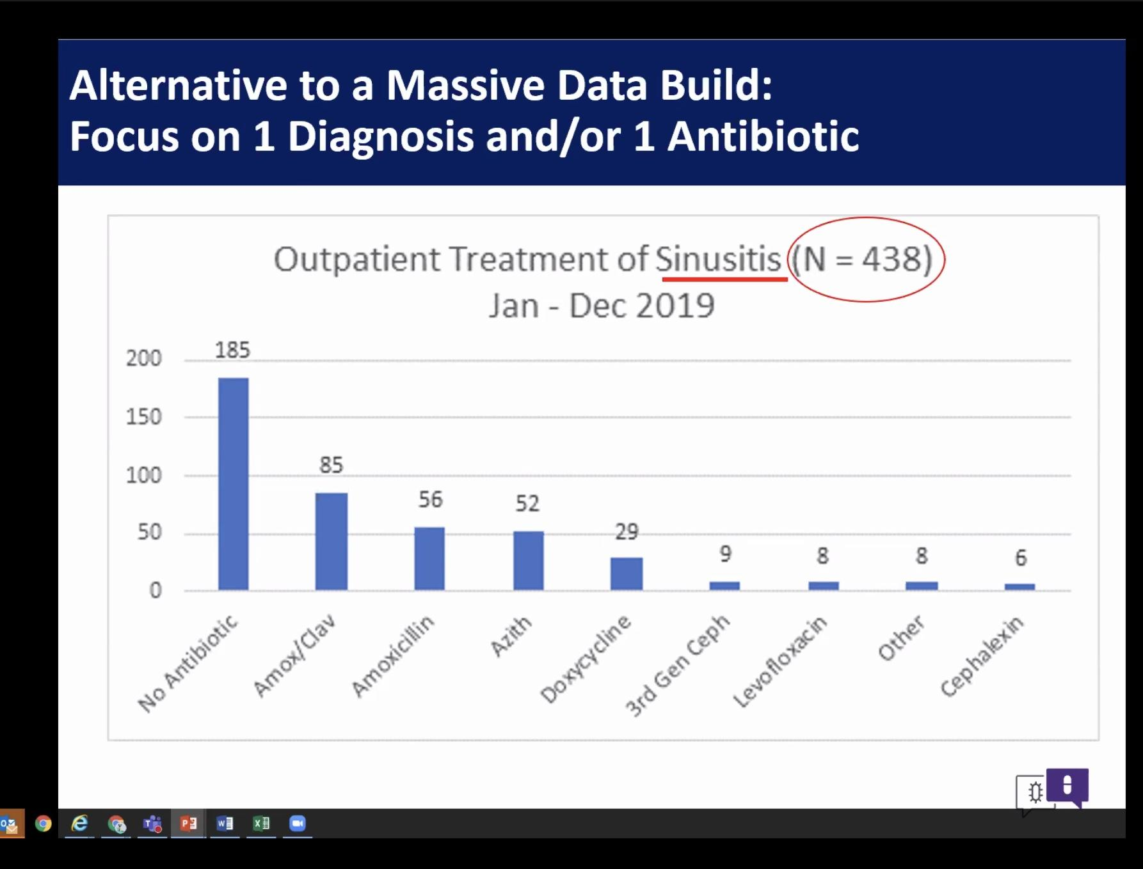
Insert slide: fewer people diagnosed w PNA but a more serious infection.

Considerations when prescribing antibiotics
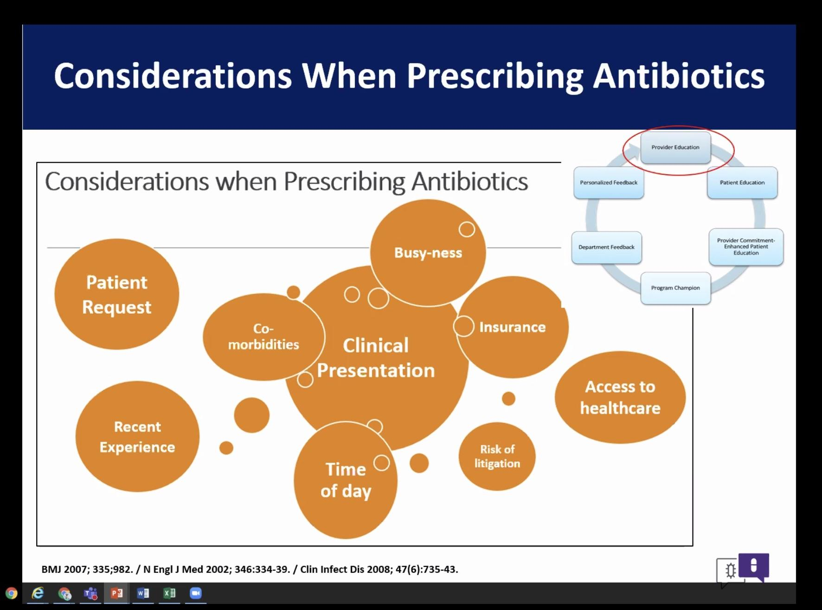Why are prescribers prescribing antibiotics, thinking of reasons that they might be
Shift the focus
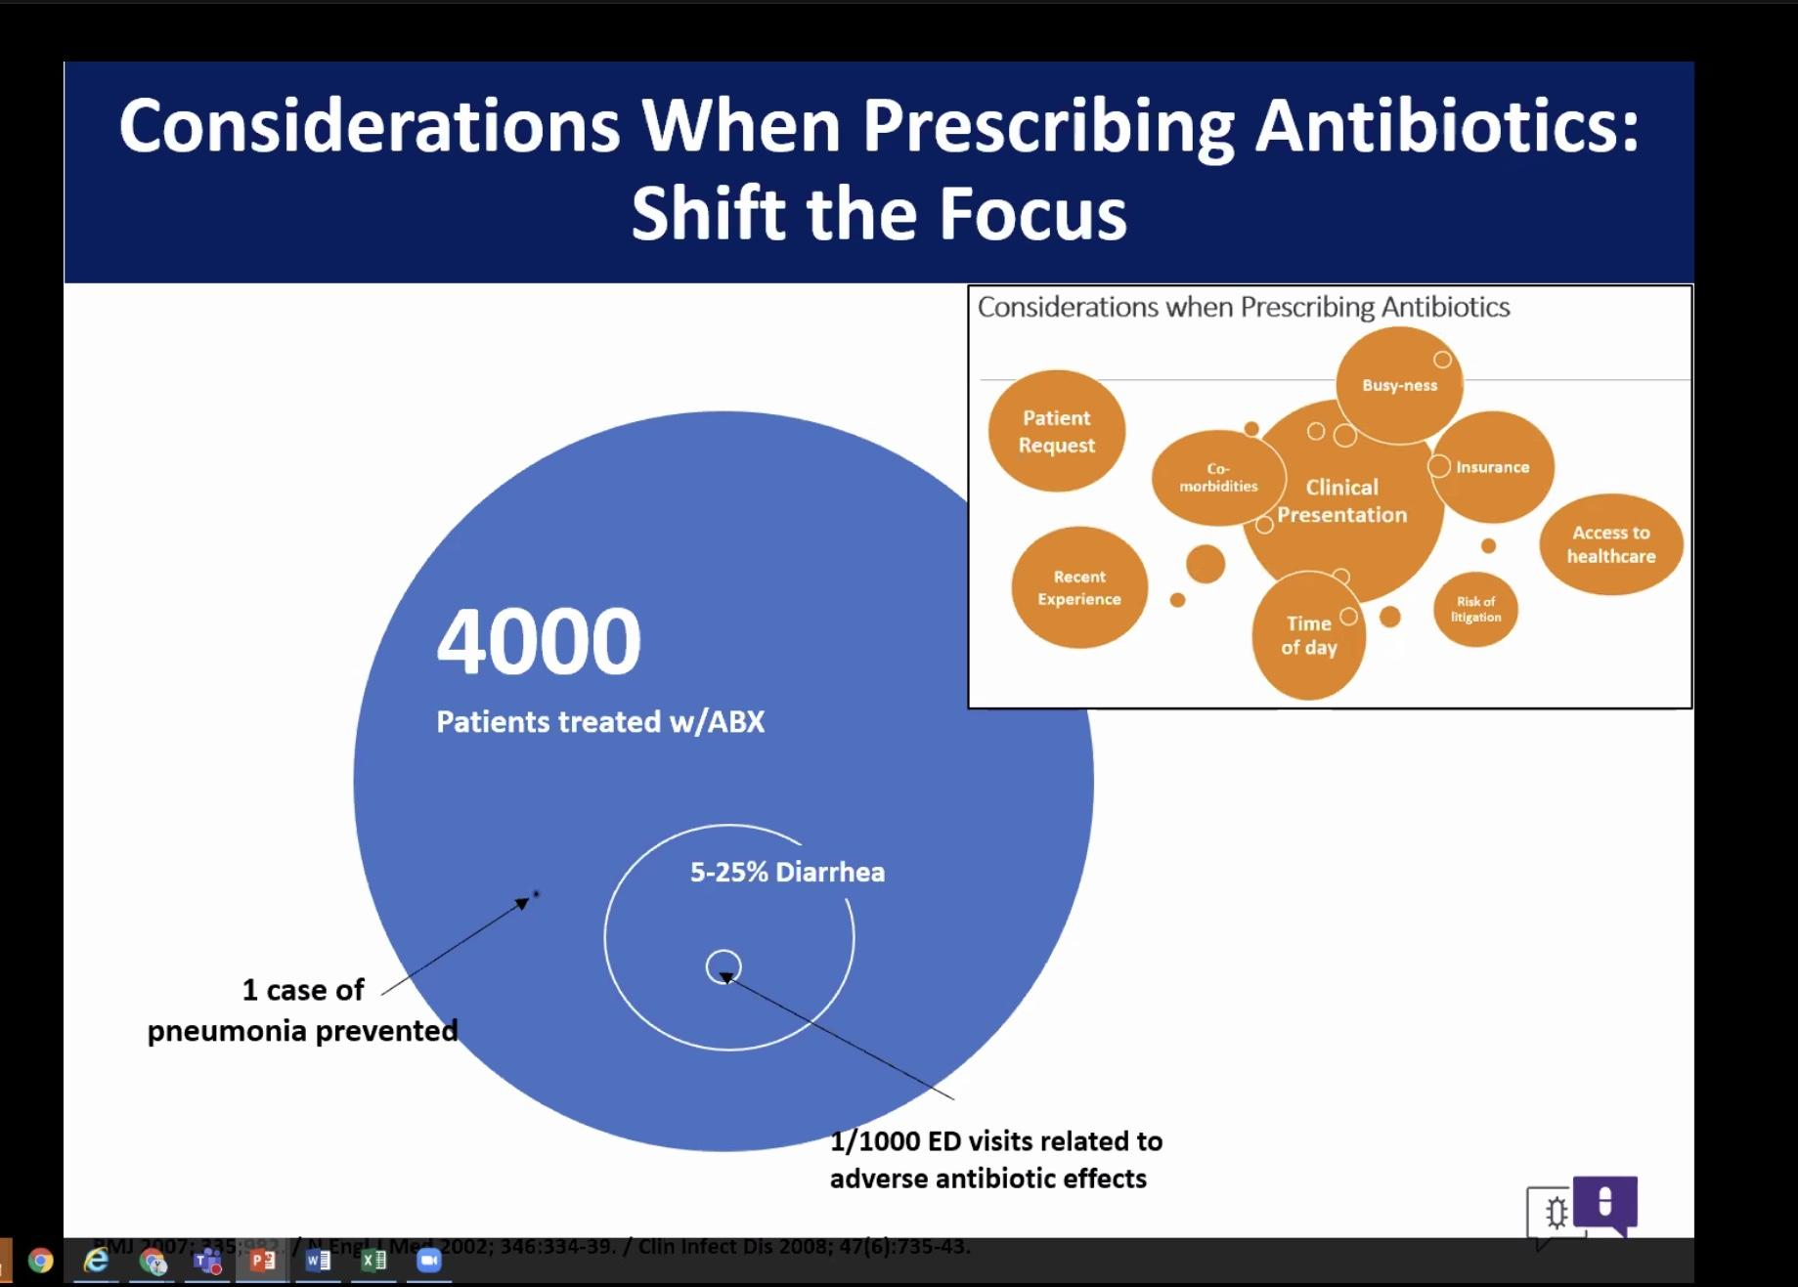

DART: Dialogue around resp illness treatment
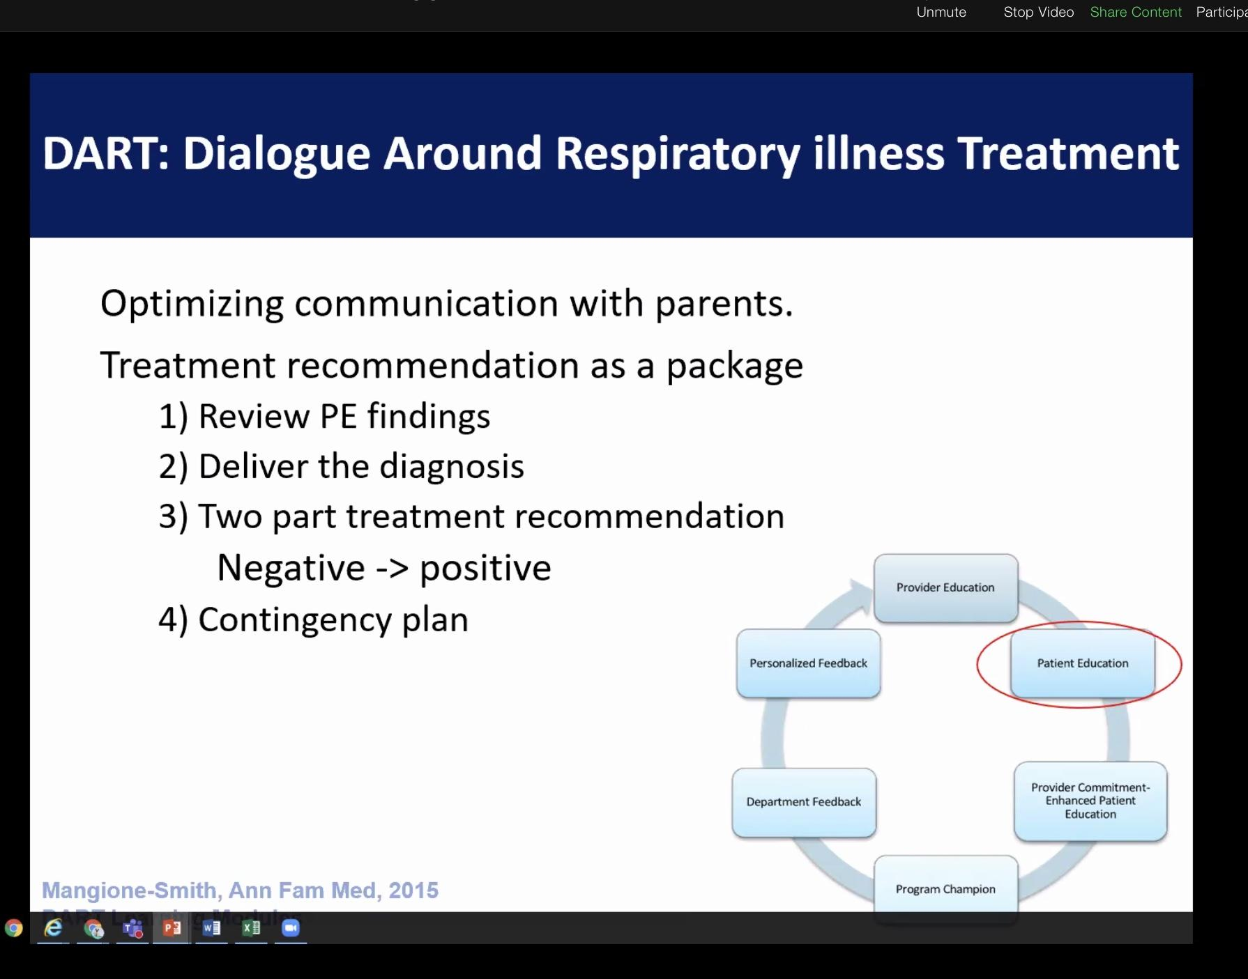
-Pt is requesting antibiotics, the prescriber just wants to get through the visit.
Need to present the treatment regimen as a package- like a treatment plan recommendation: On the one hand you do not abx this is viral, these are the other treatment plans. If XYZ call me if you have SOB, cont fevers.

Summary
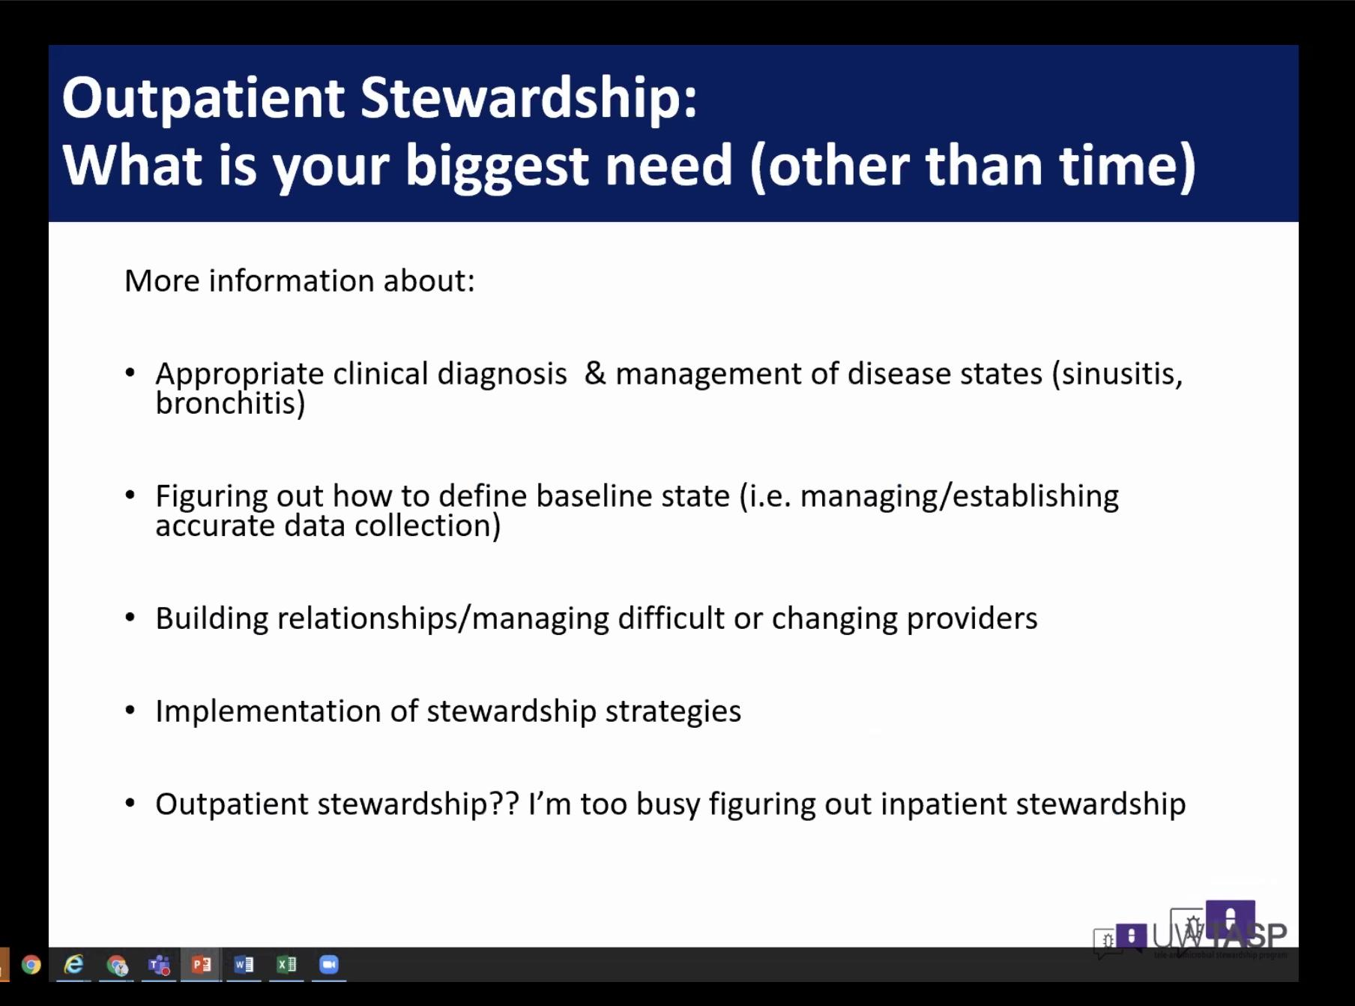

Outpatient Stewardship
-Biggest need
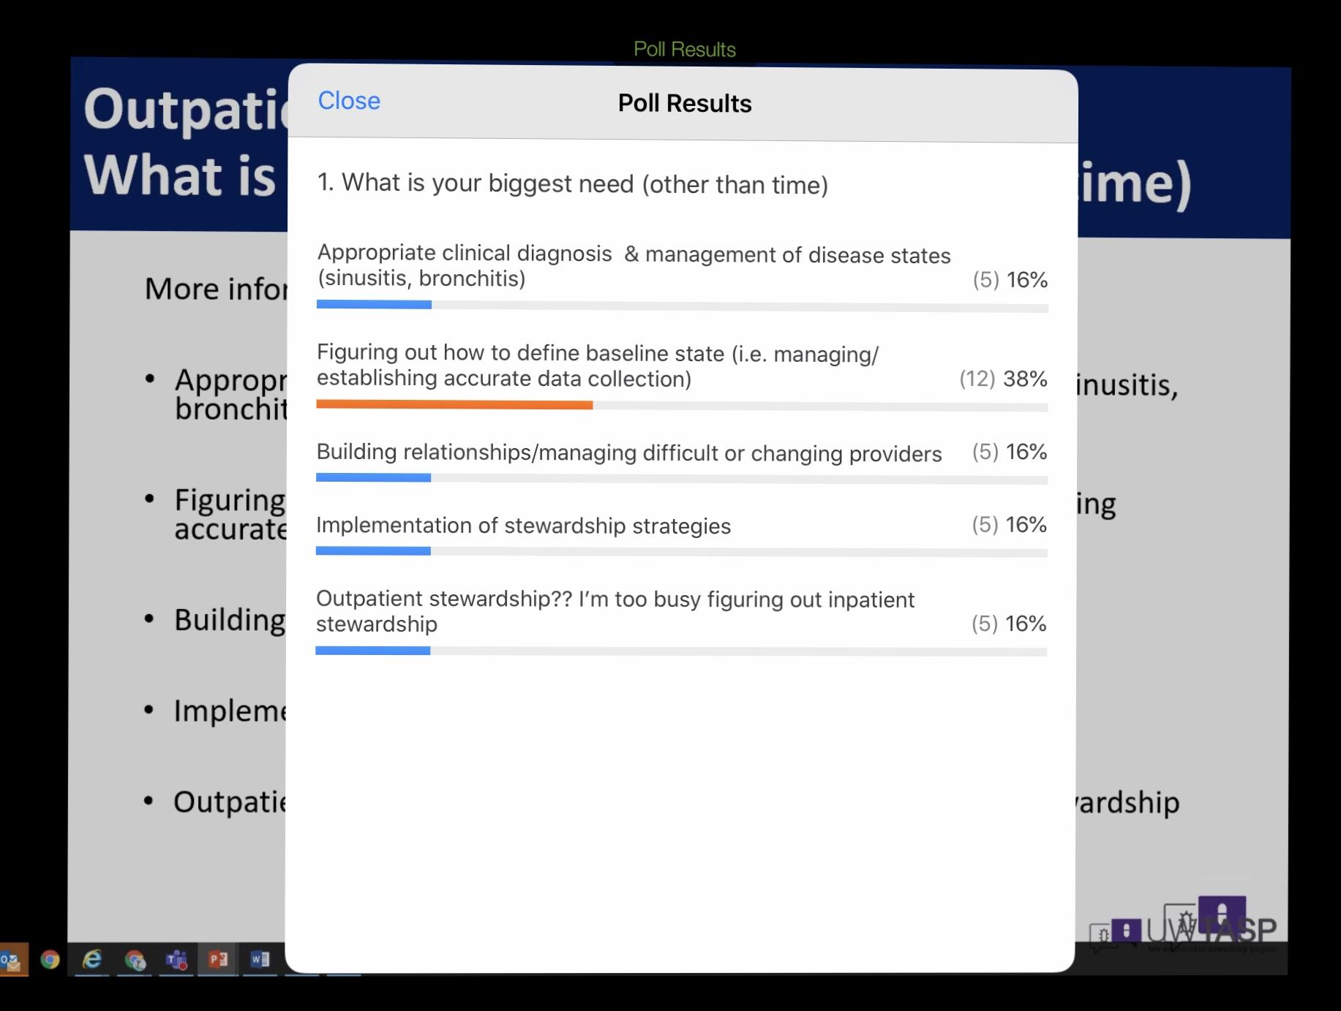

****DART modules**** increases patient satisfaction, look up the resource.
-Emphasize how relieved as a physician I don’t have to prescribe antibiotics.

Zara: pick one antibiotic and then look at the data, such as azithromycin prescribing. Easiest for pharmacists.

Necrotizing soft tissue infection: necrotizing fasciatis another term.
Can’t get antibiotics to that area because there is no blood flow because the tissue is dead.
3 different flavors:
Type 1: most commonly seen- mixed infection, more than one germ that is involved, anaerobes involved. Goin in men often, bacteroides group or fecal flora. GNR, E. coli, Klebsiella.
Type 2: One germ, almost always Group A Strep- the pyogenes the pus maker
Type 3: Gas gangrene, Clostridium pergenges and other Clostridium.
Surgery is required to help stop the spread of infection.

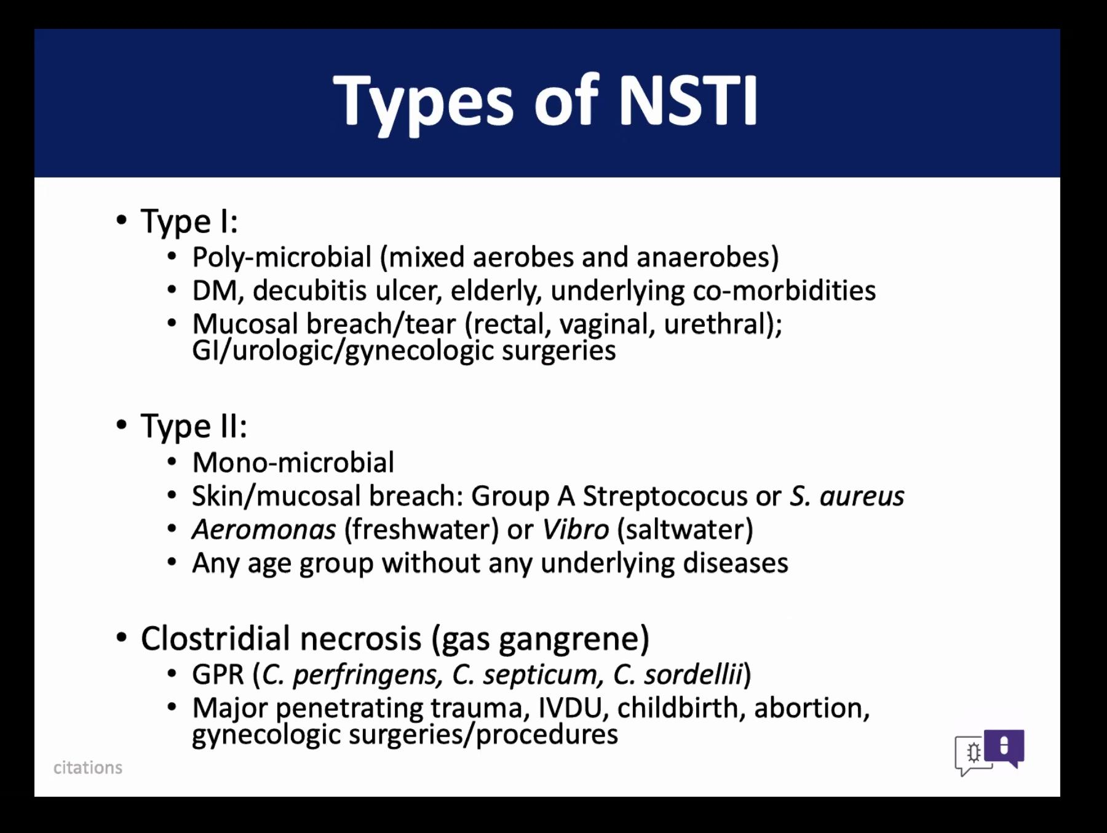
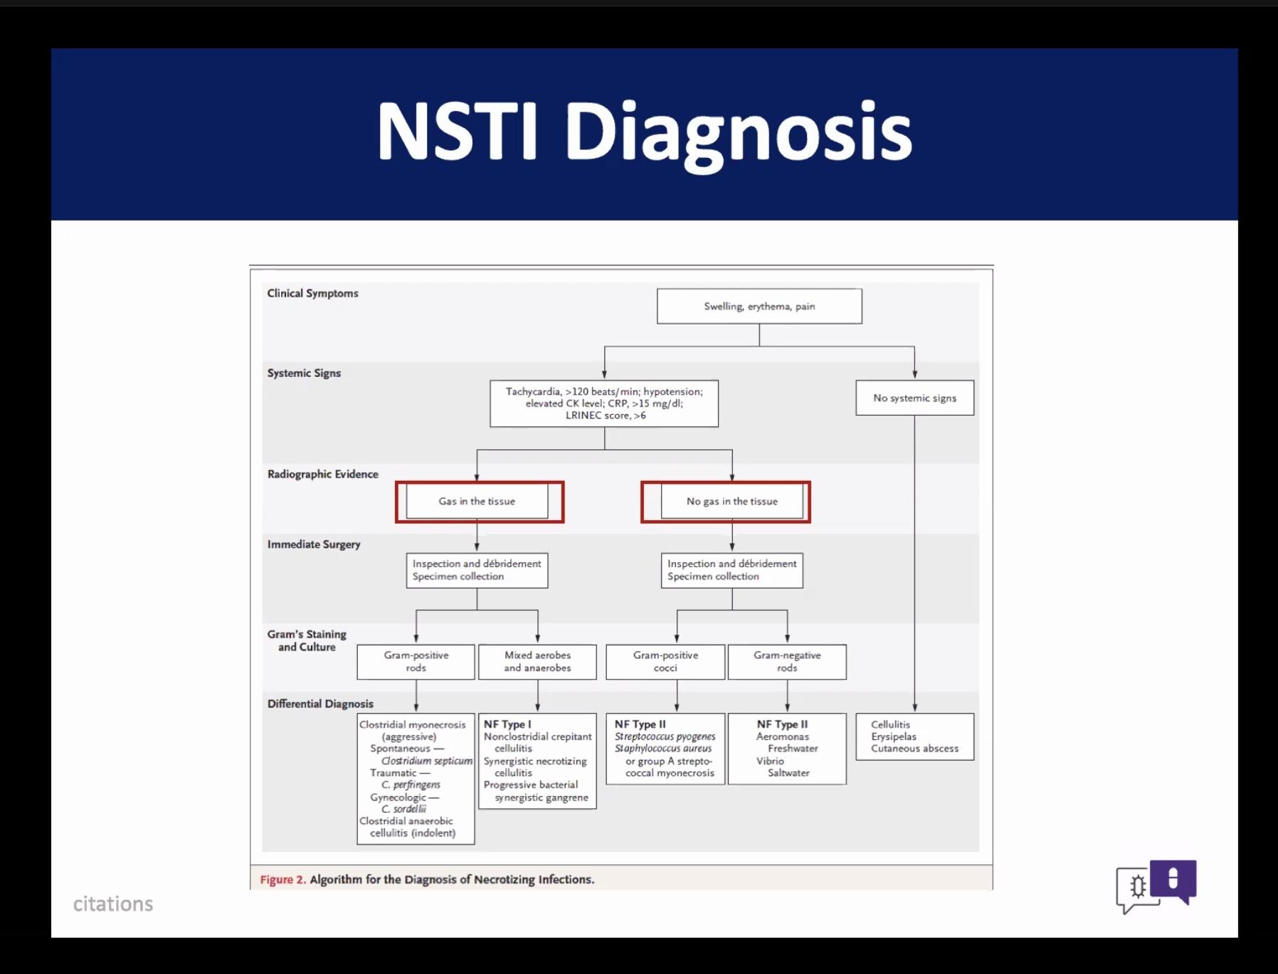
Abx management
Active phase of replication PCN works very well, then clindamycin later on can be very helpful
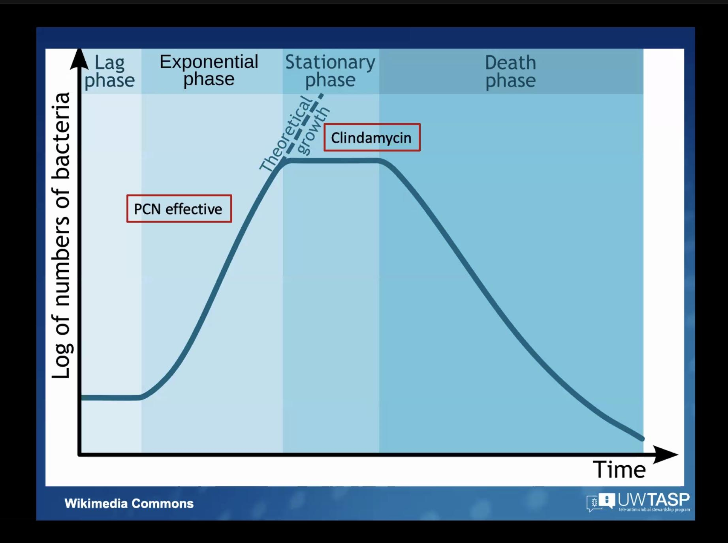

Role of clindamycin
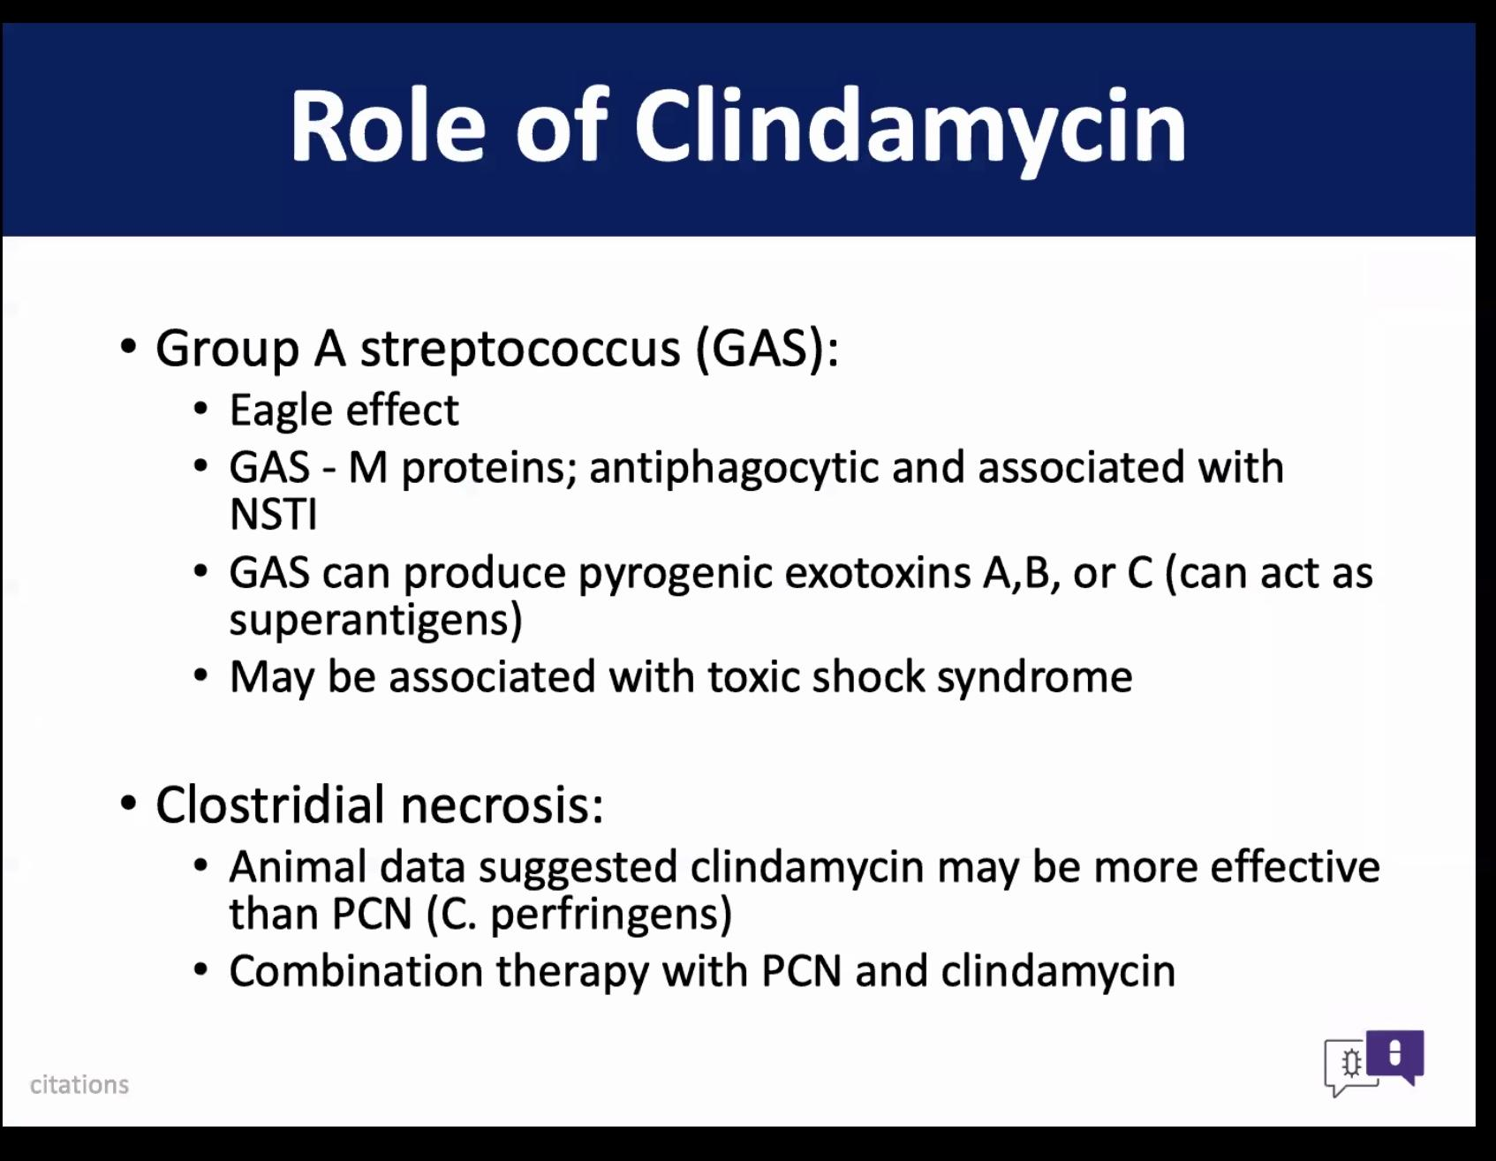
Antimicrobial for NSTI
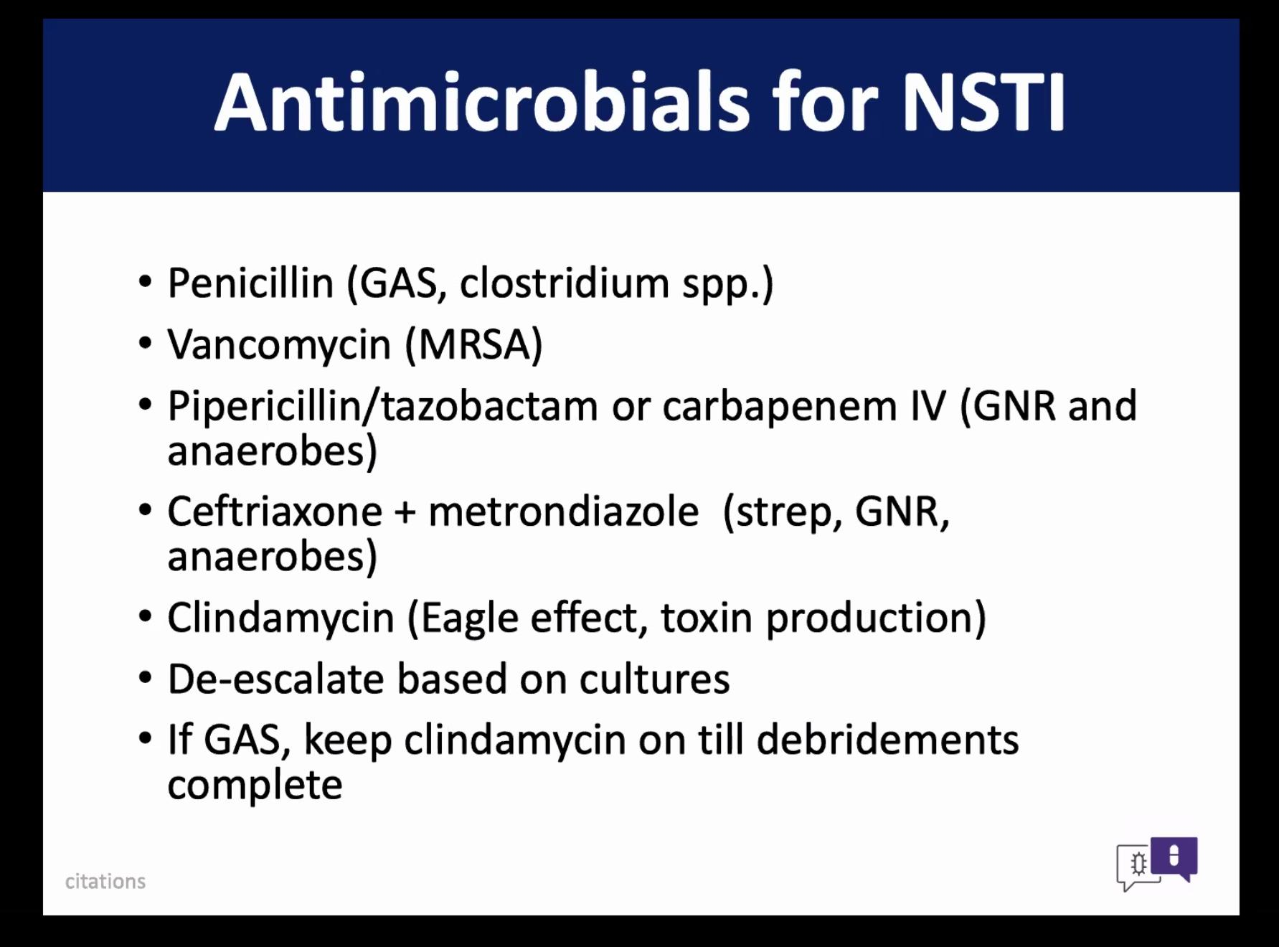
Necrotizing fasciitis is a life threatening infection. Would be ok to use Zosyn, Cleocin and Vanco until can get surgery. They use (UW) 1200 mg clindamycin q6hrs- they will be readdressing this though, do have an increase of C. diff risk with using this. Need surgeons to get good cultures so this can be de-escalated.

