UW TASP 8-18-2020 Antibiotic IV To PO Conversion + case discussion on Sepsis


1) What type of infections
2) When can you consider orals
3) Which oral antibiotic as step-down

What type of infections can we use oral abx as step-down therapy?
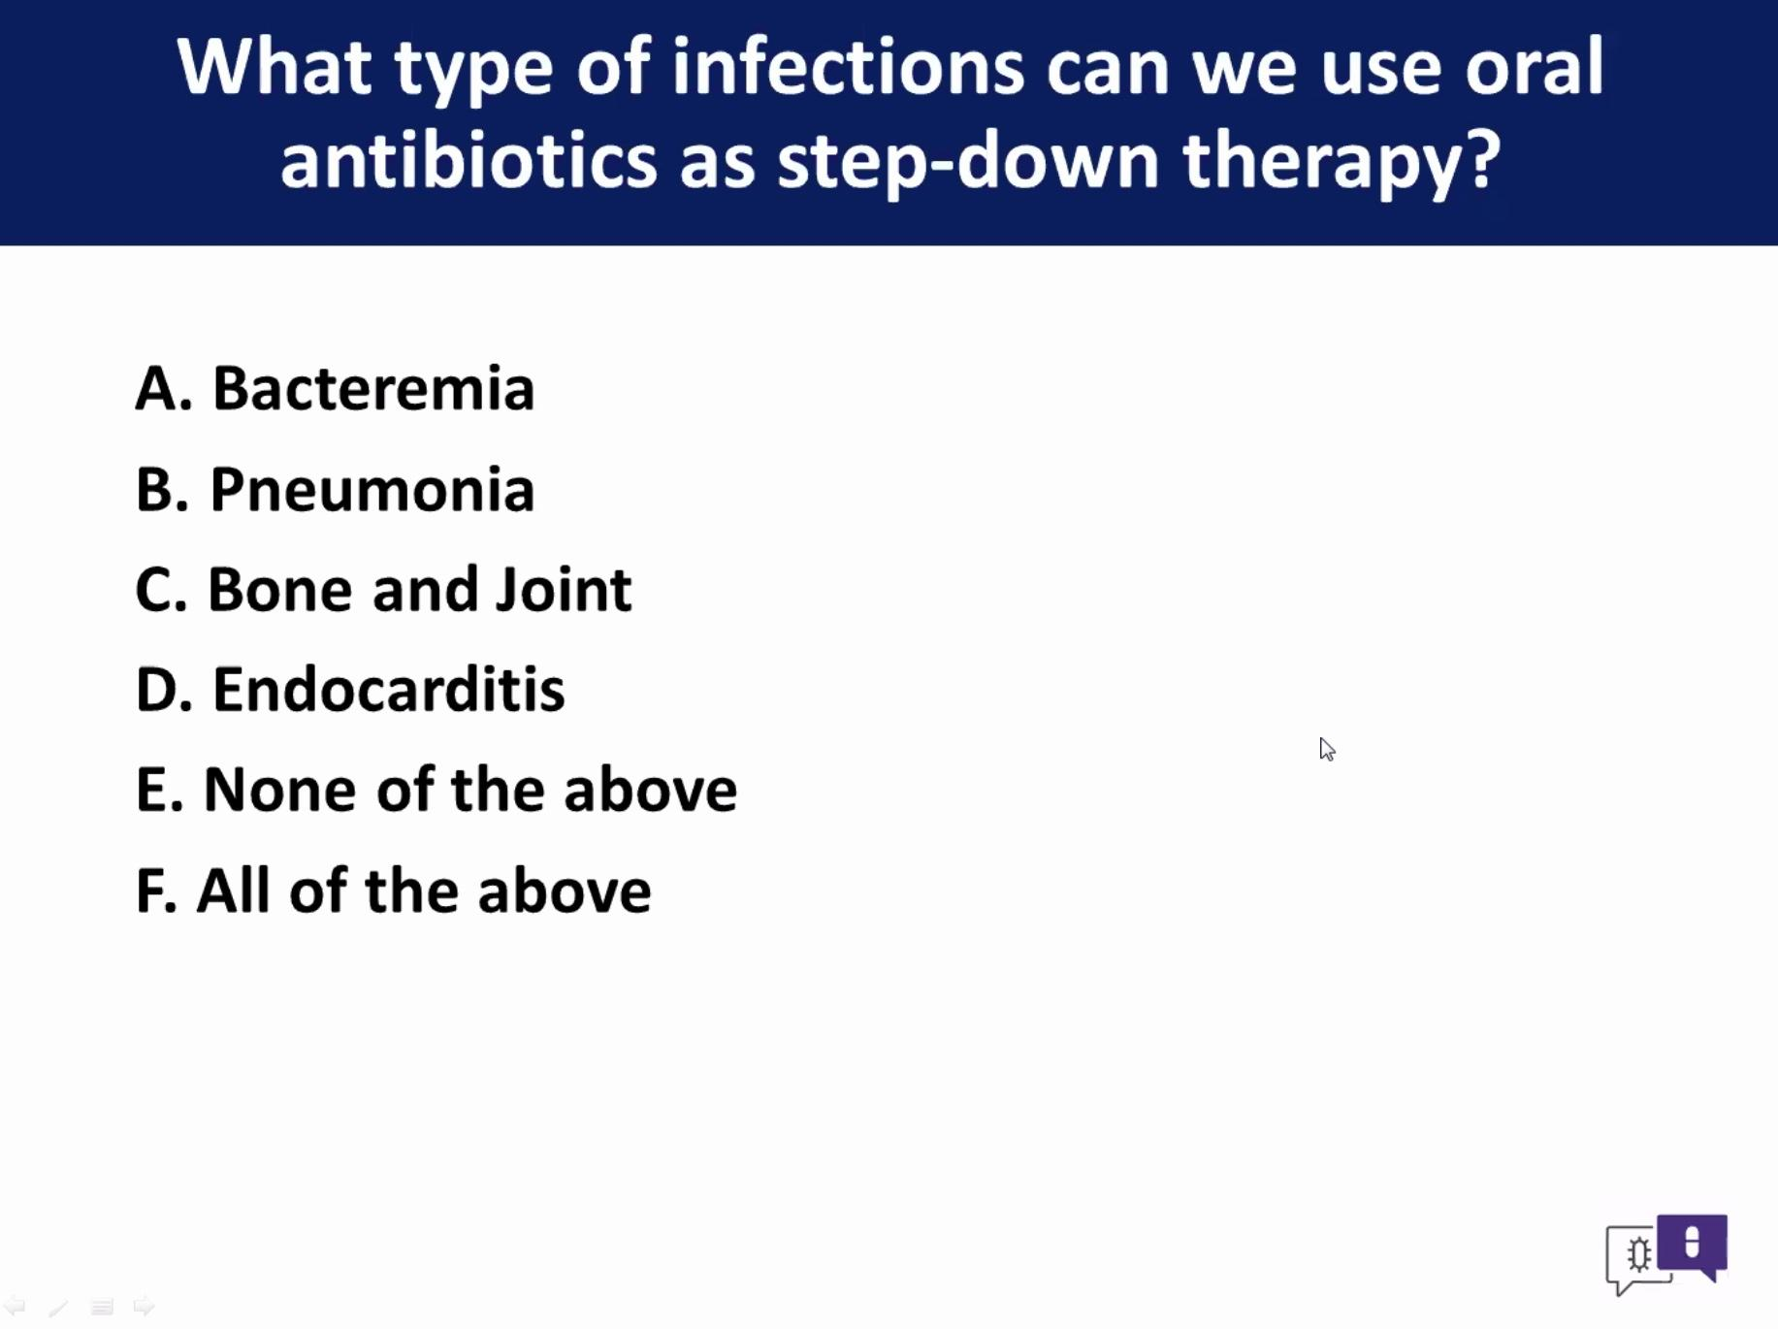
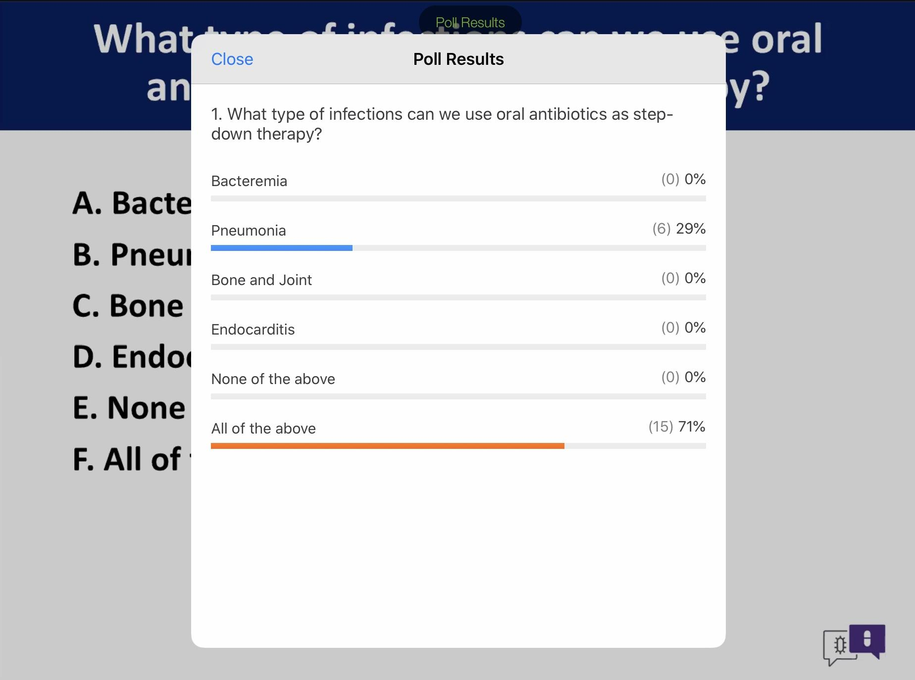

Gram-negative bacteremia
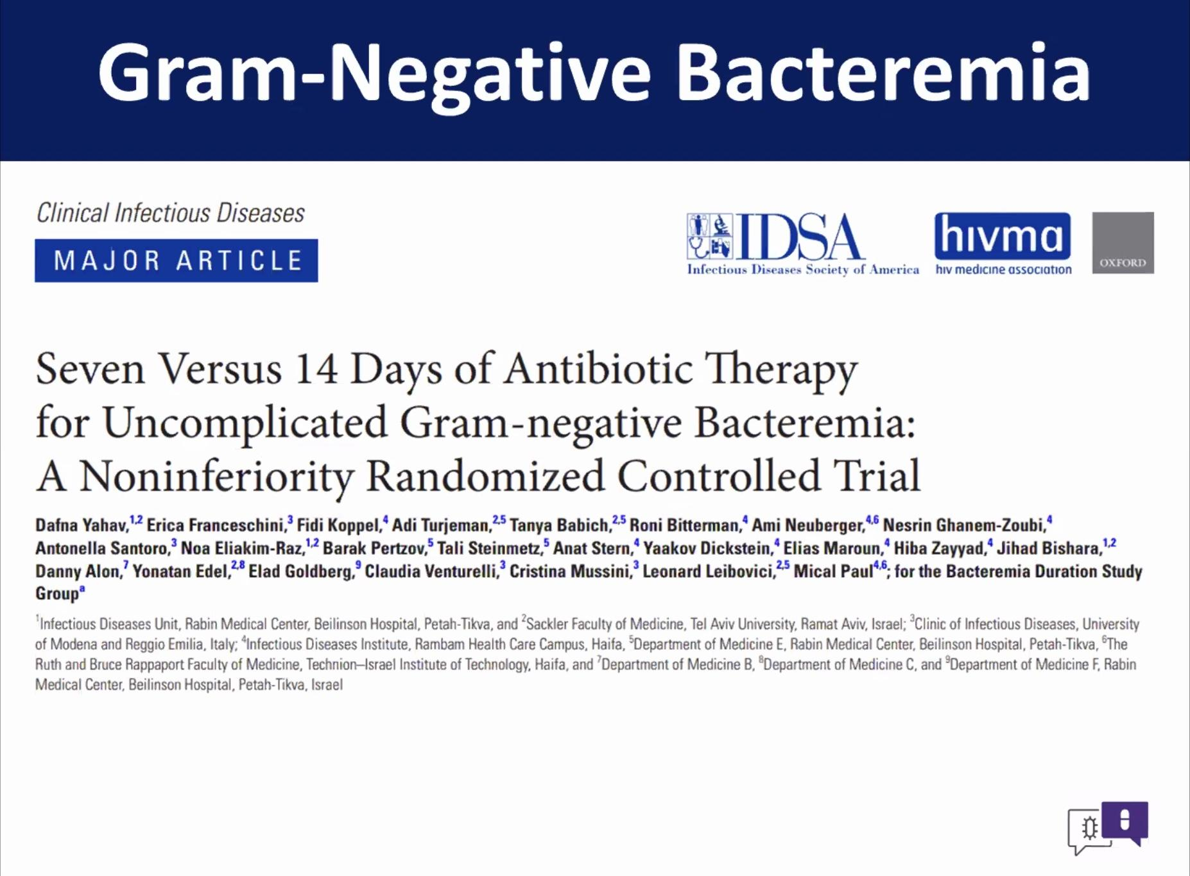
7 vs 14 days abx therapy
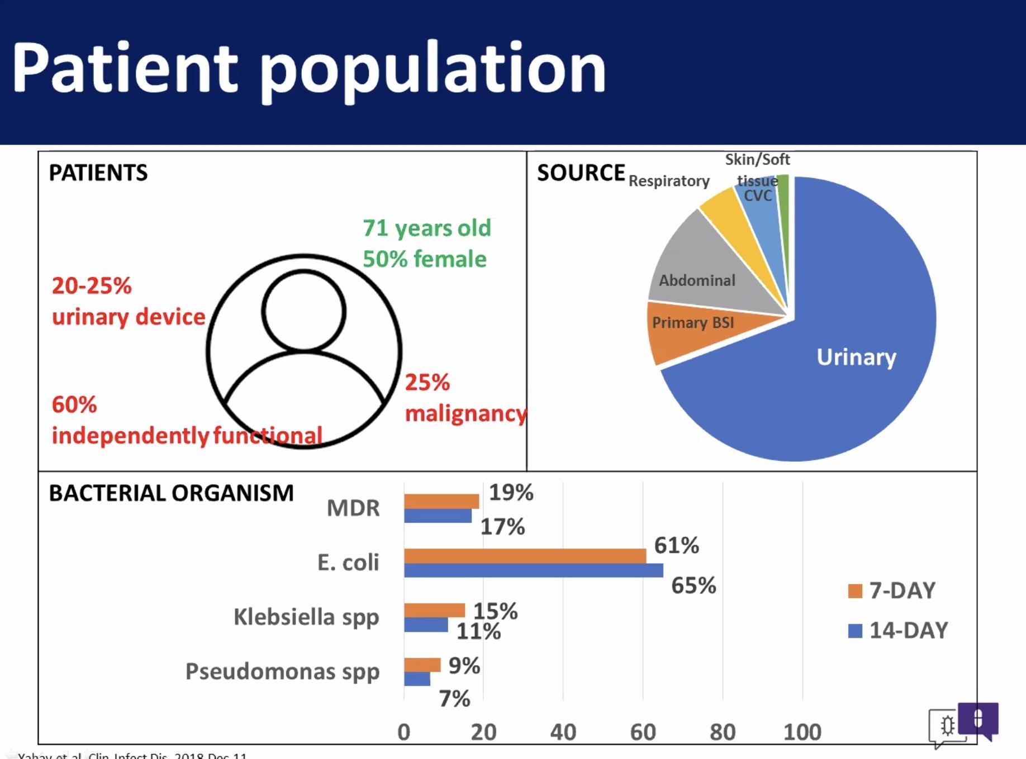
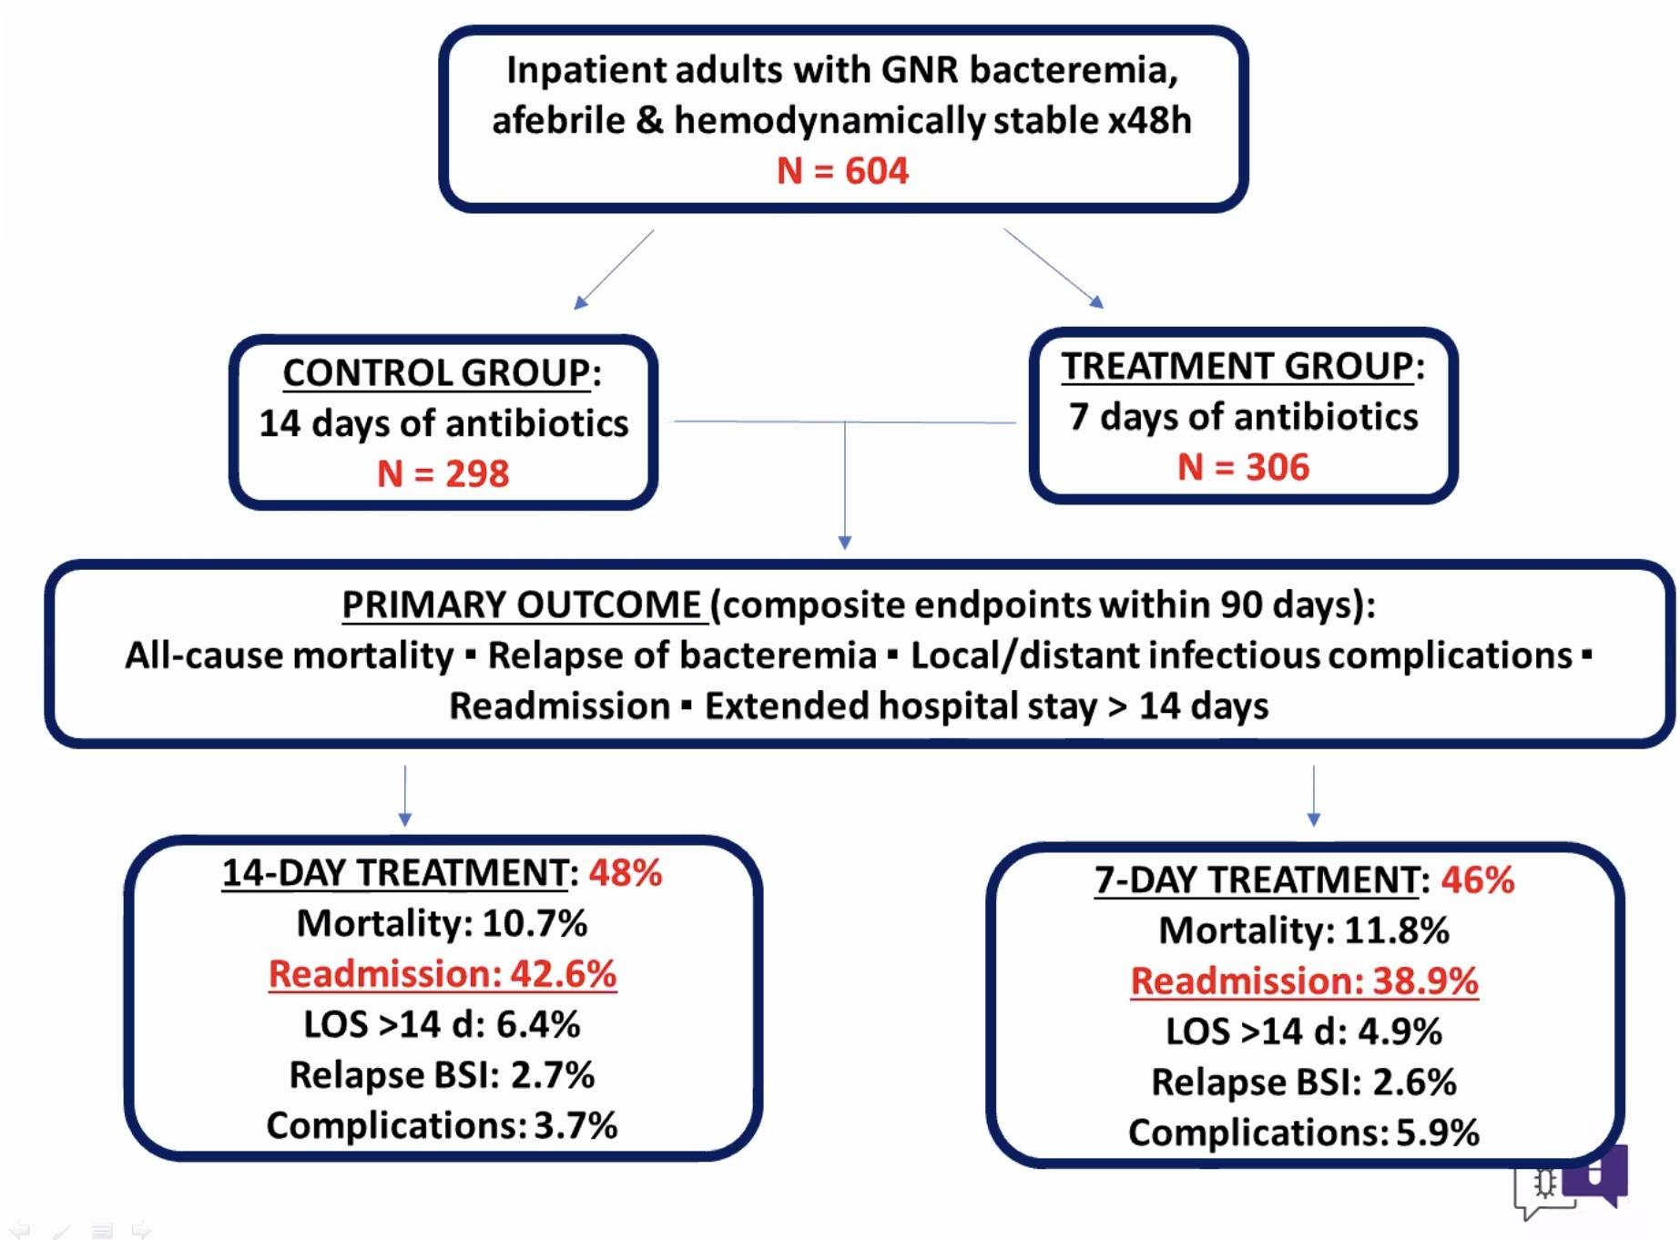
No sig difference between 7 days vs 14 days therapy.
PO abx step-down
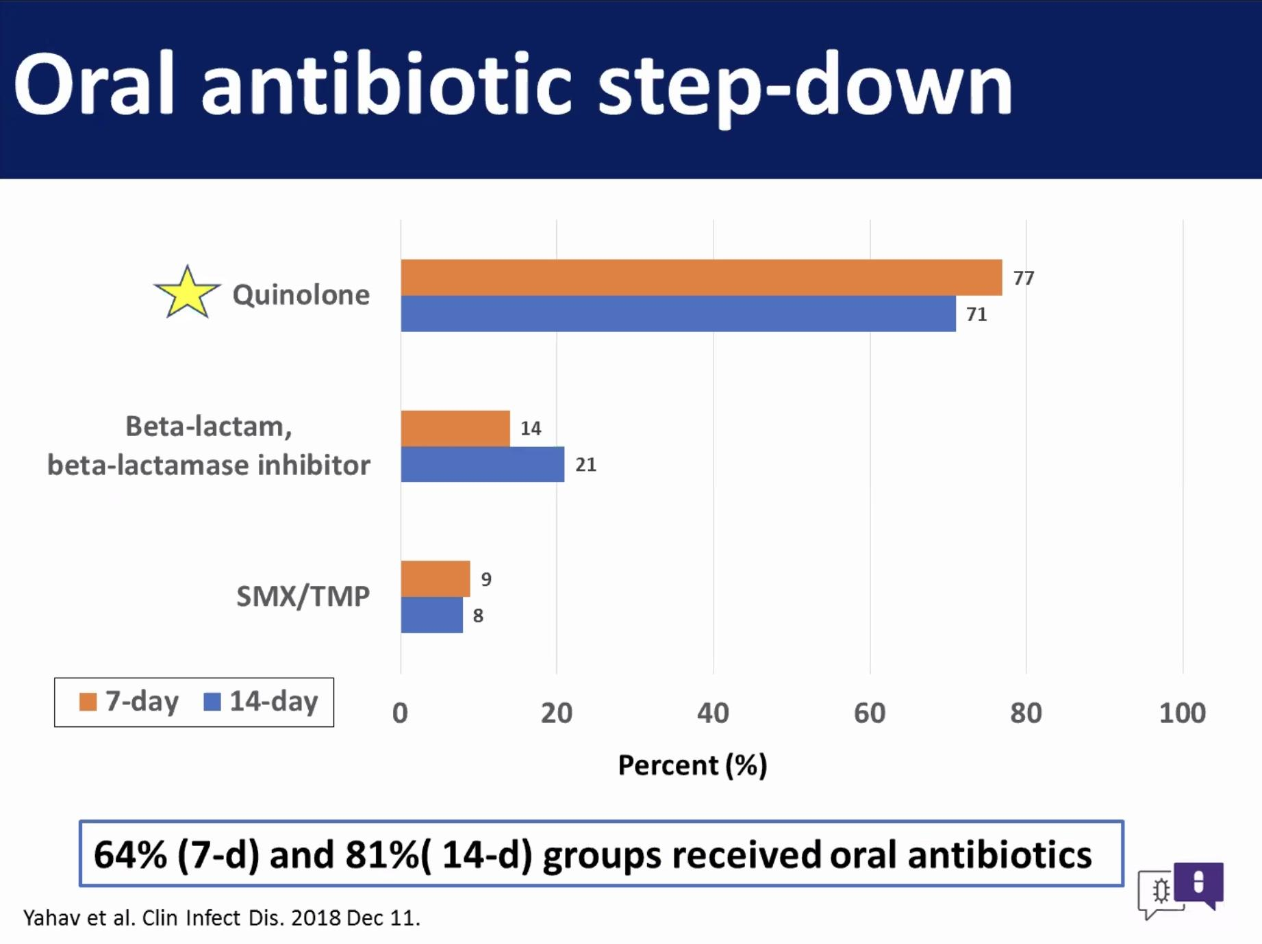
Most data is for FQ, but SMX/TMP has 90 % bioavailability. Could make a case to use any of these choices.

PO vs IV abx for bone and joint infection
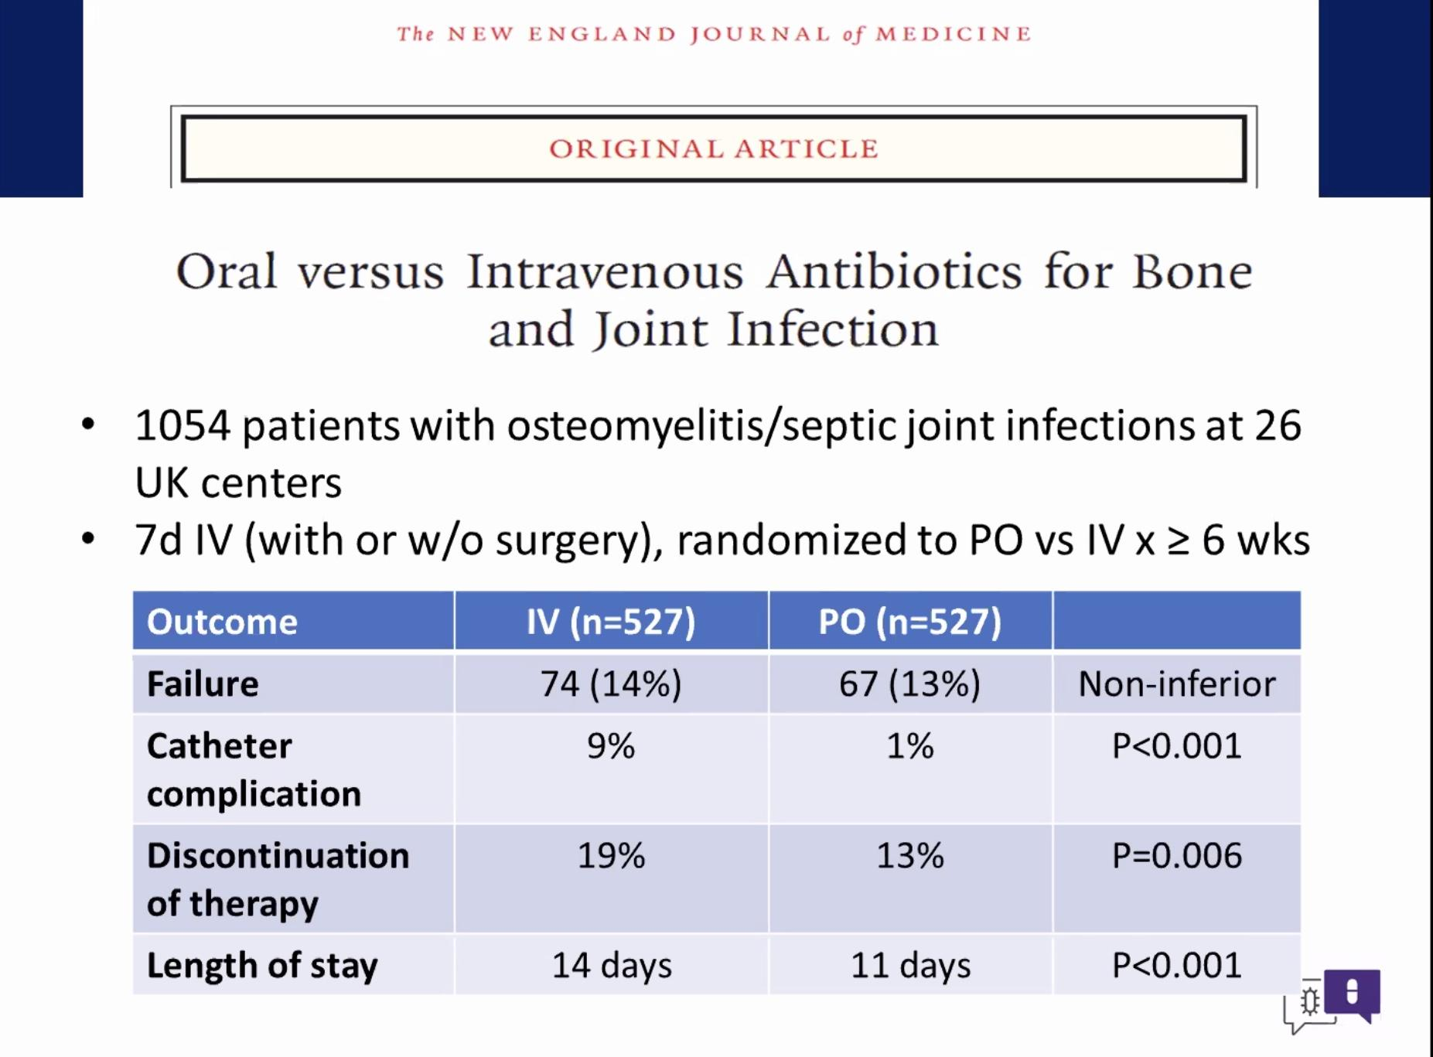
Endocarditis
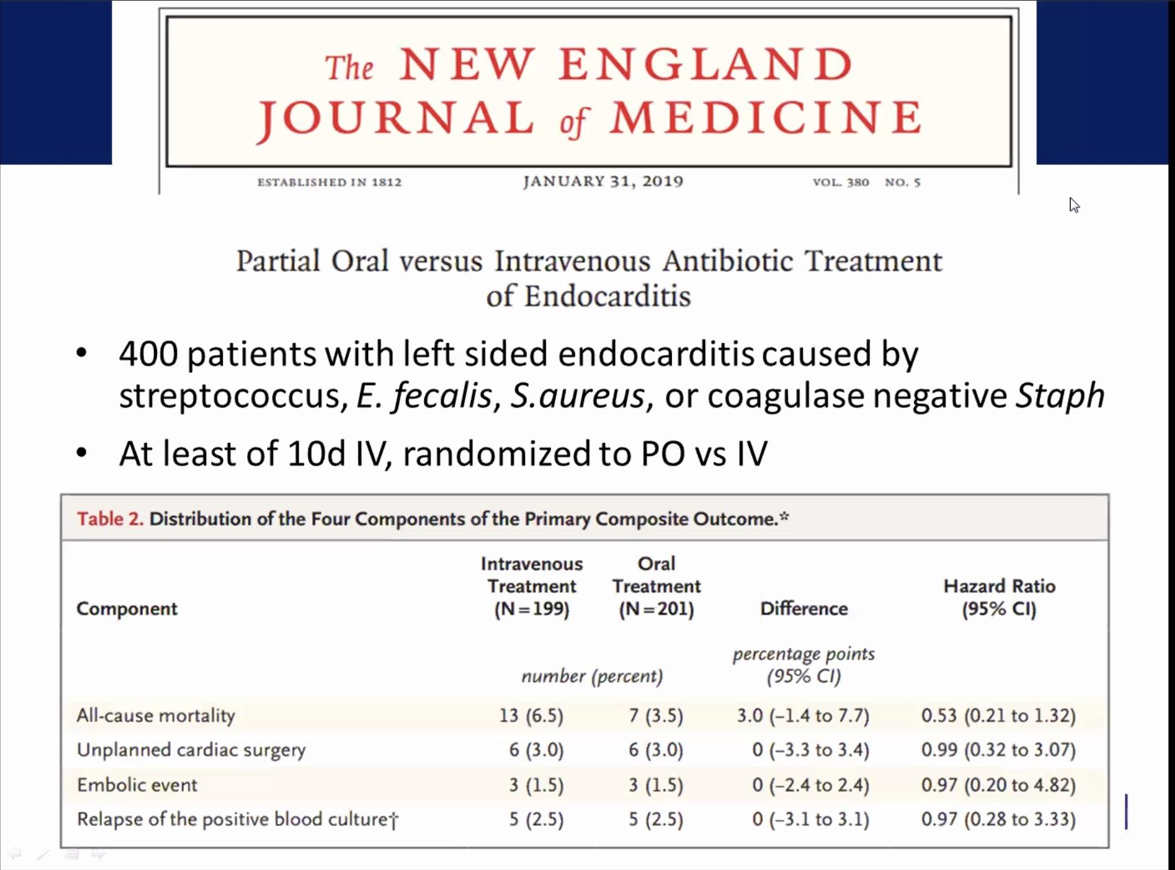
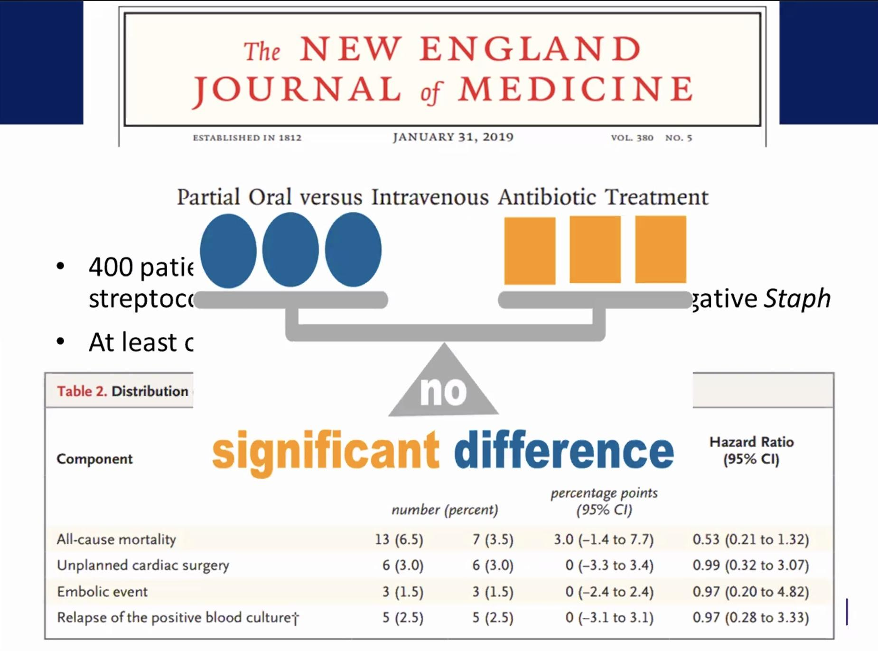
L. sided endocarditis- study in Denmark, at least 10 d IV therapy before randomization IV or PO.

Benefits of PO antibiotics
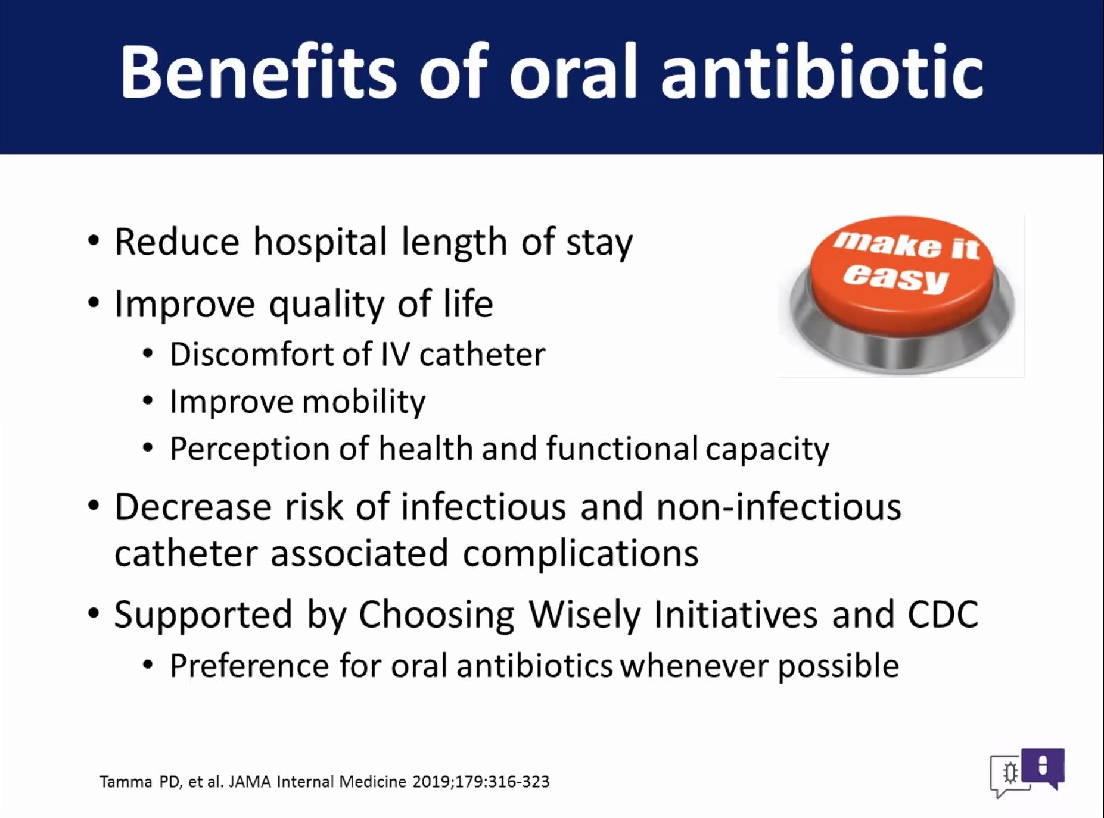
Improves quality of life, don't have to have a PICC w PO, improves recovery.
Decrease risk of complications/ infections.

Checklist- How to decide on when and what PO abx to use
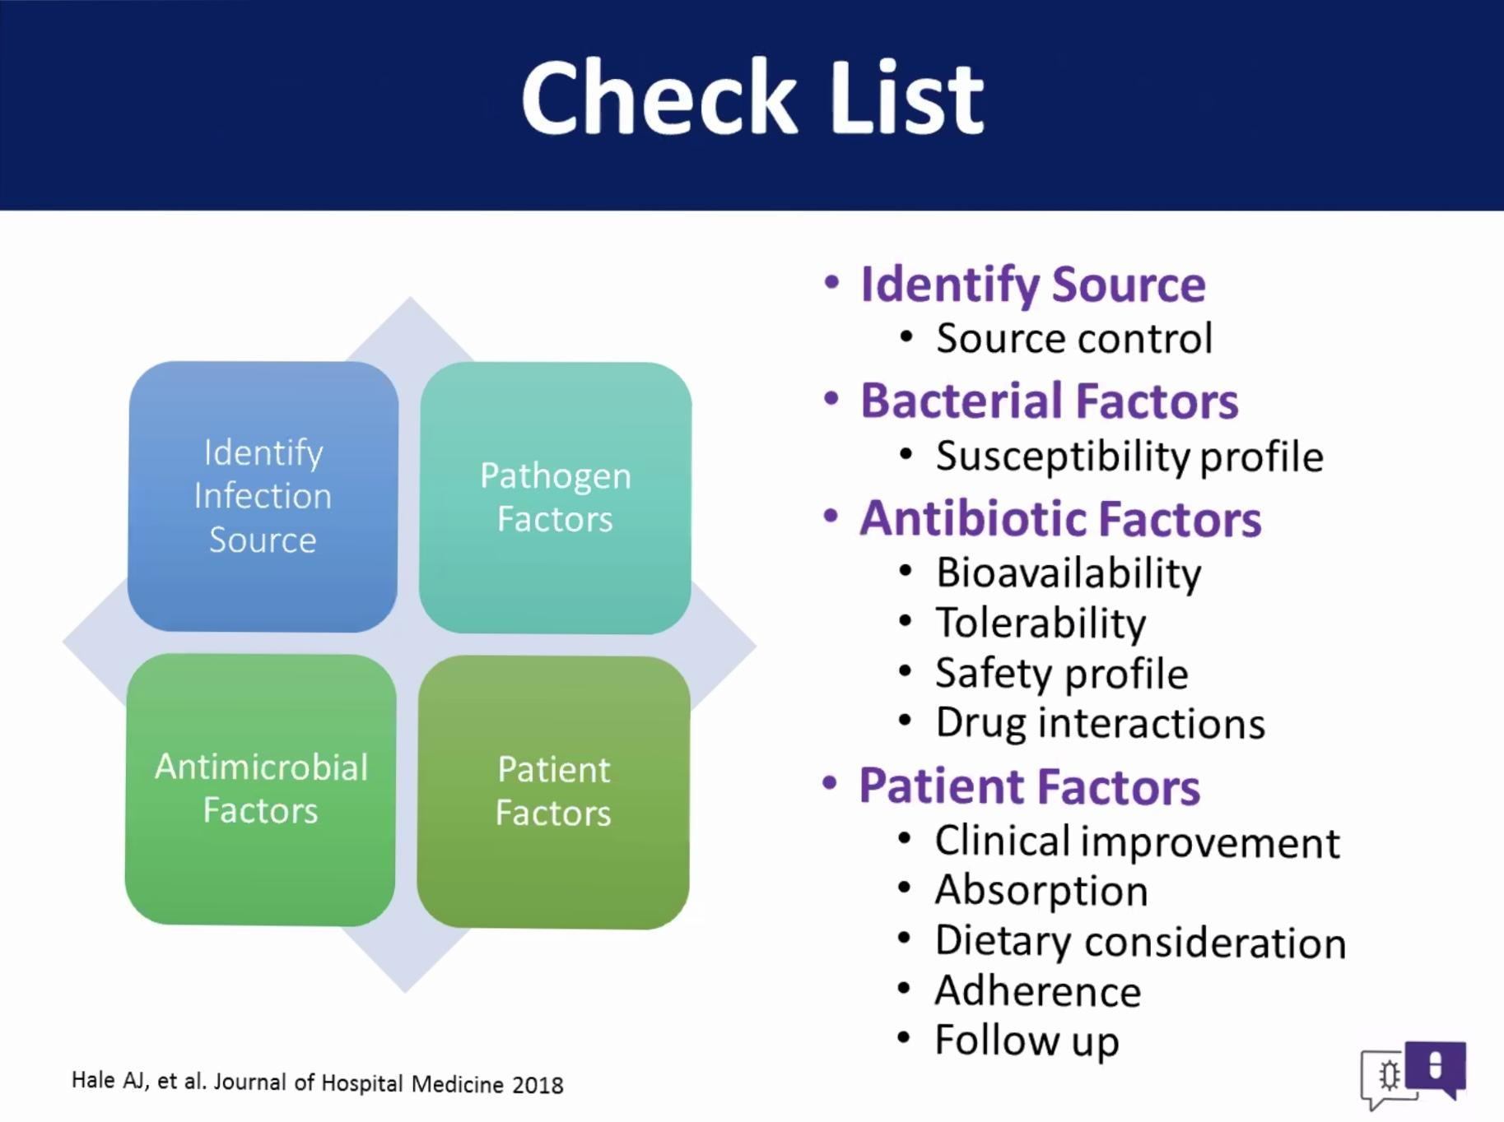

Tissue Penetration and Bioavailability
-Penetration of select PO antimicrobial to tissue sites
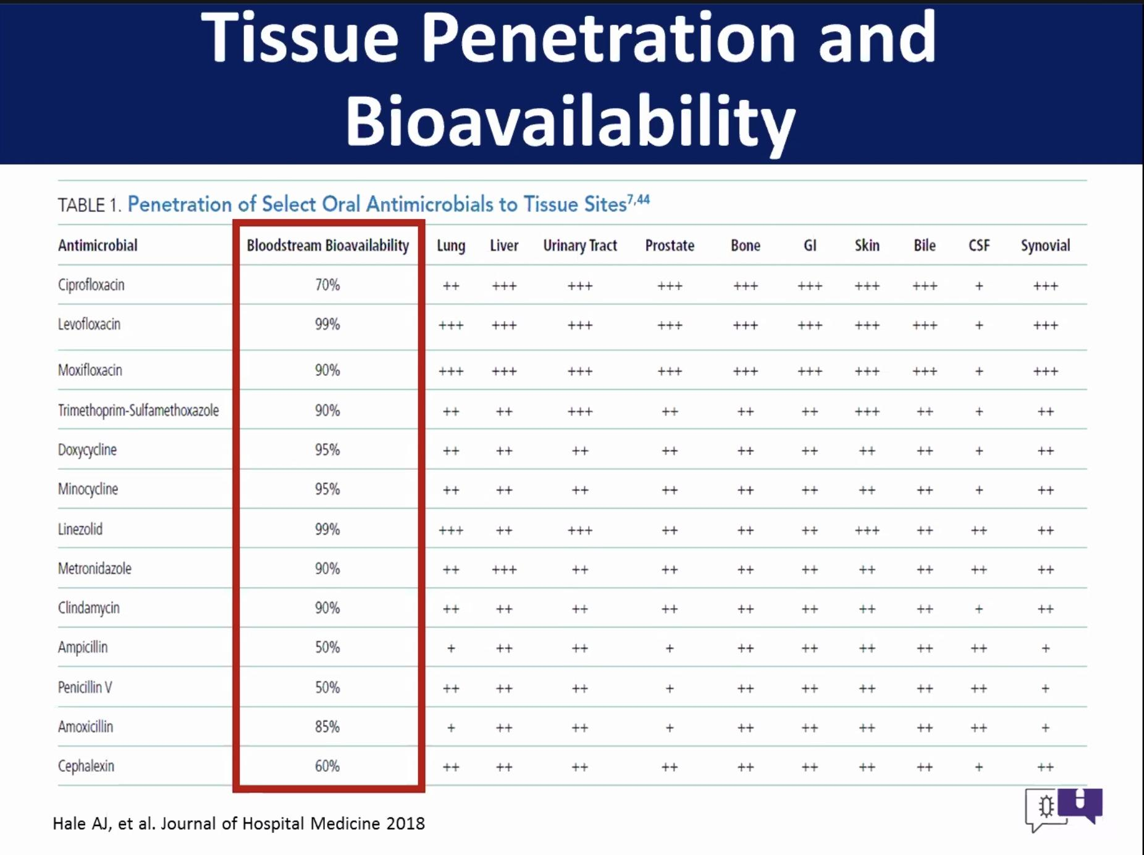

***Tissue penetration can really be variable, from my ID board certification- don’t get too hung up on penetration. More important to select the right drug for the bug. Also appropriate source control is important.

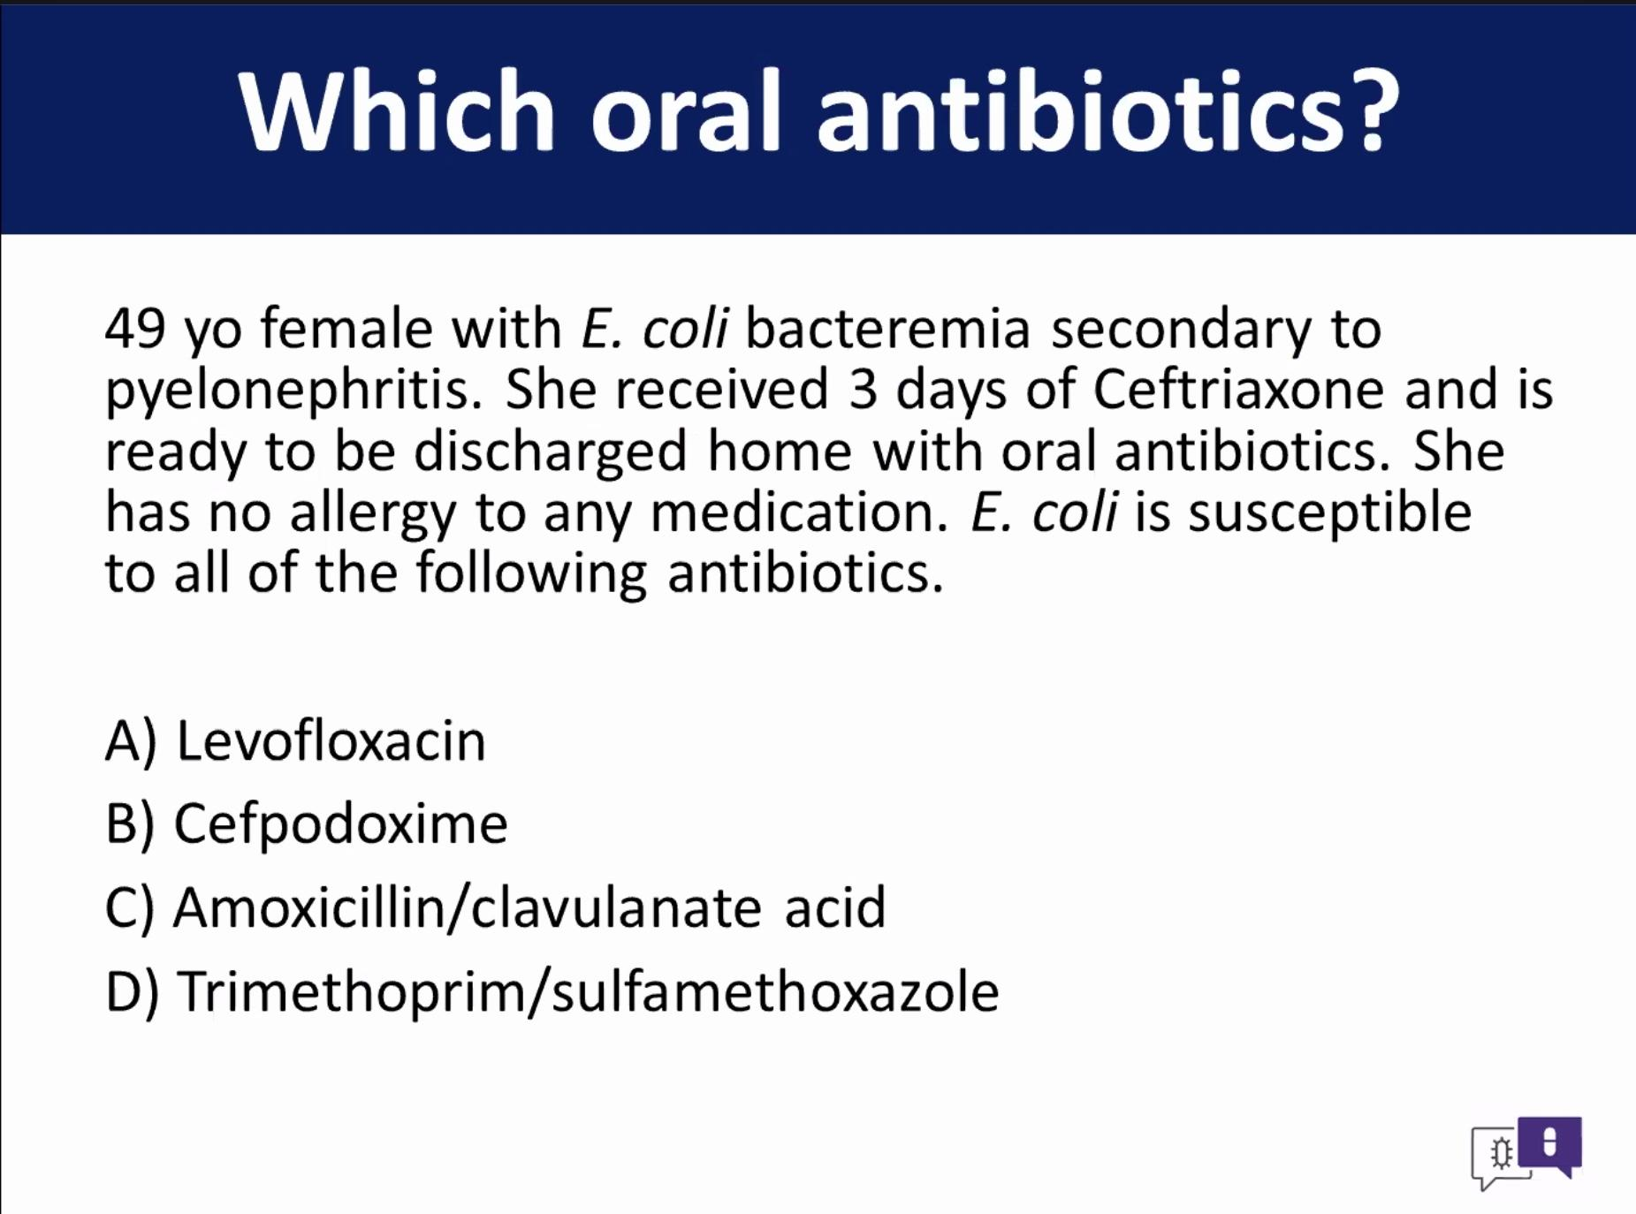
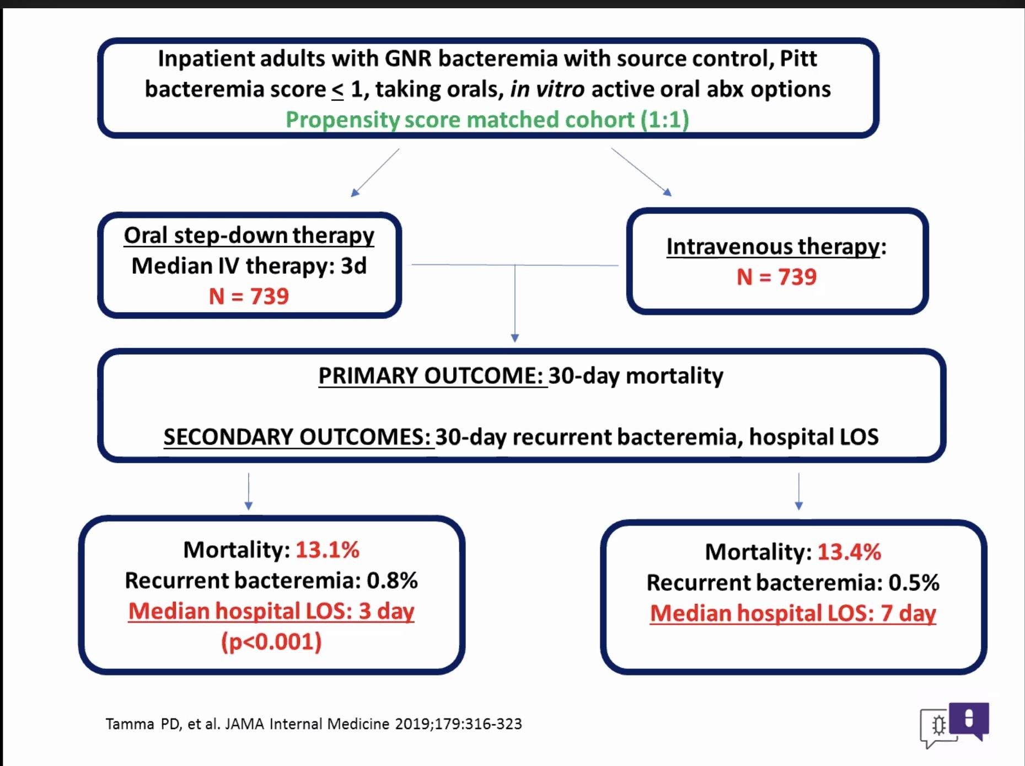
Length of stay decreased w PO abx group

Patient Population
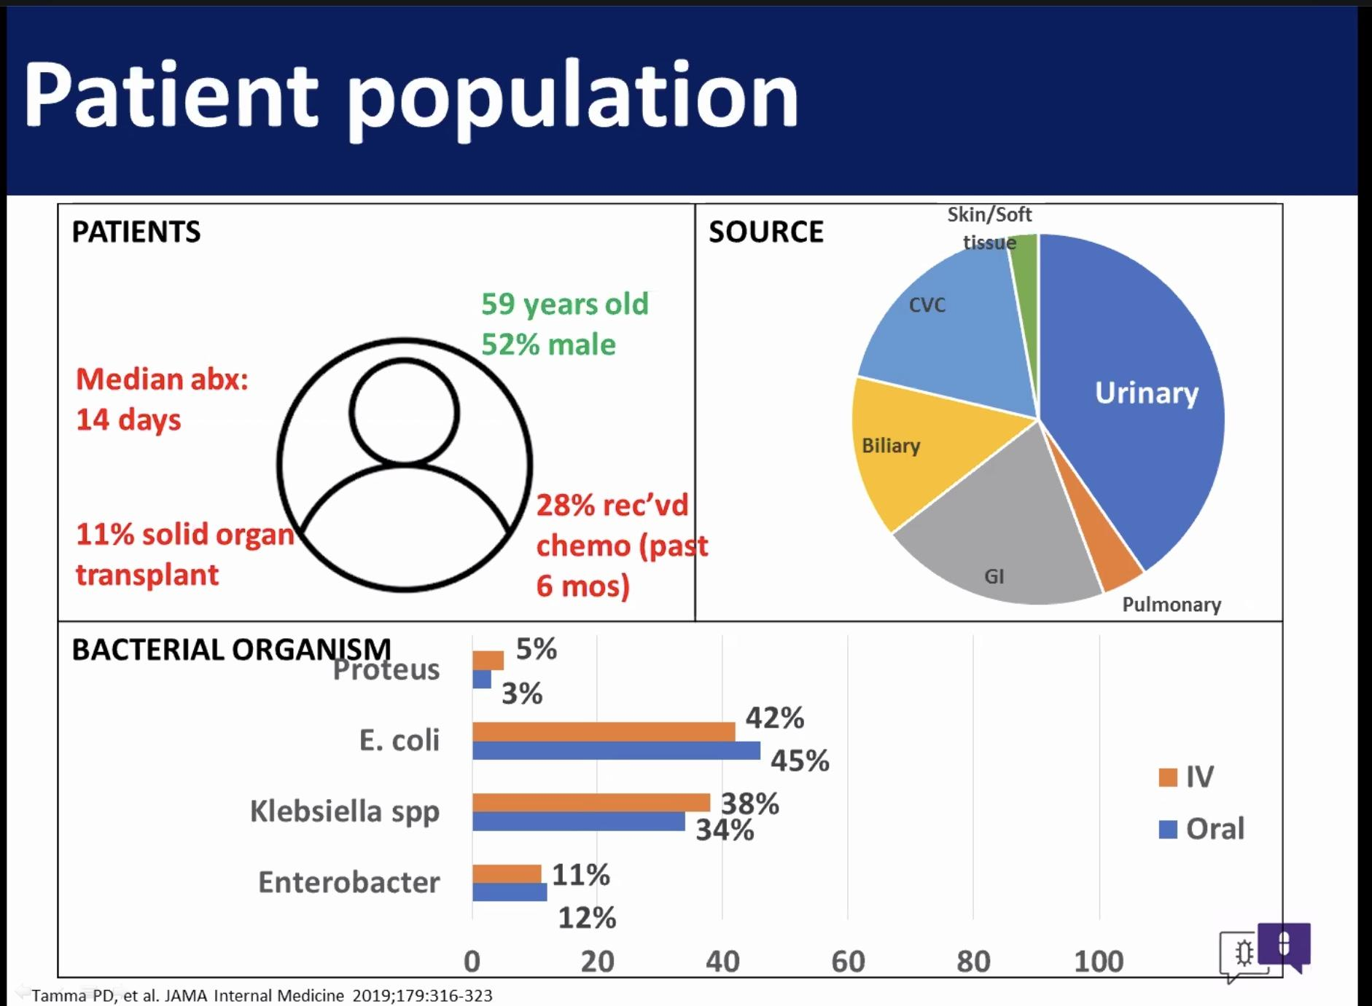
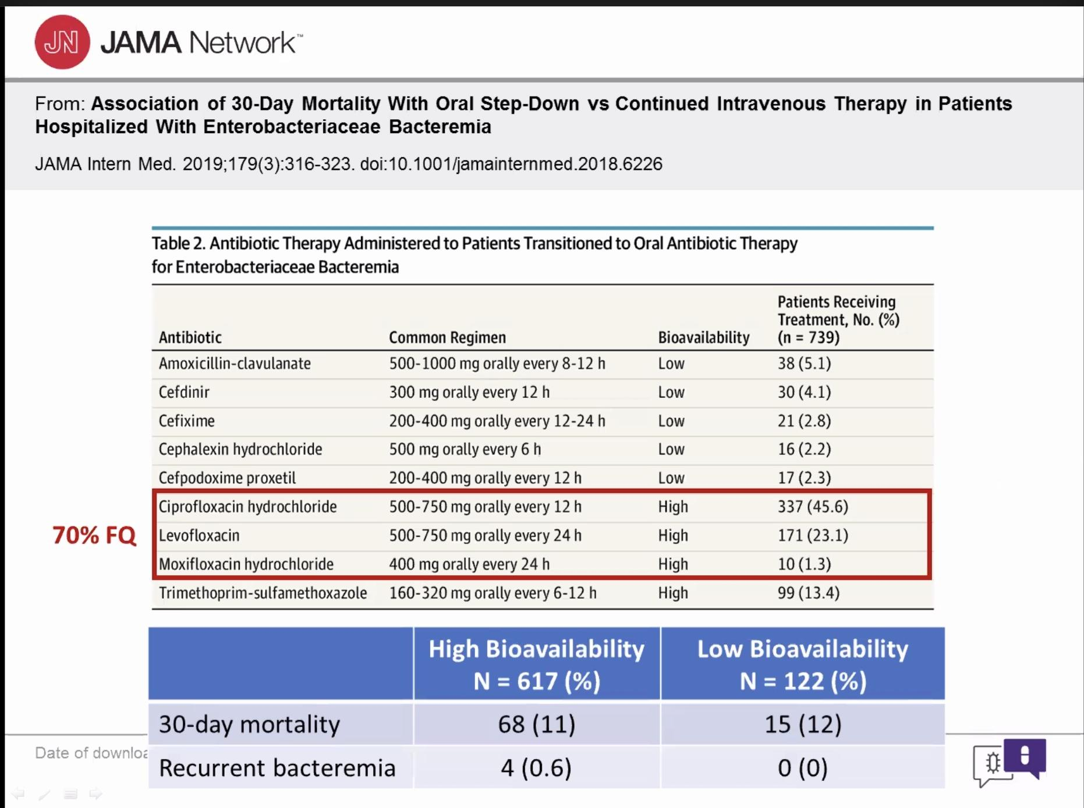
30 day mortality no difference between low and high bioavailability
-meta analysis
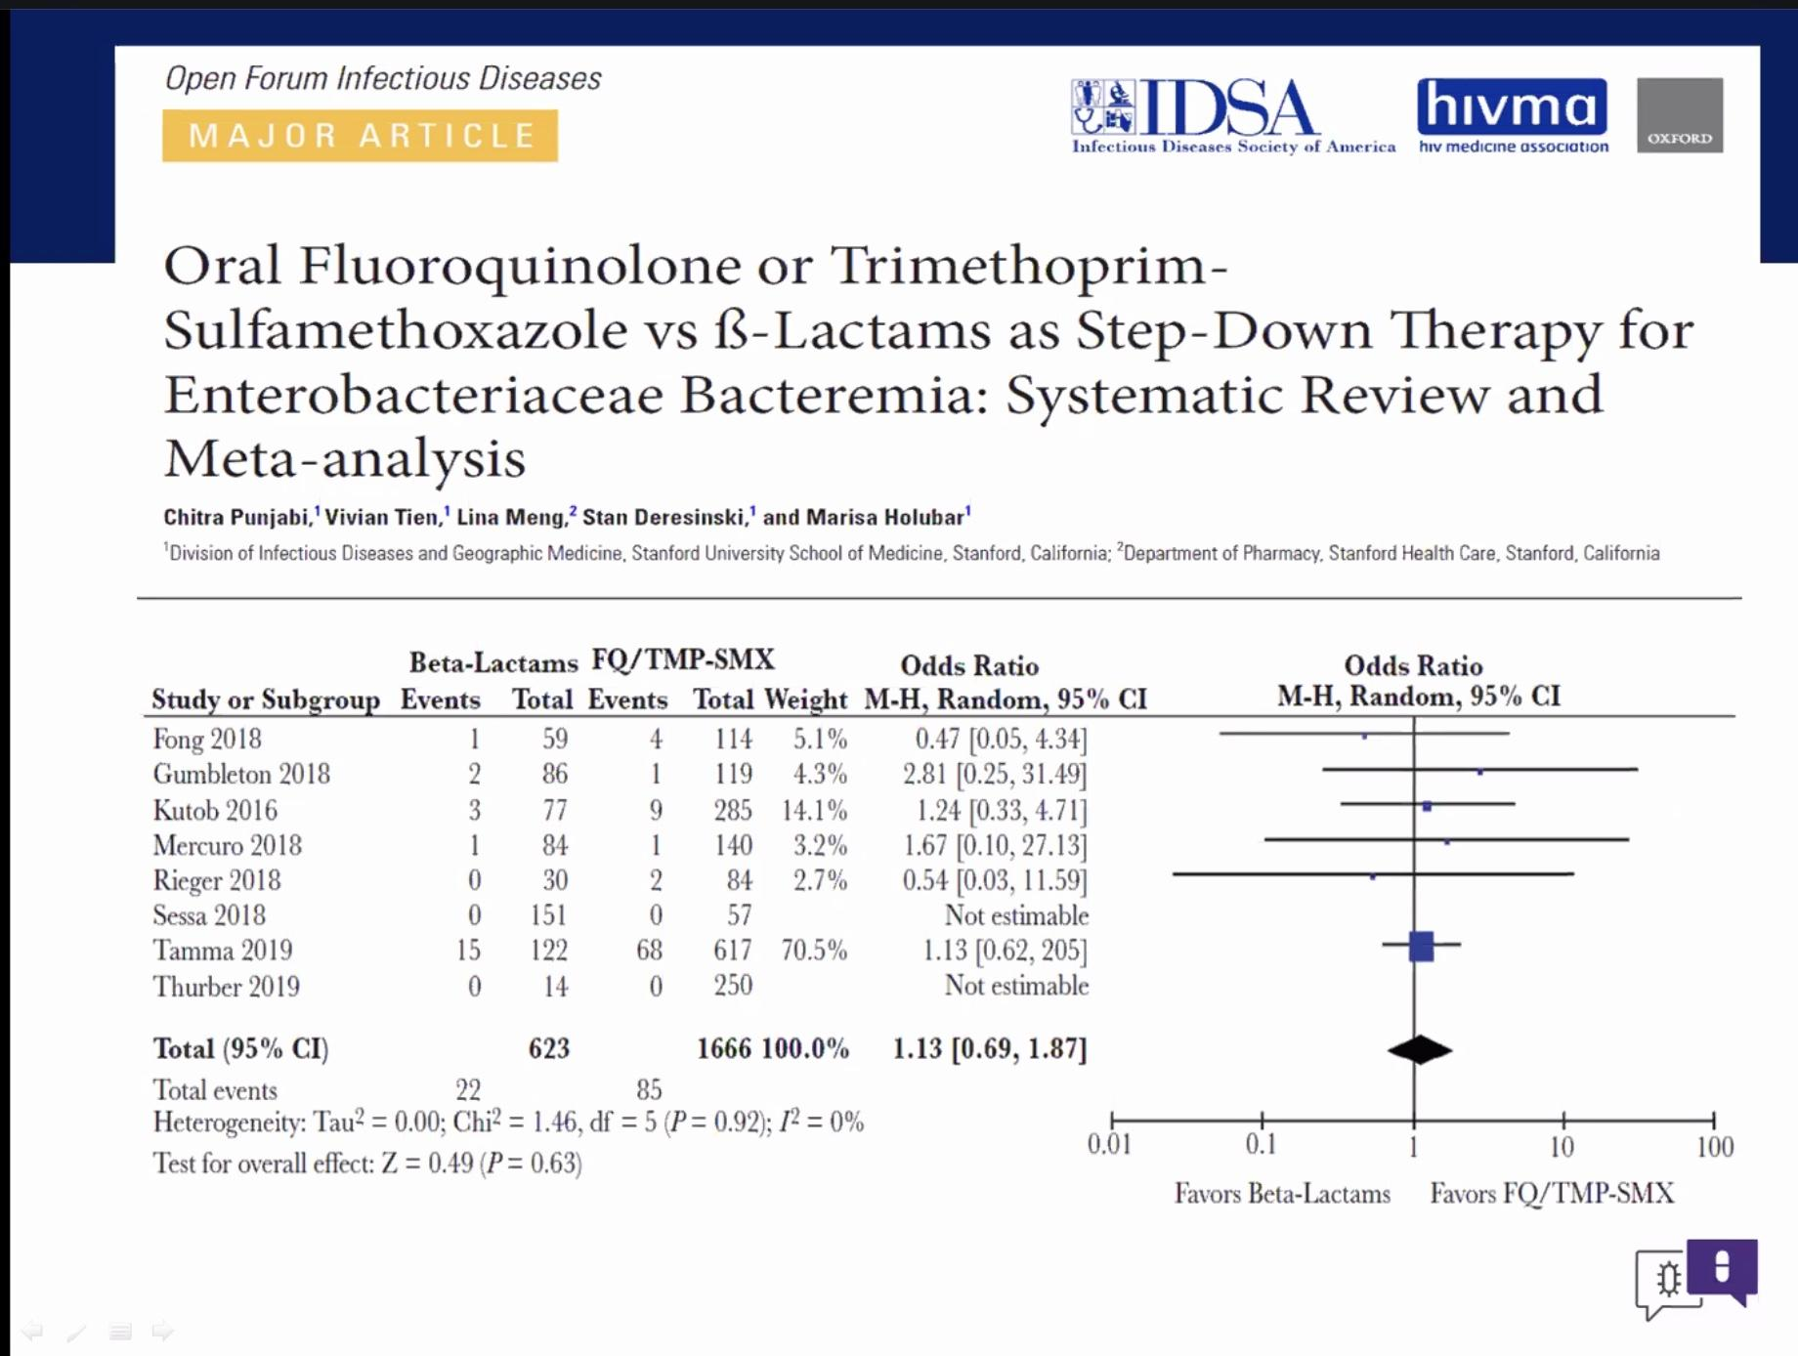
Oral Antibiotics
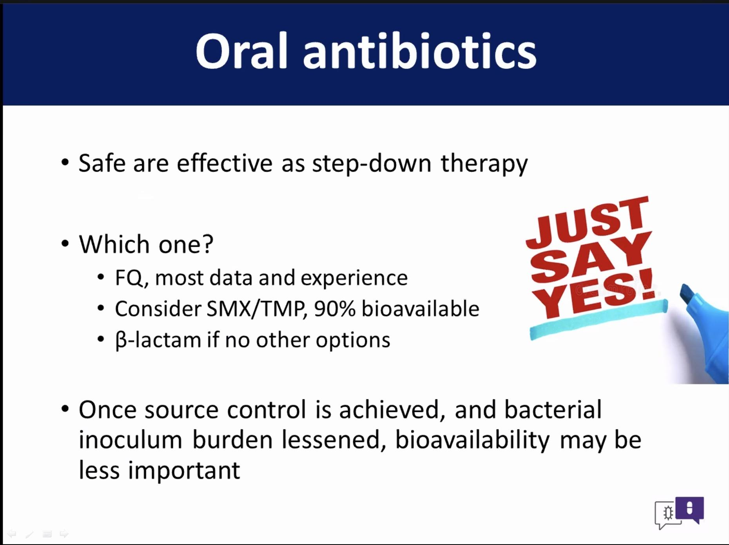
When to consider PO antibiotics?
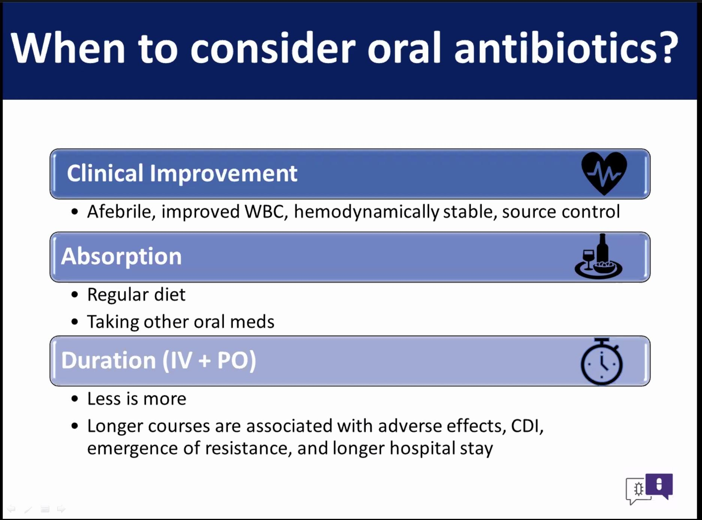
Questions/ Discussion
Using Keflex- recent studies 100% bioavailability or 80-90% bioavail?? That chart says 60% bioavail? Other studies say bioavailability is not as important. Downside of beta lactam short half life, dose them more frequently- can make them difficult from a compliance standpoint. We have over- emphasized the bioavailability, source control more important. Cefpodoxime another one used in step-down therapy for urinary source bacteremia or pneumonia.
Step-down on pneumonia- if patients still on O2 can we step them down if WBC decreases, afebrile. With more and more data PO abx becoming more appropriate even as starting therapy. All these threshold definitions are kind of made-up (decreasing WBC, O2 use, afebrile), John Lynch ID MD- nasal cannulas are the foley of the face, they stay on longer than necessary. Even if a patient needs some supplemental O2 he is very comfortable going from IV to PO. Often overused, the nasal cannula.
Where do we go next? PO abx may be fine for endocarditis, etc up front.
****The IV abx use is more for the MD’s and clinicians to feel better…….
7-10 days also made up durations… 7 days in the week, 10 fingers, etc where that came from.
-Giving IV abx- we are also giving too much fluids, Zosyn has a lot of Na, etc.
VA- has been pushing PNA treatment with PO. They transition from IV to PO on day 2.
Also pyelo- bacteremia, they go out w PO FQ and they are fine.
Keflex in MSSA PNA- good references? Does get into the lung, just lack of clinical experience. Also did they have upfront IV therapy and then transition to Keflex is fine
Elderly- resistance from providers on using FQ and Bactrim? Focus on short durations- that is the safest option.

Case Presentation: Samaritan Team- Sepsis
-Working on Sepsis
-They do the step 1 bundle, but they are falling out on antibiotic selection, when using combination abx they only give one or they are giving an additional abx with ones that should be monotherapy.
How do you get the antibiotics right?
Top 3 fallouts: second lactate, fluids and antibiotics.
Sep-1 is a mess, horrible matrix, confusing! There are antibiotics listed that should never be used in the ER. Stewardship disaster.
Jeani has a great chart: From UW
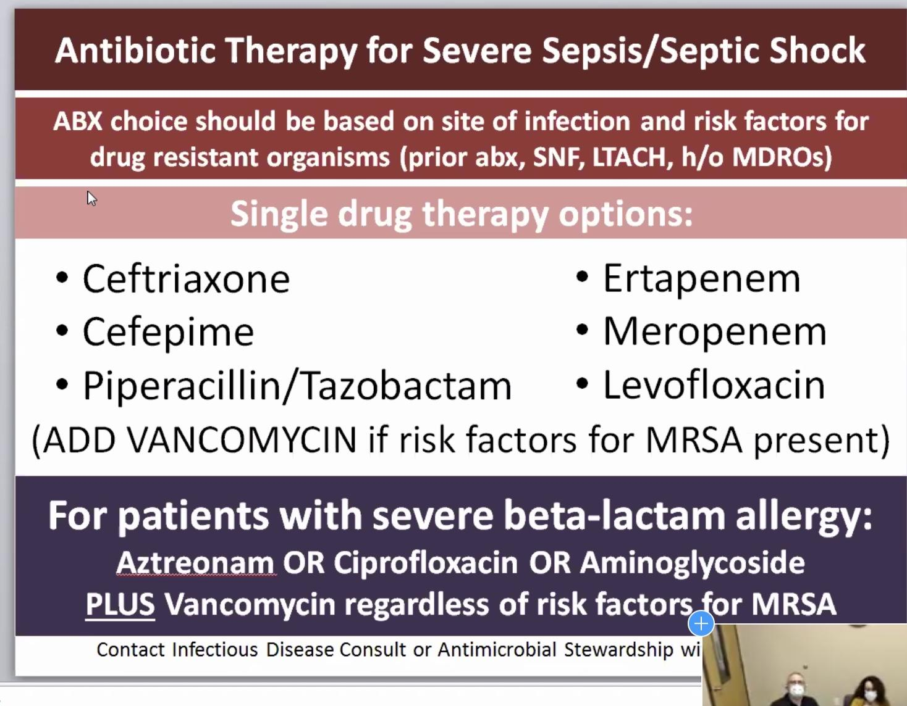
Only add vanco if worried about MRSA or really critically ill.
Should have a low threshold to give an appropriate abx for sepsis… ie ceftriaxone then vanco if MRSA concerns.
-Have ceftriaxone in the Pyxis ER- should often be the first choice.
***Look at the sepsis powerpoint from TASP. They have a list of 6 drugs they can use.
-1 gram ceftriaxone vs 2 grams? Meta-analysis recently on CAP, 1 gram as effective as 2 gram.

