UW TASP-COVID and Case Presentations 7/21/20

Discussion about COVID exposures

UW med system- They no longer asking workers to come in during an outbreak, at first concerned about enough staff. They had a patient that came from Kirkland life center that died from sepsis and had been COVID (+) not known at the time and they would have had to have 100+ health care workers stay home. They asked workers to monitor their symptoms at that time.
-Now quantifying exposure risk and health care workers who have high risk exposures now asking them to quarantine x 14 days. Same as CDC policy.
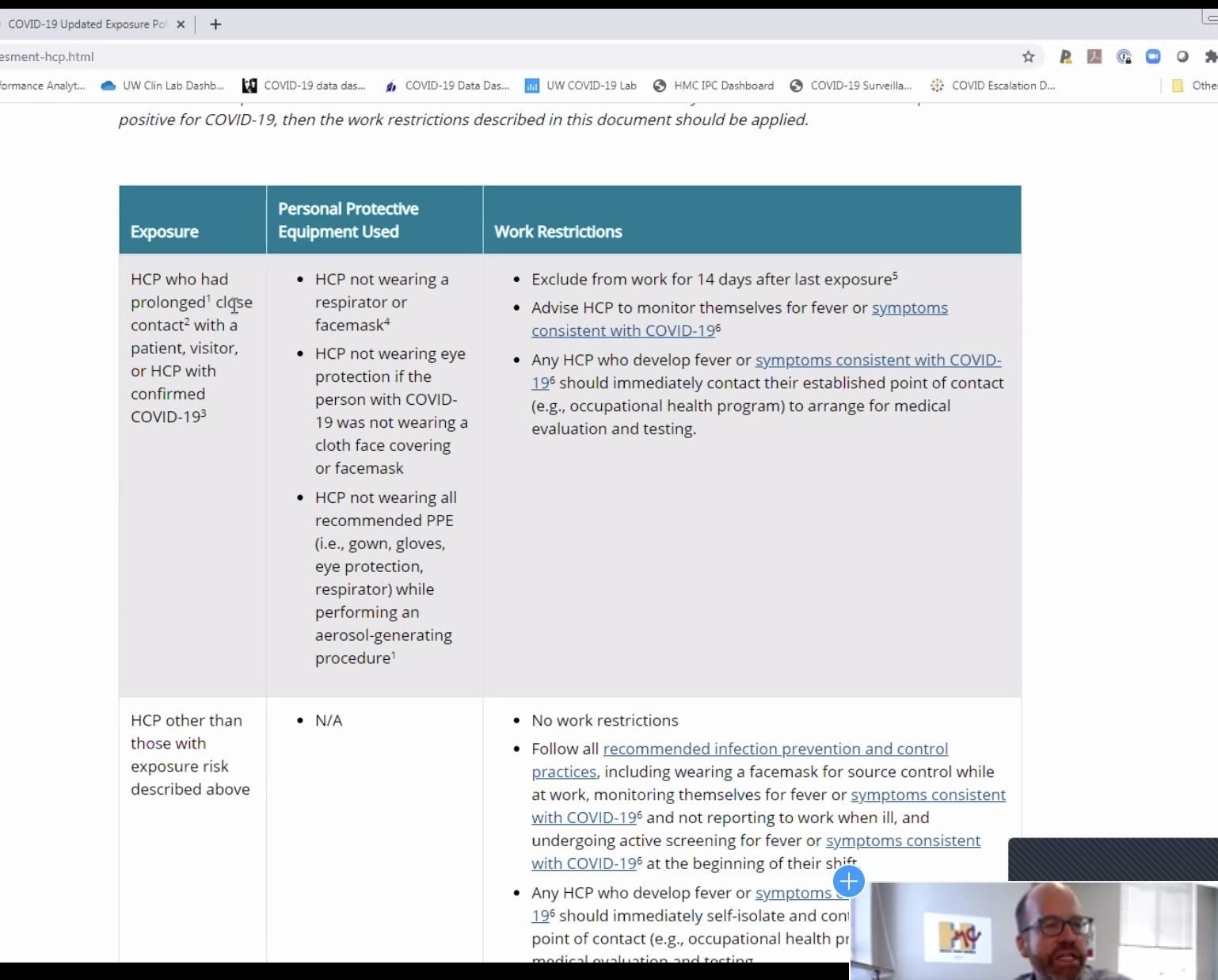

-Interim Guidance of Risk Exposure for COVID-19,
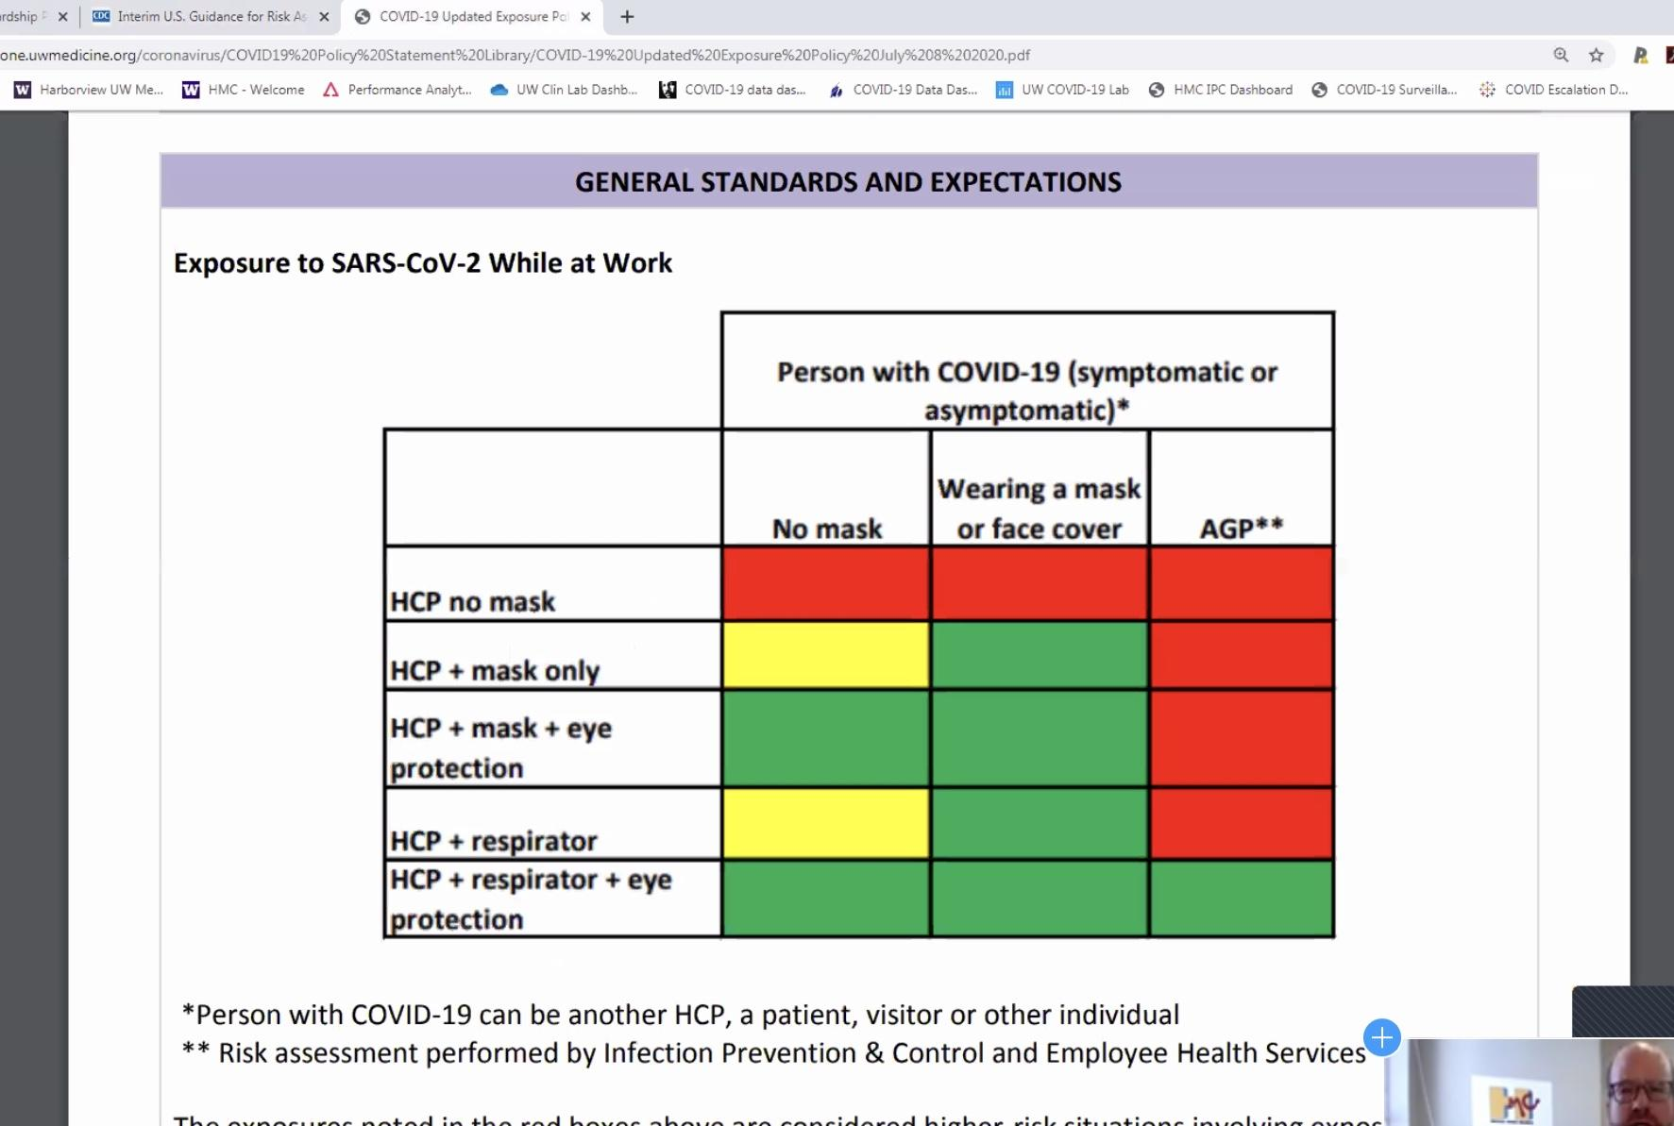
Yellow= is UW risk category- not as high of risk as red. The red and green are CDC categories.

- Biggest risk to health care workers is from other health care workers who are not wearing masks.
- Moving to a system to require eye protection with all patients.
-Isolation Precautions: Look at new updates on CDC inpatient precautions, from test based to symptom based.
-When to test someone when they have had a known exposure? No sooner than 48 hours after the contact. Healthcare workers asking them to wait 48 hrs to get that test.

Case Presentations

Lake Chelan
Case came through the quality department, health care worker w direct patient care had concern about care. 41 yr old male PT, developed redness on middle finger after some trauma. Started on Keflex and went camping. Went to ED and had red streaks up his arm. MD that saw him noted that infection was showing some improvement but MD still added doxycycline. Made him very sick and then it was stopped.

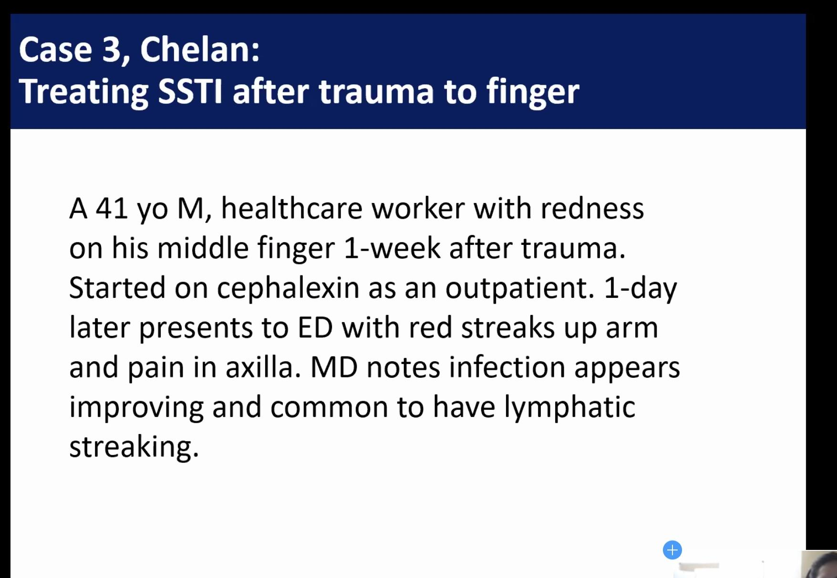
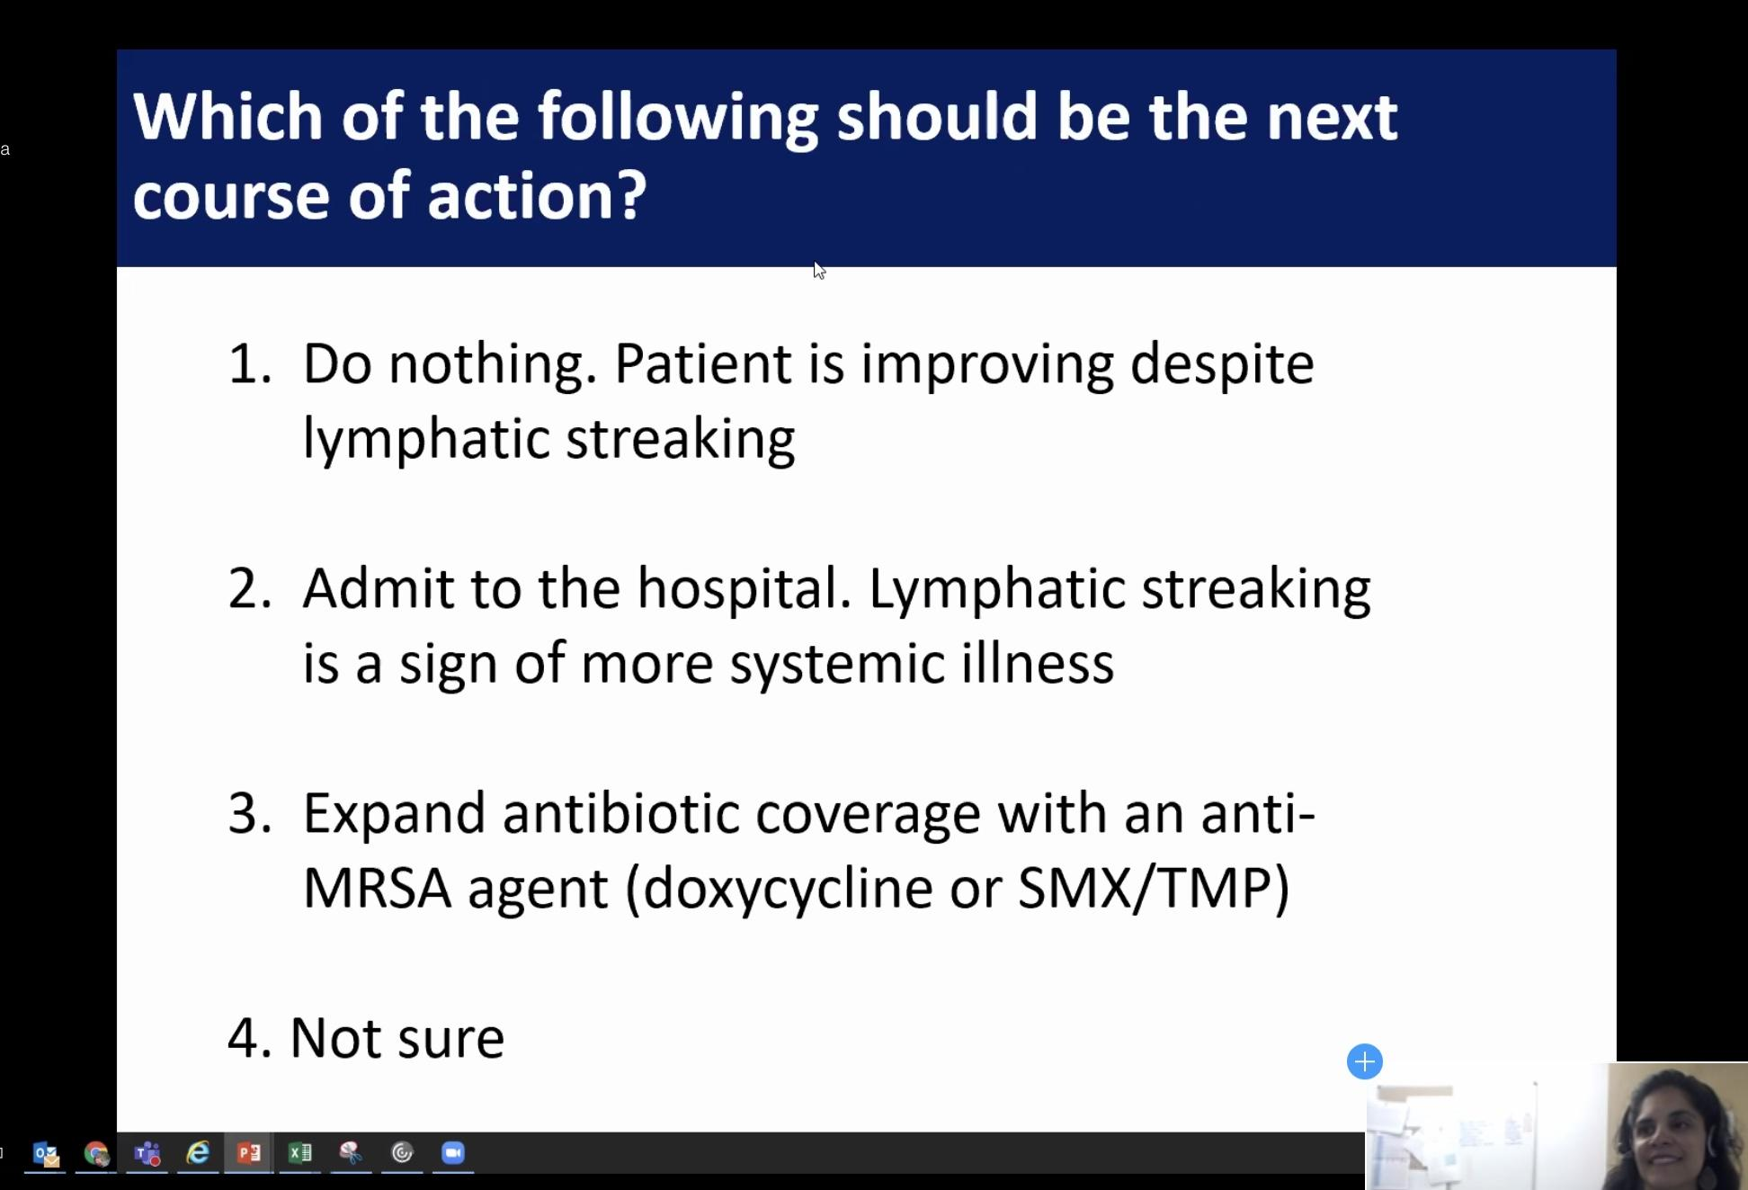
24% Do nothing, 24% Not Sure , 35 % add antiMRSA coverage, 18% admit to hospital.

-Top 10 Myths of diagnosis and treatment of cellulitis- Good paper. Look at this.
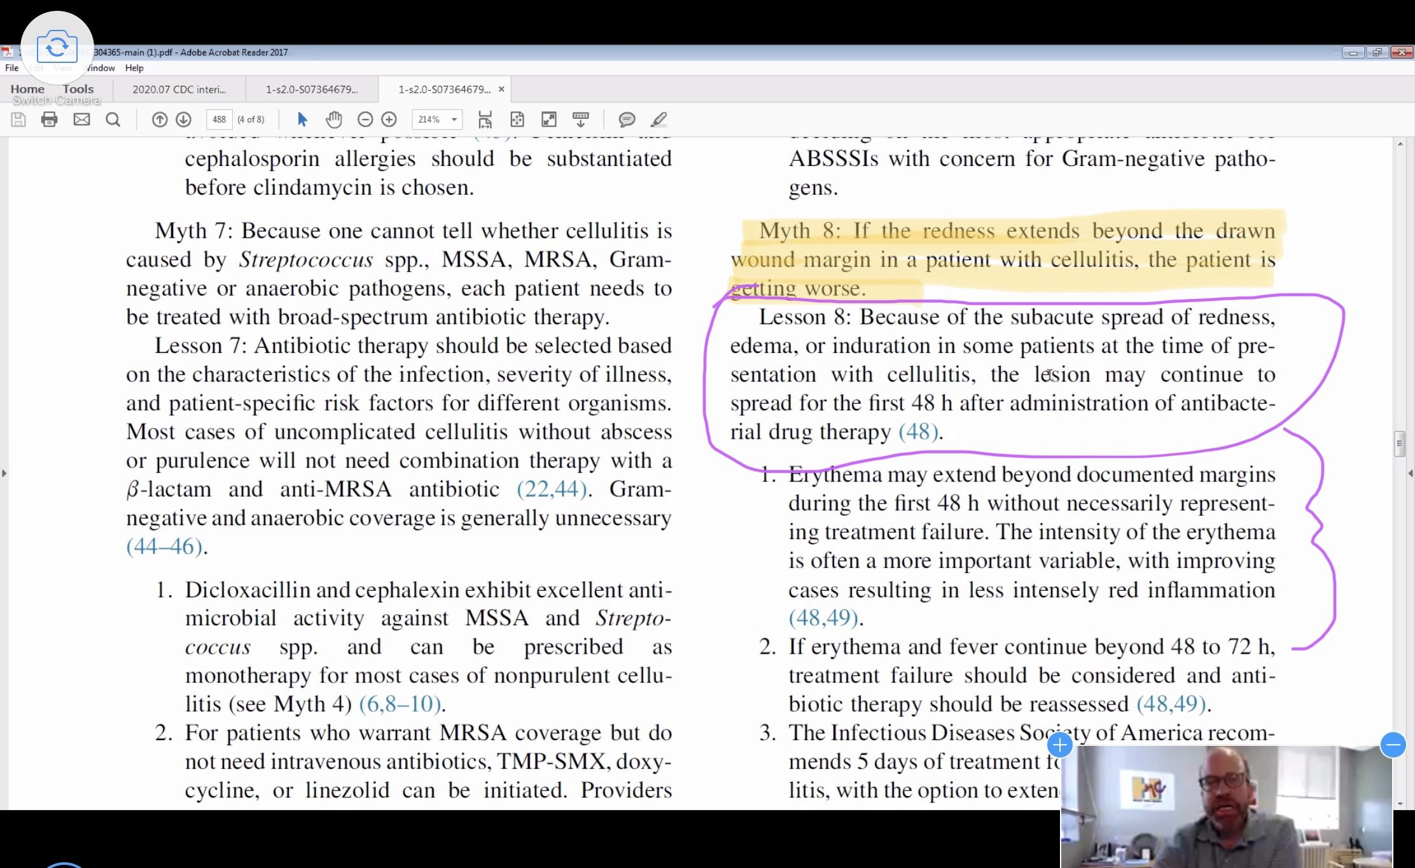
Antibiotics are often anxiolytic for the prescriber
Cellulitis 90% time is Strep and is susceptible to beta lactams.
Increasing redness does not equal increasing infection or a worse infection. Par for the course w first 48 hrs of starting antibiotics. Check for a superficial thrombus, make sure to do a through exam but wouldn't need to add additional antibiotics. It's not the bacteria streaking up the arm, it's the inflammation. The drawing of a line around cellulitis is for NSTI- necrotizing infections, it has been extrapolated to cellulitis. Patient had been concerned that he was given doxycycline and it was taken away like that with no replacement. If you take 100 mg BID Doxycycline you will have stomach upset. Person w Keflex and doxycycline seems to have more side effects (in John’s experience)- or complain of more side effects, if they told it is for PPX and not treatment.

Clearwater Case
Dr. Lima- 58 yr old male, uncontrolled DM, COVID, started w GI symptoms. Hospitalized w SOB, and resp failure. Cont to have diarrhea. Wasn’t sure if he could have loperamide w covid diarrhea? He was gien loperamide, to combat water loss and need for electrolyte replacement. -60 % say yes.
Can you use antimotility agents (e.g. loperamide) to in COVID diarrhea?
-This is different, not a toxin mediated disease like C. diff. Similar to other viruses that invade the colon are associated with inflammation and water loss across the walls of the intestine and diarrhea. Johns says yes he would give loperamide.
Article review- on GI presentations of COVID. About 10% can have GI effects. They will post article to the UW TASP site. Does C. diff need to be R/O before starting loperamide? Only if they have had a lot of recent antibiotics. If fairly certain it’s COVID.
***One person at Harborview saw a lot of patients have GI symptoms, loose stools w COVID, but not profuse diarrhea. Dr. Lima feels like about 40% pts COVID have had some GI symptoms, we are still learning!***

Olympic case
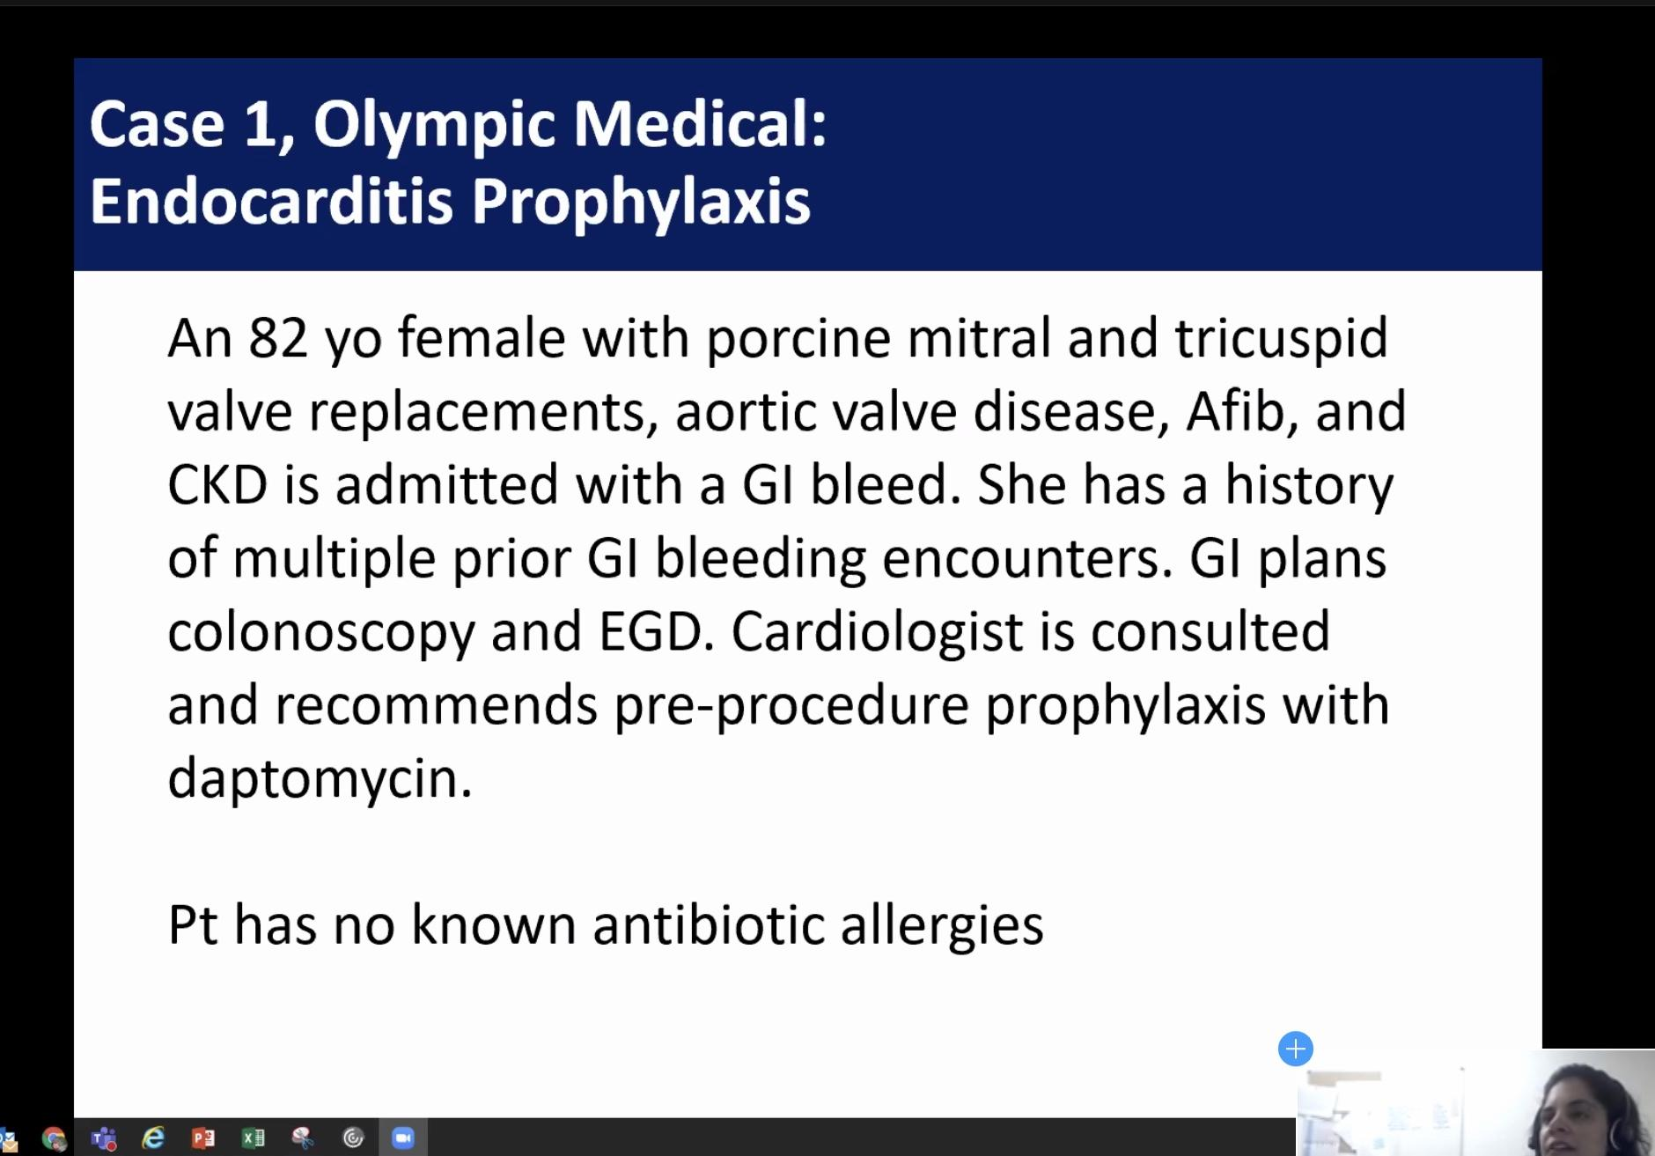
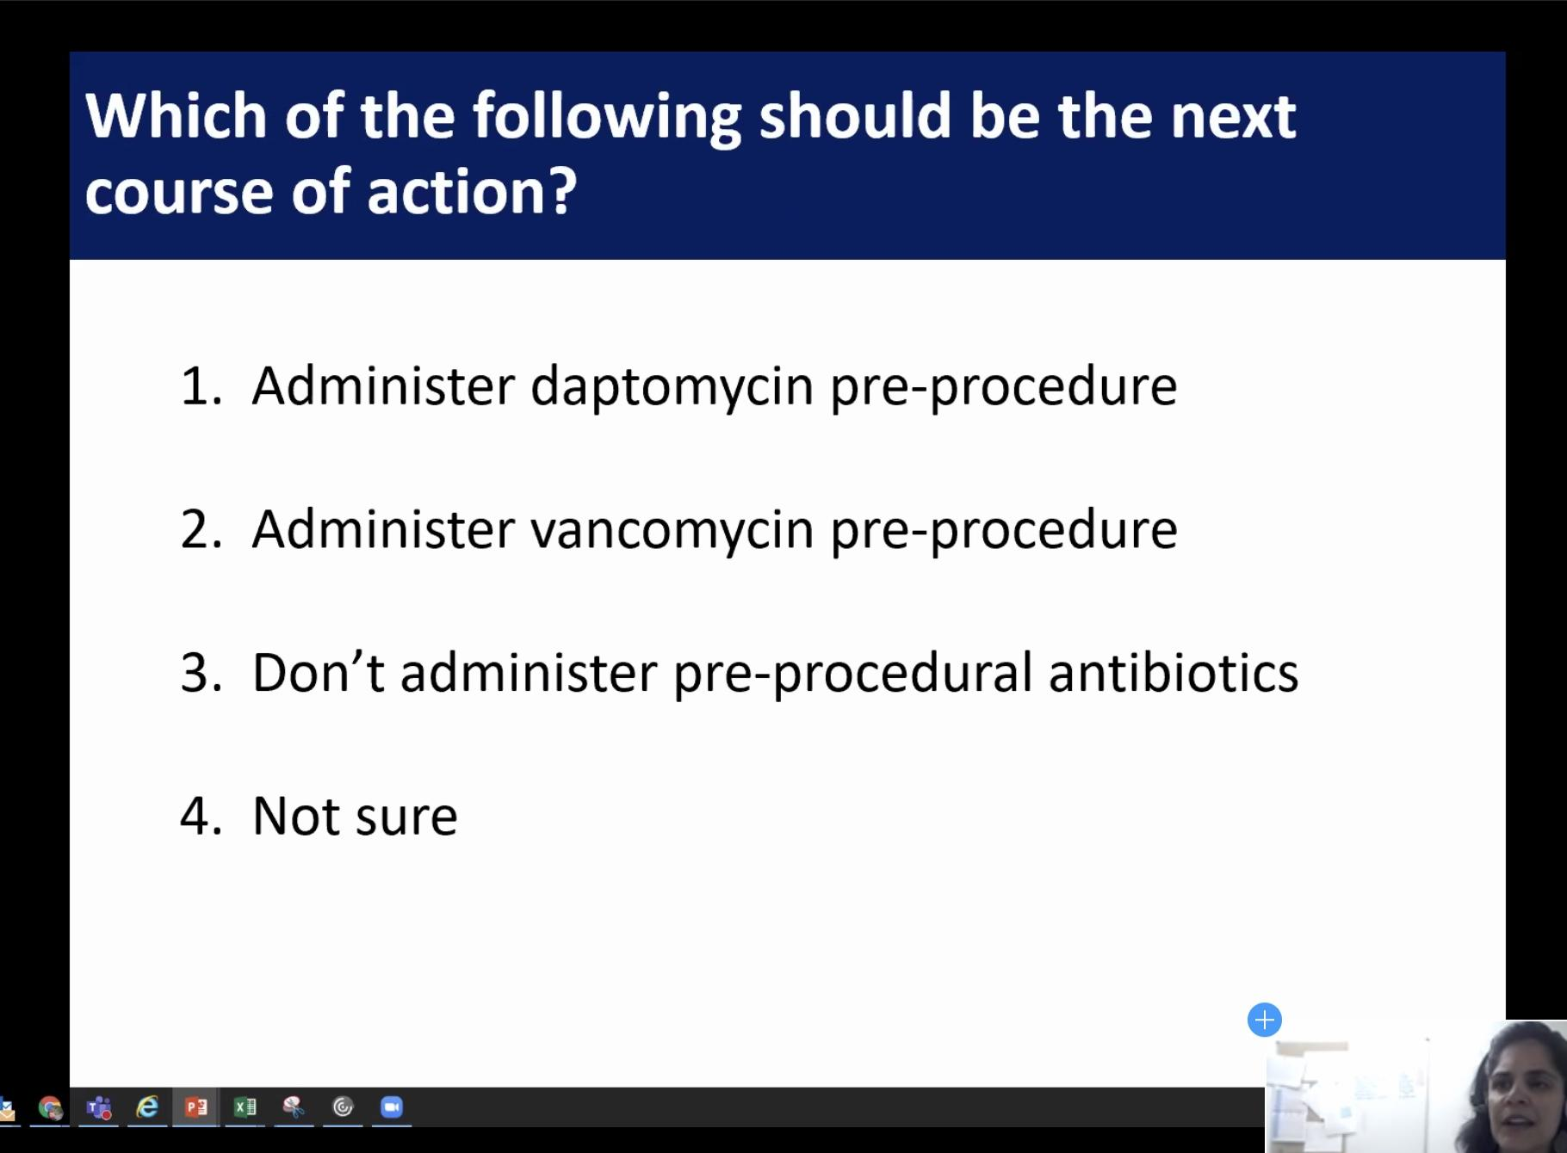
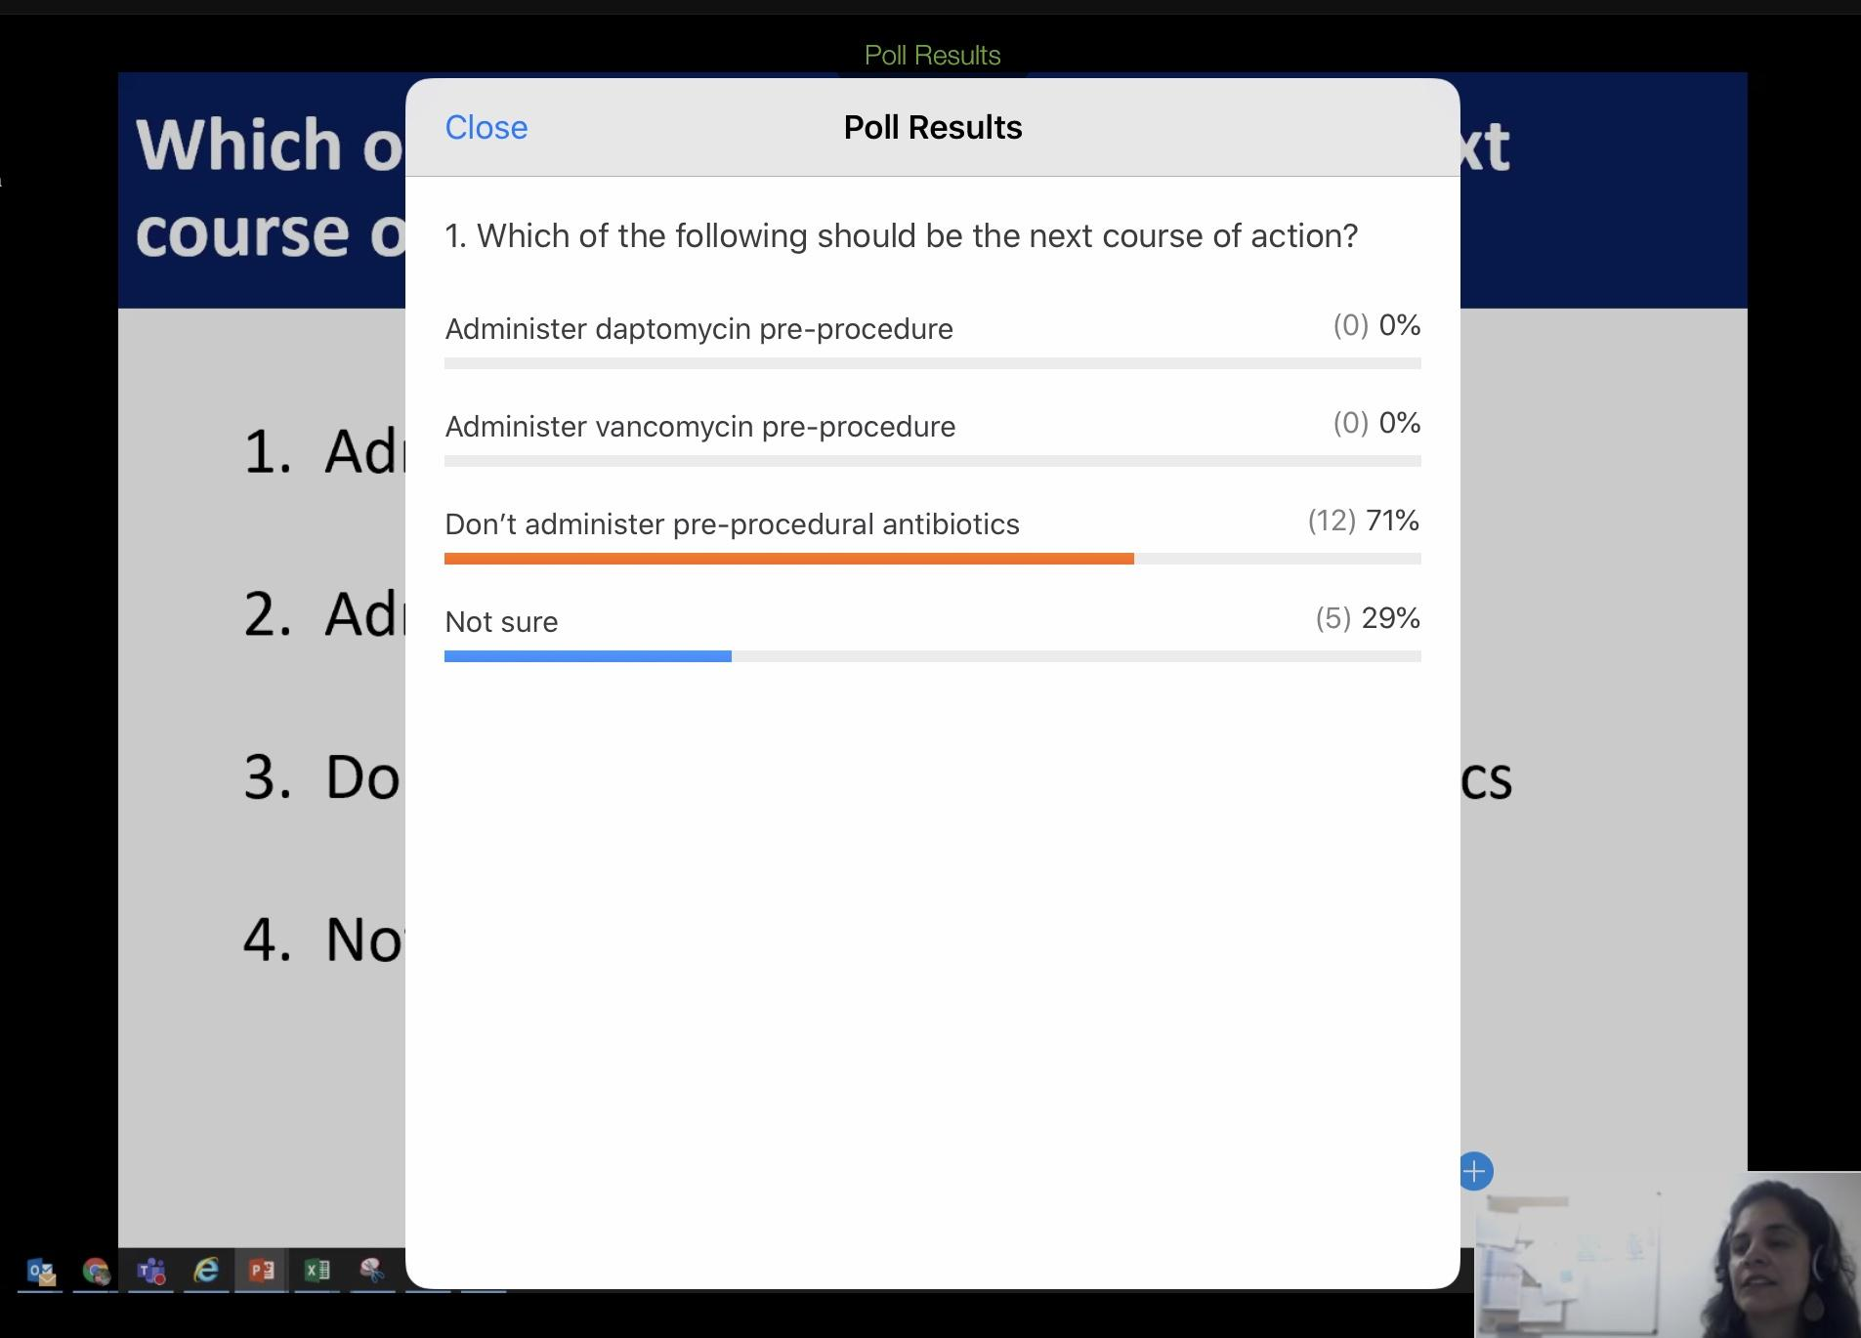

Clarify a couple of things, Genie looked up american heart assoc 2007 guideline, nothing has really changed. Guideline talked about pts w cardiac risk factors w a prosthetic valve. Most data is surrounding dental procedures. Enterococcus is really the focus of the AHA guideline, because they are so destructive to the heart valve. Extrapolation to GI literature- is really soft data. Generally for colonoscopy abx ppx is not recommended. GU procedures w manipulations who have had Enterococcus colonization in the past, then ppx abx or decolonization. DOC would be ampicillin/ amoxicillin, targeting E. faecalis specifically. Daptomycin would be used for VRE, E. faecium and rarely seen causing endocarditis. This patient would be a reasonable case, but should use amoxicillin, unless hx of VRE then use daptomycin.
John ID- 100% time goes to guidelines w treatment of endocarditis and ppx because things change so often.

